

Vehicle Showroom Management System
---------------------------------
Authors | A2209G_GROUP 2  Do Hoang An  Tran Anh Tuan  Tran Tuan Tu  Dinh The Phong
Date | October-21-2024
Instructor | Ngo Vinh Toan

Index
Acknowledgement 1
PROBLEM DEFINITION 1
Problem Abstraction 1
The Proposed System 2
Boundaries of System 2
Hardware and Software Requirements 3
CANDIDATE REQUIREMENTS 3
Users of the System 3
SYSTEM FUNCTIONS 3
SYSTEM DESIGNS 12
Database Design 12
Sitemap 13
System functions design 13
View Customer: 13
Login-Register: 17
View Admin: 18
View User: 28
User/Registration 32
User/Billing List 32
Add Billing Document 32
Task Sheet 33

Hà Nội, October – 21 - 2024

Acknowledgement
Our e-Project 3 needs assistance to be done and we, the authors, would like to give our acknowledgement to those who have supported and motivated us during the period of implementing this e-Project 3.
First and foremost, we would like to thank our instructor Mr. Ngo Vinh Toan whose support and useful advice helped us to complete our e-Project 3 effectively. His encouragement and comments had dramatically enriched and improved our work.
Secondly, we would like to thank Aprotrain - Aptech Computer Education, teachers, and staff for their support throughout our learning and completing this e-Project 3.
Thirdly, we would like to thank our families’ members including our parents, spouses and siblings for their support and care all the time, especially in the period of completing our work.
Lastly, our deep thanks come to all our classmates during studying time in Aptech. Their kind help, care, and motivation help us conquer the higher targets in the future.

PROBLEM DEFINITION
- Problem Abstraction
In the digital age, manual car management is gradually becoming outdated and no longer meets the needs of fast and accurate vehicle management and operation. Especially for transportation businesses, car rental services, or even individuals who own many cars, maintaining a system to track vehicle status, operating costs and maintenance history using books or Excel spreadsheets is not only time-consuming but also prone to errors.
To solve this problem, our group's Car Management Software was born as a comprehensive solution, helping users optimize the management process, minimize risks and operating costs. With a friendly interface, easy to use and the ability to integrate many smart features, this software is not only suitable for large enterprises but also an ideal choice for individuals or small and medium-sized units.
To solve this problem, we propose to build a car management website as a comprehensive solution, helping users optimize the management process, minimize risks and operating costs. With a friendly interface, easy to use and the ability to integrate many smart features, this software is not only suitable for large enterprises but also an ideal choice for individuals or small and medium-sized units.

We aim to develop an optimal vehicle management website, we can improve the efficiency and effectiveness of vehicle management, maintenance, repair and financial management processes. Save time and effort for both employers and candidates.
- The Current System
The traditional method of vehicle management has been used for many years. Everything such as vehicle import and export, vehicle maintenance inspection, cost control, showroom revenue and periodic reports are all carefully recorded by hand in books. That makes it take a lot of time, effort and resources for employees to rewrite all the customer's vehicle parameters every day after receiving the car.
However, with the development of technology and the internet, creating a management website brings more benefits. A vehicle management website provides a convenient online platform to post all vehicle information, new and old vehicles. Conduct the recruitment process effectively. By using technology and integrating search and filtering tools, the management website helps customers and administrators save time, optimize the process of selecting vehicles, and managing vehicles.
Creating a management website not only helps the company reach out to diverse potential customers nationwide, but also facilitates customers everywhere to view their favorite car models and car care services. This helps expand the scope and enhance the ability to find and attract all customers to the showroom.
In short, creating a management website is an important step in improving the vehicle management process. It not only saves time and effort for the company, but also benefits customers and helps to expand the business.
- The Proposed System
The user interface will have a search function, allowing users to search for their favorite car models and view showroom information. After viewing the information, they can also contact the HR department via email, phone number, facebook.
- Boundaries of System

The vehicle management website provides information on global vehicle models for customers who are looking for vehicles that fit their budget. Users can access vehicle listings on the web and view vehicle information in a suitable way, allowing them to make informed decisions and connect to the showroom's human resources department quickly.
- Hardware and Software Requirements
Hardware:
•The minimum system requirement to host the website and allow user to access all functions is a computer with an Intel Core™ i3 processor or equivalent.
• System has at least 2GB RAM, 8GB RAM is recommended.
• 1GB free of disk space, 512GB solid state drive (SSD) is recommended for the best performance.

Software:
• Windows Server 2012, Windows 7 or higher version.
• A server software (XAMPP, LAMPP…) with MySQL database management.
• An up-to-date browser (e.g., Google Chrome, Microsoft Edge, Safari, Firefox, and so on.)

- CANDIDATE REQUIREMENTS
- Users of the System
The system can be used by employees and administrators.
Employees: Employees can access the website to manage customers, vehicle services, import vehicles, sell vehicles, create vehicle registrations, generate invoices, and manage brands.
Administrators: Administrators have full system access and responsibility, including managing customers, employees, adding and editing new vehicles in the showroom, managing the waiting list, creating vehicle registrations, generating invoices, and monitoring system revenue. Administrators can also add or delete employees.
Customers:
Customers can access the website to view information about vehicles they are interested in through search categories.
Customers can contact the showroom via email, phone number, or Facebook.
- SYSTEM FUNCTIONS
- Customer Page:
For customers visiting the website to browse or purchase cars. The page is divided into sections:
1.1 Main Interface Page:
Description: Displays all cars in the inventory for sale, including out-of-stock vehicles. It also displays the car brands available in the showroom. Users can search for cars by name, by condition (new or used), by brand, and check which cars are still in stock.
1.2 About Us Page:
Description: Displays information about the showroom.
1.3 Contact Page:
Description: Displays contact information and the showroom's address.
1.4 Car Details Page:
Description: Displays detailed information about a car. This page includes the car name, price, model, brand, condition (new or used), quantity in stock, mileage (if used), production date, etc.
1.5 Register Page:
Description: Allows registration for Admin (Showroom owner) or User (Showroom staff), pending approval. Input: Full name, username, password, and role selection. Processing: Fetches data from the database and verifies if the username is already in use. If the username is taken, registration is rejected.
1.6 Login Page:
Description: Allows login to the Admin page (for showroom owners) or User page (for showroom staff). Input: Username and password. Processing: Fetches data from the database and verifies if the account exists and the password is correct. If either is incorrect, login is denied.

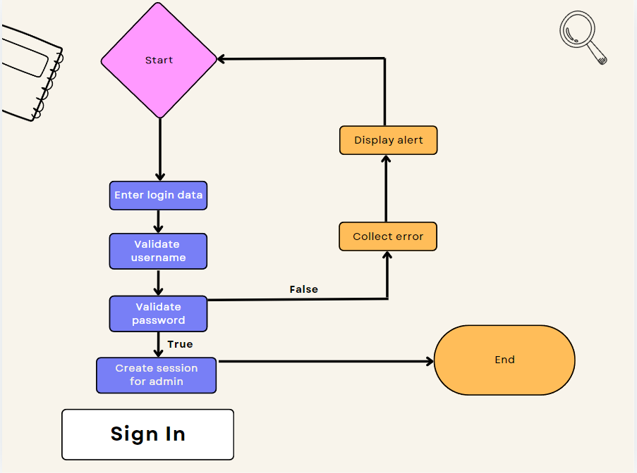

2. Admin Page:
Description: Admin can add or modify cars in the showroom, manage car imports, sales, customer information, staff, car brands, services, waiting lists, registrations, invoices, and approve Admin or User registrations.
2.1 Vehicle Manager Page (Admin Dashboard):
Description: Displays two lists—one showing all cars added to the showroom (with options to add or edit cars) and another showing cars currently in stock. Both lists allow filtering and searching by name or brand.
2.1.1 Add Vehicle:
Description: Allows the addition of new cars to the showroom with detailed information and images.
2.1.2 Edit Vehicle: Description: Allows editing of vehicle details and images.
2.2 Order Manager Page:
Description: Displays the list of car import orders, allowing searching by car name and filtering by condition (new or used) or brand. Users can edit each order's details.
2.2.1 Add Order:
Description: Allows the creation of car import orders, including car type, import date, quantity, and price.
2.2.2 Edit Order:
Description: Allows editing import order details, including car type, import date, quantity, and price. (Note: The import date must be after the car's production date.)
2.3 Customer & Employee Page:
Description: Displays two lists—one for all customers and another for all employees in the showroom. Both lists allow searching by name or email, and features to add, edit, or delete customers or employees.
2.3.1 Add Customer:
Description: Allows adding new customers, including full name, phone number, email, and address.
2.3.2 Edit Customer:
Description: Allows editing customer information, including full name, phone number, email, and address.
2.3.3 Add Employee:
Description: Allows adding new employees, including full name, phone number, email, and join date.
2.3.4 Edit Employee:
Description: Allows editing employee information, including full name, phone number, email, and join date.
2.4 Sales & Service Page:
Description: Displays two lists—one for sales orders and another for services performed. Both lists allow searching by car name or email, and provide options to add or edit sales or services.
2.4.1 Add Sales:
Description: Allows adding new sales orders, including car type (available in stock), employee, customer, sale date, and sale price.
2.4.2 Edit Sales:
Description: Allows editing sales order details, including car type, employee, customer, sale date, and sale price.
2.4.3 Add Service:
Description: Allows adding new service orders, including the sales order, service name, service description, and service date.
2.4.4 Edit Service:
Description: Allows editing service order details, including the sales order, service name, service description, and service date. (Note: The sale date must be after the car's import date, and a service order must be added after the sales order to generate an invoice.)
2.5 Brand Page:
Description: Displays a list of car brands available in the showroom, with options to add new or edit existing brands directly on the page.
2.5.1 Edit Brand:
Description: Allows editing the brand name.
2.6 Report Page:
Description: Users can select a start and end date for the report, then click "Get Report" to display charts and the following details:
- Total number of employees.
- Total number of customers.
- Total number of cars sold.
- Total number of cars imported.
- Total number of cars in stock.
- Total invoice amount.
- Total paid invoices.
- Total unpaid invoices.
- Total car sales revenue.
- Total gross revenue.
- Total car import cost.
2.7 Waiting List Page:
Description: Displays a list of customers on the waiting list, allowing searching by car name or model, and providing options to add, edit, or delete entries.
2.7.1 Add Waiting:
Description: Allows adding new customers to the waiting list, including customer name, car type (available in the showroom), and request date.
2.7.2 Edit Waiting:
Description: Allows editing waiting list information, including customer name, car type, and request date.
2.8 Registration Page:
Description: Displays two lists—one for cars not yet registered, allowing new registrations, and another for registered cars, allowing registration detail edits. Both lists have search and filter features by car name or brand.
2.8.1 Add Registration:
Description: Allows adding registration dates for cars.
2.8.2 Edit Registration:
Description: Allows editing registration dates for cars.
2.9 Billing List Page:
Description: Displays a list of invoices, allowing search by car name or customer name, and providing options to add, edit, or delete invoices.
2.9.1 Add Billing:
Description: Allows adding invoices, including car sale order, invoice date, status (paid or unpaid), and service order.
2.9.2 Edit Billing:
Description: Allows editing invoice details, including car sale order, invoice date, status, and service order.
2.10 Check Page:
Description: Displays a list of user registrations pending approval, allowing search by full name or username, and filtering by role (Admin or User). Admins can approve registrations.
2.11 View Page:
Description: Displays the showroom's name, contact information, address, map, and an introduction about the showroom. It also includes an editable section for the title introduction, as seen on the customer interface.

3. User Page:
Description: Users can add or modify cars in the showroom, manage car imports, sales, customer information, brands, services, waiting lists, registrations, and invoices.
3.1 Vehicle Manager Page (User Dashboard):
Description: Displays two lists—one showing all cars added to the showroom (with options to add or edit cars) and another showing cars currently in stock. Both lists allow filtering and searching by name or brand.
3.1.1 Add Vehicle:
Description: Allows the addition of new cars to the showroom with detailed information and images.
3.1.2 Edit Vehicle:
Description: Allows editing vehicle details and images.
3.2 Order Manager Page:
Description: Displays the list of car import orders, allowing searching by car name and filtering by condition (new or used) or brand. Users can edit each order's details.
3.2.1 Add Order:
Description: Allows the creation of car import orders, including car type, import date, quantity, and price.
3.2.2 Edit Order:
Description: Allows editing import order details, including car type, import date, quantity, and price. (Note: The import date must be after the car's production date.)
3.3 Customer Page:
Description: Displays the customer information list, allowing searching by name or email, with options to add, edit, or delete customers.
3.3.1 Add Customer:
Description: Allows adding new customers, including full name, phone number, email, and address.
3.3.2 Edit Customer:
Description: Allows editing customer information, including full name, phone number, email, and address.
3.4 Sales & Service Page:
Description: Displays two lists—one for sales orders and another for services performed. Both lists allow searching by car name or email, and provide options to add or edit sales or services.
3.4.1 Add Sales:
Description: Allows adding new sales orders, including car type (available in stock), employee, customer, sale date, and sale price.
3.4.2 Edit Sales:
Description: Allows editing sales order details, including car type, employee, customer, sale date, and sale price.
3.4.3 Add Service:
Description: Allows adding new service orders, including the sales order, service name, service description, and service date.
3.4.4 Edit Service:
Description: Allows editing service order details, including the sales order, service name, service description, and service date. (Note: The sale date must be after the car's import date, and a service order must be added after the sales order to generate an invoice.)
3.5 Brand Page:
Description: Displays a list of car brands available in the showroom, with options to add new or edit existing brands directly on the page.
3.5.1 Edit Brand:
Description: Allows editing the brand name.
3.6 Waiting List Page:
Description: Displays a list of customers on the waiting list, allowing searching by car name or model, and providing options to add, edit, or delete entries.
3.6.1 Add Waiting:
Description: Allows adding new customers to the waiting list, including customer name, car type (available in the showroom), and request date.
3.6.2 Edit Waiting:
Description: Allows editing waiting list information, including customer name, car type, and request date.
3.7 Registration Page:
Description: Displays two lists—one for cars not yet registered, allowing new registrations, and another for registered cars, allowing registration detail edits. Both lists have search and filter features by car name or brand.
3.7.1 Add Registration:
Description: Allows adding registration dates for cars.
3.7.2 Edit Registration:
Description: Allows editing registration dates for cars.
3.8 Billing List Page:
Description: Displays a list of invoices, allowing search by car name or customer name, and providing options to add, edit, or delete invoices.
3.8.1 Add Billing:
Description: Allows adding invoices, including car sale order, invoice date, status (paid or unpaid), and service order.
3.8.2 Edit Billing:
Description: Allows editing invoice details, including car sale order, invoice date, status, and service order.

- SYSTEM DESIGNS
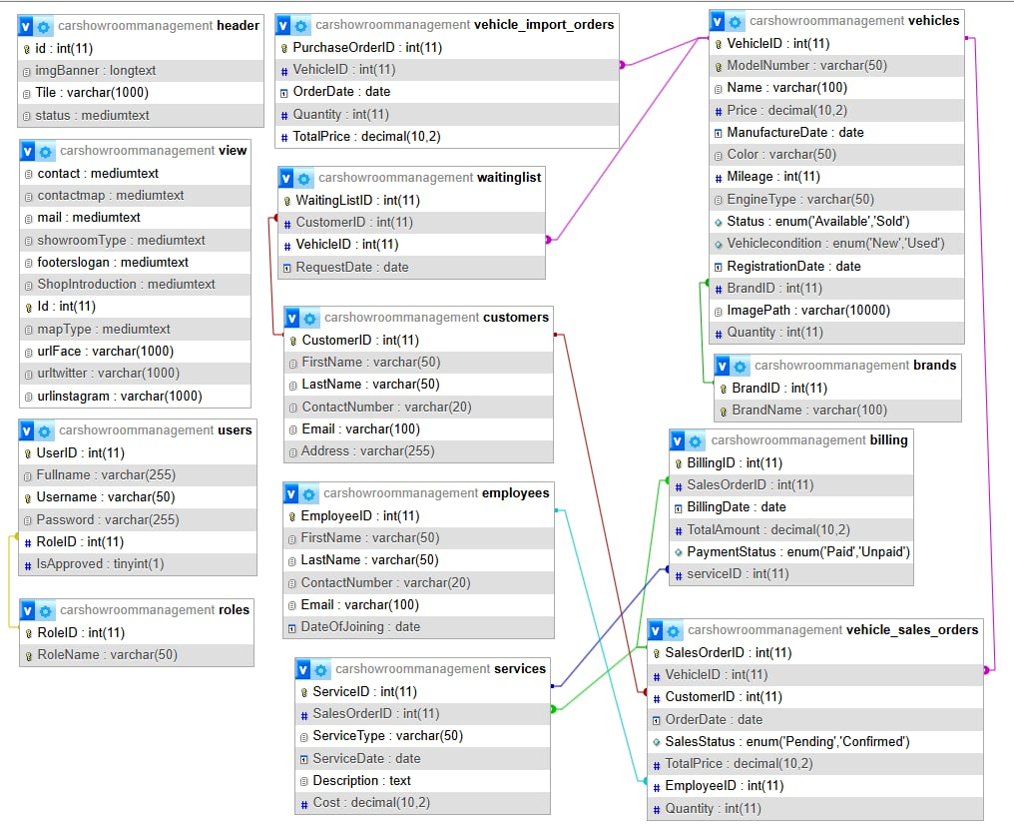
  - Database Design

- Sitemap

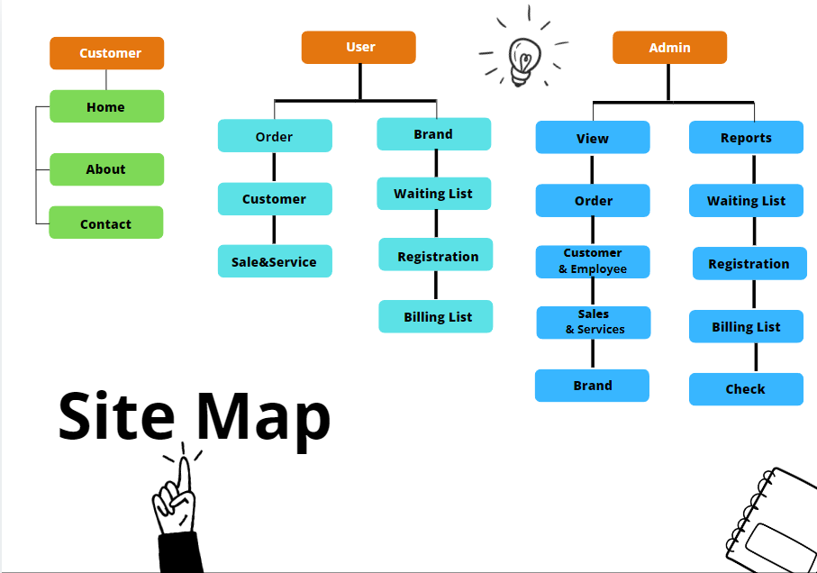

- System functions design
- View Customer:
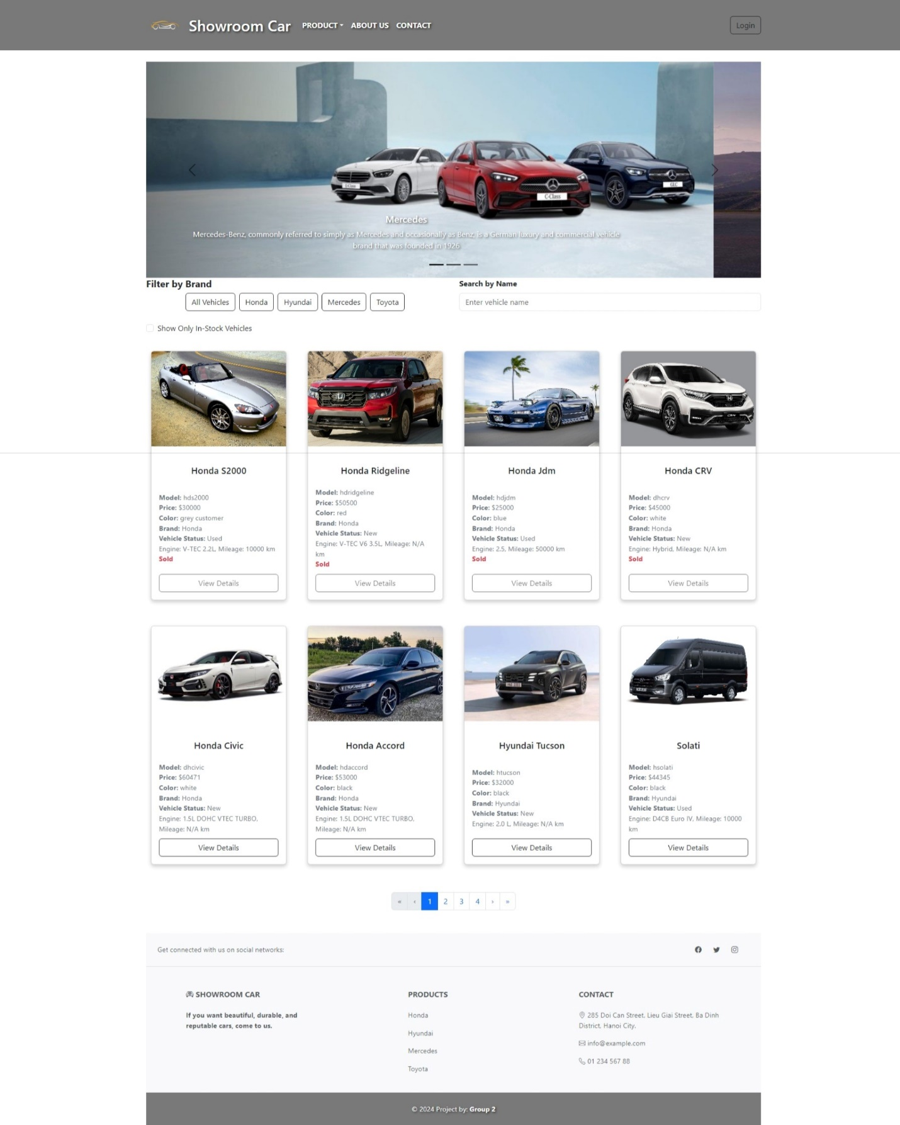

About us:

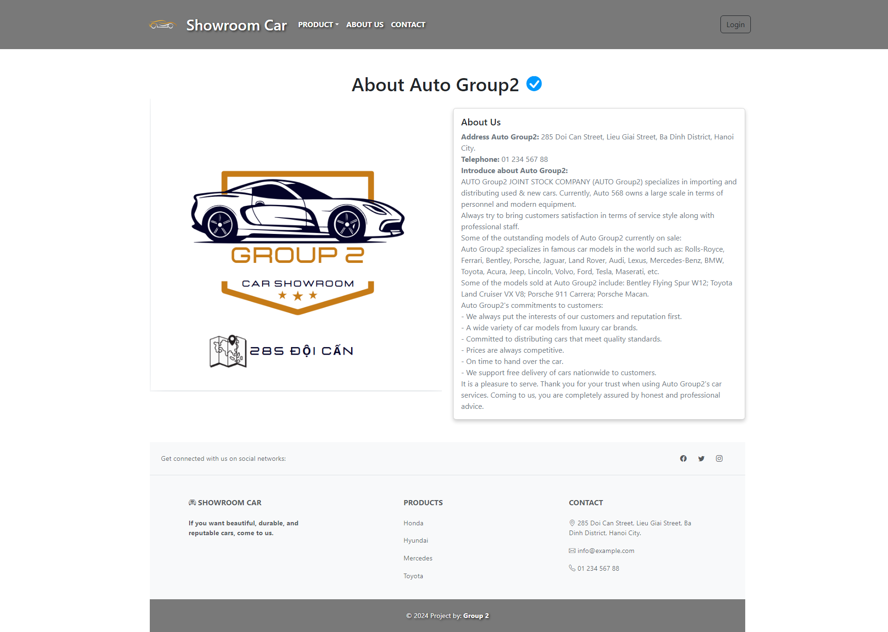

Contact:

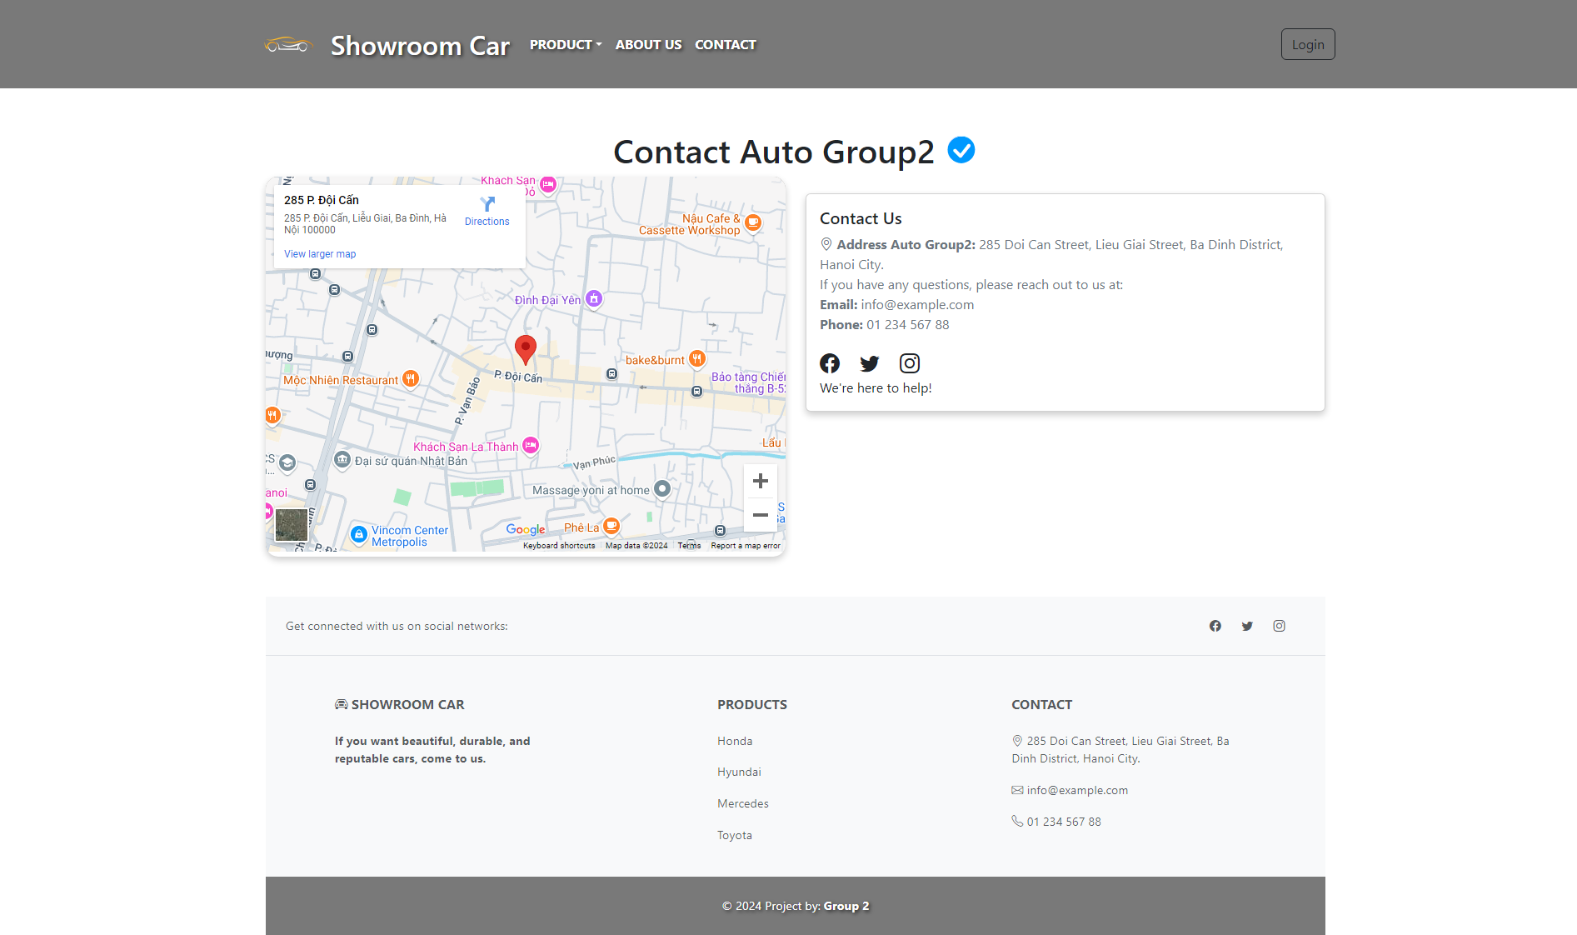

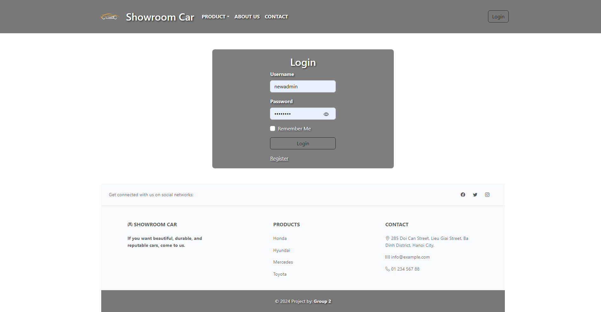
Login-Register:
Login:

Register:
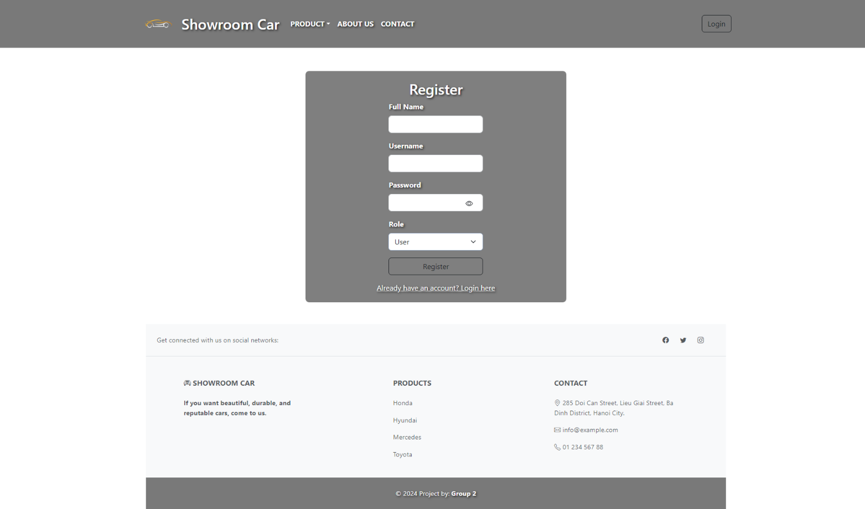

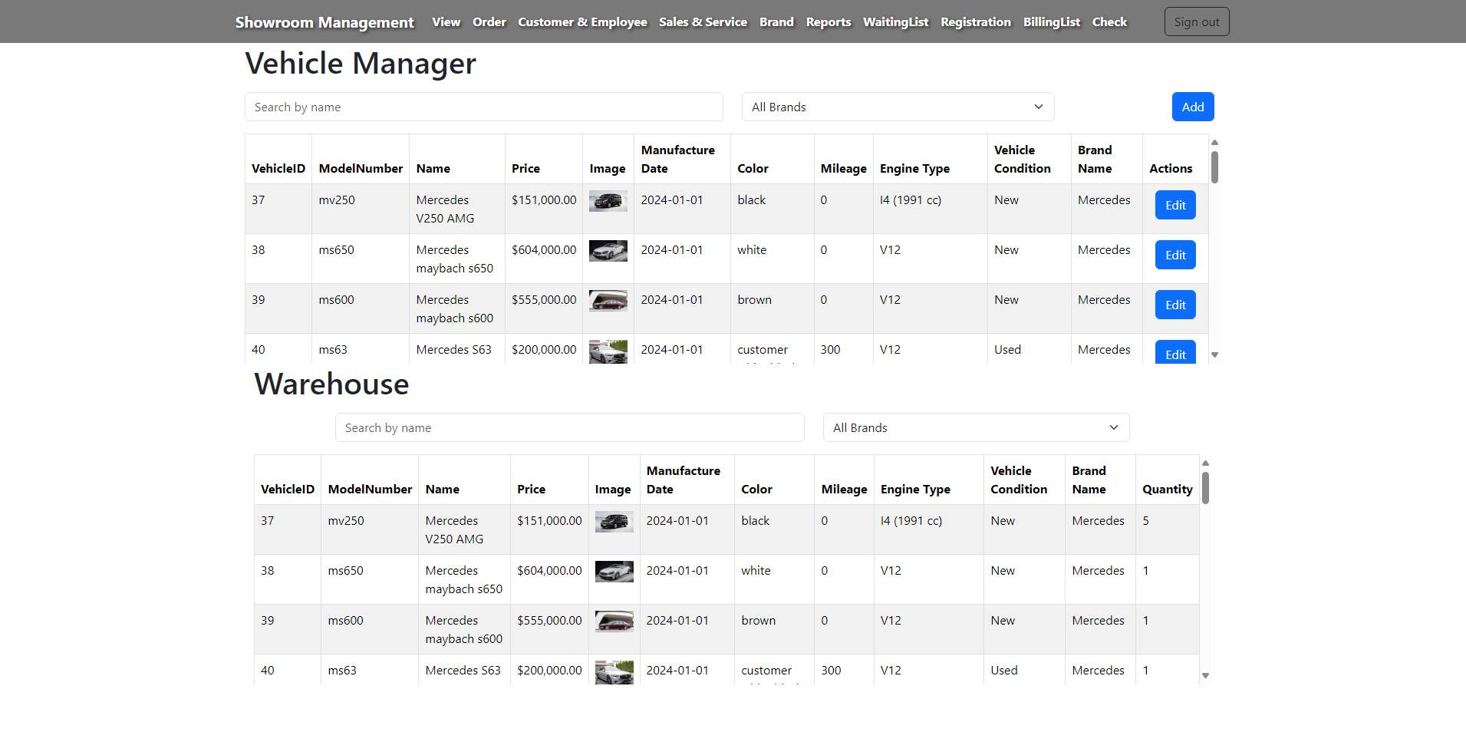
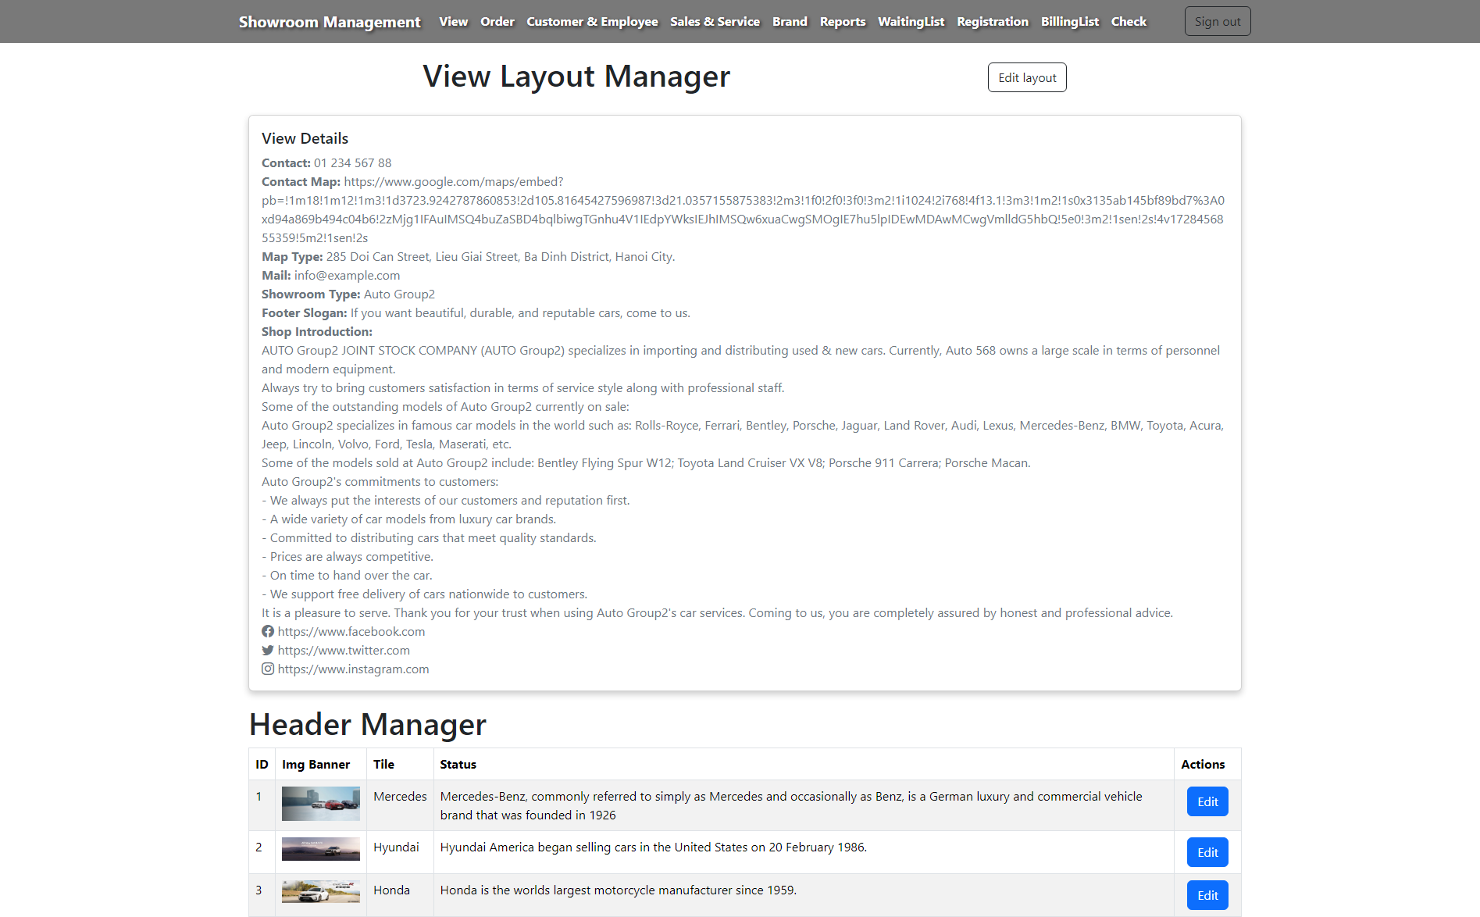
View Admin:
Admin/View Layout
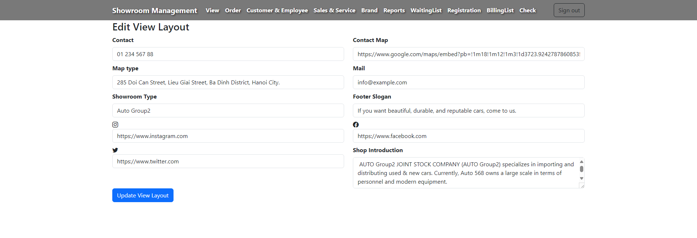
Admin/Edit-View

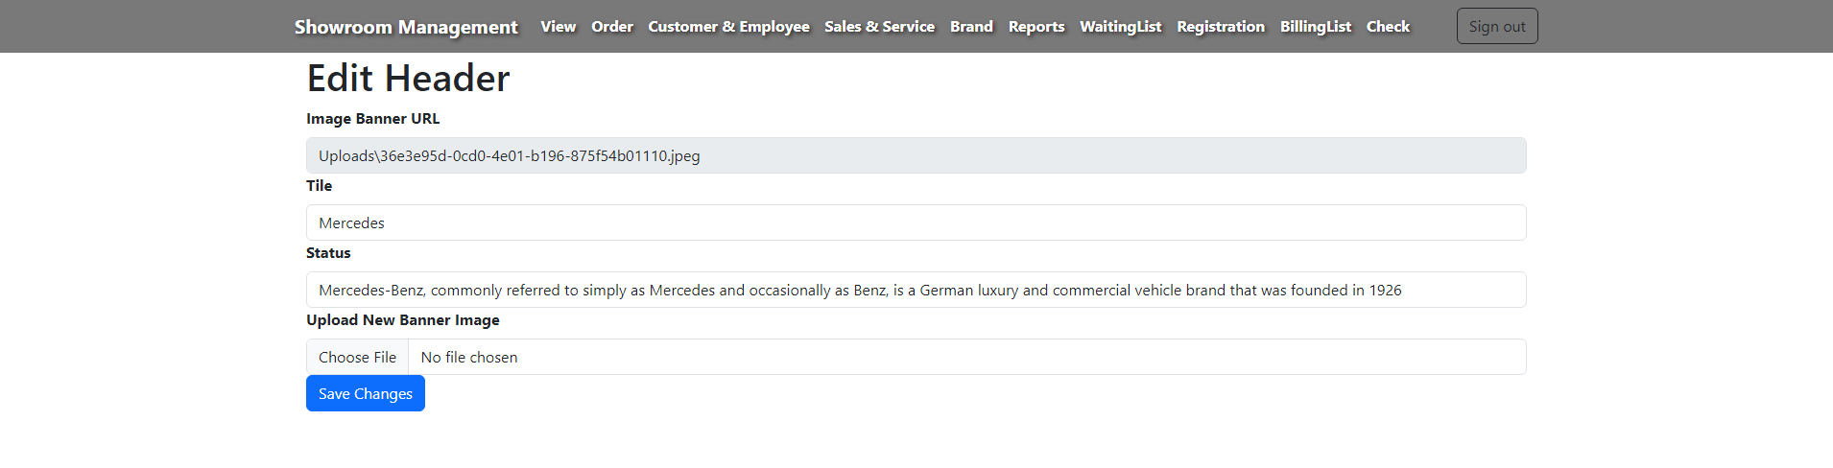
Admin/Edit-Header

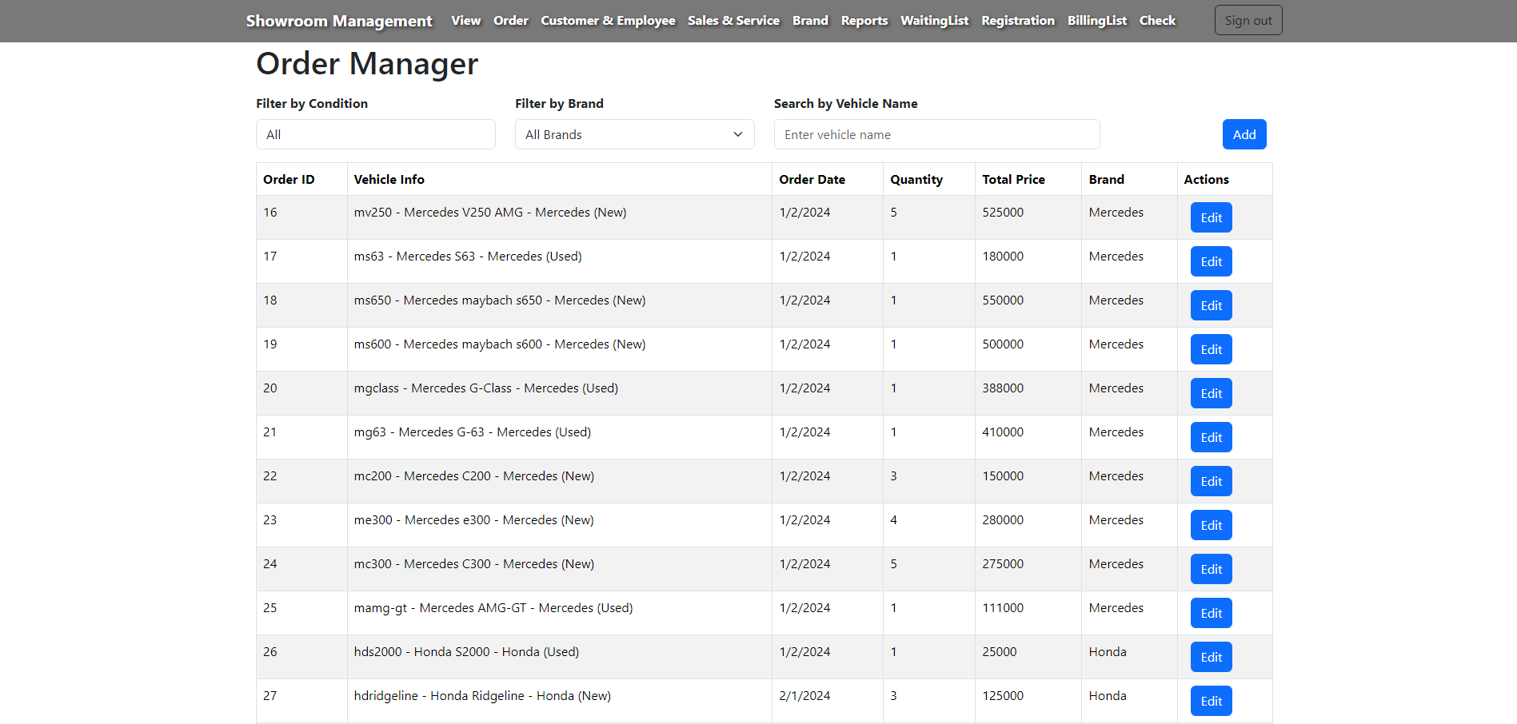
Admin/Order-List

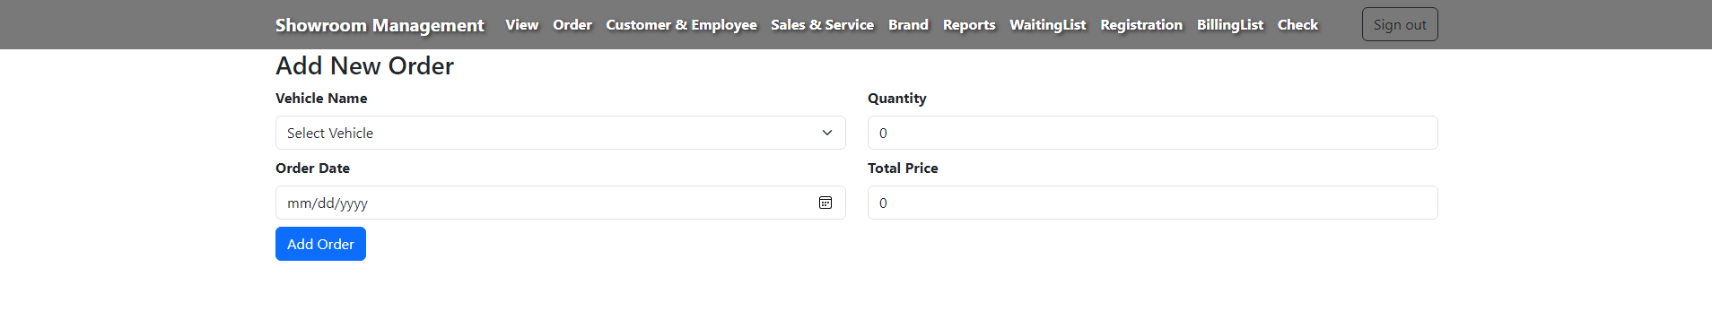
Admin/Add-Order

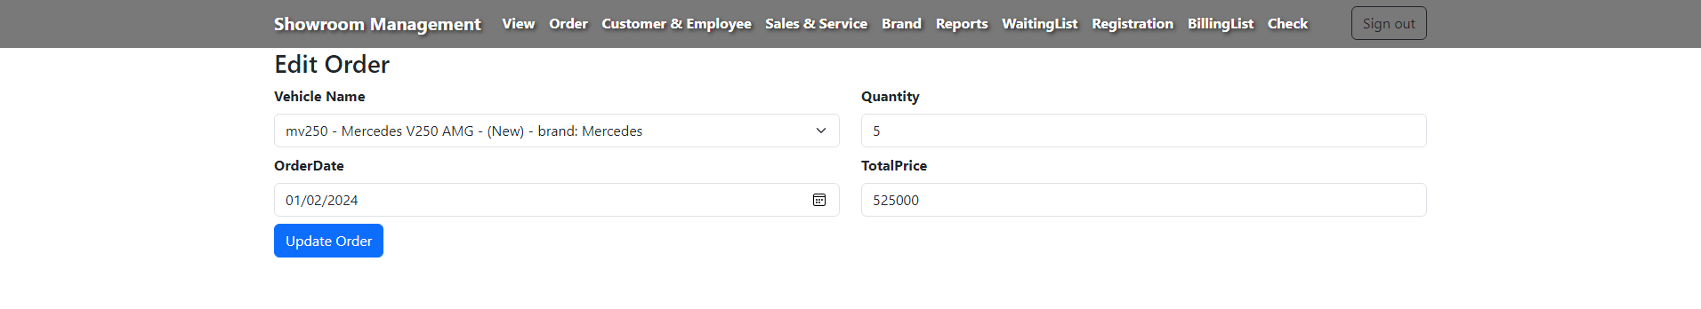
Admin/Edit-Order
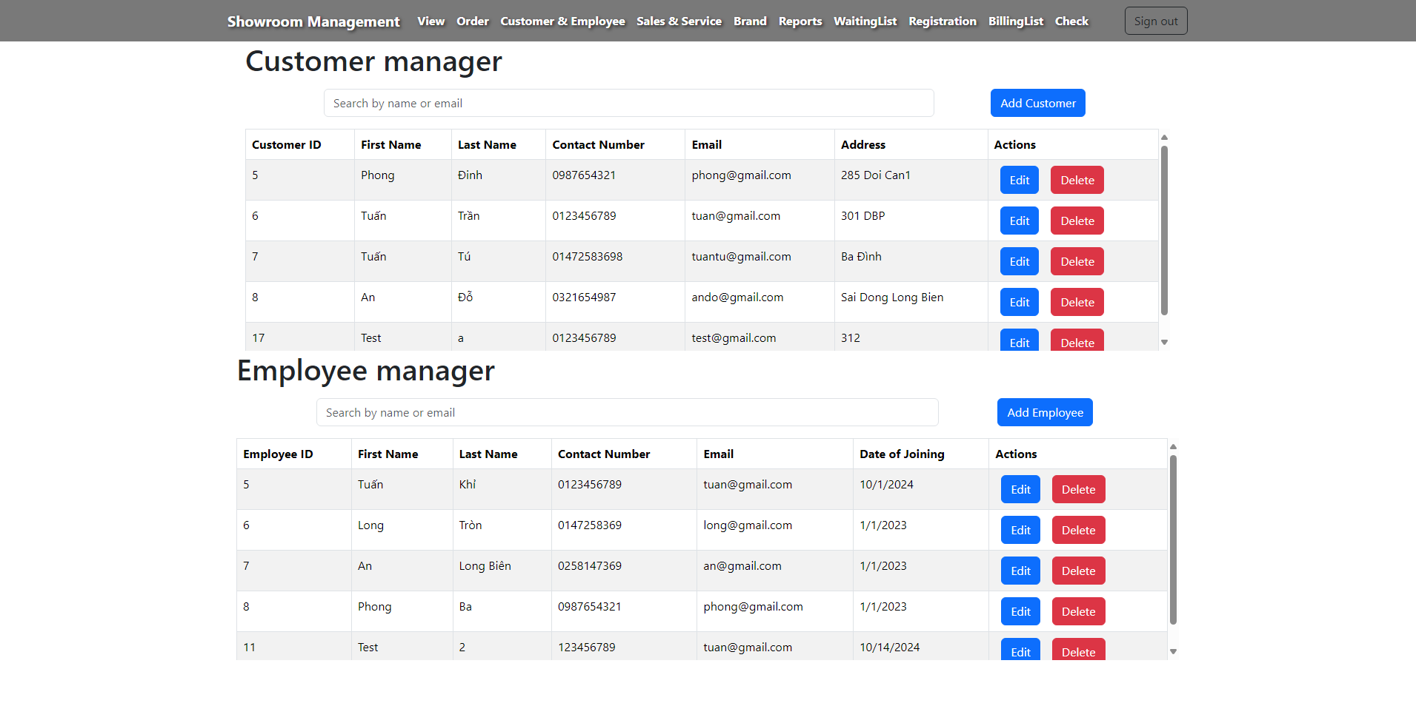
Admin/Customer-Employee
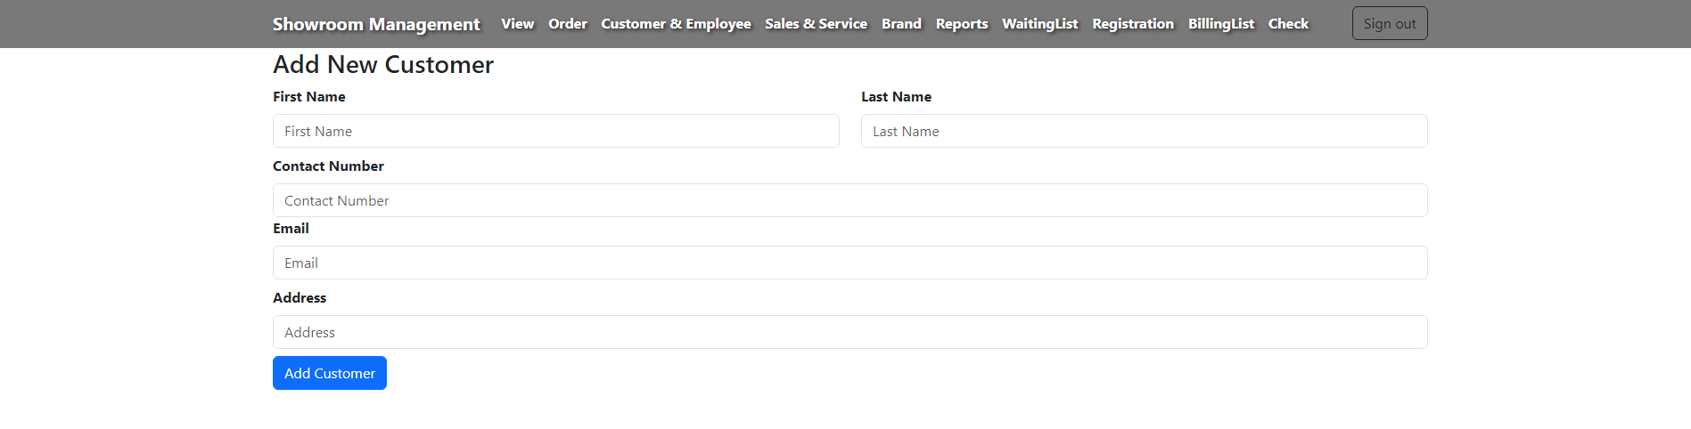
Admin/Add-Customer
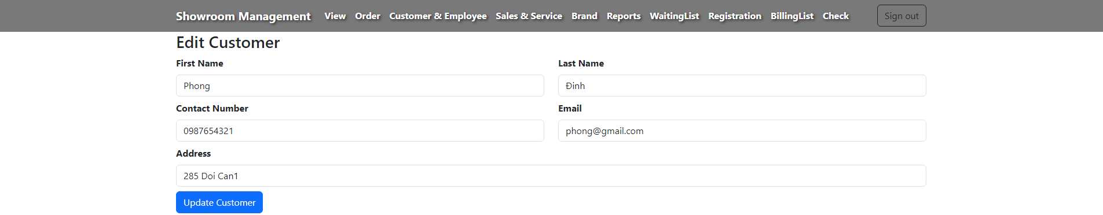
Admin/Edit-Customer
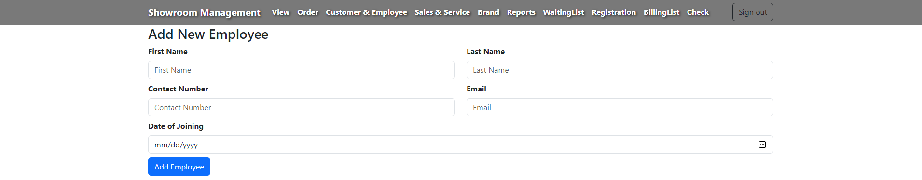
Admin/Add-Employee

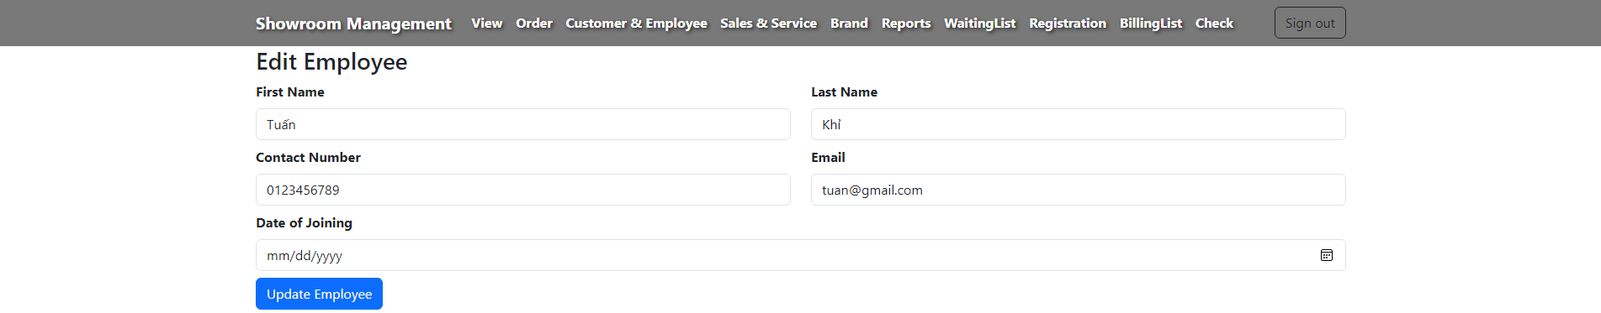
Admin/Edit-Employee

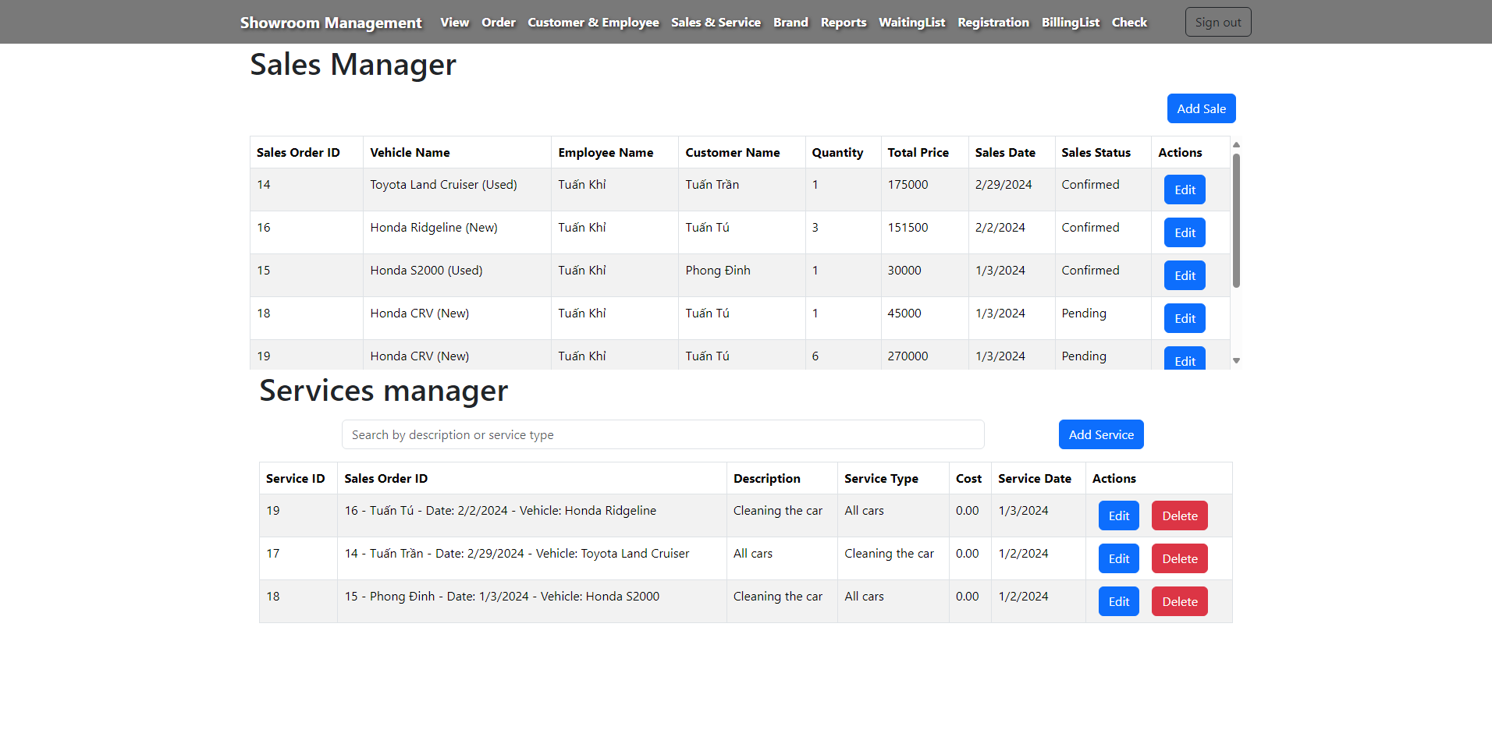
Admin/Sales&&Service-list
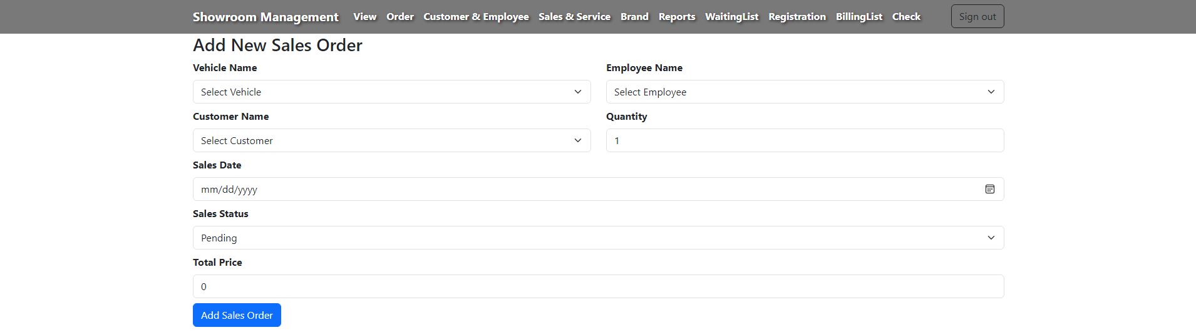
Admin/Add-Sales

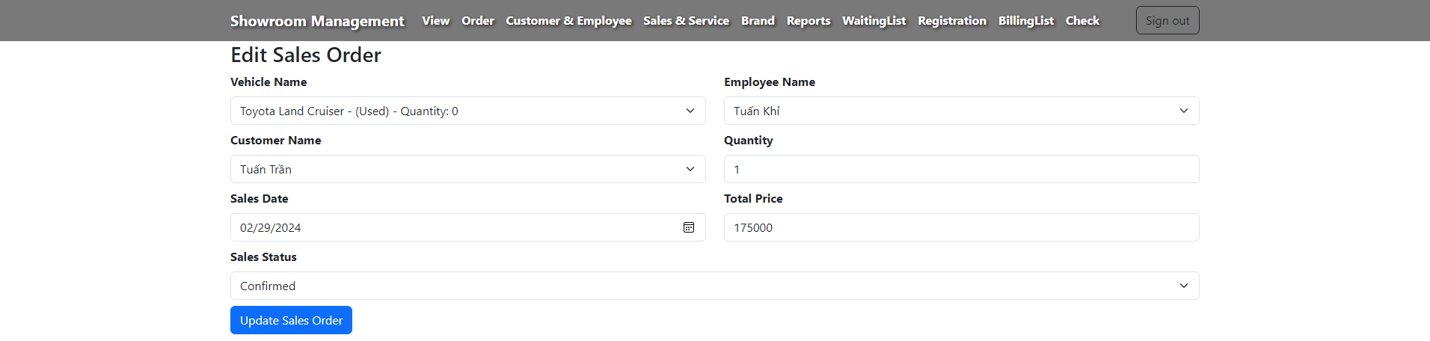
Admin/Edit-Sales

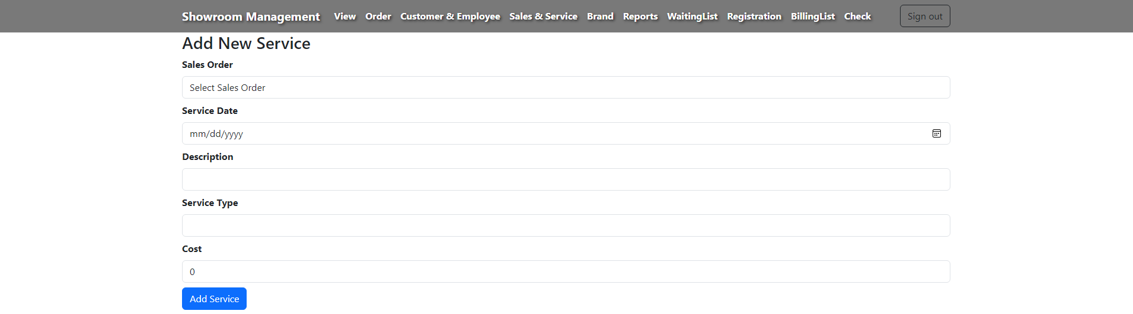
Admin/Add-Service
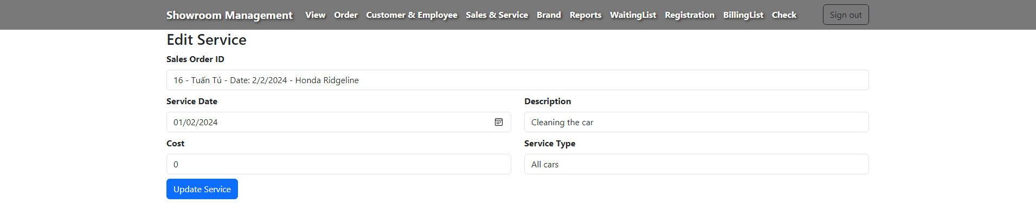
Admin/Edit-Service

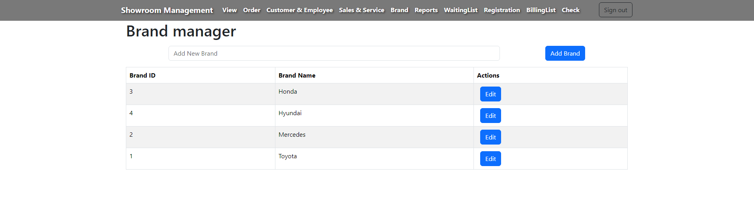
Admin/Brand-List


Admin/Edit-Brand

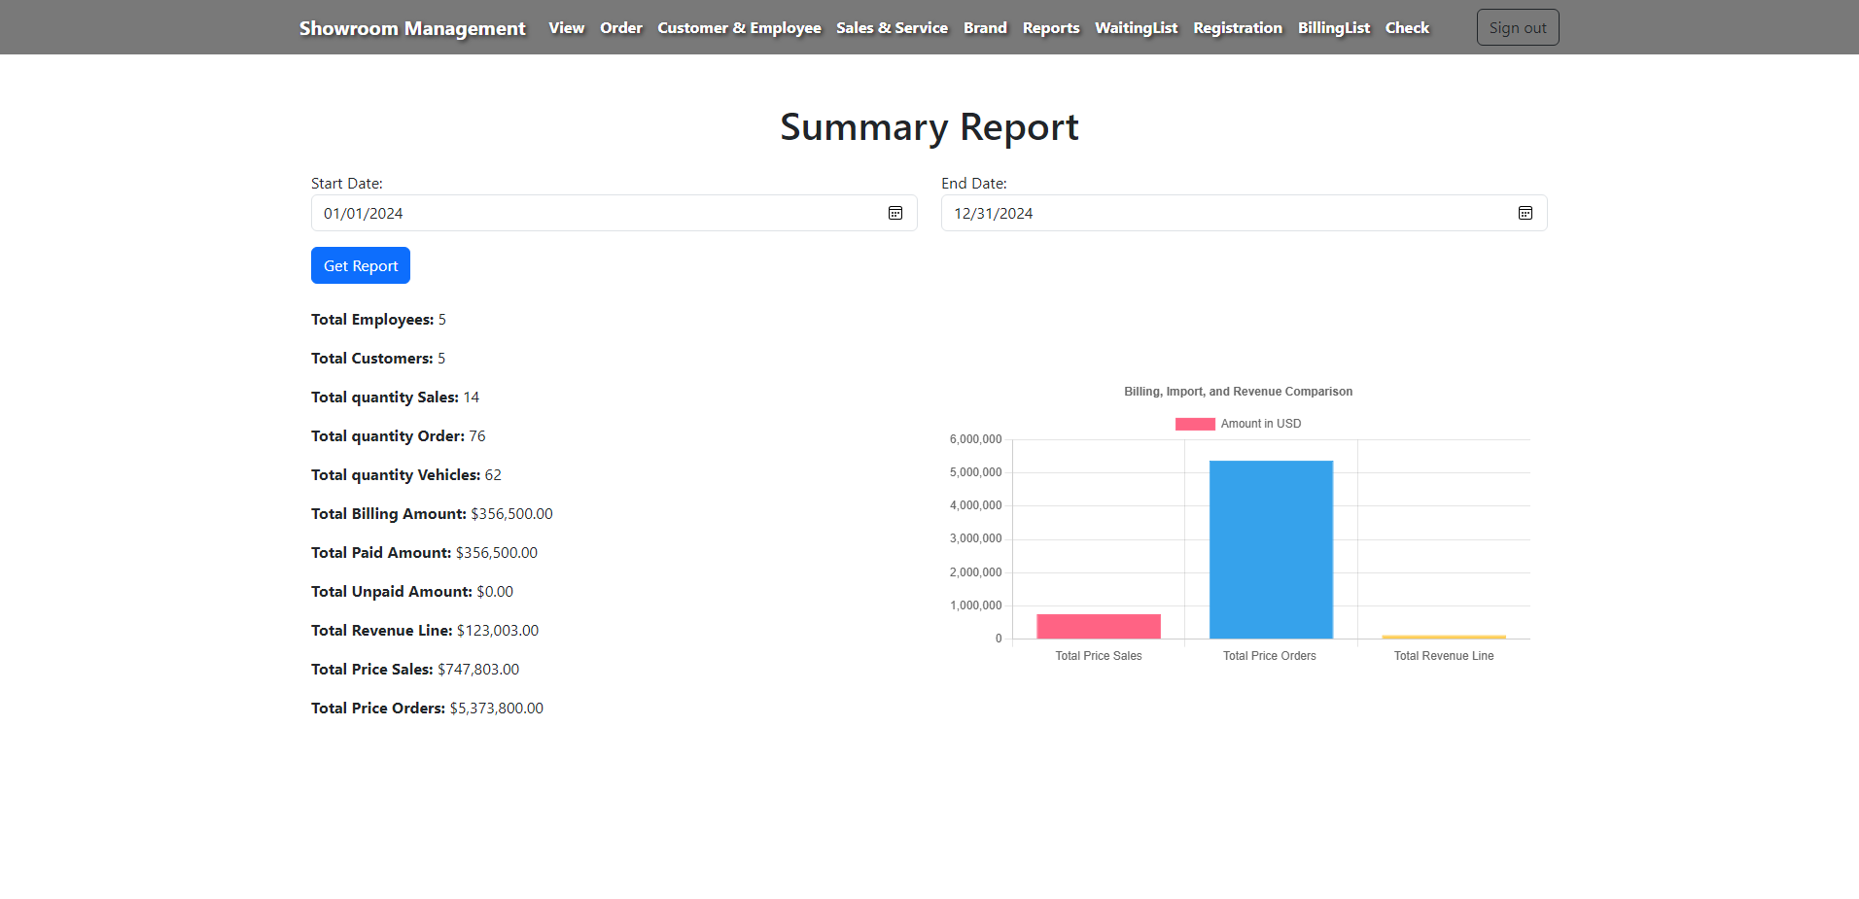
Admin/Report
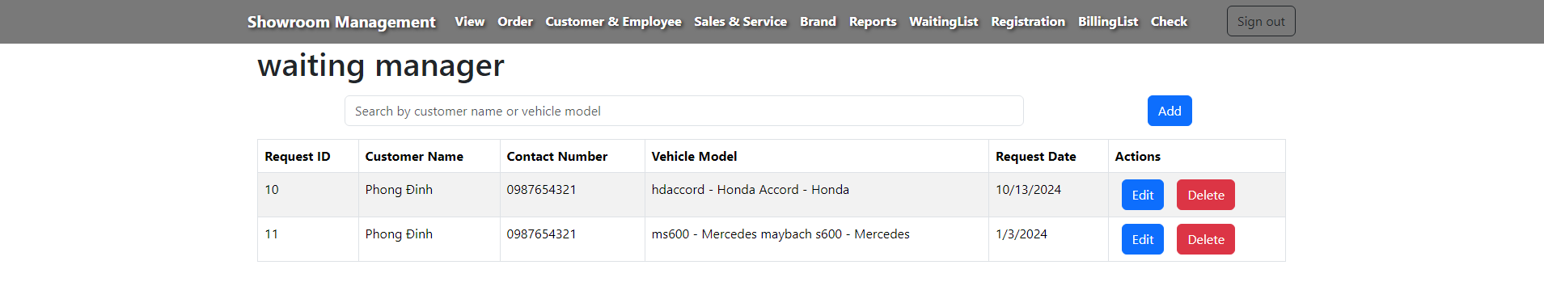
Admin/Waiting-List

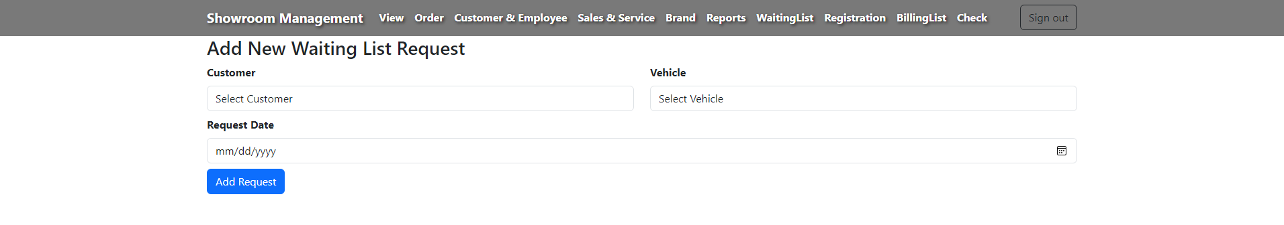
Admin/Add-Waiting List
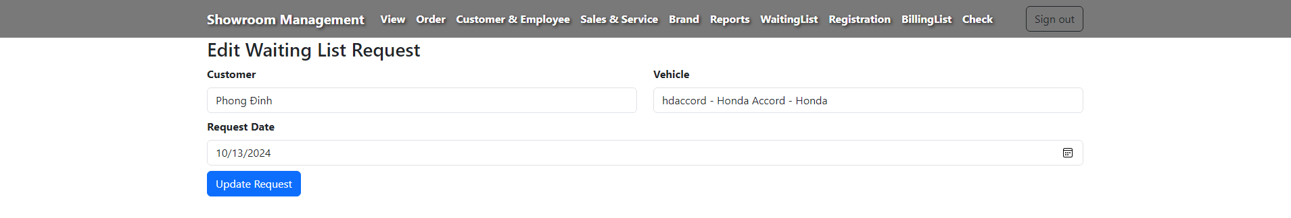
Admin/Edit-Waiting List

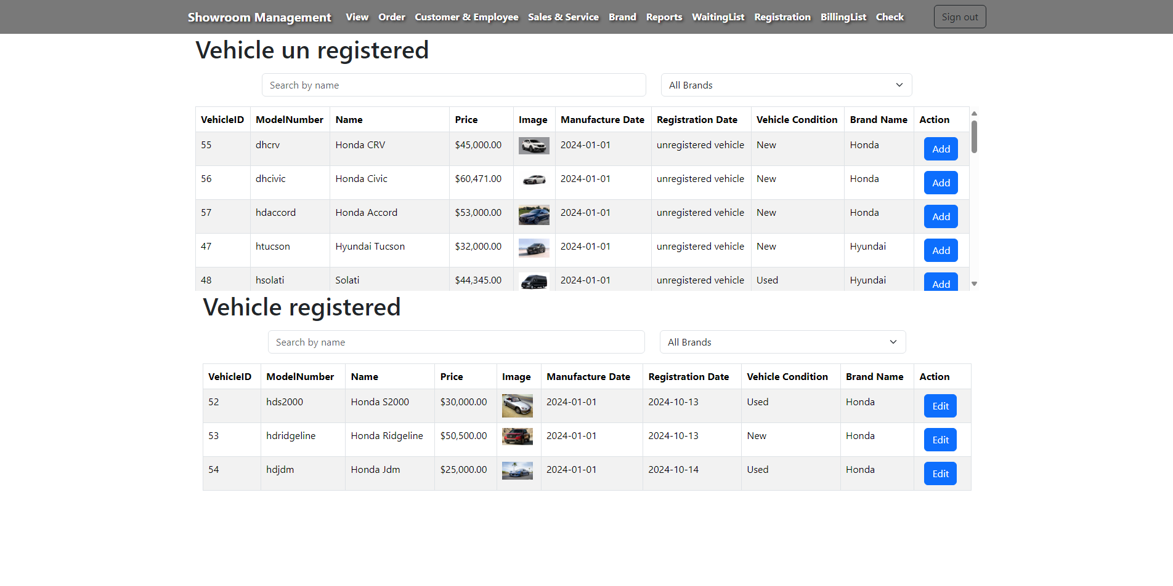
Admin/View Registration
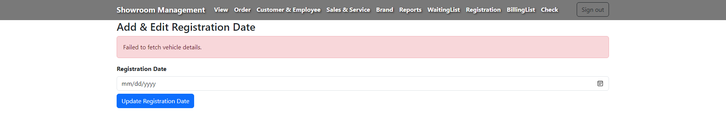
Admin/Add-Edit Registration
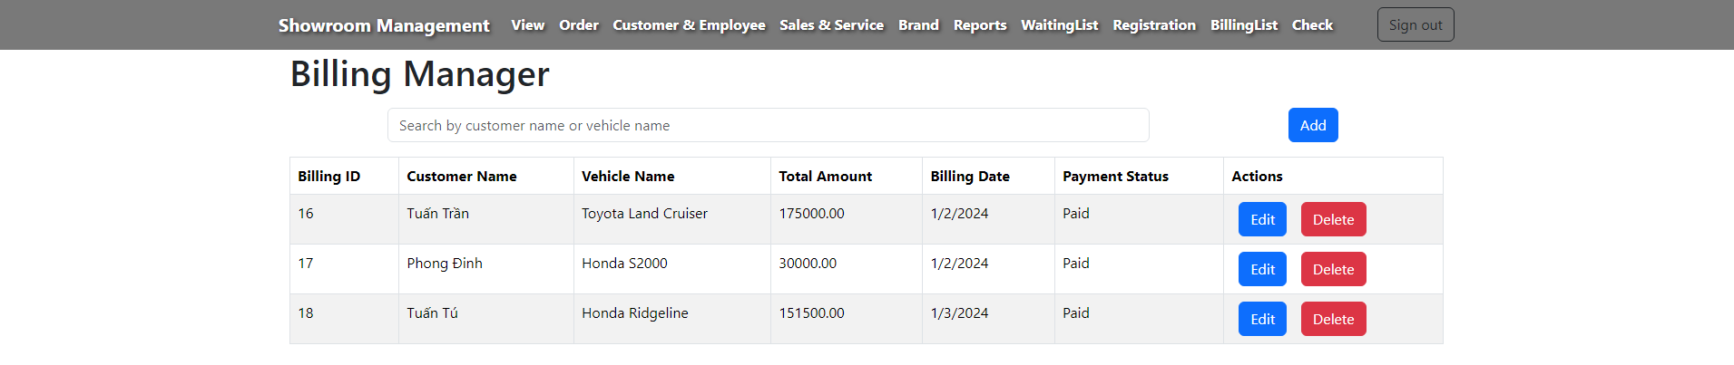
Admin/Billing-List

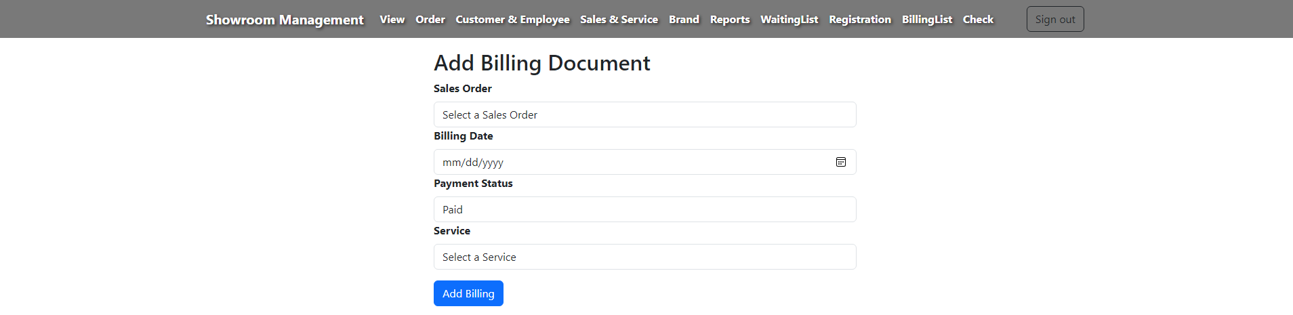
Admin/Add-Billing

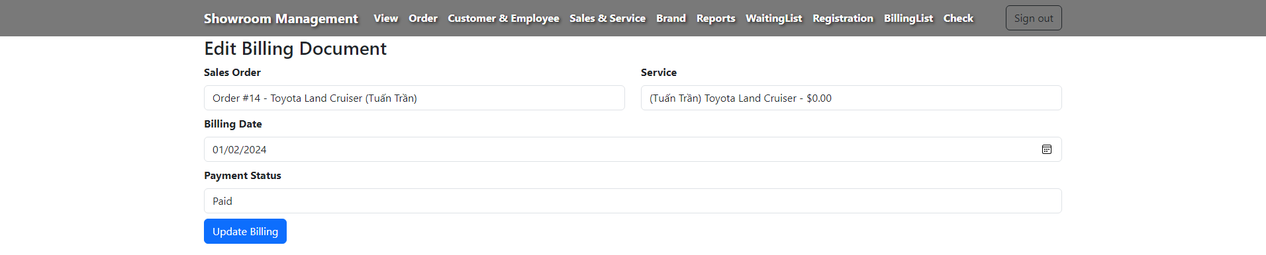
Admin/Edit-Billing

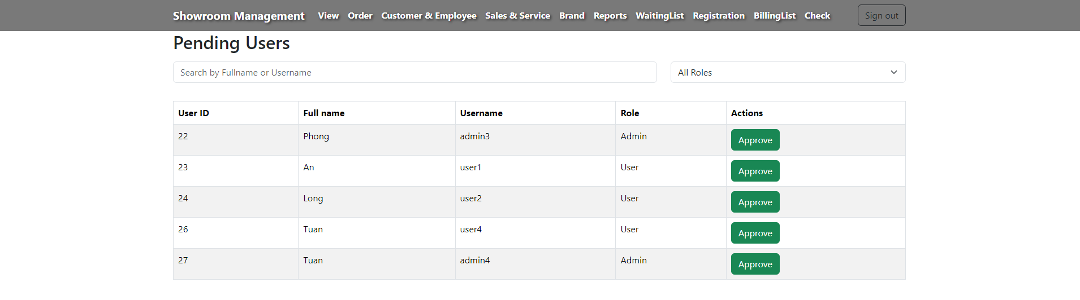
Admin/check Admin-User

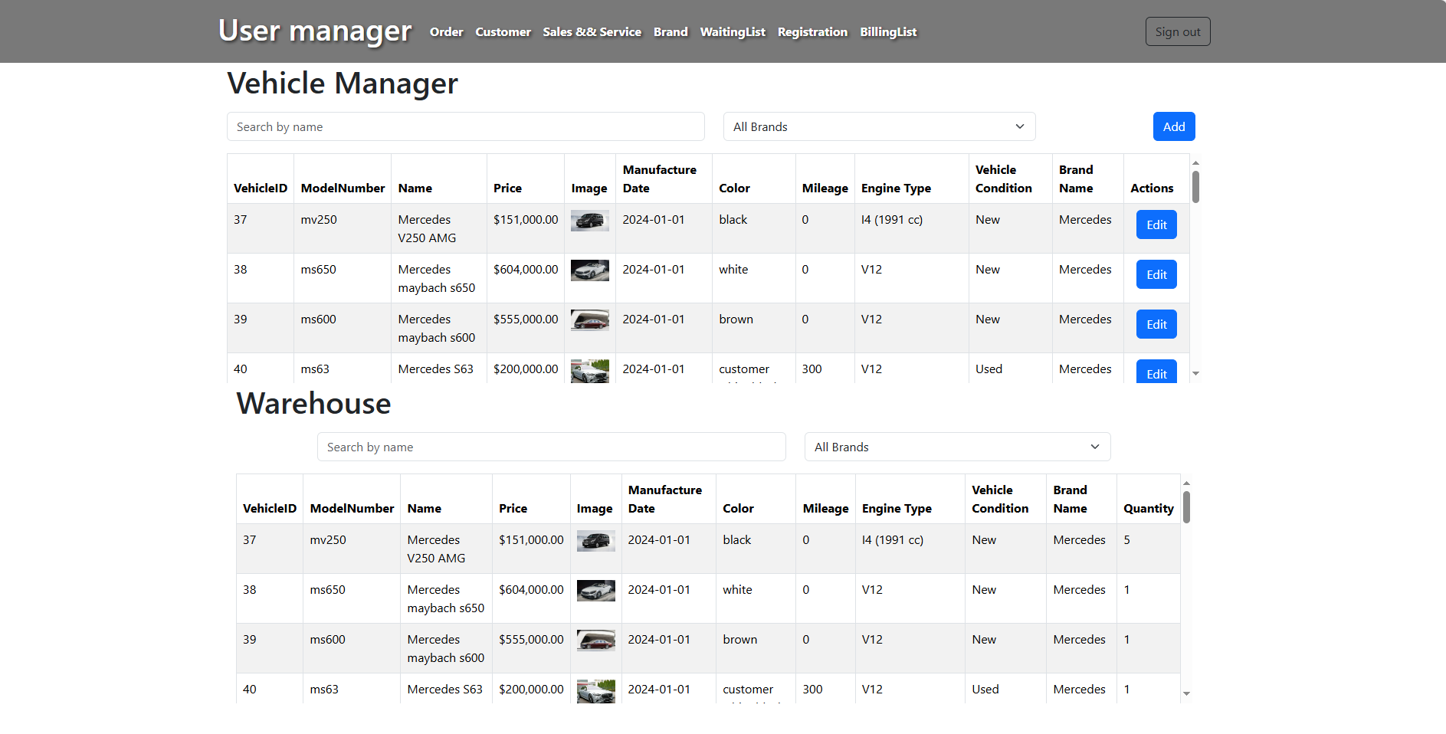
View User:

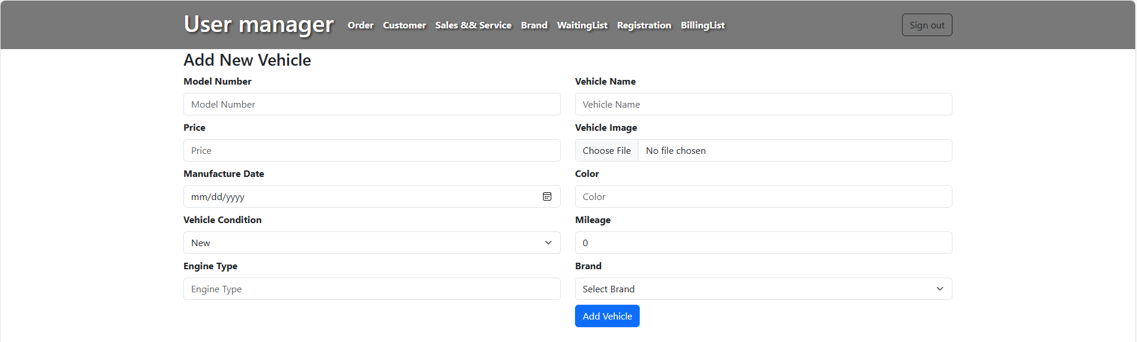
User/ Add New Vehicle

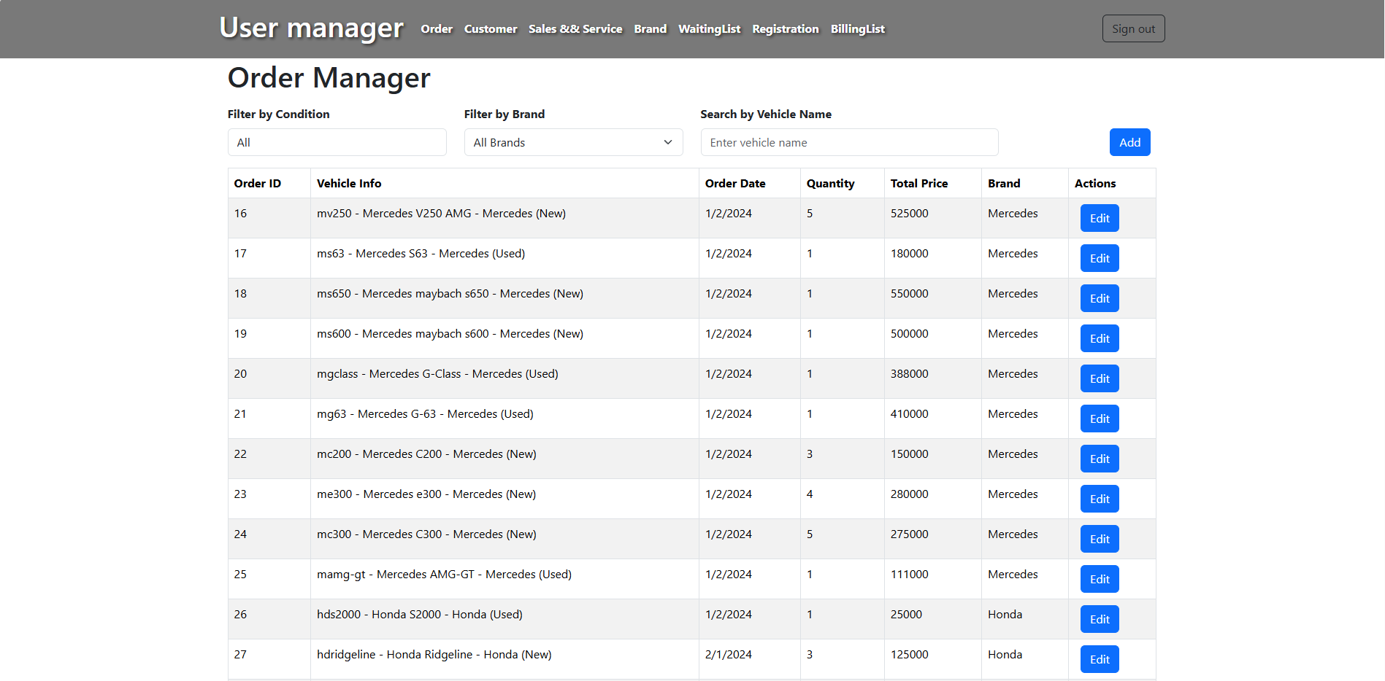
User/Order Manager

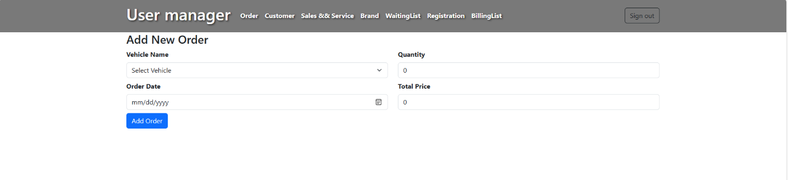
User/Add New Order

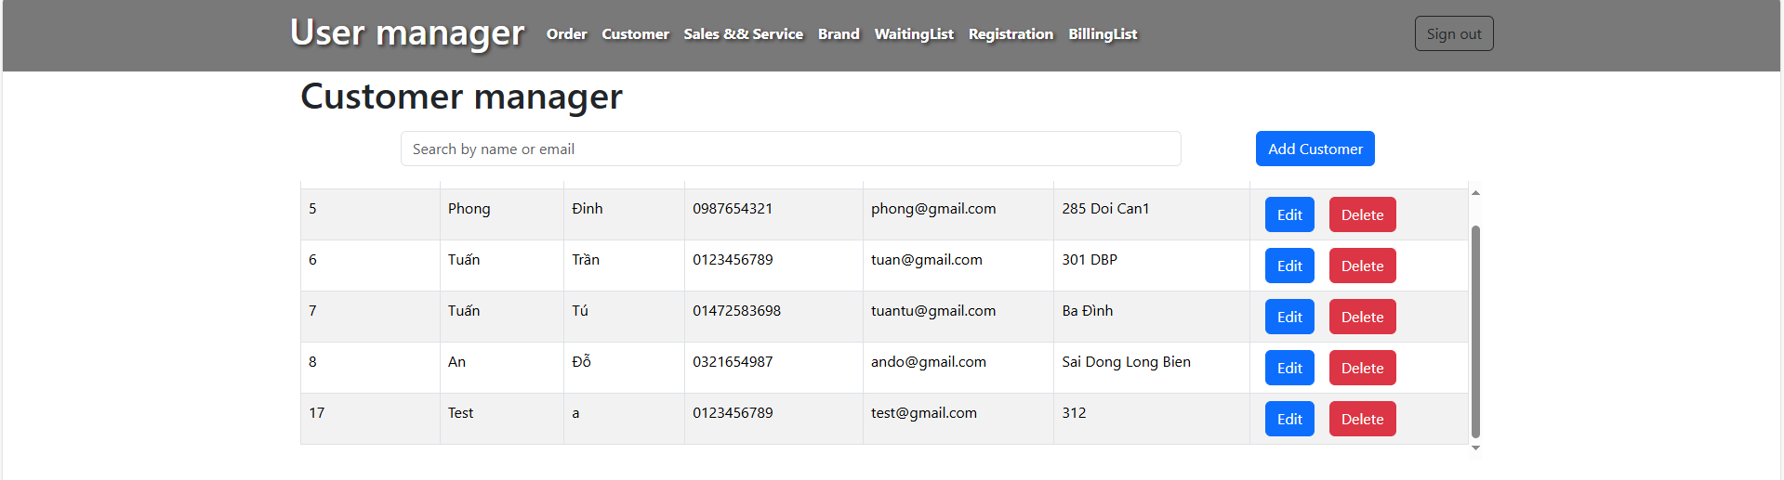
User/Customer Manager

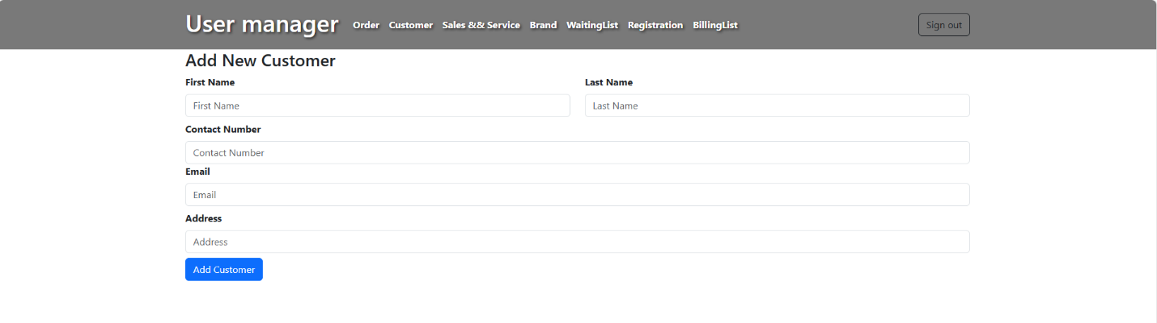
User/Add New Customer
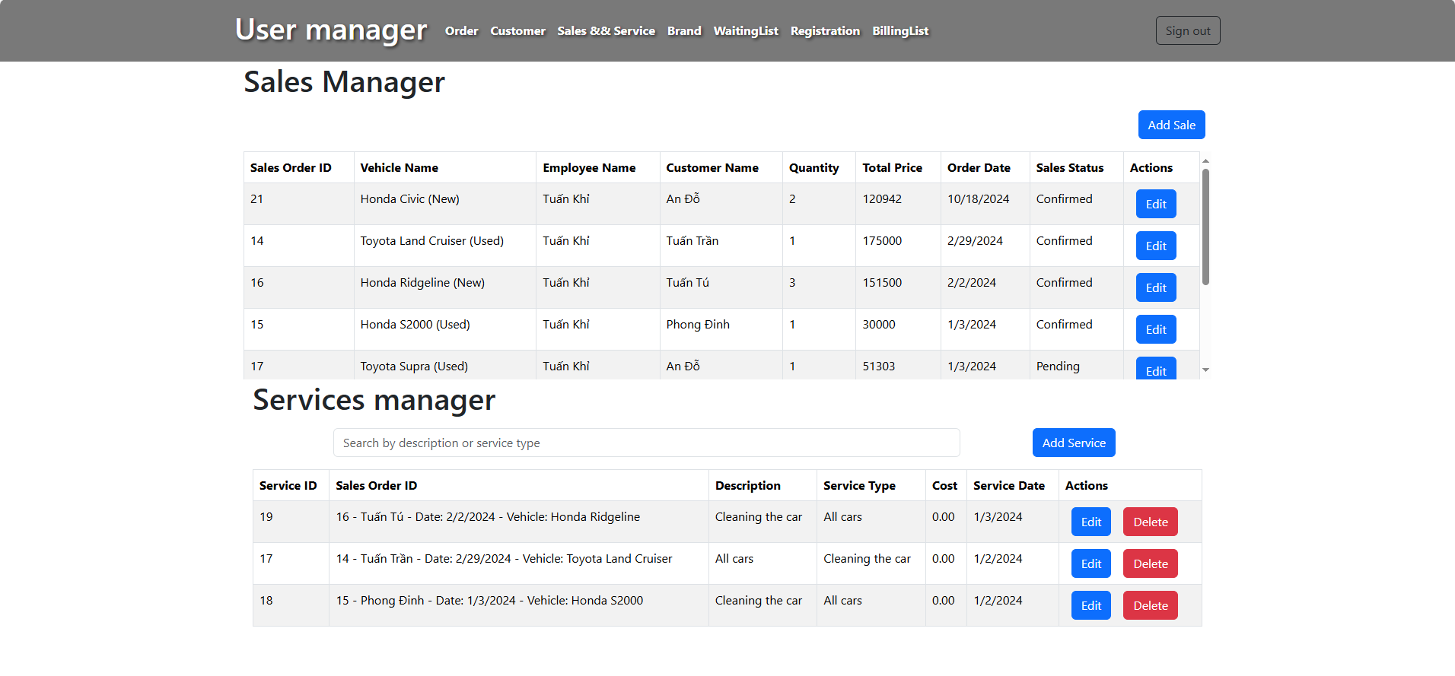
User/Sale & Service

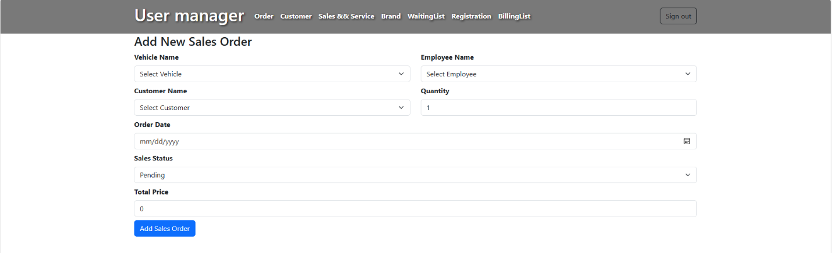
Add New Sales Order

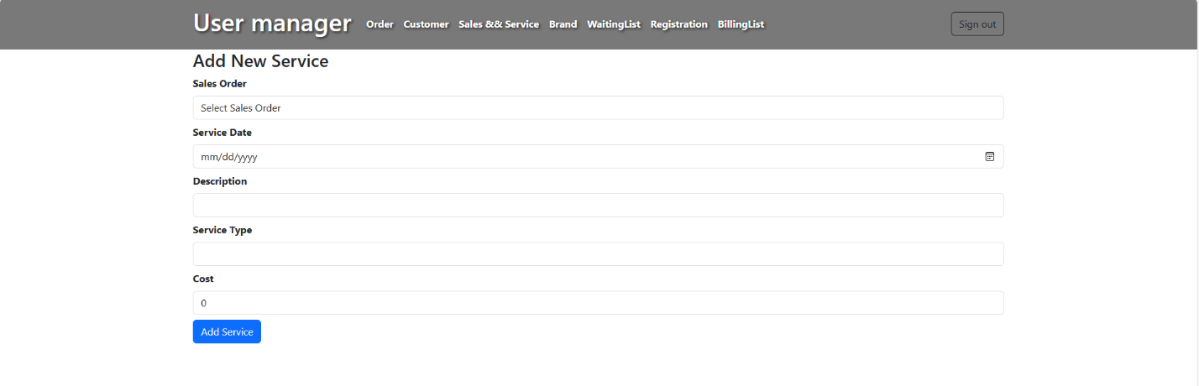
Add New Service
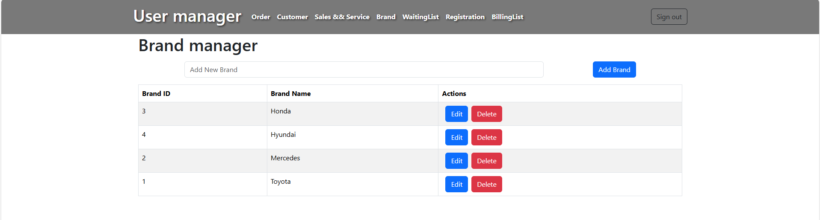
User/Brand Manager

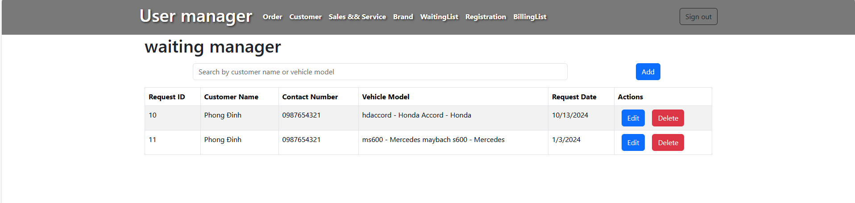
User/Waiting List
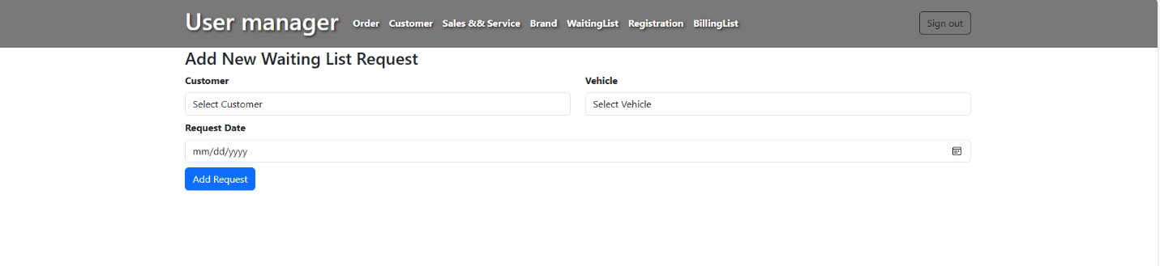
Add New Waiting List Request

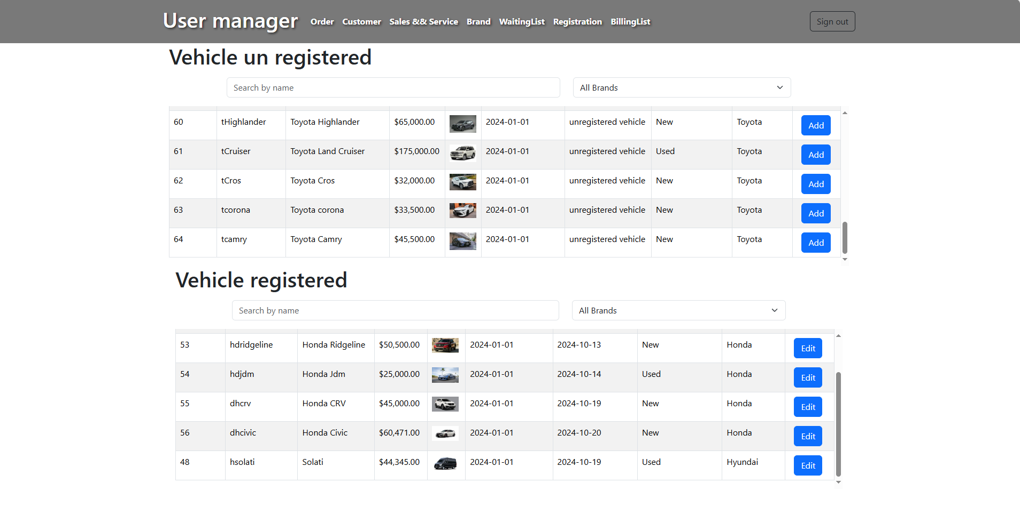
User/Registration

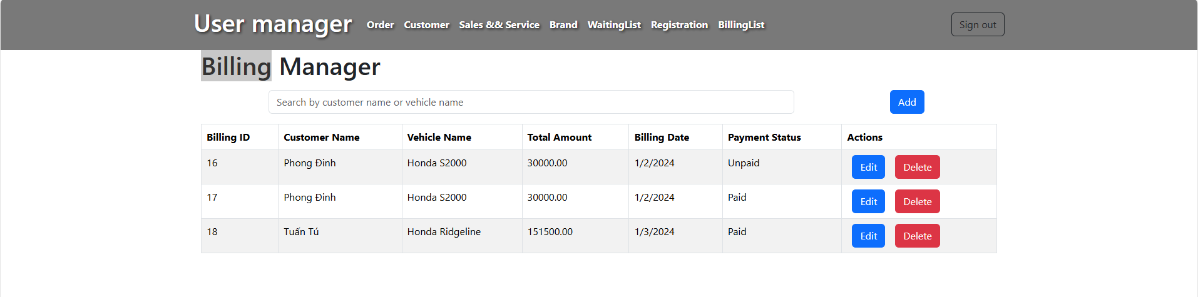
User/Billing List

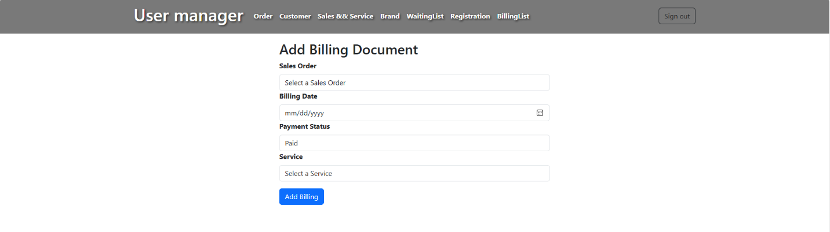
Add Billing Document

- Task Sheet
Task | Start time | Finish time | Implemented by | Evaluation(%)
feasibility study phase
Read, understand and analyze the topic. | 20-09-24 | 23-09-24 | Tran Anh Tuan  Do Hoang An  Tran Tuan Tu  Dinh The Phong | 5%
Build database | 23-09-24 | 25-09-24 | Tran Anh Tuan | 60%
Contribute ideas to edit the database | 25-09-24 | 26-09-24 | Tran Anh Tuan  Do Hoang An  Tran Tuan Tu  Dinh The Phong | 10%
Receive comments to edit the database | 26-09-24 | 28-09-24 | Tran Anh Tuan | 20%
Complete database | 28-09-24 | 28-09-24 | Tran Anh Tuan | 5%
Requirement Analysis phase
Analyze customer page | 29-09-24 | 29-09-24 | Tran Anh Tuan  Do Hoang An  Tran Tuan Tu  Dinh The Phong | 20%
Analyze user page | 30-09-24 | 1-10-24 | Tran Anh Tuan  Do Hoang An  Tran Tuan Tu  Dinh The Phong | 40%
Analyze admin page | 2-10-24 | 5-10-24 | Tran Anh Tuan  Do Hoang An  Tran Tuan Tu  Dinh The Phong | 40%
Design phase
Design the customer interface | 6-10-24 | 9-10-24 | Dinh The Phong | 70%
Contribute ideas to edit the interface | 9-10-24 | 11-10-24 | Tran Anh Tuan  Tran Tuan Tu  Do Hoang An | 25%
Synthesize comments to complete the interface design | 11-10-24 | 11-10-24 | Dinh The Phong | 5%
Design phase
Design the user interface | 6-10-24 | 10-10-24 | Tran Tuan Tu | 50%
Contribute ideas to edit the interface | 10-10-24 | 13-10-24 | Dinh The Phong  Tran Anh Tuan  Do Hoang An | 45%
Synthesize comments to complete the interface design | 13-10-24 | 13-10-24 | Tran Tuan Tu | 5%
Design phase
Design the admin interface | 6-10-24 | 10-10-24 | Tran Anh Tuan | 80%
Contribute ideas to edit the interface | 10-10-24 | 13-10-24 | Tran Tuan TU  Dinh The Phong  Do Hoang An | 15%
Synthesize comments to complete the interface design | 13-10-24 | 13-10-24 | Tran Anh Tuan | 5%
Development phase
Design functions for Api login admin,user | 11-10-24 | 13-10-24 | Do Hoang An | 50%
Design login, logout  (admin,user) | 13-10-24 | 14-10-24 | Do Hoang An | 50%
Testing phase
admin,user page:  - Check login,  - Check button, link | 14-10-24 | 14-10-24 | Tran Anh Tuan  Do Hoang An  Tran Tuan Tu  Dinh The Phong | 100%
Admin page :  API view , order , customer & employee, sale & service , brand , reports, wating list, registration, billing list, check | 15-10-24 | 18-10-24 | Do Hoang An  Tran Anh Tuan | 60%
Design admin page :  view , order , customer & employee, sale & service , brand , reports, wating list, registration, billing list, check | 15-10-24 | 22-10-24 | Tran Tuan Tu | 40%
User page :  API order , customer, sale & service , brand, wating list, registration, billing list | 15-10-24 | 18-10-2024 | Do Hoang An  Tran Anh Tuan | 60%
Design user page :  API order , customer, sale & service , brand, wating list, registration, billing list | 15-10-24 | 22-10-24 | Tran Tuan Tu | 40%
Customer page:  API product, about us, contact | 15-10-24 | 18-10-24 | Dinh The Phong | 50%
Design customer page:  API product, about us, contact | 18-10-24 | 22-10-24 | Dinh The Phong  Do Hoang An | 50%
Deployment phase
Submit source code and database | 22-10-24 | 23-10-24 | Tran Anh Tuan | 100%

