**Practical Examination**   
Subject code: DBI202   
Duration : 90 minutes

**Requirements:**

+ Download the file **PE_DBI202.sql** and execute it to create the database and the tables that are already in the file.  
+ Students should complete their exams in the file named **PE_DBI202.sql** and submit this file.

+ Submit the exam consisting of 2 files: **PE_DBI202.sql** and file containing the **ERD** for question 1.

1. (2 points) There are two entities extracted from the ERD diagram of the club management information system as shown in the diagram. Add the following business requirements to the diagram:

Each member can register for multiple events. Each registration requires recording the registration date. An event needs to have an event ID, event name, event description, event date, and event location. (Add to the existing diagram in the exam).

*Use the diagram below to complete question 1 (you can draw it in MS Word).*

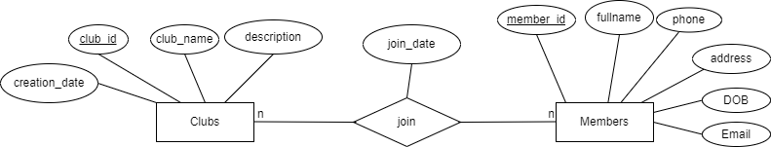

**Entities Description**  
Entity Members: Contains personal information of the members.

Entity Clubs: Contains information about the clubs.

1. (2 points) From the diagram in question 1, write SQL statements to create a table to store information when members join clubs *(the table is created from the relationship between two entities: Clubs and Members).* The statements should include the maximum possible data constraints on the table fields. Insert 3 appropriate data rows into each newly created table. (Other tables are already available)
2. (2 points) Write a procedure to perform the addition of a new member. Requirement: Error notification procedure if the data addition operation is not successful.
3. (2 points) Write a trigger constraint that ensures each member is allowed to join no more than 5 clubs. If a member tries to join more than 5 clubs, perform a rollback operation.
4. (2 points) Create a view displaying a list of clubs with more than 10 members participating. The view should include the following information: Club ID, Club Name, Number of Members.

End