Z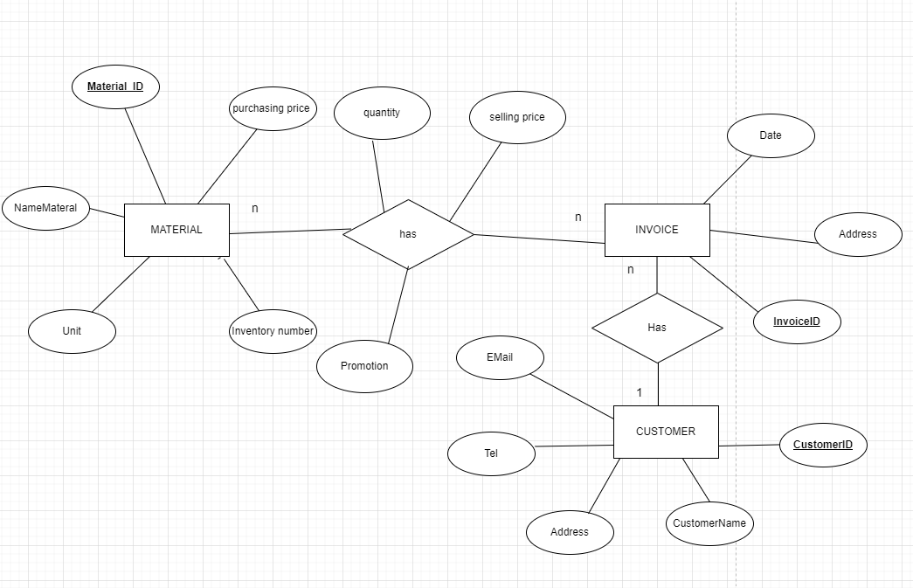

n

1

Store

Warehouse