Create Hello project from template (Demo with CSS v10.0)

File > New > CSS Project

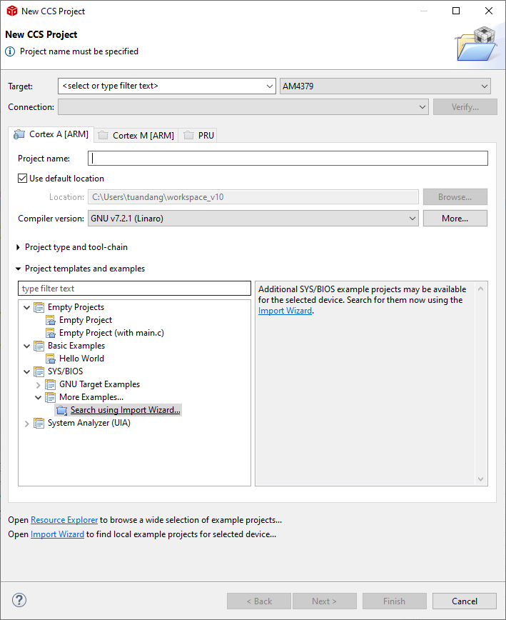

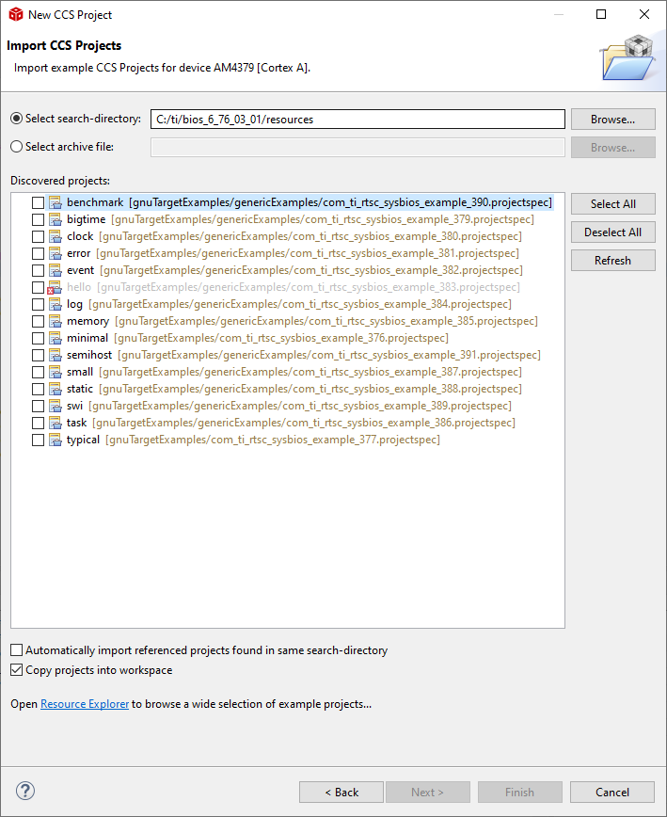

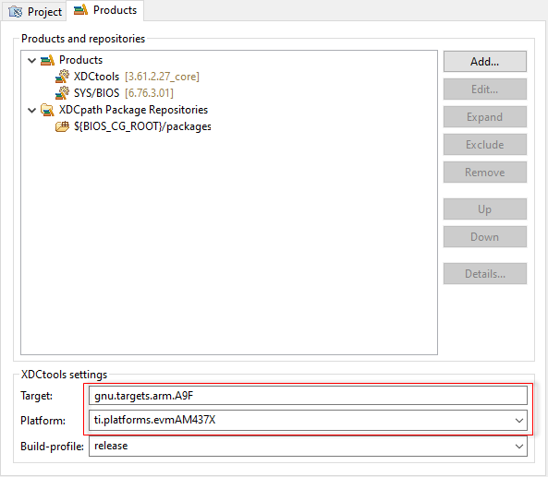

Buil Project

Create Target Confiuration

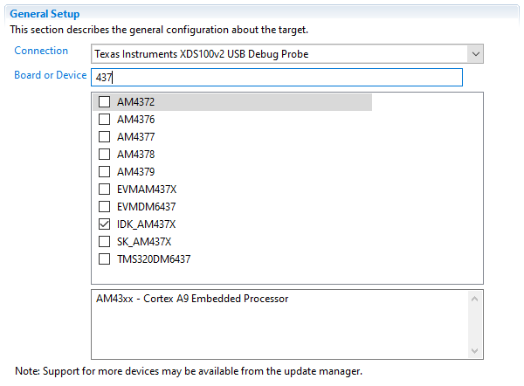

>> Test Connection

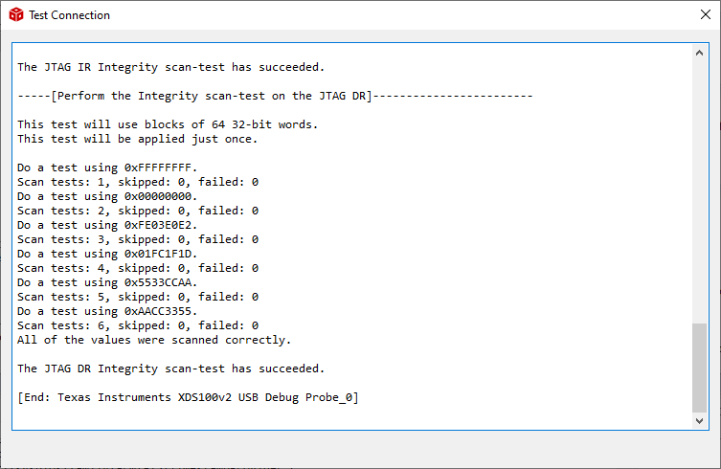

Add

var SemiHostSupport = xdc.useModule('ti.sysbios.rts.gnu.SemiHostSupport');

to **hello.cfg**

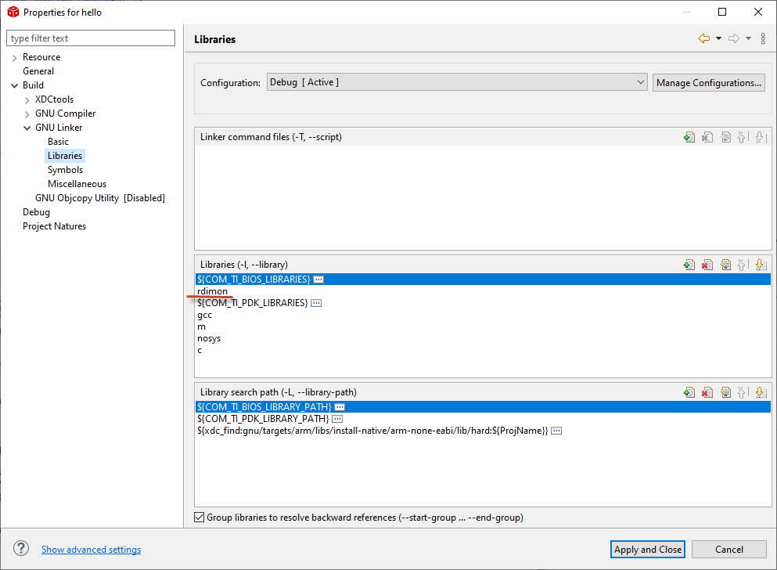

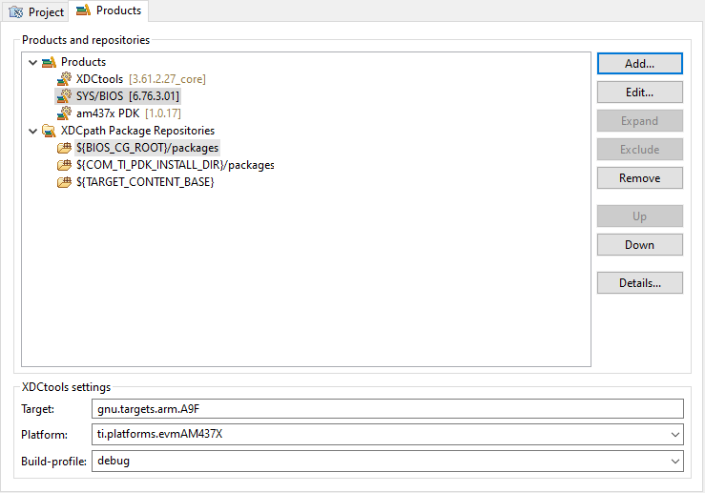

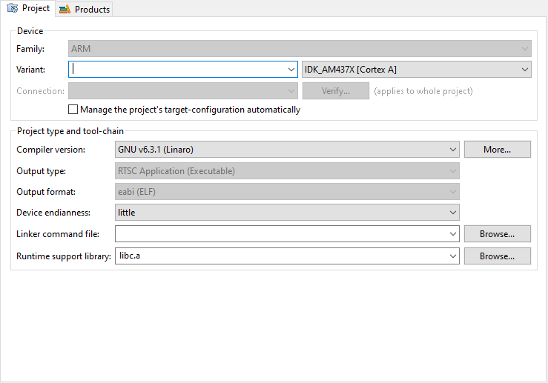

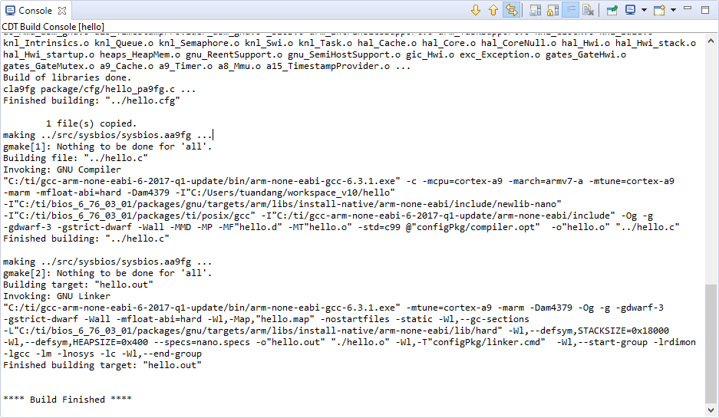

>> Launch Debug with Target Configuration

>> Connect to CortexA9

>> Run > Load Program

