The LV distribution network shown in the figure is the network:

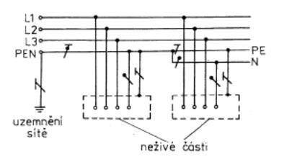

b.TN-CS.

Indicate according to which connection (sockets were made in 1995) of the sockets 230 of your appliance must not be made?

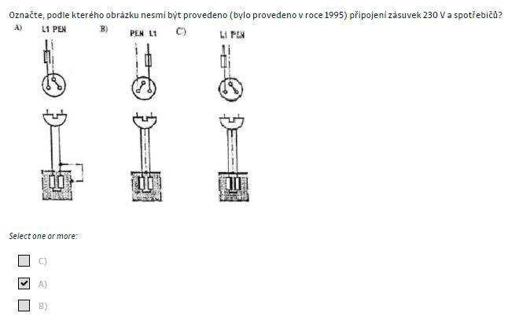

Use of marks for figures 31A1 to 31M in accordance with IEC 60617-11

Neutral conductor (N): middle conductor (M)

Protective conductor (PE)

Wire with combined protective function and neutral function (PEN)

The screen shown in the figure below is a distribution network: B) TN-S

The distribution network shown in the figure is the network: A) TN-C

The distribution network shown in the figure is a network: C) TT

Mark the correct connection of the sockets in the TN-S distribution network, which was made after 1999 and later. C)

The correct connection of the flexible supply of the appliance to the socket and the socket in the TN-S distribution network is shown in the picture: D)

Terminal marked or PE:

c. It protects the protective conductor connection

The electrical distribution network shown in the figure below is the network: D) IT

The correct connection of the sockets is shown in the picture: C)

The supply line to the electrical device with an operating voltage of 230 V AC, which has a schematic mark O on its label. B)

1. Lubricates the apartment is 2 core, but the skeleton of the mass( the apartment is connected by a PE conductor)
2. It can be 2 core.
3. Must be tikilove

