

**QRCODE**

*Nguyen Thanh Tuan (NGU0120)*

*May 2021*



1. **Introduction**

* A “Quick Response Code” also known as QR code is a two-dimensional type of barcode that Denso Wave develops, a Japanese barcode developer, in 1994(1) which can store many different types of characters (numbers, characters, characters in the Japanese Kanji encoding…). QR codes have many outstanding advantages compared to Barcode codes such as the ability to store large amounts of data, the ability to self-correct errors...
* QR code can be used for scanning using by smartphones.
* Nowadays, QR codes are generally used in health care, education, social, entertainment, …
* 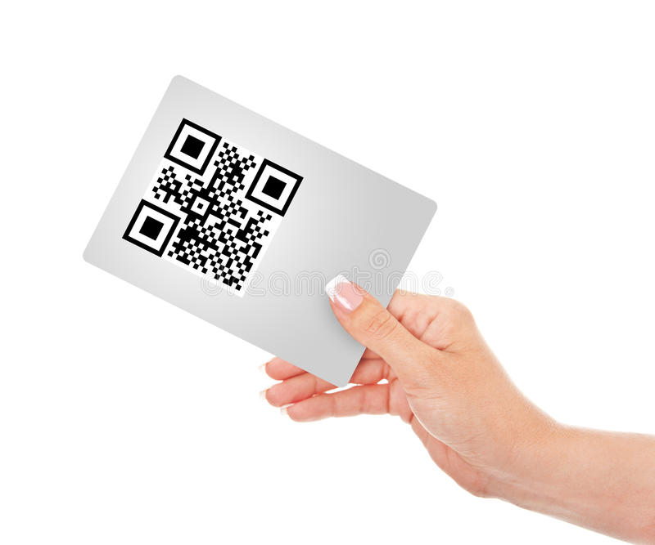The detection of openCV is mainly determined by the ratio of the length of the vertical and horizontal line segments, but such a rotation is not deformed. Although there may be some parts that retain this ratio after the rotation, it can be found, but if it is a photo If there is some perspective in addition to publicity, then openCV can easily not detect it, like this picture.

Picture 1: The photo is tilted

* Because it has perspective bending, the ratio is not necessarily correct, or when the image is not clear, it is easy to find it if you strictly count the points, so the detection rate of this method of openCV is extremely low.
* Contour in image is an outline on the object present in the image. The significance of the objects depends on the requirement and threshold you choose.
* This is one of the ways that I use to define contour and get data in QR Code.

1. **The algorithm**

* I use the method of finding contours. According to the contour level, I find the contours of 3 layers, and then use them as candidates.
* Contour is a closed curve joining all the continuous points having some color or intensity, they represent the shapes of objects found in an image. Contour detection is a useful technique for shape analysis and object detection.
* First, I use getContours to determine the contour of the image. And I will describe the steps and implementation in the following sections.
  1. ***Start with get contours***
* I will define the contour in the image. By based on the sample image to identify.

Picture 2.1: The original image

1. I convert the image data to binary number.
2. After processing the picture and first binarize, then do a canny to extract the edge information.
3. This is my result after I had extracted the edge information.



Picture 2.2: All contours after converting black and white images

* This is all contours I can find it, but the most important thing is the last return value, which is the hierarchical relationship. This is the core information of out algorithm.
* The outline of the QR code is three layers of black and white, so I will find three layers of outlines.
  1. ***Contour with level***
* Finding the contour with 3 layers of sub-contours, and return it back, where the hierarchy object, the fixed shape is 1, n, 4, where n is the number of contours.
* The fourth dimensions represent the next contour id, the previous contour id, the child contour id, and the parent contour id are all.
* If there is no one, so we can get hierarchy[0][contourIndex][2] here to get the child, the id of the contour, and the number of sub-contours in 3 levels is saved, but not all of them are saved, because there is also a checkRatioOfContours function at the end, this is to prevent the size of the sub-contours from being abnormal.
* 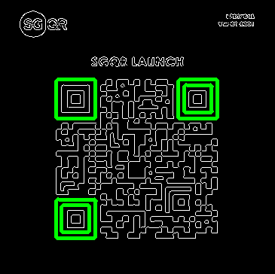I made a comparison, the size of the parent border should be 1-10 times the size of the child border, the noise will be removed.

Picture 2.3: Contours to be defined (5 lines)

* If there are more than 3, we need to extract the parent contour.
* Let's evaluate them one by one and add those who don't have a father to the ones that are interested, but there is a problem, if some have a father, but his father was eliminated in the early stage, for example, some pictures have a whole picture the super-large circle, all the patterns are the sub-contours of the outer circle.
* We can extract the largest one first, and the rest is impossible to be the parent contour of the previous one, so we judge each contour, whether it has a father has been selected by us.

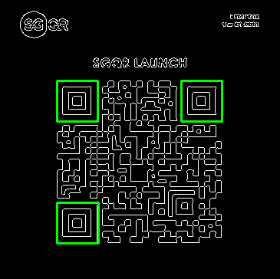Picture 2.4: Contours to be defined (3 lines)

* But there are a few points that are still unclear so I based on the defined contours and I will find the center point of the QR code.
* 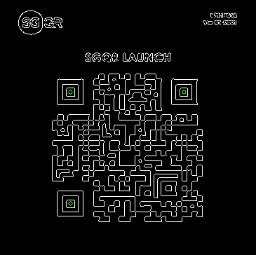I found the center of gravity by calculating the moment of the image. To put it bluntly, it means that the point is shifted to which side. This is in line with the principle of the center of gravity. Of course, it is also possible to directly use the contour to find the center of gravity, but the noise impact is relatively large.

Picture 2.5: Find the centroid in the squares

* After finding the center of gravity, we have to pick the final three points.
  1. ***Select patterns***
* My approach is to create two-line segments for 3 points and then evaluate that if the line segment is almost 90 degrees, my scope here is relatively loose and can float 30 degrees, which means the angle covers can be up to 60 - 120 degrees long. The next step is to choose the closest length segment from all the suitable angles.
* Finally, it is time to calculate the rotation angle, i.e., which of the three points is the lower left, which is the upper left, and which is the upper right.
  1. ***The focus point in the original image***
* I use the distance to find the two furthest points, the other is the right-angle point, then calculate the slope of the hypotenuse, then calculate which side of the hypotenuse the right-angle point lies on, you can get this.
* Finally, we get the 3 points we want, when we go back, we return in the order of the upper left corner, the lower left corner, and the upper right corner.
* My recognition results.

Picture 2.6: Return results based on original image

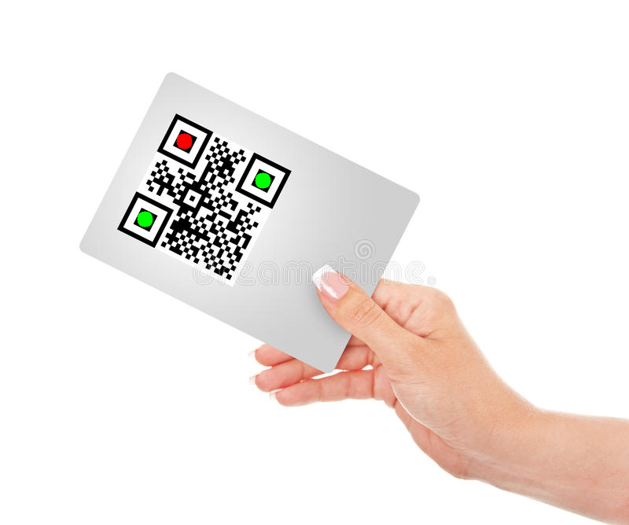Picture 2.7: Result on section 1 (Picture 1)

* These are all steps to describe how to define contours and points needed to get and extract data in QR Code.

**3. Evaluation**

* Among the ways that I refer to and evaluate, there are many ways to recognize QR Codes and identify horizontal or vertical lines.
* The methods that I found out all have certain disadvantages.
* Like how to define horizontal or vertical lines. When processing image data, the results will be clearer and faster, but when dealing with some photos that are tilted or noisy, the identification will become difficult and difficult to identify.
* My way and I find out. Finding contours and finding focus points makes it easy to locate locations in the QR Code, and this way can deal with skewed or blurred images. If it is too blurred, it cannot be processed. But the downside is that processing will go through many steps and it will take some time in image processing.
* From the way to find the contour in section 2.1, you can see, each step that I take will be very long and time consuming, but the results are qualified and identifiable.
* Besides, with openCV technology gradually improved and supported by many things, the design and identification of QR Code gradually becomes easier with a few lines of programming, we can recognize the images that we use. We want and the speed of the algorithm will be faster.
* Through the steps of finding the contour and center of the image, the returned results can be guaranteed and protected, and the image quality and data can be used and searched more easily.
* I try to use multiprocessing to calculate the speed when the QR area recognition verification is completed. And here is the result that I tested. You can see in table 1.

|  |  |
| --- | --- |
| Processors | Time(s) |
| 1 | 0.781804 |
| 2 | 0.944425 |
| 10 | 2.137472 |
| 20 | 3.414250 |
| 40 | 6.708084 |

Table 1: Result of using multiprocessing

**4. Conclusion**

* With the support of libraries in today's algorithms, it becomes easier to use algorithms to create applications to recognize QR Codes. The way I used is to describe step by step to see why QR Code can recognize and get data.
* And with the development of technology today, QR Code is used for many different purposes such as in newspapers, advertising, culture, food, events, ...
* QR Code is competitive marketing tool today, it can also be regarded to provide commercial opportunities in different business areas in the future(2).

**References**

1. *QR TIGER, The Ultimate Guide To Or Code Marketing, 2020*
2. *Ji Qianyu, Exploring The Concept Of QR Code And The Benefits Of Using QR Code For Companies. Bachelor Thesis, School of Business and Culture Degree Programme in Business Information Technology, 2014.*