Name: Date: Points:

|  |  |  |  |  |  |  |  |
| --- | --- | --- | --- | --- | --- | --- | --- |
| Login: |  |  |  |  |  |  |  |
|  |  | | | | | | |

2. Write the code based on UML diagram
3. All methods and property are public
4. You have to use: delegate

[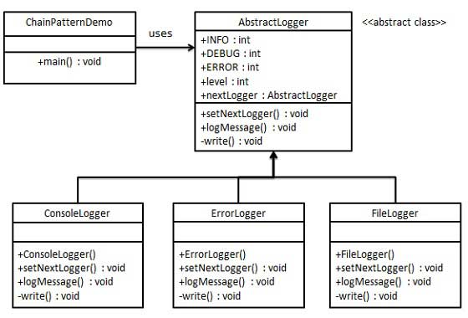](http://www.google.cz/url?sa=i&rct=j&q=&esrc=s&source=images&cd=&cad=rja&uact=8&ved=0CAcQjRw&url=http://www.tutorialspoint.com/design_pattern/design_pattern_quick_guide.htm&ei=tn1PVZLaFoP9UoDAgegH&bvm=bv.92885102,d.bGQ&psig=AFQjCNFCH23KJoNPr8ydL2thfXNHtvZjKA&ust=1431359245456016)



Create a few instances for testing each class and print results.

1. Add method LoadConfiguration: load settings from XML file (You can set attributes for example maximal number of observers)
2. Add methods Save and Load to AbstractLogger: Save/load current state of all instances (Binary files – without serialization)

* Every 5 seconds add a new random instance
* Every 9 seconds print the results from all instances