INFORMATION SYSTEM OF SHOE SHOP

Student: Nguyen Thanh Tuan (NGU0120)

# Introduce of Shoe Shop System

* We want to design an information system for a chain of shoe shops.
* The IS will work with 3 types of users:
  + Customers will be able to access the website 24/7/365, including holidays, customers can create an account to use on the website or can make purchases as a guest without having to register .
  + What can customers do when accessing the website ?, customers will be able to choose the products they want to buy such as shoes, shoelaces, shoe soles,... Besides, customers can use the filter to be able to filter out the parts you want to choose such as price, material, brand, ...
  + The store staff will work on the desktop application, and will confirm the orders that have been placed and transferred to the delivery staff, besides, the store staff will also have to check the number of shoes in stock to keep the correct data on the website up to date.
  + The store manager will also work on the desktop application, but the manager's task is to recount the number of orders received each day to make a report of statistics to know the income and quantity sold, ... Besides, the store manager will also manage the employee's working time and arrange the working time accordingly. The store manager can work as store staff.
* On a web interface, what will they see? They will be able to see the shoe name, image, shoe size, description, favorite buttons, checkout, other products, etc. Users will feel comfortable choosing and referring to the products in our store.
* For sold products, we will put the words "Sold Out" in the title to notify everyone that they are sold out.
* On holidays, we will have new shoes with special designs, users will be able to pre-order to buy because there are a limited number of special shoes.
* The store's information system will track the customer's order information, delivery status, and payment status. This system is very important in promoting the product business.
* On public holidays, the IS operates continuously via the internet to serve the needs of customers who cannot come to buy goods in person, including data servers located at the stores' branches. If customers come to buy directly, they can see the working time to choose and try on shoes.
* The joy of customers when owning shoes is also our joy when bringing customers the best products.

# Use Case and Scenario of Shoe Shop System

## Use Case Diagram

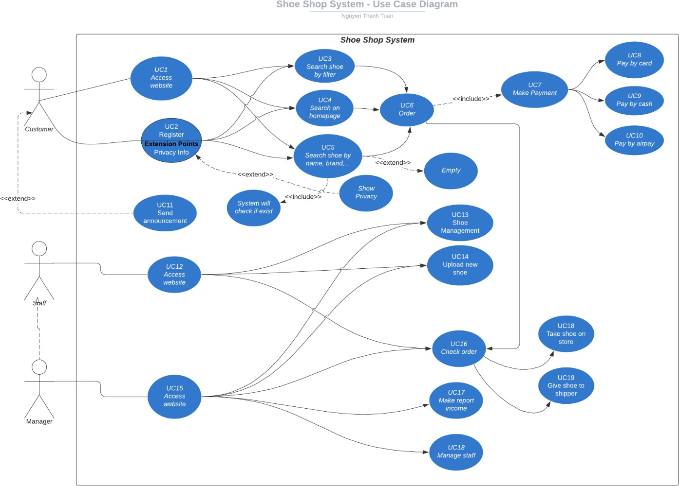

Picture 2.1: Shoe Shop System – Use Case Diagram

## Scenario of Shoe Shop System

* + 1. Use Case ID 13.

|  |  |
| --- | --- |
| Use Case ID | 13 |
| Use Case Name | Shoe Management |
| Actors | Staff |
| Description | Staff will manage the store and can add shoe, remove shoe, change. |
| Pre-conditions |  |
| Post-conditions | Staff has performed the Shoe Management. |
| Main Flow | 1. Pressing the Shoe Management button. 2. Display a List of Managed Items. 3. Choose the Shoe you want in management. 4. Select Change button. 5. Display the page change the product data in the select. 6. Fill in the Shoe data change form. 7. Pressing the Change Shoe Data button. 8. Processing Shoe data change. |
| Alternative flow | 1. Select Remove button. 2. Warning box appear. 3. Choose Yes. 4. Processing Delete data. 5. Page will refresh and shoe is deleted. |

* + 1. Use Case ID 6

|  |  |
| --- | --- |
| Use Case ID | 6 |
| Use Case  Name | Order |
| Actors | Customer |
| Description | Customer can add items to shopping cart and check out. |
| Pre-  conditions |  |
| Post-  conditions |  |
| Main Flow | 1. Customer add items to shopping cart. 2. System display message indicate the item added to shopping cart. 3. Customer proceed to check out. 4. System ask customer provide shipping and billing information. 5. Customer provide shipping and billing information. 6. System confirms the shipping information, process the order and payment. |
| Alternative flow | 1. Customer go to Shopping Cart button. 2. System will appear result of adding shoes to cart. 3. Customer can delete the shoe which customer don’t want to   buy.   1. The warning box will appear and customer agree. 2. System will refresh the page and delete the shoe of cart. |

C. Use Case ID 5

|  |  |
| --- | --- |
| Use Case ID | 5 |
| Use Case  Name | Search Shoe By Name, Brand, … |
| Actors | Customer |
| Description | When customers access Shoe Shop website, and customer want to find the brand or name which customer want to buy and |
| Pre-  conditions | Customer want to find the shoe or brand which customer to buy. |
| Post-  conditions | Customer can find and choose the shoe, and they will order and  pay for the shoe. |
| Main Flow | 1. Customer click to text box. 2. Customer write the brand or the shoe they want to find. 3. All search information will be displayed on screen and customer can see it. 4. If the customer wants to buy the shoe, the customer will   click to “Buy” button.   1. The product will be added to cart. |
| Alternative flow | 3a. If the product or brand the customer is looking for does not exist, the result will be displayed on screen “is empty”.   1. Customer can choose another choice like using filter. 2. Customer can write the other shoe want to find. 3. Customer click to “Find” button. 4. The result will be displayed on screen. |

## Activity Diagram

1. Use Case ID 13 – Shoe Management

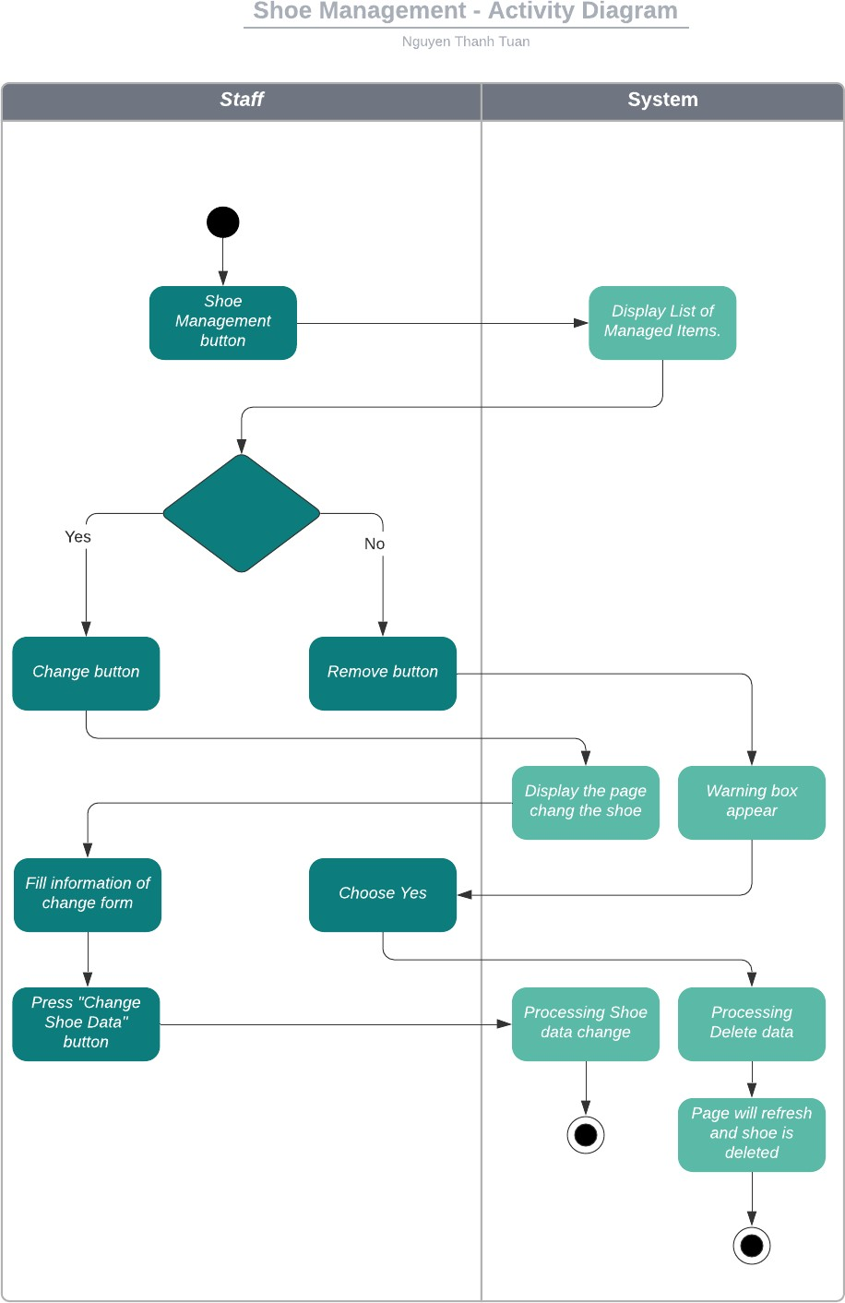

1. Use Case ID 6 – Order

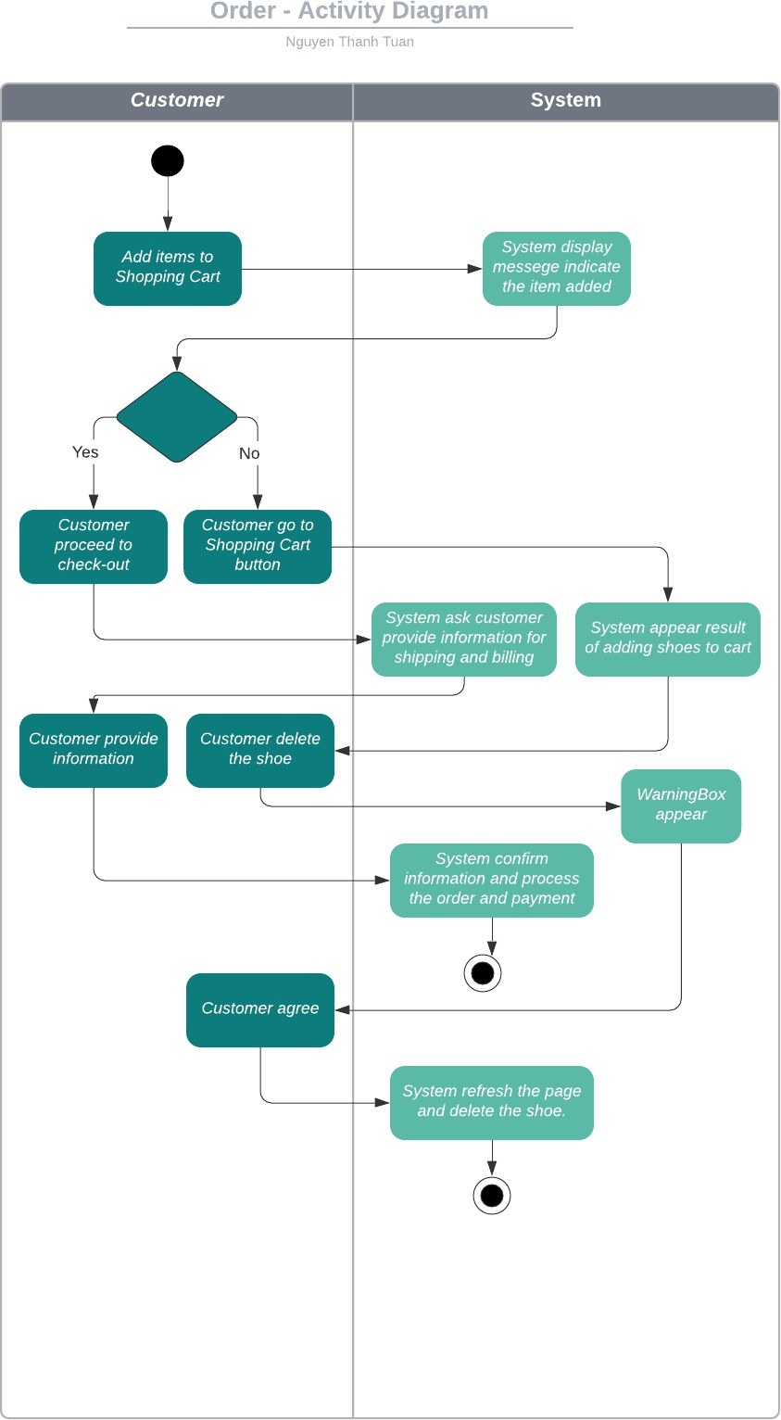

1. Use Case ID 5 – Search Shoe By Name, Brand, …

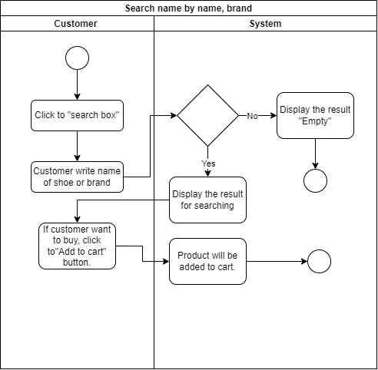

# Technical Specification

**Conceptual model:**

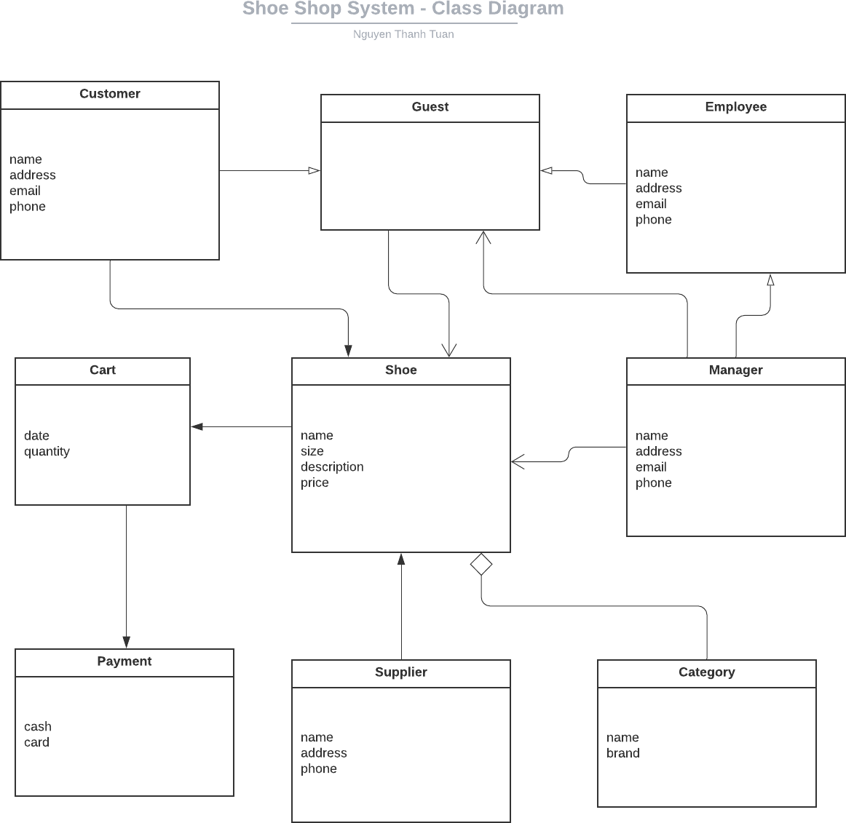

**Description:**

* In Shoe Shop System will be used to manage the items being sold in the store, including sold items, product postings, ...
* Product management will allow employees to update products on sale, edit out-of-stock items or edit information such as name, size, description, ... and delete items is no longer updated and sold.
* Customers can also register for an account, like the products they want to buy, select products and make payments, etc. Especially when there are new products with limited quantities, users can register in advance. product, and when the product arrives in the store, the customer can pick up the product or pay online and the delivery person will deliver it to the customer. If the pre-registered product is full, the system will notify the customer that it is full and reschedule the customer for another time.
* There may be one more function that will have part-time employees, different from full- time employees who receive monthly wages with a fixed salary contract, part-time employees will receive hourly wages.

**Estimations:**

|  |  |  |  |  |
| --- | --- | --- | --- | --- |
| Class | Storage | Estimated Entity Size in KB | Estimated number of entities after 1  year | Estimated number of entities after 1  year in KB |
| Customer | SQL | 2 | 2000 | 2000 |
| Guest | SQL | 1 | 3000 | 3000 |
| Shoe | SQL | 1 | 1400 | 1400 |
| Employee | SQL | 1 | 200 | 200 |
| Manager | XML | 1 | 100 | 100 |
| Payment | SQL | 1 | 1000 | 1000 |
| Category | SQL | 0.7 | 100 | 70 |

Estimated database size after one year is 8000 KB Estimated growing factor is 2 per year.

**Platform choice:**

* Language: .NET Core Version 3.1, a project template for creating an ASP.NET Core application with example ASP.NET Razor Pages content.
* System: Windows 10 Home.
* Data Storage: MS-SQL 2016 Server will be used so that data can be accessed from any computer company.

**IS requirements by location:**

* Web application.
* OS: Windows 10
* **System Layout:**
  + The system will run on computer and will download data from HW requirements.
  + CPU: 3 GHz
  + RAM: 200 MB

# Sketch of The User Interface

For admin (Employee, Manager): (UC12, UC15)

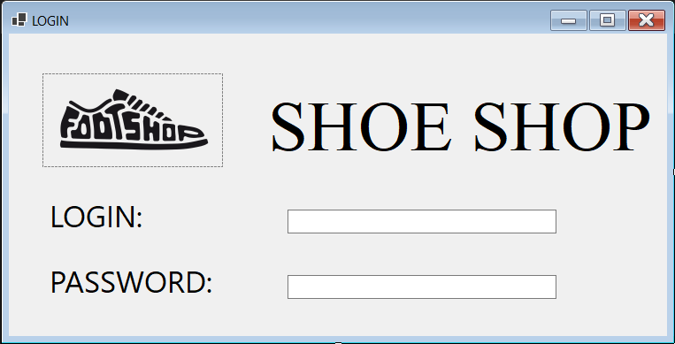

After login:

UI of employee

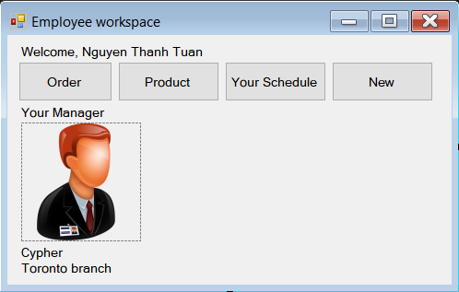

UI of manager

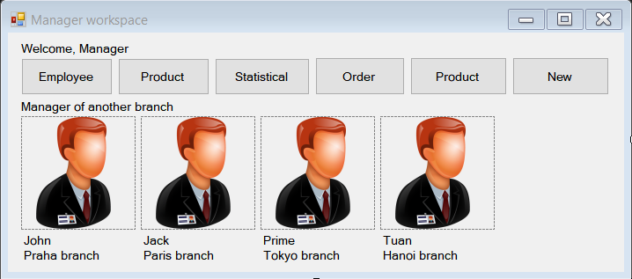

For customer:

Homepage and search by name, brand, … (UC5)

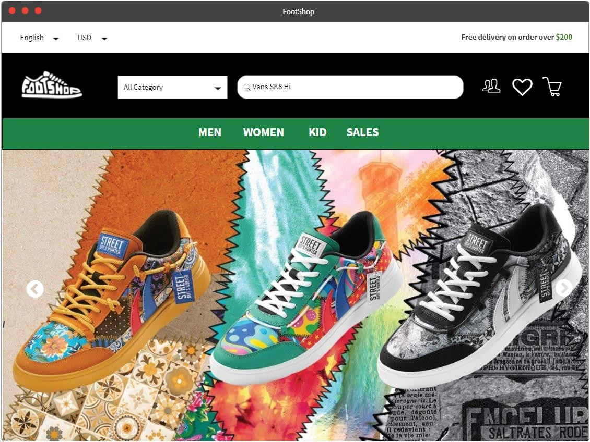

# Class Diagram

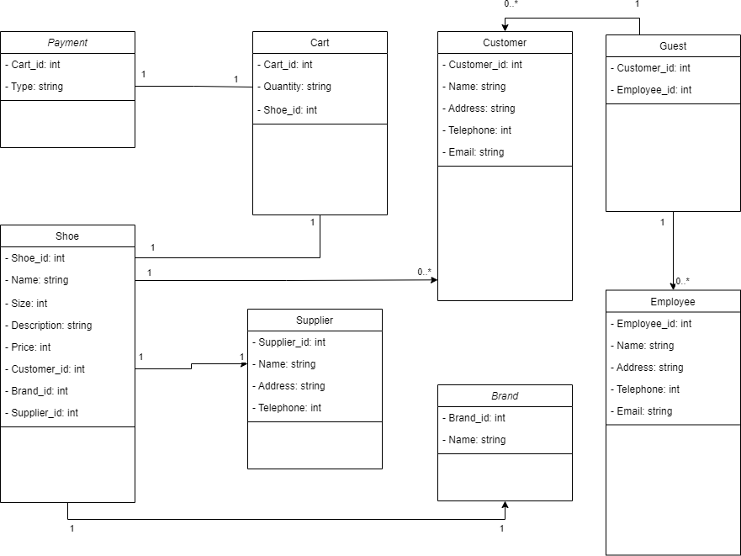

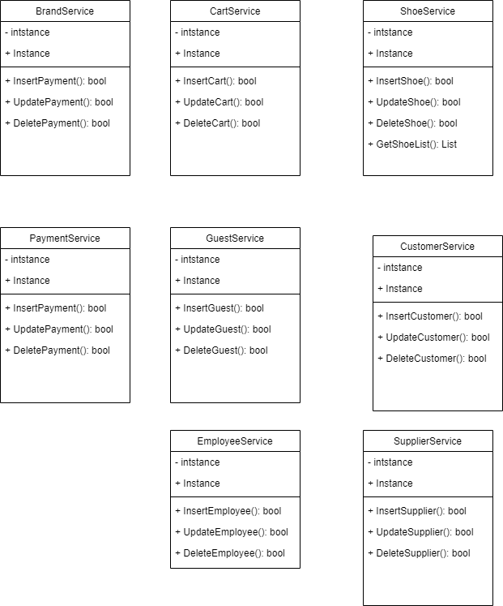

1. Sequence Diagram

Use Case ID 6 – Shoe Management

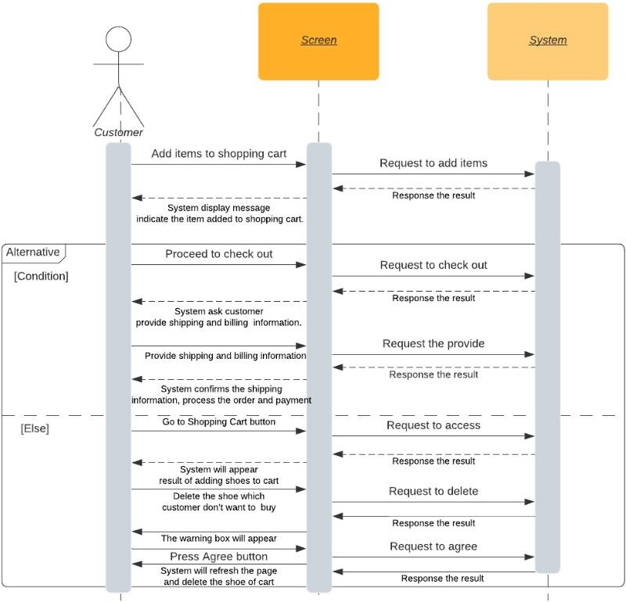

Use Case ID 13 – Shoe Management

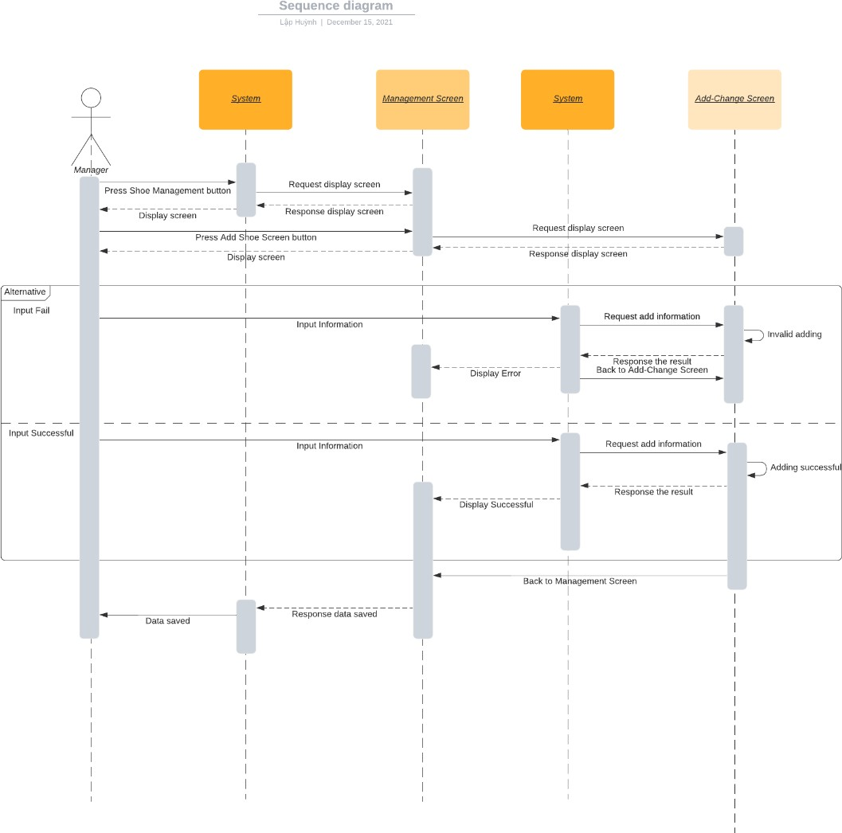

Use Case ID 5 – Search Shoe By Name, Brand, …

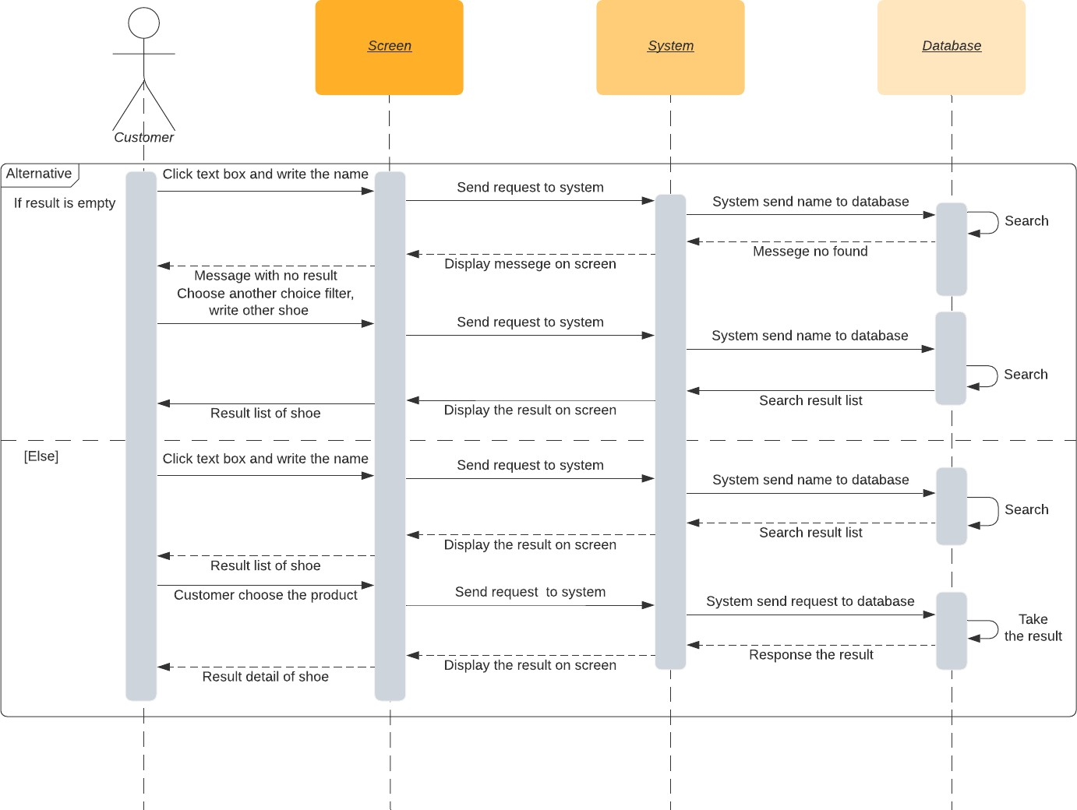

# Component Diagram

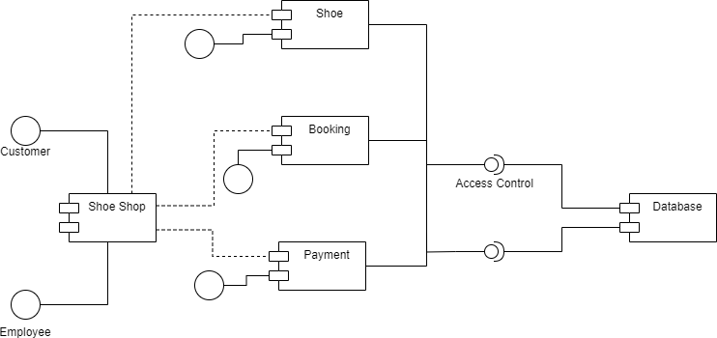

1. Deploy Diagram

