Ultrasonics Water Meter
User Manual 1.1

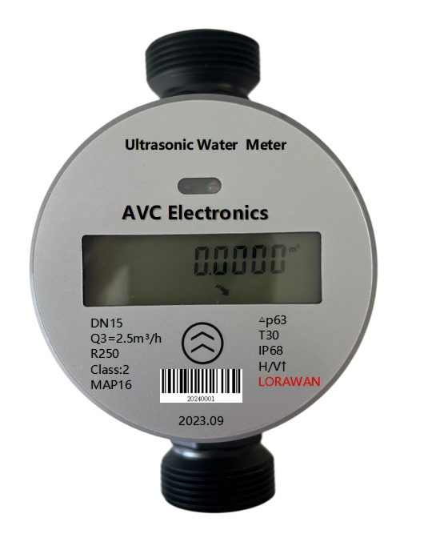

Ultrasonics Water Meter
AVC NBIoT/ AVC LoRaWAN Series

User Manual
Document No.: 08-2025 VN
Issue date: 2025.08
Revision: VA.01

AVC Electronics Inc.
16600 Harbor Blvd. Suite F
Fountain Valley, CA 92708
infomation@acv.com

© Copyright 2025 and Liability Disclaimer
AVC Electronics and its subsidiaries reserve the right to change specifications and/or descriptions without prior notice. AVC Electronics and its subsidiaries shall not be liable for any inaccuracies or errors in this manual.

⚠️ Attention!
- Please carefully read this manual before operating this product.
- Do not open or modify any hardware, as this may cause irrecoverable damage.
- Do not use this product if you suspect any malfunction or defect.
- Do not use this product with corrosive media or in environments with strong vibration.
- Operate this product strictly within the specified parameters.
- Only trained or qualified personnel are permitted to perform product-related services.

⚠️ Use with Caution!
- Be mindful of electrical safety. Even at low voltage, electrical shock may still cause unexpected damages.
- The liquid to be measured must be clean and free of particles, as even small particles may accumulate inside the flow channel, resulting in metrology errors, clogging, or irrecoverable damage.
- Do not apply this product to any unknown or unspecified liquids that may cause damage.
- Pay attention to bubbles or cavitation inside the fluid, whether visible or invisible, as they may lead to inaccurate or erroneous outputs.

Table of Contents
1. Overview 5
2. Receipt/ unpack of the product 5
3. Knowing the products 6
a. Product description 6
b. Mechanical dimensions 7
4. Technical specifications 7
5. Installation 8
6. Basic operation 9
a. Check the Product Specifications 9
b. Check the Pipeline System 10
c. Check for Leakage 10
7. Display 10
a. Display 10
b. Symbols description 11
8. NB-IoT Communication 11
a. NB-IoT Communication – Downlink Control Protocol 11
b. Agreement Content 12
c. Definition of Status Word 22
9. Warrantx and Liabilitx 23
10. Service contact and information 24

- Overview
All contact details can be found at the end of this manual.

This manual provides essential information for the AVC Electronics Ultrasonic Water Meter used in water flow measurement applications. It includes information on product performance, installation, operation, maintenance, troubleshooting, and technical support.

The meters are designed using Time-of-Flight ultrasonic sensing technology, offering high accuracy across a wide dynamic range. They are compatible with AMR/AMI remote metering systems.
- Receipt/ unpack of the product
Upon receiving the package, inspect the box for visible damage before unboxing. Ensure the product was not damaged during shipping. If any abnormality is found, immediately notify the shipping carrier, distributor, or AVC Electronics technical support.

If the box is intact, open it to find the ordered water meter unit (based on your order specification – e.g., DN15 with NB-IoT communication).

Figure 1. AVC Electronics
Please verify the product’s integrity immediately. If any issues are identified, contact your distributor or AVC support as soon as possible. If confirmed defective, a replacement will be arranged through official sales channels. This user manual is provided inside the box or available electronically prior to delivery.

- Knowing the products
  - Product description
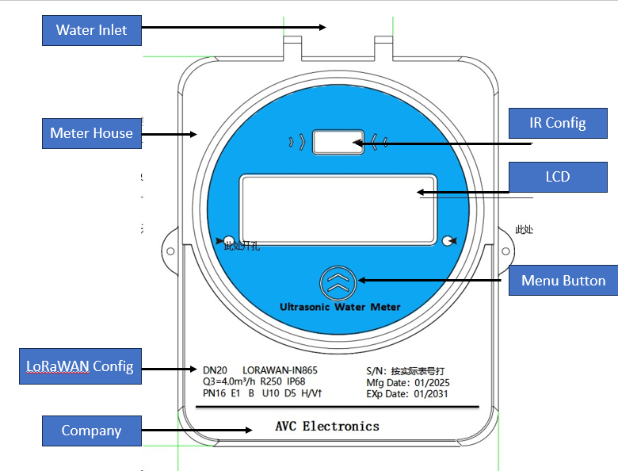
Figure 2. Product description
  - Mechanical dimensions
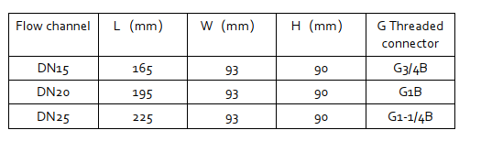

- Technical specifications
All specifications listed in the table below apply under calibration conditions at 20°C and 101.325 kPa absolute pressure using clean water. The device is factory-calibrated in horizontal installation mode.

Spec | Value |  |  | Unit
DN | DN15 | DN20 | DN25 | L/min
Class |  | 2.0 |  | %
Q3 | 2.5 | 4 | 6.3 | m³/h
Q3/Q1 |  | 400/250
Q1 | 6.25/10 | 10/16 | 15.8/25.2 | L/min
Q2 | 10/16 | 16/25.6 | 25.2/40.4 | m³/h
Q4 | 3.125 | 5 | 7.9 | m³/h
Flowpipe | U10 D5
Pressure | MAP16
Pressure Loss | Δ40
Temperature | T30/T50
Protection Level | IP68
Communication | Optional: NB-IoT, LoRaWAN

- Installation
Do not attempt to open, disassemble, or modify any part of the product, as this may cause malfunction or permanent damage.
For best performance, the ultrasonic water meter should be installed in a low-vibration pipeline system. Avoid installation near strong mechanical vibrations or electromagnetic fields.
Horizontal installation is recommended. If vertical installation is unavoidable, ensure the pipe is completely filled with water, especially at the measurement section.
The meter performs best under vibration-free conditions. Excessive vibration may generate turbulent flow and acoustic noise, leading to inaccurate measurements.
Before installation, carefully check the pipeline and fittings:
- Ensure the pipeline is clean, free from particles, rust, oil, or any foreign substances.
- Connectors must be intact, undamaged, and free of leakage.
- After installation, pipes should not be twisted or bent sharply. If bends are required, they must be smooth and gradual.
Always install the device in accordance with the flow direction arrow printed on the meter body.
⚠️ Note: The ultrasonic water meter is not suitable for corrosive liquids or high-viscosity fluids. For questions regarding fluid compatibility, please contact AVC Electronics Technical Support.
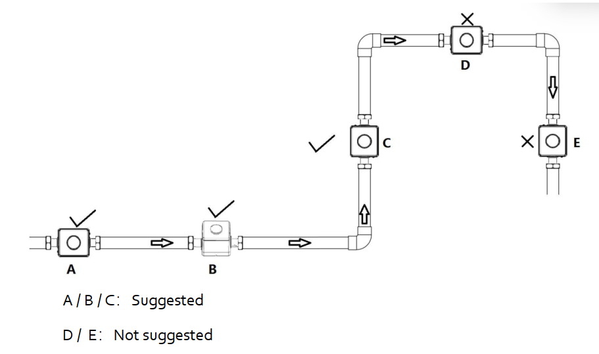

- Basic operation
  - Check the Product Specifications
Before using the water meter, verify the specifications in this manual or on the product label:
- The operating pressure rating of the meter must not be lower than the system pressure.
- The operating flow range must remain within the specified limits.
- The measured liquid must be clean water, without suspended solids, corrosive agents, or high viscosity.
⚠️ Note: Exceeding the rated pressure may cause permanent damage to the device.
  - Check the Pipeline System
For accurate measurement and safe operation:
- Ensure the pipe is clean and free of particles, rust, grease, or foreign materials.
- An upstream filter is recommended to prevent contamination.
- Check all connections to ensure no leakage, twisting, or sharp bends.
- Always confirm the installation direction matches the flow arrow on the meter body.
  - Check for Leakage
Before commissioning, check the system for leakage. Pressurized air or nitrogen may be used for testing. Any detected leakage must be resolved before normal operation begins.

- Display
  - Display
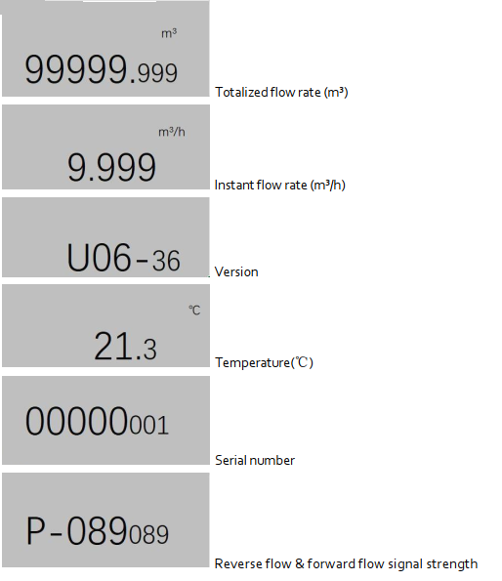
  - Symbols description
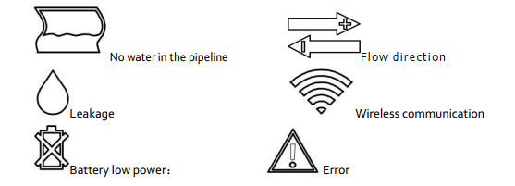

- NB-IoT Communication
  - NB-IoT Communication – Downlink Control Protocol
The water meter supports NB-IoT communication. Downlink control is performed using AT commands.
AT+SUPLDPA:01440,00010,60,01440,00000\r\n
Original Data Feedback:
AT+SUPLDPA:OK\r\n<Command>
Upload interval: 1440 minutes
Upload delay (minutes): 10 minutes
Upload delay (seconds): 60 seconds
Active meter reading cycle: 1440 minutes
"reserve": "1", "cmdData": "AT+SUPLDPA:01440,00010,60,01440,00000\r\n"
AT+SUPLDPA:01440,00010,60,01440,00000\r\n
  - Agreement Content
Specific Analysis of Upload Protocol:
FE FE FE 68 10 78 56 34 12 00 00 00 81 91 92 1F 01 00 30 06 15 03 18 28 03 DD 05
03 F8 1F 00 2B 18 06 00 2B 09 03 00 35 00 50 01 00 25 00 08 00 00 68 01
00 00 00 00 03 2B 18 06 00 00 00 2B 09 03 00 00 00 15 03 18 2B 18 05 00
00 2B 09 02 00 05 00 00 00 00 14 03 18 2B 18 04 00 00 2B 09 01 00 00 00
13 03 18 A0 05 E0 01 3C A0 05 64 00 62 00 62 00 01 15 00 92 29 04 00 50 25
18 11 86 89 30 50 82 45 40 81 64 08 00 00 28 03 DD 05 01 00 FF FF 2E EB 8C 16

68 is the frame start symbol 68H
10 is the instrument type T
78 56 34 12 00 00 00 is the address A0–A6, BCD code, with the lower order first.
Parsed as: 00000012345678
81 is the control code C
91 is the data length field L

92 1F 01 00 30 06 15 03 18 28 03 DD 05 03 F8 1F 00 2B 18 06 00
00 2B 09 03 00 35 00 50 01 00 25 00 08 00 00 68 01 00
00 00 00 03 2B 18 06 00 00 00 2B 09 03 00 00 00 15 03 18
2B 18 05 00 00 2B 09 02 00 05 00 00 00 00 14 03 18 2B 18 04 00
00 2B 09 01 00 00 00 13 03 18 A0 05 E0 01 3C A0 05 64
00 62 00 62 00 01 15 00 92 29 04 00 50 25 18 11 86 89
30 50 82 45 40 81 64 08 00 00 28 03 DD 05 01 00 FF FF 2E EB A
Total of 145 characters
92 is the data identifier DIO
1F is the data identifier DII
01 is the serial number SER (00: key triggered; 01–250: serial number)
00 30 06 15 03 18 is the time → March 15th, 2018 at 6:30:0s
28 03 is Protocol No. 808
DD 05 is the status word number 1501
03 F8 1F 00 is the identification code
Data Area Definition
- 2B 18 06 00 00 represents a positive cumulative flow of 0.618 m³
- 2B is the flow unit code representing 0.001 m³
Flow unit codes:
- 2A → 0.0001 m³
- 2B → 0.001 m³
- 2C → 0.01 m³
- 2D → 0.1 m³
- 2E → 1 m³
- 2B 09 03 00 00 is the reverse cumulative traffic of 0.309 m³
- 2B is again the flow unit code representing 0.001 m³
Additional flow unit codes:
- 29 → 0.00001 m³
- 2A → 0.0001 m³
- 2B → 0.001 m³
- 2C → 0.01 m³
- 2D → 0.1 m³
- 35 00 50 01 00 is the instantaneous flow rate, BCD code, with the lower digit first.
→ 1.5000 m³/h, where 35 represents the instantaneous flow unit code m³/h.
- 05 25 00 00 is the water temperature → 25.05°C
- 08 00 is the working time → 8 hours
- 68 01 is the power supply voltage, unit: 0.01 V
  - Example: 0x0168 → 3.60 V
- 00 00 is the status word
- 00 00 is the status word 2
- 00 is the working mode
  - 00 → No valve
  - 01 → Remote control mode
  - 02 → Prepaid mode
- 03 is the number of daily historical data records (here: 3 records)
- 2B 18 06 00 00 represents the previous day’s frozen positive flow of 0.618 m³
- 2B represents the flow unit code of 0.001 m³
Flow unit codes:
- 29 → 0.00001 m³
- 2A → 0.0001 m³
- 2B → 0.001 m³
- 2C → 0.01 m³
- 2D → 0.1 m³
- 2E → 1 m³
- 2B 09 03 00 00 represents the previous day’s frozen reverse flow of 0.309 m³
- 2B represents the flow unit code of 0.001 m³
Flow unit codes:
- 29 → 0.00001 m³
- 2A → 0.0001 m³
- 2B → 0.001 m³
- 2C → 0.01 m³
- 2D → 0.1 m³
- 2E → 1 m³

- 00 00 is the status word
- 00 00 is the status word 2

- 15 03 18 was frozen on the previous day with a timestamp of March 15th, 2018
- 2B 18 05 00 00 represents the positive flow rate of 0.518 m³ frozen in the first 2 days
- 2B is the flow unit code of 0.001 m³
Flow unit codes:
- 29 → 0.00001 m³
- 2A → 0.0001 m³
- 2B → 0.001 m³
- 2C → 0.01 m³
- 2D → 0.1 m³
- 2E → 1 m³

- 2B 09 02 00 00 represents the previous 2 days’ frozen reverse flow of 0.209 m³
- 2B represents the flow unit code of 0.001 m³
Flow unit codes:
- 29 → 0.00001 m³
- 2A → 0.0001 m³
- 2B → 0.001 m³
- 2C → 0.01 m³
- 2D → 0.1 m³
- 2E → 1 m³

- 00 00 is the status word
- 00 00 is the status word 2

- 14 03 18 was frozen on the previous day with a timestamp of March 14th, 2018
- 2B 18 04 00 00 represents the positive flow rate of 0.418 m³ frozen in the first 3 days
- 2B represents the flow unit code of 0.001 m³
Flow unit codes:
- 29 → 0.00001 m³
- 2A → 0.0001 m³
- 2B → 0.001 m³
- 2C → 0.01 m³
- 2D → 0.1 m³
- 2E → 1 m³

- 2B 09 01 00 00 is the reverse cumulative flow of 0.109 m³ in the first 3 days
  - 2B represents the flow unit code of 0.001 m³
Flow unit codes:
- 29 → 0.00001 m³
- 2A → 0.0001 m³
- 2B → 0.001 m³
- 2C → 0.01 m³
- 2D → 0.1 m³
- 2E → 1 m³

- 00 00 is the status word
- 00 00 is the status word 2

- 13 03 18 was frozen on the previous day with a timestamp of March 13th, 2018

- A0 05 is the reporting interval unit in minutes → 1440 minutes (1 day)
Content | Data format | Unit | Byte count | Description | Note
Reporting interval | HEX | Minute | 2 | Reporting interval | Example:  Original data: A0 05  Analysis method: HEX  Low position in front, high position in back  0x05A0 → 1440  Result: 1440 minutes

- E0 01 is the upload delay minute → 480 minutes (8 hours)
Content | Data format | Unit | Byte count | Description | Note
Upload Delay Score | HEX | Minute | 2 | Upload Delay Score | Example:  Original data: E0 01  Analysis method: HEX  Low position in front, high position in back  0x01E0 → 480  Result: 480 minutes

3C is an upload delay of 60 seconds (hexadecimal value).
If it is greater than or equal to 60 seconds, the NB module will split the data according to its own IMEI number and reporting interval.

Upload Delay in Seconds
- 3C = Upload delay in seconds → 60 seconds
Content | Data format | Unit | Byte count | Description | Note
Upload delay seconds | HEX | Second | 1 | Upload delay in seconds | Example:  Original data: 3C  Analysis method: HEX  0x3C → 60  Result: 60 seconds
Meter Reading Interval
- A0 05 = Meter reading interval in minutes → 1440 minutes (1 day)
Content | Data format | Unit | Byte count | Description | Note
Meter reading interval | HEX | Minute | 2 | Meter reading interval | Example:  Original data: A0 05  Analysis method: HEX  Low in front, high in back  0x05A0 → 1440  Result: 1440 minutes
Total Number of Uploads
- 64 00 = Total number of uploads → 100 times
Content | Data format | Unit | Byte count | Description | Note
Total number of uploads | HEX | Times | 2 | Total uploads | Example:  Original data: 64 00  Analysis method: HEX  0x0064 → 100  Result: 100 times

Number of Successful Uploads
- 5A 00 = Number of successful uploads → 90 times
Content | Data format | Unit | Byte count | Description | Note
Number of successful uploads | HEX | Times | 2 | Successful upload count | Example:  Original data: 5A 00  Analysis method: HEX  Low in front, high in back  0x005A → 90  Result: 90 times
Total Number of Meter Readings
- 62 00 = Total number of meter readings (hexadecimal value) → 98 times
Content | Data format | Unit | Byte count | Description | Note
Total number of meter readings | HEX | Times | 2 | Total meter readings | Example:  Original data: 62 00  Analysis method: HEX  0x0062 → 98  Result: 98 times
Number of Successful Meter Readings
- 62 00 = Number of successful meter readings → 98 times
Content | Data format | Unit | Byte count | Description | Note
Number of successful meter readings | HEX | Times | 2 | Successful meter readings count | Example:  Original data: 62 00  Analysis method: HEX  Low in front, high in back  0x0062 → 98  Result: 98 times

Validity of Data Before This Frame
- 01 = Validity of the data before this frame
  - 00 = Invalid
  - 01 = Valid
Content | Data format | Unit | Byte count | Description | Note
Is the data before this frame valid | U8 | — | 1 | Data validity before this frame | Example: Original data: 01  Result: 01 (Valid)

Signal Strength (RSSI)
- 15 = Signal strength (hexadecimal data) → 21
Content | Data format | Unit | Byte count | Description | Note
Signal strength | U8 | — | 1 | RSSI (signal strength) | Example: Original data: 15  HEX: 0x15 → 21  Result: 21

Type of Operation Room (NB Module Type)
- 00 00 = Type of operation room (hexadecimal data)
  - 00: Telecom NB
  - 01: Mobile NB
  - 02: Unicom NB

Content | Data format | Unit | Byte count | Description | Note
Type of operation room | U8 | — | 1 | NB module type | 00 = Telecom NB  01 = Mobile NB  02 = Unicom NB
ICCID of SIM Card
- 92 29 04 00 50 25 18 11 86 89 = ICCID (BCD code) of the SIM card
Content | Data format | Unit | Byte count | Description | Note
ICCID of SIM card | BCD  Little Endian  High position at the back | — | 10 | ICCID of SIM card | Example:  Original data: 92 29 04 00 50 25 18 11 86 89  Analysis method: BCD code  Result: 8986111825500042992

IMEI of the Module
- 30 50 82 45 40 81 64 08 00 00 = IMEI (BCD code) of the module
Content | Data format | Unit | Byte count | Description | Note
IMEI of the module | BCD  Little Endian  High position at the back | — | 10 | IMEI of the module | Example:  Original data: 30 50 82 45 40 81 64 08 00 00  Analysis method: BCD code  Result: 864814045825030

Protocol Version
- 28 03 = Protocol version 808 (used for removing status words from uploaded data blocks)
Content | Data format | Unit | Byte count | Description | Note
Protocol version | HEX  Little Endian  High position at the back | — | 2 | Protocol version | Example:  Original data: 28 03  Analysis method: HEX  0x0328 → 808  Result: 808
Upload the Verification Code for Data Blocks
Content | Data format | Unit | Byte count | Description | Note
Upload the verification code for the data block | HEX (U16)  Little Endian  High position at the back | — | 2 | Upload the verification code of the data block, and accumulate it from the reporting interval to the first 2 bytes of the current byte | Example:  Accumulated bytes:  A0 05 E0 01 3C A0 05 64 00 5A 00 62 00 62 00 01 15 00 92 29 04 00 50 25 18 11 86 89 30 50 82 45 40 81 64 08 00 00 28 03 DD 05 01 00 FF FF  Result: 0xEB
8C is the verification code CS
68 10 78 56 34 12 00 00 00 81 91 92 1F 01 00 30 06 15 03 18 28 03
DD 05 03 F8 1F 00 2B 18 06 00 00 2B 09 03 00 35 00 50 01 00 25 00
08 00 00 68 01 00 00 00 00 03 2B 18 06 00 00 00 2B 09 03 00 00 00
15 03 18 2B 18 05 00 00 2B 09 02 00 05 00 00 00 00 14 03 18 2B 18
04 00 00 2B 09 01 00 00 00 13 03 18 A0 05 E0 01 3C A0 05 64 00 62
00 62 00 01 15 00 92 29 04 00 50 25 18 11 86 89 30 50 82 45 40 81
64 08 00 00 28 03 DD 05 01 00 FF FF 2E EB
- Perform binary arithmetic accumulation, disregarding overflow values exceeding FFH.
- 16 is the ending symbol 16H.

  - Definition of Status Word
Table 1. IOTST1501.2 Status ST First Byte Definition Table
Bit | Definition | Description
D7 | Reverse measurement | 0: Positive  1: Reverse direction
D6 | Flow sensor malfunction or air traffic control | 0: Normal  1: Fault
D5 | Temperature Sensor Failure | 0: Normal  1: Fault
D4 | Water pipe leakage fault | 0: Normal  1: Fault
D3 | Water pipe burst fault | 0: Normal  1: Fault
D2 | Main power status | 0: Normal  1: Undervoltage
D1 | Reserve | Reserve
D0 | Reserve | Reserve

Table 2 IOTST1501.2 Status ST Second Byte Definition Table
Bit | Definition | Description
D7 | Verification status | 0: Non-calibrated  1: Verification
D6 | Reserve | 0
D5 | Reserve | 0
D4 | Reserve | 0
D3 | Reserve | 0
D2 | Reserve | 0
D1 | Reserve | 0
D0 | Reserve | 0

- Warrantx and Liabilitx

- Service contact and information

AVC Electronics is committed to ensuring the quality of its products. For any questions or product support, please contact our customer service at the address below. We will respond to your request in a timely manner and work with you toward your complete satisfaction.
Customer service and all orders should be addressed to:
AVC Electronics Inc.
16600 Harbor Blvd. Suite F
Fountain Valley, CA 92708
Email: infomation@avcelectronic.com

For orders, please provide an accurate and full postal address. AVC Electronics does not ship to P.O. Boxes or via a third party.
Please contact infomation@acv.com to obtain a Return Materials Authorization (RMA) before shipping products back for returns or factory services such as calibration. Please specify as clearly and detailed as possible in your email the product’s status and your intention to return it. Be sure to include the RMA on the returned package or attach a letter with the RMA information.
For further information and updates, please visit www.acvelectronic.com.

