

Rosavin User Guide
Version 1.0 · macOS 13+ and Windows 10/11 · Tiếng Việt
Rosavin is a tiny app that keeps your computer awake. It stops your Mac or PC from going to sleep, dimming the screen or starting the screen saver while you are presenting, downloading, building, reading or watching. This guide walks you through every feature, step by step.

Contents
- What Rosavin does
- Install Rosavin
- Your first minute
- The menu bar icon
- The Rosavin window
- Timers
- Keep screen on, or system only
- Learn about Rhodiola rosea
- Preferences
- Automation: links and command line
- About Rosavin and quitting
- Troubleshooting & FAQ
- Uninstall
- Privacy and health disclaimer

What Rosavin does
Your computer normally dims and then sleeps after a few minutes without keyboard or mouse activity. That is great for saving energy, but annoying when you are giving a talk, following a recipe, watching a long upload or reading. Rosavin pauses that behaviour only while you want it to:
- On: no sleep, no screen dimming, no screen saver.
- Off: your normal energy settings apply again, exactly as before.
Rosavin does not change your system settings; it simply asks macOS or Windows to stay awake while it is on, and releases that request as soon as you switch it off or quit.

Install Rosavin

macOS
- Choose the right file. Download one disk image from the project’s Releases page:
  - Rosavin-1.0.0-arm64.dmg: Apple Silicon Macs (M1, M2, M3, M4…)
  - Rosavin-1.0.0-x64.dmg: Intel Macs
  - Rosavin-1.0.0-universal.dmg: works on every Mac (larger download)
- Not sure which chip you have? Open the Apple menu › About This Mac and look at Chip (Apple M…) or Processor (Intel).
- Open the disk image and drag Rosavin into Applications.
- 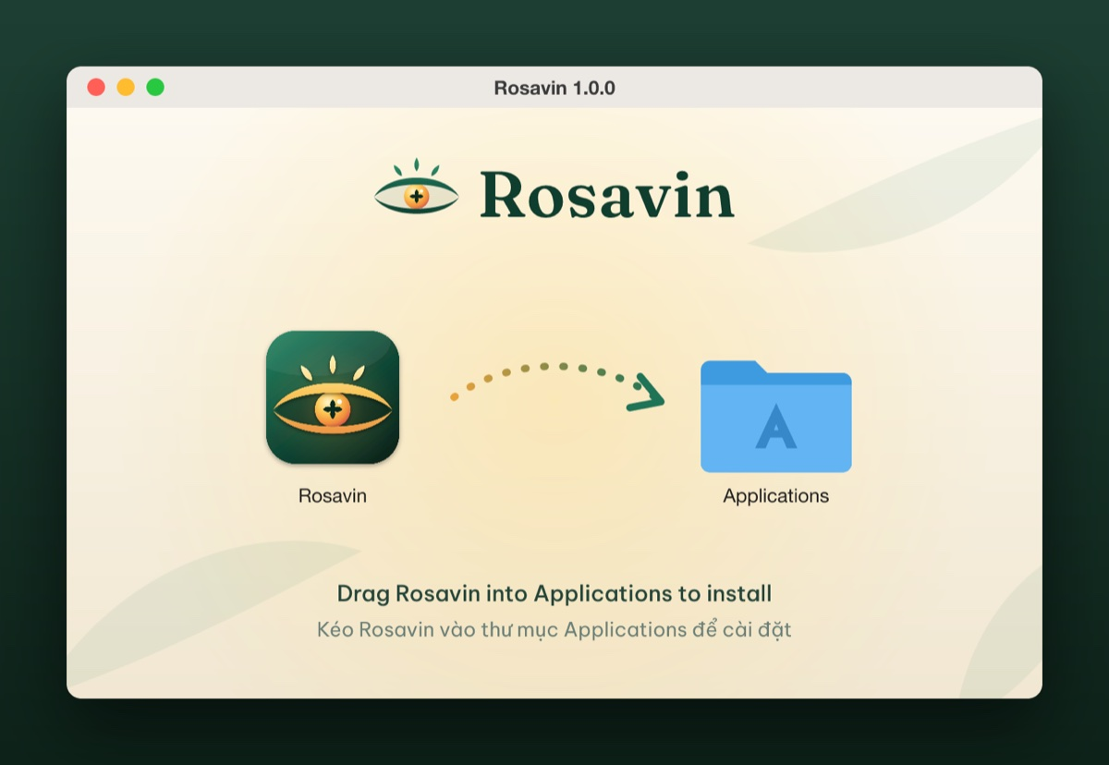
- The Rosavin installer: drag the app onto the Applications folder
- Eject the disk image (click ⏏ next to “Rosavin 1.0.0” in the Finder sidebar). You can delete the .dmg afterwards.
- Open Rosavin from Applications, Launchpad or Spotlight (⌘ Space, type Rosavin).
- Confirm the first launch. Rosavin is free and open source and is not notarized by Apple, so macOS asks you to approve it once:
  - macOS 15 Sequoia or later: a message says “Rosavin” Not Opened. Click Done. Open System Settings › Privacy & Security, scroll down to the Security section, and click Open Anyway next to “Rosavin” was blocked to protect your Mac. Enter your password (or use Touch ID), then click Open Anyway once more.
  - macOS 13 Ventura / 14 Sonoma: in the Applications folder, Control-click (or right-click) Rosavin and choose Open, then click Open in the dialog.
  - Alternative (Terminal): xattr -dr com.apple.quarantine /Applications/Rosavin.app
- You only need to do this once. Afterwards Rosavin opens normally.

Windows
- Run the installer Rosavin Setup 1.0.0.exe.
- If Microsoft Defender SmartScreen shows Windows protected your PC, click More info › Run anyway (the installer is not code-signed).
- Choose the install location (the default is fine) and finish the wizard. Rosavin creates Start menu and desktop shortcuts.
- Rosavin appears in the system tray, next to the clock. If you don’t see it, click the ^ arrow to show hidden icons, then drag the eye icon onto the taskbar to keep it visible.

Your first minute
When Rosavin starts for the first time, its window opens and an eye icon appears in the menu bar (top-right of the screen on a Mac) or in the system tray (bottom-right on Windows).
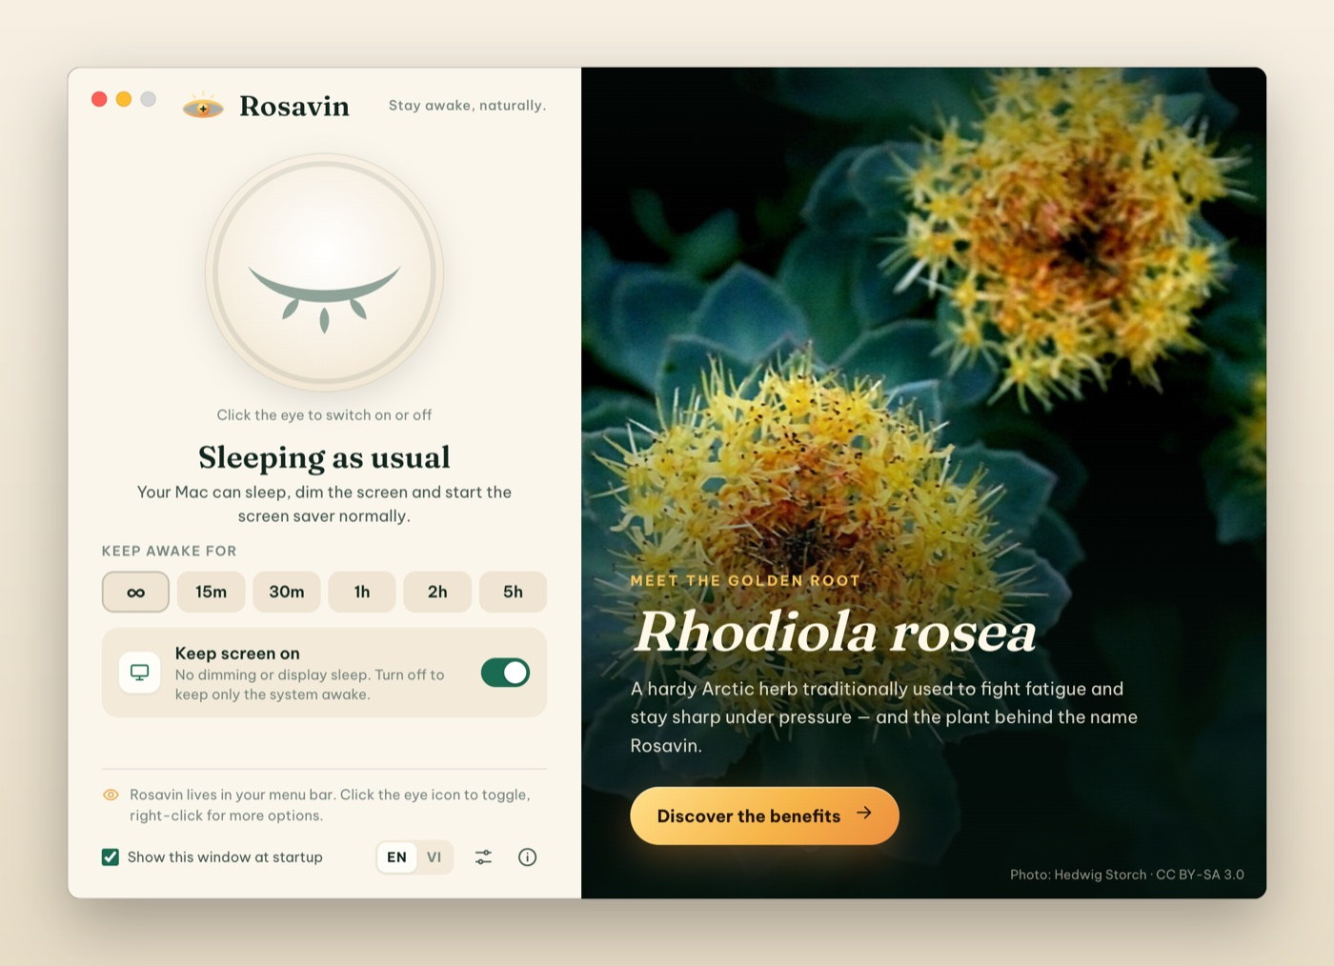
The Rosavin window when it is off
- Click the big closed eye in the window. It opens, glows gold, and Rosavin says Staying awake. Your computer will now stay awake.
- Click it again to switch Rosavin off. The eye closes and your computer sleeps normally again.
- Close the window whenever you like. Rosavin keeps running in the menu bar, so you can control it from there.
Tip: if you don’t want this window every time Rosavin starts, untick Show this window at startup at the bottom of the window.

The menu bar icon
The eye icon shows Rosavin’s state at a glance:
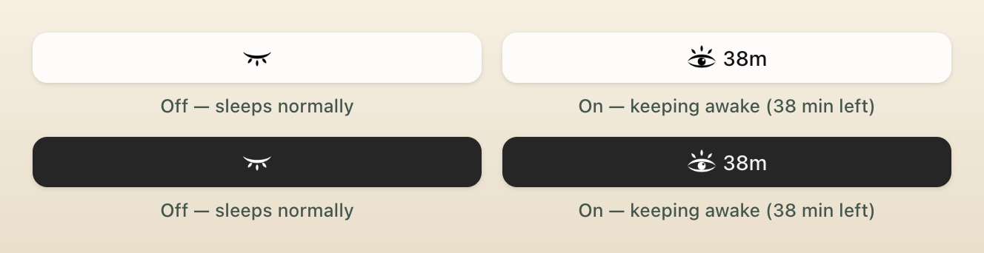
The menu bar icon when Rosavin is off (closed eye) and on (open eye with countdown), in light and dark menu bars
Icon | State
Closed eye with lashes | Off: your computer sleeps normally
Open eye with three rays | On: your computer stays awake
Open eye + 38m | On with a timer; 38 minutes remaining (macOS)
What clicking does:
- Click the icon to switch Rosavin on or off (it uses your default duration; see Preferences).
- Right-click the icon (or ⌘-click, or Control-click on a Mac) to open the menu.
On Windows, hover over the tray icon to see the state and remaining time in the tooltip.

The menu
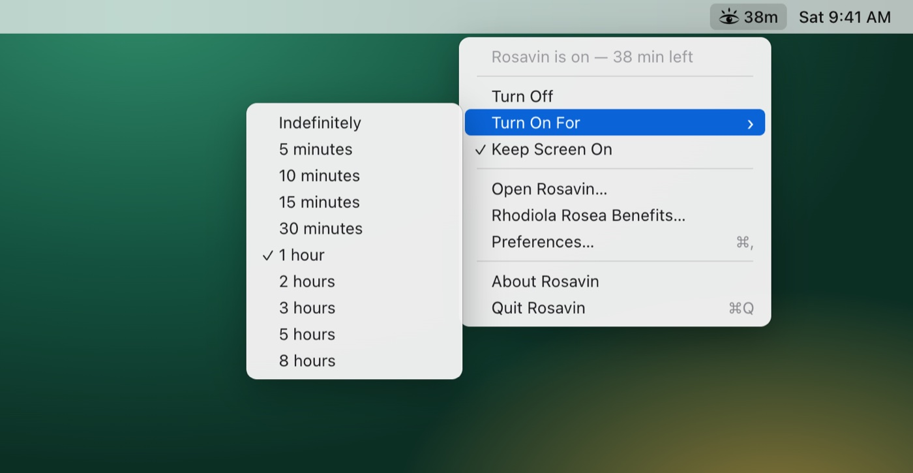
The Rosavin menu with the “Turn On For” timer submenu
Menu item | What it does
Rosavin is on — 38 min left | Status line (not clickable)
Turn On / Turn Off | Switch Rosavin on or off
Turn On For › | Start a session that ends by itself: Indefinitely, 5, 10, 15, 30 minutes, 1, 2, 3, 5 or 8 hours. The running duration has a check mark
Keep Screen On | Ticked: no dimming or display sleep. Unticked: only the system stays awake (see below)
Open Rosavin… | Open the Rosavin window
Rhodiola Rosea Benefits… | Open the window directly on the Rhodiola rosea guide
Preferences… | Open the settings
About Rosavin | Version and credits
Quit Rosavin | Close Rosavin completely (your computer then sleeps normally)

The Rosavin window
Open the window from the menu (Open Rosavin…) or by opening the app again from Applications / the Start menu.
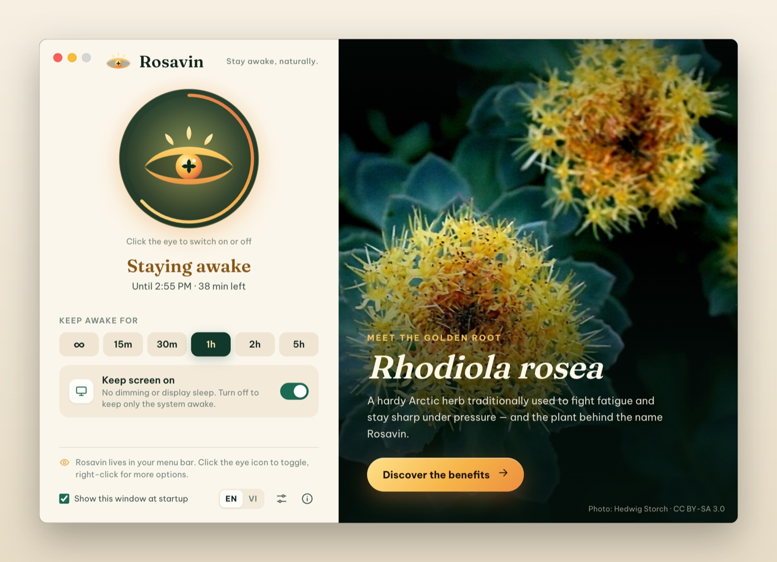
The Rosavin window while a one-hour session is running
- The eye button. Click it to switch Rosavin on or off. When a timer is running, the golden ring around it empties as time passes.
- Status. Staying awake with the end time and the time left, for example Until 2:50 PM · 38 min left, or Sleeping as usual when Rosavin is off.
- Keep awake for. Quick durations: ∞ (until you turn it off), 15m, 30m, 1h, 2h, 5h. Click one to start a session right away; click the highlighted one again to stop. When Rosavin is off, your default duration has a thin outline.
- Keep screen on. Choose whether the display stays on, or only the system.
- Bottom bar. A reminder of where the icon lives, the Show this window at startup option, the EN / VI language switch, Preferences (sliders) and About (i).
- The golden root panel. A photo of Rhodiola rosea and the Discover the benefits button.
Rosavin follows your system’s light or dark appearance (you can also force one in Preferences):
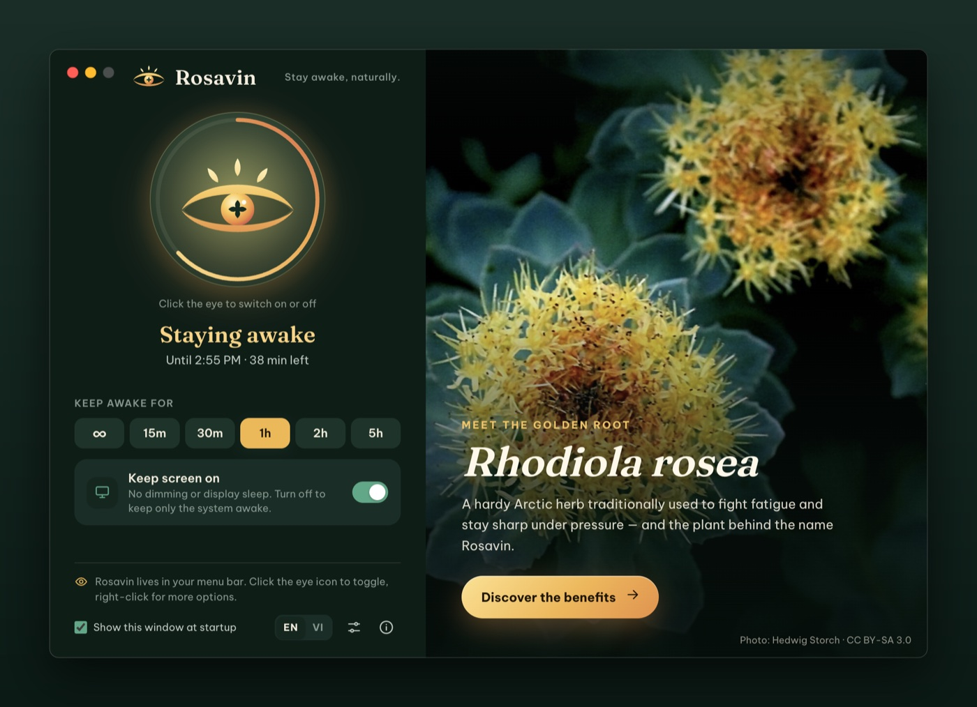
Rosavin in dark mode

Timers
A timer switches Rosavin off automatically, so you never leave your computer awake by accident.
- From the menu: right-click the icon › Turn On For › choose a duration.
- From the window: click a duration chip (15m, 30m, 1h, 2h, 5h).
- Default duration: set what a simple click on the icon does in Preferences › Default duration (for example 1 hour instead of Indefinitely).
While a timer runs you will see the remaining time next to the menu bar icon (macOS), in the tooltip (Windows), in the menu’s status line and in the window. When it ends, Rosavin switches off and shows a notification (Rosavin is off). You can turn that notification off in Preferences.
Choosing a new duration while Rosavin is on restarts the timer from now. If your computer is forced to sleep anyway (for example by closing a MacBook lid) and the timer ends meanwhile, Rosavin switches off as soon as the computer wakes up.

Keep screen on, or system only
Mode | Use it for | What happens
Keep Screen On (default) | Presentations, reading, recipes, dashboards, video calls | No sleep, no dimming, no screen saver
System only (Keep Screen On unticked) | Long downloads, uploads, renders, backups, remote sessions | The display may turn off as usual, but the computer keeps running
Switch modes from the menu (Keep Screen On) or with the switch in the window. You can switch while Rosavin is on; the current session and timer continue.

Learn about Rhodiola rosea
Rosavin is named after rosavin, the signature compound of Rhodiola rosea, the “golden root” from the Arctic. Click Discover the benefits in the window (or choose Rhodiola Rosea Benefits… in the menu) to open an illustrated guide with six tabs. Close it with the × button or the Esc key.
Overview. What the plant is, where it grows, its traditional use and key facts, plus an honest note on how strong the science is.
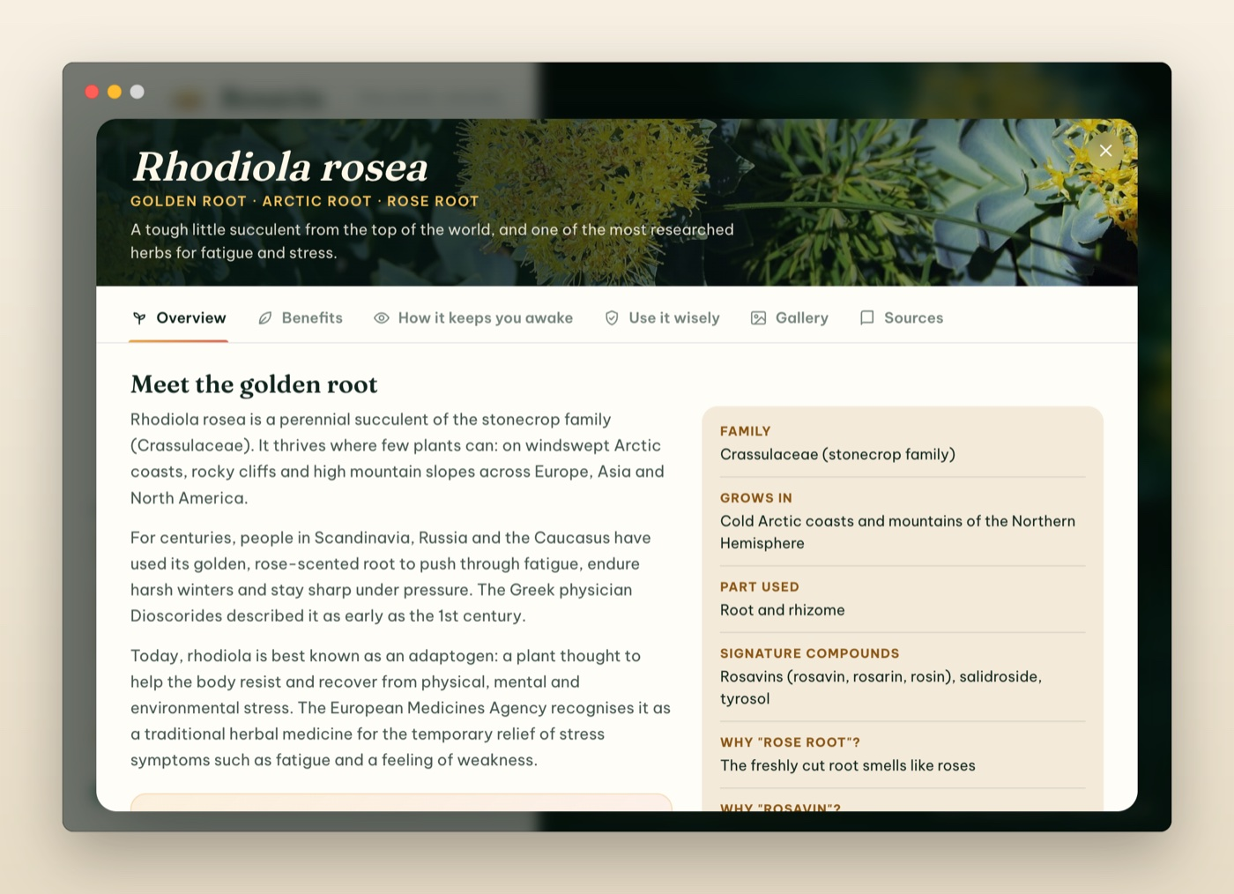
Overview tab
Benefits. Six health benefits, each with an evidence badge (Promising evidence, Some evidence, Early research). Click a number such as 2 or 5 to jump to that study in the Sources tab.

Benefits tab with evidence levels and source numbers
How it keeps you awake. The four ways rhodiola is thought to fight fatigue (calming the stress response, supporting brain messengers, fuelling cells, building stress resistance), the molecules behind it, and a reminder that nothing replaces sleep.
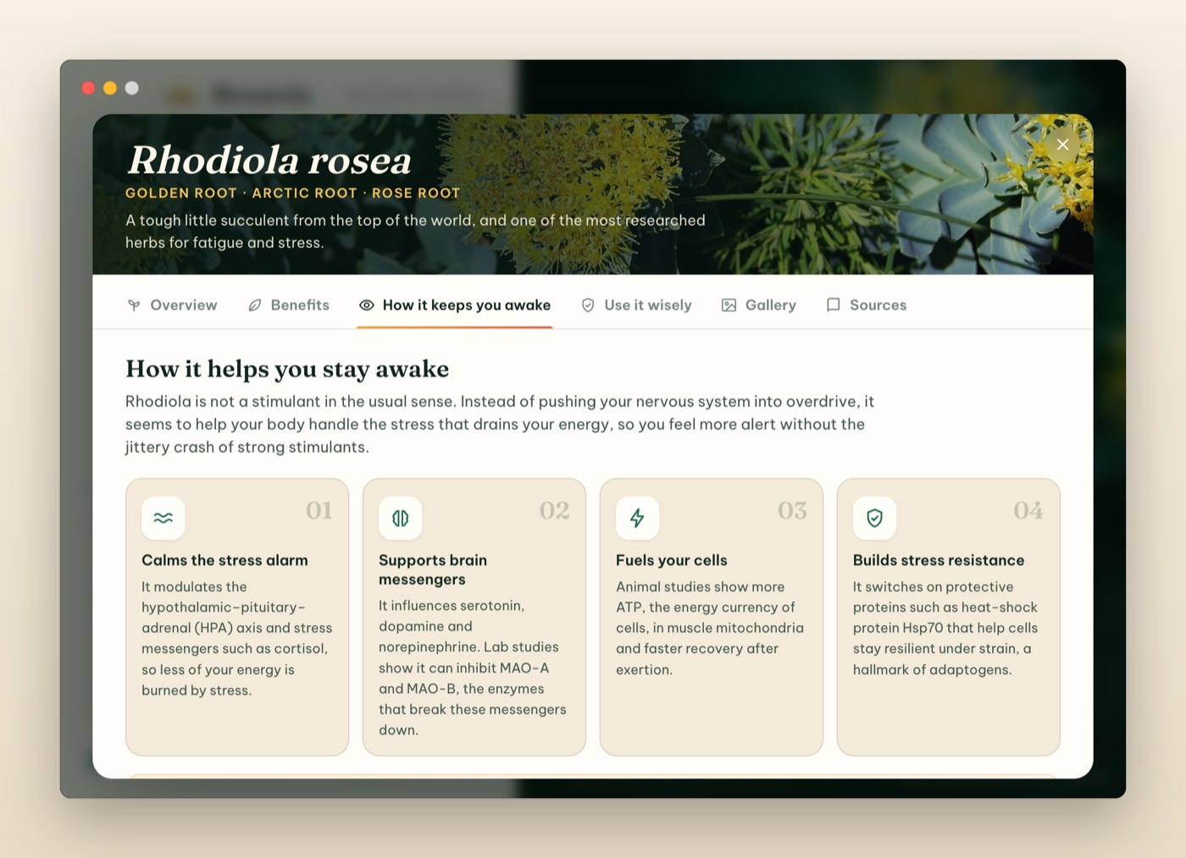
How it keeps you awake
Use it wisely. How it was taken in studies, possible side effects, who should talk to a doctor first, and how to choose a quality product, followed by the medical disclaimer.
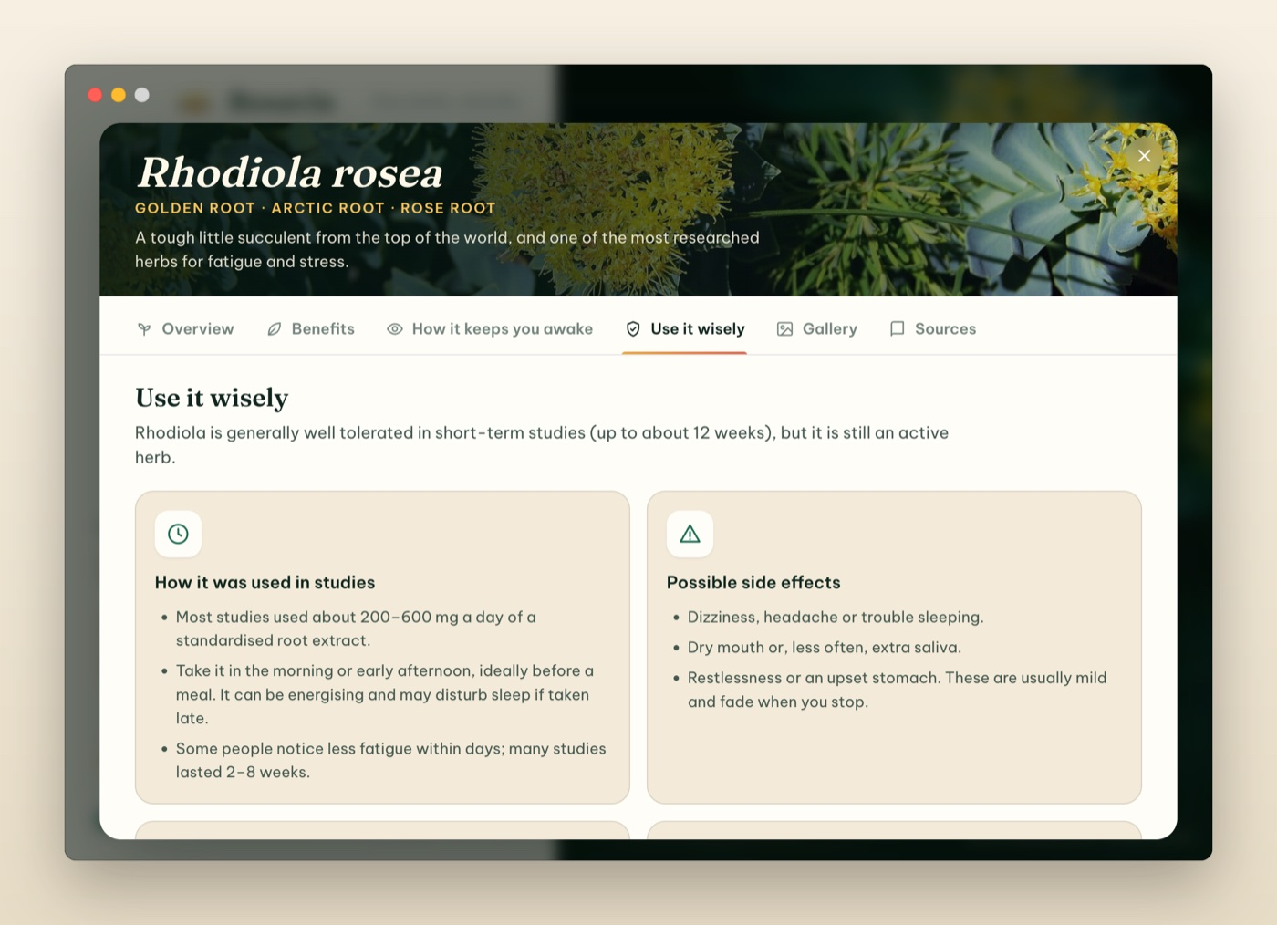
Use it wisely
Gallery. Photos of Rhodiola rosea in the wild. Click a photo to enlarge it; click the credit line to open the original on Wikimedia Commons.

Gallery
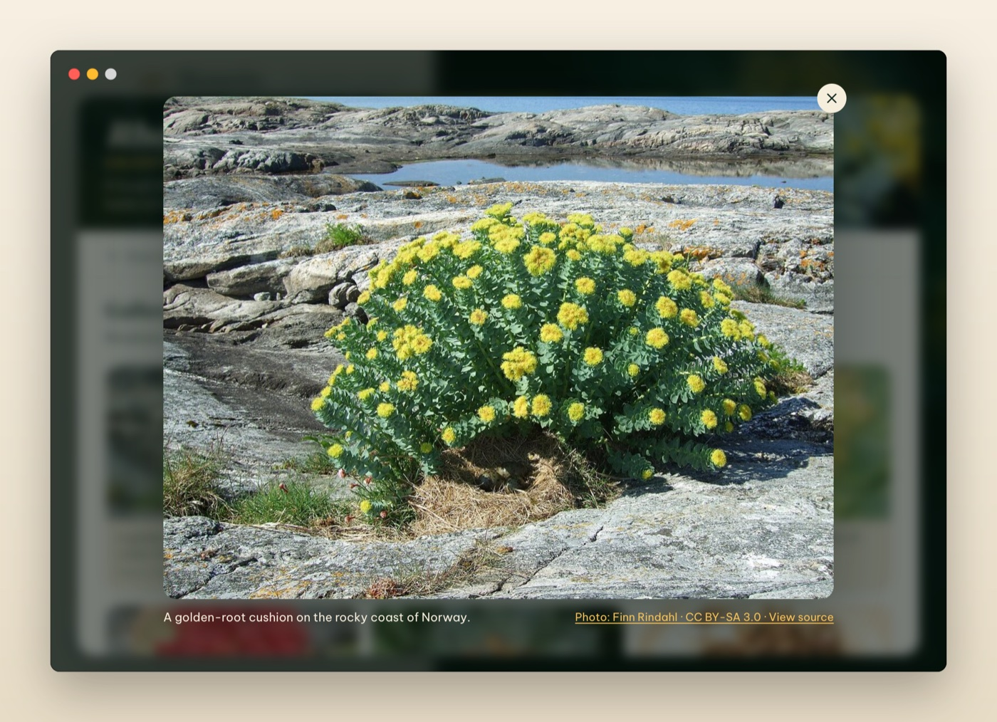
An enlarged photo with its caption and credit
Sources. The 19 peer-reviewed studies and official monographs behind the summary. Click a link to open it in your browser.
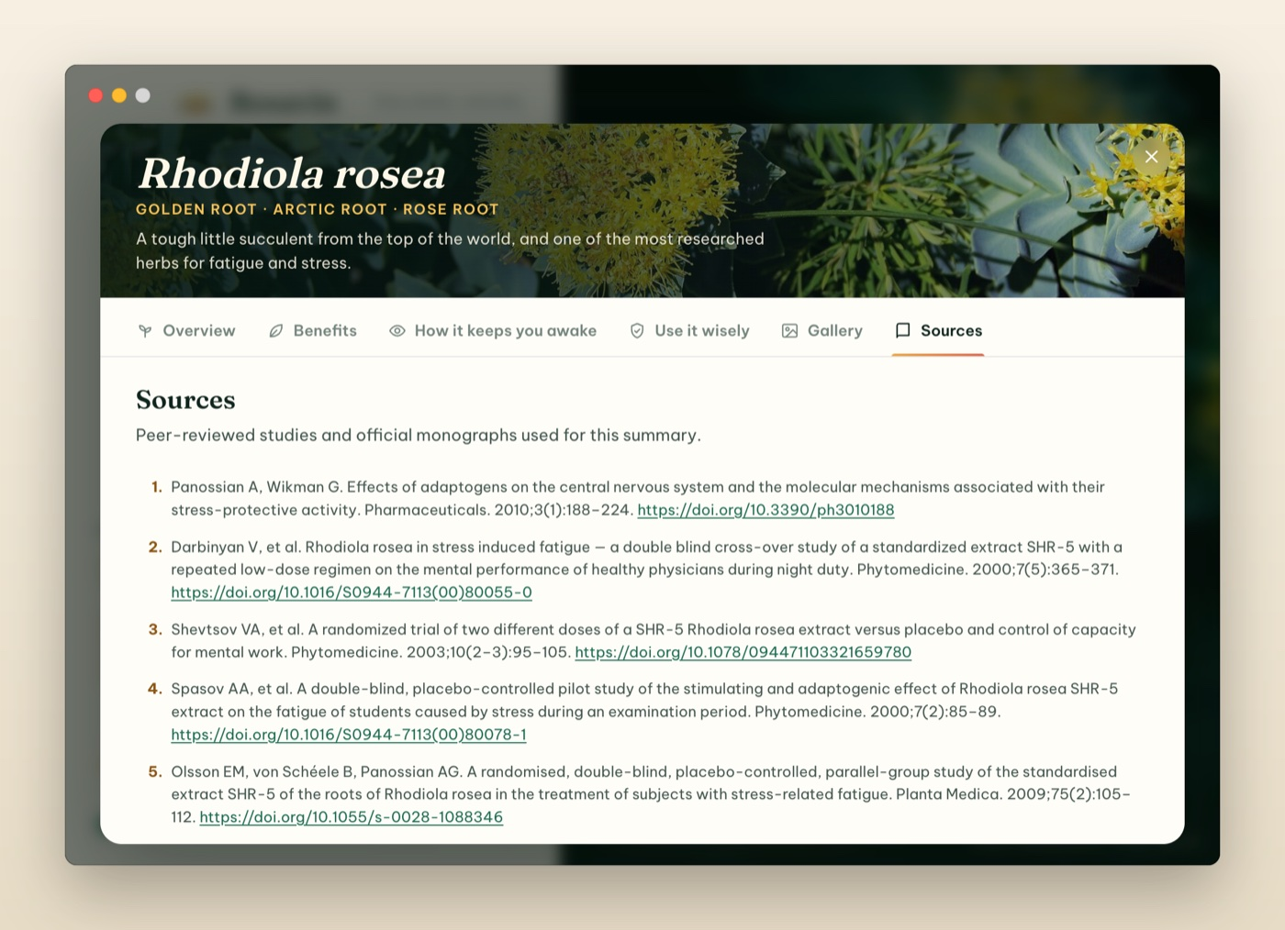
Sources

Preferences
Open Preferences with the sliders button in the window, Preferences… in the menu, or ⌘, (Ctrl+, on Windows). Changes apply immediately.
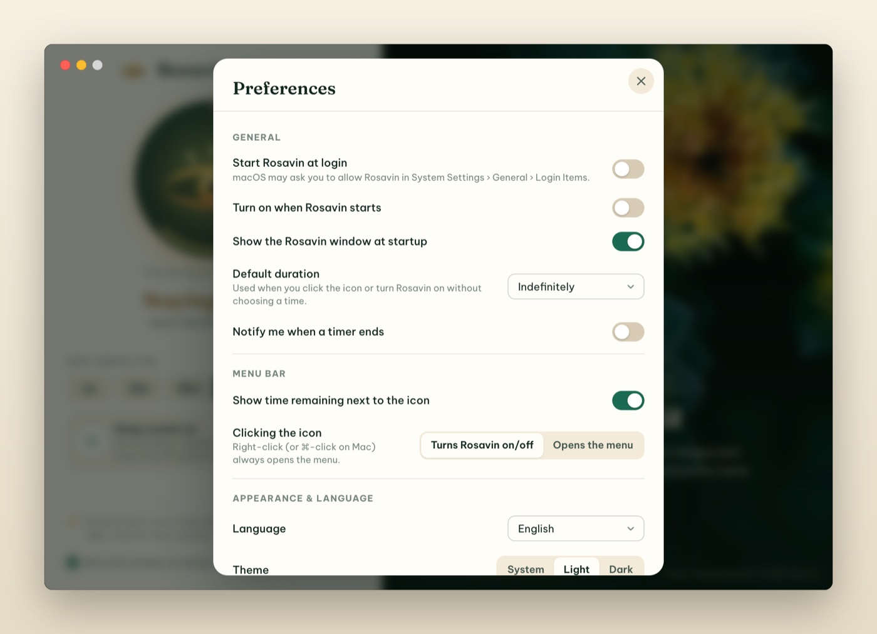
Preferences
Setting | What it does
Start Rosavin at login | Rosavin starts automatically (quietly, in the menu bar) when you log in. On macOS you may need to allow it in System Settings › General › Login Items
Turn on when Rosavin starts | Rosavin switches itself on every time it starts, using the default duration
Show the Rosavin window at startup | Open the window when Rosavin starts (same as the checkbox at the bottom of the window)
Default duration | What clicking the icon (or Turn On) does: Indefinitely or a time from 5 minutes to 8 hours
Notify me when a timer ends | Show a notification when a timed session finishes
Show time remaining next to the icon | macOS only: show 38m-style countdowns in the menu bar
Clicking the icon | Turns Rosavin on/off (default) or Opens the menu. Right-click always opens the menu
Language | System default, English or Tiếng Việt. You can also use the EN / VI switch in the window
Theme | System, Light or Dark

Automation: links and command line
Power users can control Rosavin from scripts, the macOS Shortcuts app, Alfred/Raycast, or a terminal.
Links (type them in Terminal with open, or use them in Shortcuts’ Open URLs action):
Link | Action
rosavin://activate | Turn on (default duration)
rosavin://activate?minutes=45 | Turn on for 45 minutes (0 = indefinitely)
rosavin://deactivate | Turn off
rosavin://toggle | Switch on/off
rosavin://show | Open the window
rosavin://benefits | Open the Rhodiola rosea guide
rosavin://preferences | Open Preferences
open "rosavin://activate?minutes=45" # macOS
start rosavin://deactivate # Windows
Command line: the same actions as flags, e.g. --activate=30, --deactivate, --toggle, --show. Add --hidden to start Rosavin without its window. If Rosavin is already running, the command is passed to the running app.
/Applications/Rosavin.app/Contents/MacOS/Rosavin --activate=30

About Rosavin and quitting
Click (i) in the window or choose About Rosavin in the menu to see the version, licence and credits.
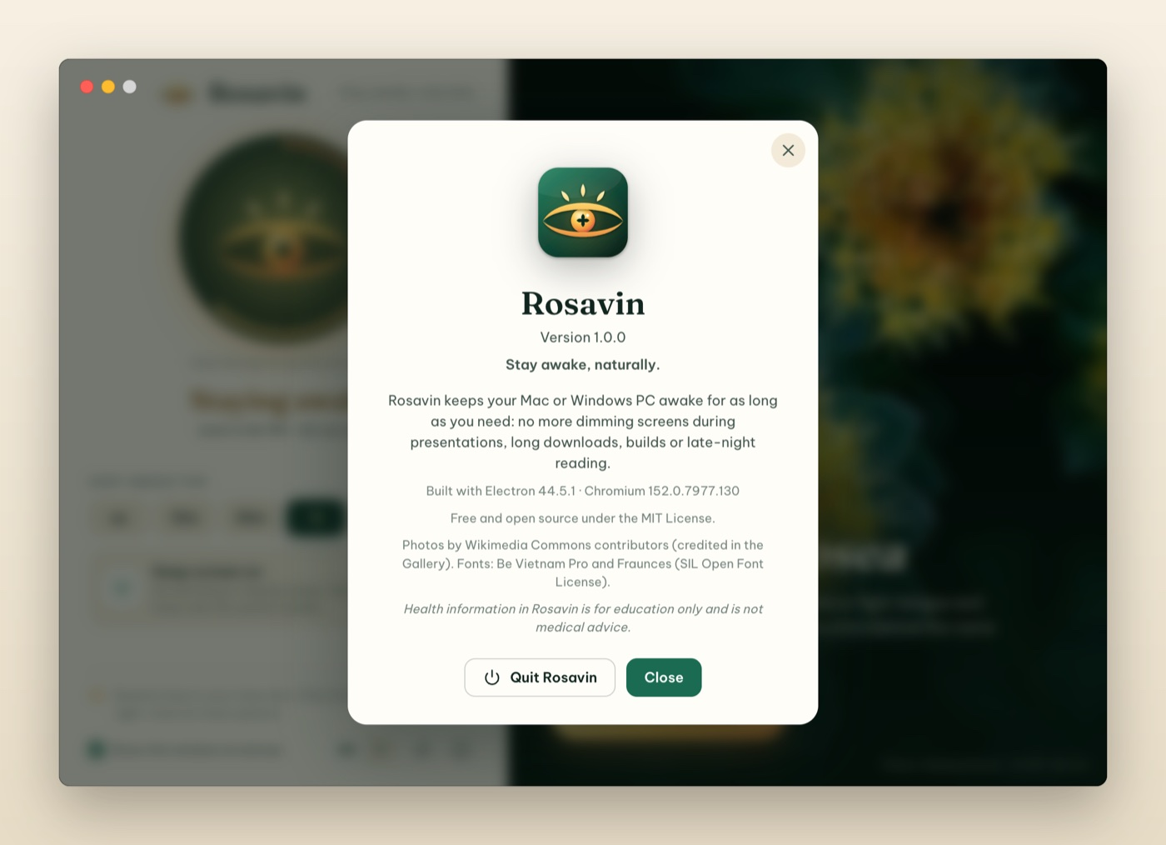
About Rosavin
To quit, choose Quit Rosavin in the menu, click Quit Rosavin in the About box, or press ⌘Q while the window is active. Quitting always releases the keep-awake request.

Troubleshooting & FAQ
I can’t see the eye icon in the menu bar. On MacBooks with a notch, menu bar icons can hide behind it when the menu bar is crowded. Quit a few menu bar apps or use a smaller font size for menu bar items. If you use a menu bar organiser (such as Bartender or Ice), check its hidden section. You can always open Rosavin’s window from Applications.
My MacBook still sleeps when I close the lid. That is a macOS rule for every app: a MacBook sleeps when its lid is closed unless it is connected to power and an external display. Keep the lid open, or use clamshell mode.
The screen still turns off. Make sure Keep Screen On is ticked. In system only mode the display may sleep while the computer keeps running.
How can I check that Rosavin is working? - macOS: in Terminal, run pmset -g assertions and look for a line with Rosavin (NoDisplaySleepAssertion, or NoIdleSleepAssertion in system-only mode). - Windows: in an administrator terminal, run powercfg /requests and look for Rosavin under DISPLAY or SYSTEM.
“Rosavin can’t be opened” / “Not Opened” on first launch. Follow step 5 of the macOS install section. This only happens once.
I don’t get a notification when the timer ends. Allow notifications for Rosavin in System Settings › Notifications (macOS) or Settings › System › Notifications (Windows), and check that Notify me when a timer ends is on.
“Start Rosavin at login” switches itself off. Rosavin reads the real login-item state from the system. On macOS, open System Settings › General › Login Items and make sure Rosavin is allowed.
Does Rosavin drain my battery? Rosavin itself uses almost no energy. Keeping the display on does use power, so use a timer or system-only mode when you’re on battery.

Uninstall
- macOS: quit Rosavin, then drag Rosavin from Applications to the Trash. To remove its settings too, delete ~/Library/Application Support/Rosavin. If you enabled Start at login, turn it off first (or remove Rosavin from System Settings › General › Login Items).
- Windows: Settings › Apps › Installed apps › Rosavin › Uninstall. Settings are stored in %APPDATA%\Rosavin.

Privacy and health disclaimer
Privacy. Rosavin works fully offline: no accounts, no analytics, no network requests. Your preferences are saved only on your computer.
Health information. The Rhodiola rosea content in Rosavin is for general education only and is not medical advice. Supplements are not approved to diagnose, treat, cure or prevent any disease. Talk to a qualified healthcare professional before taking any supplement, especially if you are pregnant, breastfeeding, taking medication or living with a health condition.
Rosavin is free and open source software under the MIT License. Photos of Rhodiola rosea by Wikimedia Commons contributors; see CREDITS.md.

