**Tran Quoc Tuan – UG2F20**

**Task 9:**  
Fill a collection with several regular shapes (circle, regular triangle, square, regular hexagon). Which shape has the smallest difference between its area and perimeter? Each shape can be represented by its center and side length (or radius), if we assume that one side of the polygons are parallel with x axis, and its nodes lies on or above this side. Load and create the shapes from a text file. The first line of the file contains the number of the shapes, and each following line contain a shape. The first character will identify the type of the shape, which is followed by the center coordinate and the side length or radius. Manage the shapes uniformly, so derive them from the same super class.

**SOLUTION:**

UML Diagram

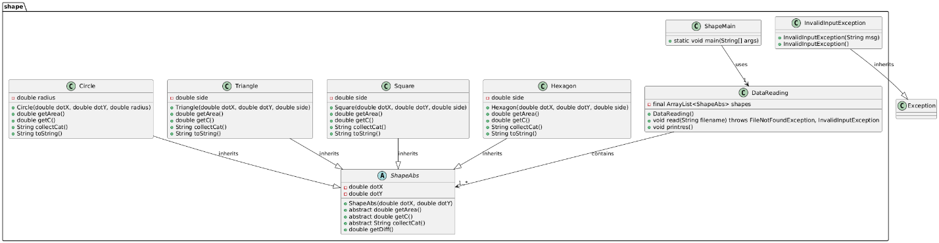

*/Abstract Class – ShapeAbs:

+Universal variable: dotX, dotY. For coordinates of shapes on coordinate axes (although it’s trivial info in this task.)  
+abstract classes – getArea(), getC(), getCat() – later to override for each shape accordingly to calculate and returns statistics and category letter (at this point I don’t even know what I did with the category things, but I’m too lazy and afraid to delete it).  
+getDiff() – return the difference of circumference and area for the main tasks.

*/Subclass – Circle, Square, Hexagon, Triangle:

Inherits ShapeAbs. Also override the Abstract classes accordingly

*/DataReading:

+read(): we use wrapped FileReader inside wrapped BufferedReader inside Scanner, it returns FileNotFoundException and InvalidInputException (custom exception

). It returns corresponding Exception if:   
-No int value on the beginning of file to indicates amount of shapes.

-int value mismatched with given amount of shapes .

-The abbreviated shape name isn’t belong to any of the cases.

+printres(): Minimum search with lambda function

*/Main(): main  
⠀⠀⠀⠀⠀⠀⢀⣤⠤⠤⠤⠤⠤⠤⠤⠤⠤⠤⢤⣤⣀⣀⡀⠀⠀⠀⠀⠀⠀

⠀⠀⠀⠀⢀⡼⠋⠀⣀⠄⡂⠍⣀⣒⣒⠂⠀⠬⠤⠤⠬⠍⠉⠝⠲⣄⡀⠀⠀

⠀⠀⠀⢀⡾⠁⠀⠊⢔⠕⠈⣀⣀⡀⠈⠆⠀⠀⠀⡍⠁⠀⠁⢂⠀⠈⣷⠀⠀

⠀⠀⣠⣾⠥⠀⠀⣠⢠⣞⣿⣿⣿⣉⠳⣄⠀⠀⣀⣤⣶⣶⣶⡄⠀⠀⣘⢦⡀

⢀⡞⡍⣠⠞⢋⡛⠶⠤⣤⠴⠚⠀⠈⠙⠁⠀⠀⢹⡏⠁⠀⣀⣠⠤⢤⡕⠱⣷

⠘⡇⠇⣯⠤⢾⡙⠲⢤⣀⡀⠤⠀⢲⡖⣂⣀⠀⠀⢙⣶⣄⠈⠉⣸⡄⠠⣠⡿

⠀⠹⣜⡪⠀⠈⢷⣦⣬⣏⠉⠛⠲⣮⣧⣁⣀⣀⠶⠞⢁⣀⣨⢶⢿⣧⠉⡼⠁

⠀⠀⠈⢷⡀⠀⠀⠳⣌⡟⠻⠷⣶⣧⣀⣀⣹⣉⣉⣿⣉⣉⣇⣼⣾⣿⠀⡇⠀

⠀⠀⠀⠈⢳⡄⠀⠀⠘⠳⣄⡀⡼⠈⠉⠛⡿⠿⠿⡿⠿⣿⢿⣿⣿⡇⠀⡇⠀

⠀⠀⠀⠀⠀⠙⢦⣕⠠⣒⠌⡙⠓⠶⠤⣤⣧⣀⣸⣇⣴⣧⠾⠾⠋⠀⠀⡇⠀

⠀⠀⠀⠀⠀⠀⠀⠈⠙⠶⣭⣒⠩⠖⢠⣤⠄⠀⠀⠀⠀⠀⠠⠔⠁⡰⠀⣧⠀

⠀⠀⠀⠀⠀⠀⠀⠀⠀⠀⠀⠉⠛⠲⢤⣀⣀⠉⠉⠀⠀⠀⠀⠀⠁⠀⣠⠏⠀

⠀⠀⠀⠀⠀⠀⠀⠀⠀⠀⠀⠀⠀⠀⠀⠈⠉⠉⠛⠒⠲⠶⠤⠴⠒⠚⠁⠀⠀

**Testing:**  
Standard case:  
4

C 0 0 5

T 2 3 6

S -1 3 4

H 1 2 5

Output:

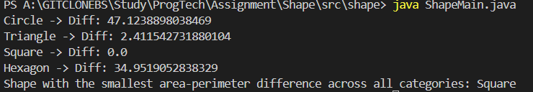

Wrong input case:  
3 (or) 5 (or none)

C 0 0 5

T 2 3 6

S -1 3 4

H 1 2 5   


Wrong file name:  
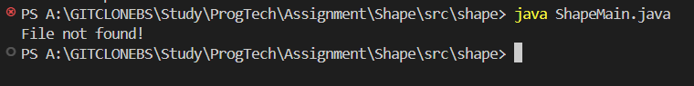

Wrong shape datas:  
4

C 0 0 5

T 2 3 6

S -1 3

H 1 2 5 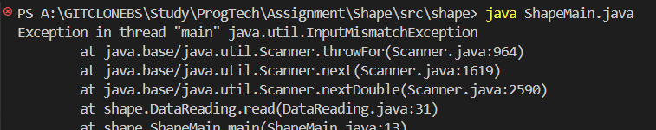

Negative shape value for side/radius:  
4

C 0 0 5

T 2 3 6

S -1 3 4

H 1 2 -5

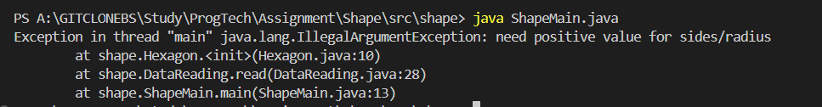

Empty file:

