Software Requirement Specification
mTravelling

Revision Date: 24/11/2011
Version 1.0

Business Unit:
Issue Date:
Issue Status:
Author:
Location:
Confidential Class:
Reviewer information:
Approver information: | <Approver> | <Role>

Table of contents

1. Introduction 5
1.1 Overview 5
1.2 Scope 5
1.3 Assumptions 5
1.4 References 5
2. Deliverables 5
3. Functional Requirements 6
3.1 Feature 1: Waiting page – Main Menu 6
3.1 Feature 2: Home page 7
3.2 Feature 3: Place search result page 8
3.3 Feature 4: Detail place screen 9
3.4 Feature 5: Favorite Page 10
3.5 Feature 6: Web Page 12
4. Revision History 13

1. Introduction

1.1 Overview
Nowadays, the demand of using the smart phone is popular with the public because of its useful functions to people. It meets many living needs of people for work, study, entertainment etc.
Realizing it is necessary to have a mobile application that supports travelers to find information such as Hotel, Airport, Taxi, Gas Stations, restaurants, interesting places, ATMs, etc., our mobile development team decided to produce mTravelling.
This application also gives the best solutions to the user's choice. For instance, it suggests the nearest interesting places/ places of interest from the user's current location, and it directs the user to a specific location.

1.2 Scope
- Android OS: 2.1, 2.2, 2.3

1.3 Assumptions
- Google Place Apis are available

1.4 References
 | Title | Author | Date | Version
1.
2.

2. Deliverables
- Binary application files
- Software design documents
- Source code
- Release notes
- Test reports

3. Functional Requirements

3.1 Feature 1: Waiting page – Main Menu

3.1.1 User Interfaces

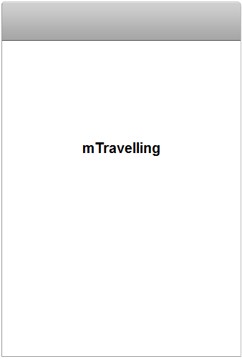

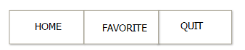

3.0.2 Functional Requirements
Show flash about mTraveling on 3 second to load application.
Current screen | Description | Action | Next screen
Home page | Show flash about Traveling then go to homepage |  | Home page
Main menu | This menu used in all screen | Home | Back Home page
Main menu | This menu used in all screen | Favorite | Go to Favorite page
Main menu | This menu used in all screen | Quit | Close application and delete all activity

3.1 Feature 2: Home page

3.1.1 User Interfaces
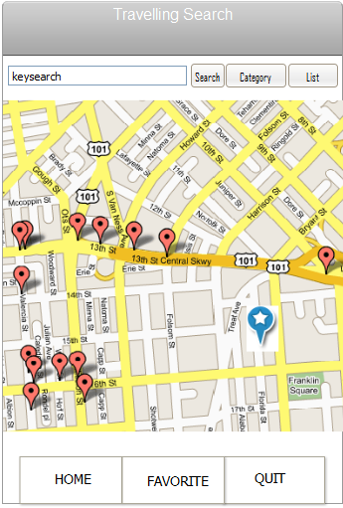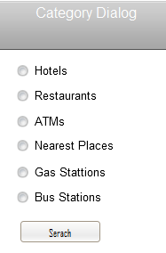

3.1.2 Functional Requirements
List categories as restaurants, hotels, interested places, ATM, Taxi, Bus station, etc and add more categories for search.
Current screen | Description | Action | Next screen
Home page | List specific places that are nearest from current user location(about 30Km2) | Select categories button | Show Categories dialog
Home page |  | Type keyword on textbox & search | Place list view
Home page |  | List place | Place list view
Home page |  | Tap on place marker to view place detail view | Place detail view
Categories Dialog | List place categories | Select category to search | View place markers on map

3.2 Feature 3: Place search result page

3.2.1 User Interfaces
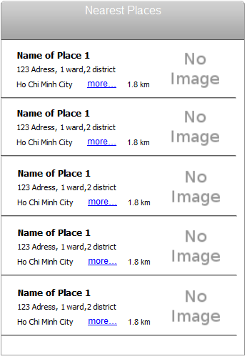

3.2.2 Functional Requirements
Find nearest places base current user's location
Current screen | Description | Action | Next screen
Place result list | View specific places which user selected from home page as name place, address, distance from user , link to web view etc. | Tap on name or image to view detail screen | View place detail page
 |  | Link to web view | Web view of place

3.3 Feature 4: Detail place screen

3.3.1 User Interfaces
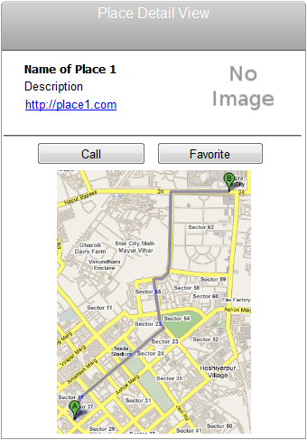

3.3.2 Functional Requirements

Get detail information of place
Current screen | Description | Action | Next screen
Place detail page | Show information detail place(name, address, phone)  Show direction on map | Call | Call page
 |  | Add favorite | Place favorite page
 |  | Link to web | Place web page

3.4 Feature 5: Favorite Page

3.4.1 User Interfaces

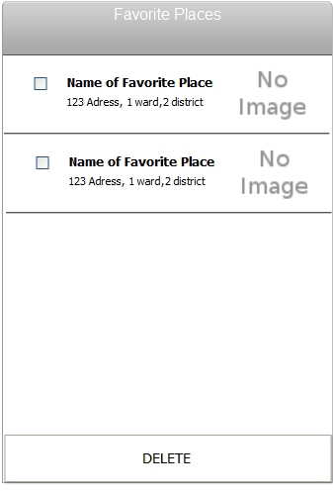

3.4.2 Functional Requirements

Current screen | Description | Action | Next screen
Favorite page | Show favorite place which user book mark | Check place on checkbox to delete
 |  | Tap on name or image to view detail screen | View place detail page

3.5 Feature 6: Web Page

3.5.1 User Interfaces

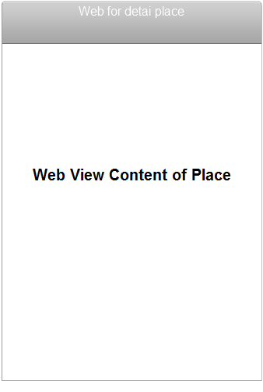

3.5.2 Functional Requirements
Current screen | Description | Action | Next screen
Web view page | View place’ web page

Message ID | Messages | Description
Msg001
Msg002
Msg003
Msg004

4. Revision History
Date | Version | Description | Revised by

---------- End of Document ----------

