mTravelling
mtravelling-k15

Version 1.0

Class Name | Android Application Development
Class Code | K15
Group | mtravelling_1(Thuong,Hai,Khoi,Vinh,Toan)
Teacher | Nam Khanh
Project Manager | Nam Khanh
Assign Date | 11/07/2011
Complete Date | 15/07/2011
Author | mtravelling_1(Thuong,Hai,Khoi,Vinh,Toan)
Version | 1.0
Approved By | mtravelling_1(Thuong,Hai,Khoi,Vinh,Toan)
Approved Date | 16/07/2011

Table of Contents
1 Introduction 3
1.1 Purpose 3
1.2 Scope 3
1.3 Definitions, Acronyms and Abbreviations 3
1.4 References 3
2 OVERAL Description 3
2.1 Product Perspective 3
2.2 Product Features 4
2.3 User Documents 4
• Installation guide 4
2.4 Assumptions and Constraints 4
3 Use case model 4
3.1 The Actors 5
3.2 The use cases 5
3.3 Use cases diagram 5
4 Functional Requirements 6
4.1 List categories and Search listing 6
4.1.1 List categories _ mTravelling_UC_1.1 6
4.1.2 Search listing _ mTravelling_UC_1.2 7
4.2 Detail location 8
4.2.1 View detail _ mTravelling_UC_2.1 8
4.2.2 View web _ mTravelling_UC_2.2 9
4.2.3 Route _ mTravelling_UC_2.3 9
4.2.4 Phone_ mTravelling_UC_2.4 10
4.2.5 Share via _ mTravelling_UC_2.5 11
4.3 My Favourites 12
4.3.1 Add POI _ mTravelling_UC_3.1 12
4.3.2 Remove POI _ mTravelling_UC_3.2 13
4.3.4. Select POI _ mTravelling_UC_3.3 14
4.3.5. Show the weather information _ mTravelling_UC_3.4 15
4.4 Search and change location 15
4.4.1. Search location_mTravelling_UC_4.1 16
4.4.2. Change location _ mTravelling_UC_4.2 17
4.5 Map View 17
4.5.1. List results _ mTravelling_UC_5.1 18
4.5.2. Show my location on map _ mTravelling_UC_5.2 19
4.5.3. Change map types _ mTravelling_UC_5.3 19
4.5.4 Setting _ mTravelling_UC_5.4 20
5. Non-Functional Requirements 21
5.1 Usability 21
5.2 Reliability 21
5.3 Performance 21
5.4 Supportability 22
5.5 Interface Requirements 22
5.6 Security Requirements 22
5.7 Reports and Form templates Requirements 22
5.7.1 Reports 22
5.7.1.1 <Functional Name 1> Reports 22
5.7.2 Form Templates 22
5.7.2.1 <Functional Name 1> Forms 22
5.8 Other 22
5.8.1 <Feature 1> 23
5.8.2 <Feature 2> 23
6. Conclusion 23

Introduction

Purpose
This Software Requirements Specification provides a complete description of all the functional requirements, non-functional requirements, and other specifications of the “mTravelling” application.
The expected readers of this document are the project managers, developers and customer of the application.

Scope
This document covers the requirements of “mTravelling” app. The features, functional and non-functional requirements of the system are gathered from customer’s need. Details of all requirements from “mTravelling” company are documented in this document. The final app shall confront to all requirements specified in this document.
The aimed users of “mTravelling” are travellers or everyone want to find location information of banks, hotels, places, ATMs, Restaurants, Airport, Cab& Taxi, Gas stations through Android Mobile.

Definitions, Acronyms and Abbreviations
Term | Definitions, Acronyms and Abbreviations
mTravelling | Mobile travelling
app  POI | Application  Point of Interest

References
Http://www.tma.com.vn/androidmobile/mTravelling

OVERAL Description

Product Perspective
The application described in this document consists of functions for travellers or common users who want to find location information. The application allows user easily find information based on current user’s location such as banks, hotels, places, ATMs, Restaurants, Airport, Cab& Taxi, Gas stations.

Product Features
The main features of application:
- List categories and Search listing: banks, hotels, places, ATMs, Restaurants, Airport, Cab& Taxi, Gas stations
- Detail location: view detail location, web information of location, route, call and share via SMS or email.
- My Favourites: add new favorite, remove a favorite place, choose a favorite place to show on map.
- Search and change location
- Map View

User Documents
As with any good application, documentation and help facilities will exist for mTravelling application. The following documents will be made available to users:

Installation guide
- User guide/document

Assumptions and Constraints
No other special assumptions or Constraints have been identified.

Use case model

The Actors
# | Main functions | User
1 | List categories and Search listing | x
2 | Detail location | x
3 | My Favourites | x
4 | Search and change location | x
5 | Map View | x

The use cases
System Features | Main Use Case | Use Case ID
List categories and Search listing
 | List categories | mTravelling_UC_1.1
 | Search listing | mTravelling_UC_1.2
Detail location
 | View detail | mTravelling_UC_2.1
 | View web | mTravelling_UC_2.2
 | Route | mTravelling_UC_2.3
 | Phone | mTravelling_UC_2.4
 | Share via | mTravelling_UC_2.5
My Favourites
 | Add POI | mTravelling_UC_3.1
 | Remove POI | mTravelling_UC_3.2
 | Select POI | mTravelling_UC_3.3
 | Show the weather information | mTravelling_UC_3.4
Search and change location
 | Search location | mTravelling_UC_4.1
 | Change location | mTravelling_UC_4.2
Map View
 | List results | mTravelling_UC_5.1
 | Show my location on map | mTravelling_UC_5.2
 | Change map types | mTravelling_UC_5.3
 | Setting: distance, unit | mTravelling_UC_5.4

Use cases diagram
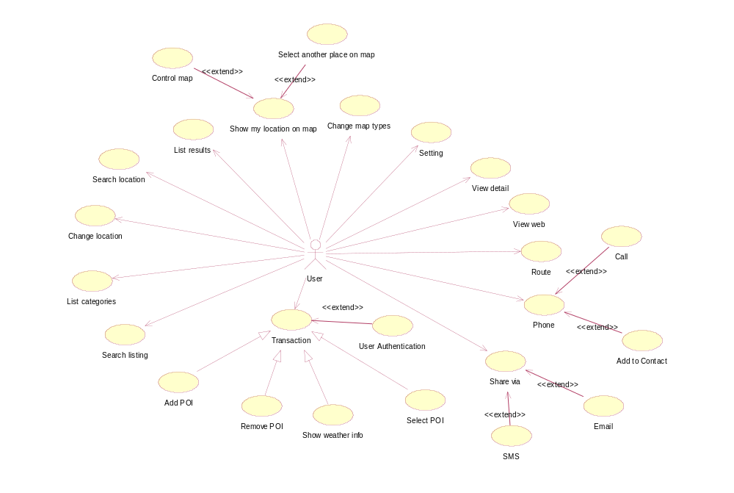
Figure 1: Use cases Diagram

Functional Requirements

List categories and Search listing
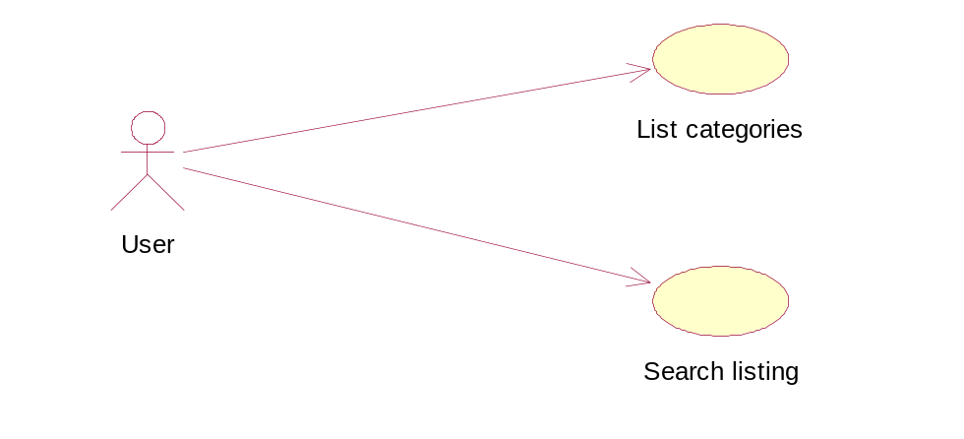
Figure 2.0: Select list of categories

List categories _ mTravelling_UC_1.1
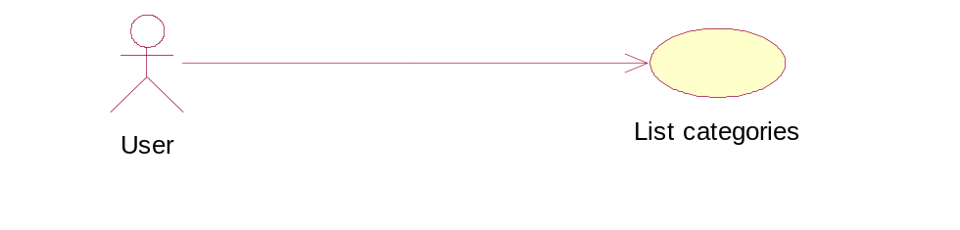
Figure 3: Listing categories
User Case ID | mTravelling_UC_1.1
Name | List categories
Goal | List all items in the categories such as: banks, hotels, places, ATMs, Restaurants, Airport, Cab& Taxi, Gas stations.
Actors | User
Include | N/A
Extended | N/A
Pre-conditions | Must have Android Mobile and mTravelling app
Post-conditions | N/A
Main Flow | 1. Select “List categories” button.  3. Select one of all items in list. | 2. Display all items in the categories such as: banks, hotels, places, ATMs, Restaurants, Airport, Cab& Taxi, Gas stations.
Exception | N/A
Open Issues | N/A

Search listing _ mTravelling_UC_1.2
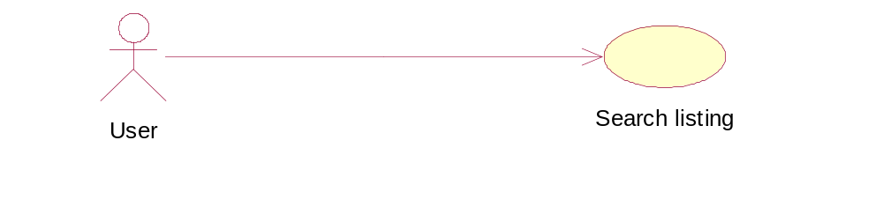
Figure 4: Search listing
User Case ID | mTravelling_UC_1.2
Name | Search listing
Goal | Search item in the list of categories such as: banks, hotels, places, ATMs, Restaurants, Airport, Cab& Taxi, Gas stations.
Actors | User
Include | N/A
Extended | N/A
Pre-conditions | Must have Android Mobile and mTravelling app
Post-conditions | N/A
Main Flow | 1. Type item which user need such as: banks, hotels, places, ATMs, Restaurants, Airport, Cab& Taxi, Gas stations.  3. Select item in search result list. | 2. Show result in list.
Exception | N/A
Open Issues | N/A

Detail location
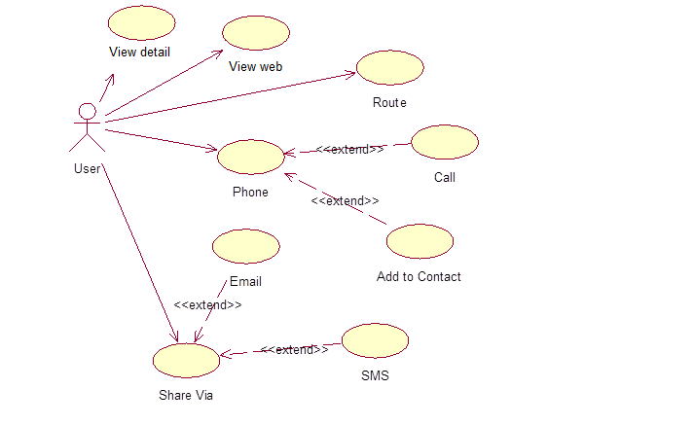
Figure 5: Detail location

View detail _ mTravelling_UC_2.1
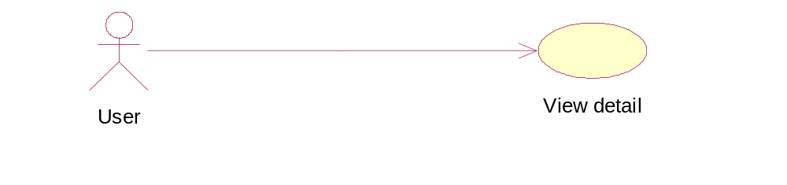
Figure 6: View detail
User Case ID | mTravelling_UC_2.1
Name | View detail
Goal | User wants to view detail target location
Actors | User
Pre-conditions | Connecting internet
Post-conditions | Success: User can view detail target location
Main Flow | - User clicks on detail view. | 2. Display detail location and 4 buttons: View web, Phone, Route, Share Via.
Exception | N/A
Open Issues | N/A

View web _ mTravelling_UC_2.2
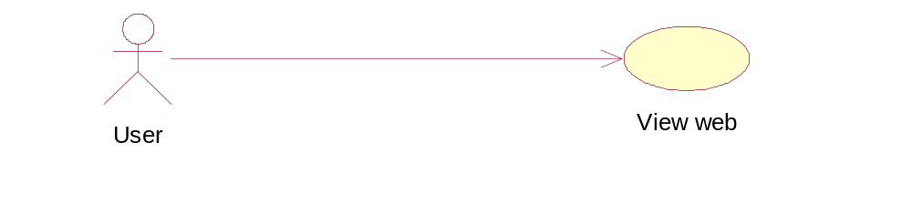
Figure 7: View web
User Case ID | mTravelling_UC_2.2
Name | View web
Goal | User wants to view website of location
Actors | User
Pre-conditions | Connecting internet
Post-conditions | Success: User can view website of location
Main Flow | - User clicks on “View web” button. | 2. Redirect to website of location.
Exception | N/A
Open Issues | N/A

Route _ mTravelling_UC_2.3
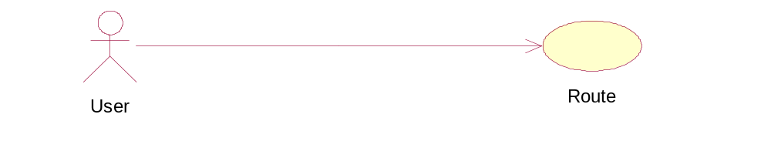
Figure 8: Route
User Case ID | mTravelling_UC_2.3
Name | Route
Goal | User wants to view direction of location on map
Actors | User
Pre-conditions | Connecting internet
Post-conditions | Success: User can view direction of location on map
Main Flow | - User clicks on “Route”. | - Show direction of location on map.
Exception | N/A
Open Issues | N/A

Phone_ mTravelling_UC_2.4
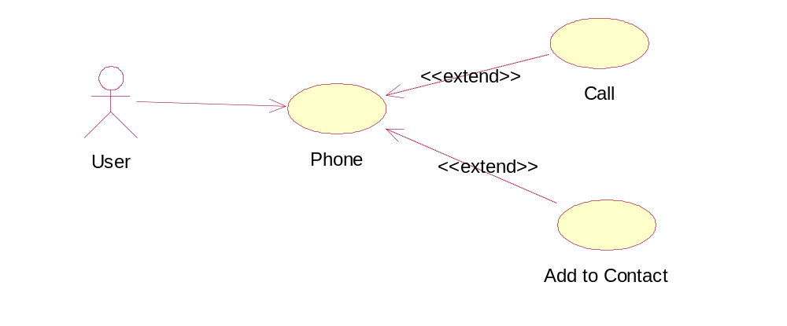
Figure 9: Phone
User Case ID | mTravelling_UC_2.4
Name | Phone
Goal | User wants to call or add phone to contact
Actors | User
Pre-conditions | Connecting internet
Post-conditions | Success: User can call or add phone to contact
Main Flow | - User clicks on “Phone” button  - If user clicks on Call  - If user clicks on Add to Contact  e. If user click on Cancel | 2. Show dialog 3 buttons: Call, Add to contact, Cancel.  b. Redirect to service of call  d. Add phone of location to user contact  f. Exit dialog
Exception | N/A
Open Issues | N/A

Share via _ mTravelling_UC_2.5
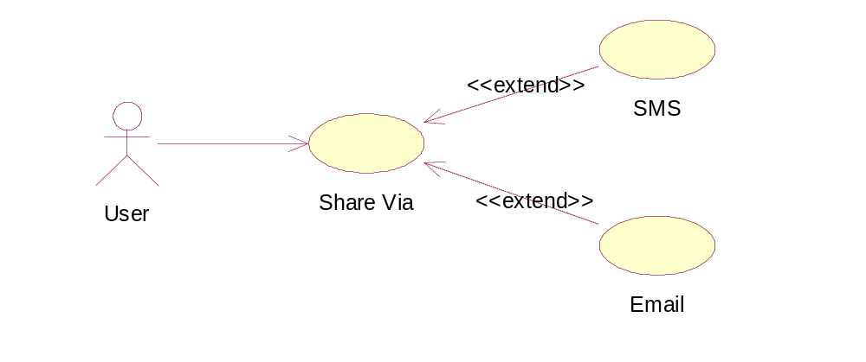
Figure 10: Share via SMS or Email
User Case ID | mTravelling_UC_2.5
Name | Share Via
Goal | User wants to share via information SMS or email
Actors | User
Pre-conditions | Connecting internet
Post-conditions | Success: User can share information via by SMS or email
Main Flow | 1. User clicks on Share Via  a. If user clicks on SMS  - If user clicks on Email  - If user clicks on Cancel | 2. Show dialog 3 buttons: SMS, Email, Cancel.  b. Redirect to service of SMS  - Redirect to service of Email  - Exit dialog
Exception | N/A
Open Issues | N/A

My Favourites
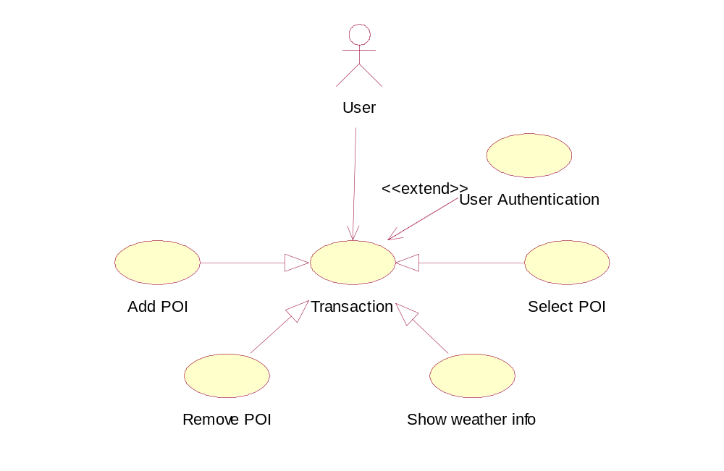
Figure 11: My Favourites

Add POI _ mTravelling_UC_3.1
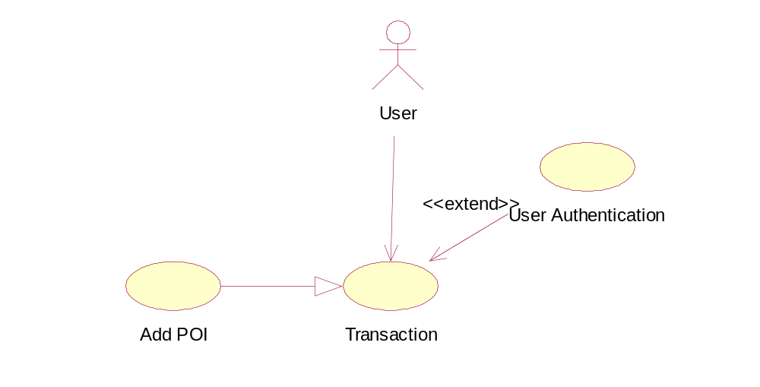
Figure 12: Add POI
User Case ID | mTravelling_UC_3.1
Name | Add POI
Goal | User wants to add the point of interest to the list POIs
Actors | User
Pre-conditions | - Connected to the internet.  - Searched the place that user wants to come and showed the details of that place.
Post-conditions | User will receive a notification and confirmation button.
Main Flow | - Click the button “Add POI” on the details list. | 2. Add to the list POIs.
Exception | N/A
Open Issues | N/A

Remove POI _ mTravelling_UC_3.2
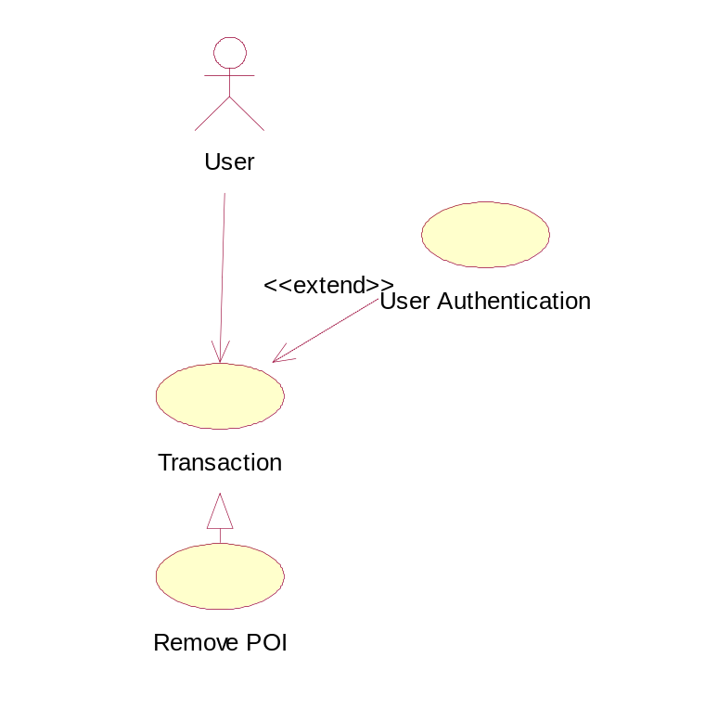
Figure 13: Remove POI
User Case ID | mTravelling_UC_3.2
Name | Remove POI
Goal | User wants to remove the point of interest from the list POIs.
Actors | User
Pre-conditions | The list of POIs consists of one or more the added place.
Post-conditions | User will receive a notification and confirmation button.
Main Flow | - Click on the button “My favourites” tab.  3. Choose POIs.  4. Click on the button “Remove”. | 2. Display the list of the POIs.  5. Remove the POI.
Exception | N/A
Open Issues | N/A

Select POI _ mTravelling_UC_3.3
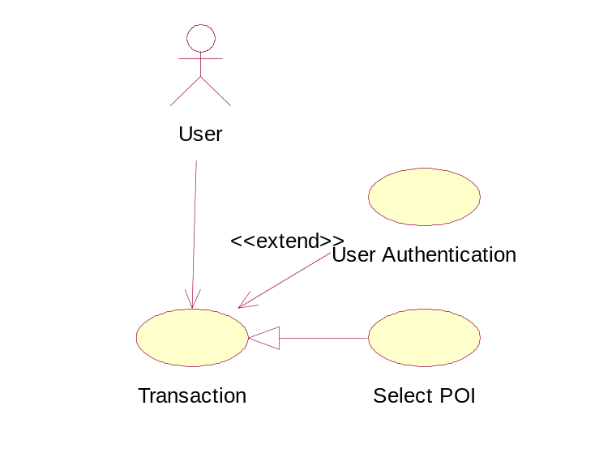
Figure 14: Select POI
User Case ID | mTravelling_UC_3.3
Name | Select POI
Goal | User wants to select the point of interest from the list POIs
Actors | User
Pre-conditions | The list of POIs consists of one or more the added place.
Post-conditions | Show the POI on the map.
Main Flow | - Click on the button “My favourites” tab.  - Choose POIs.  4. Click on the button “Select POI”. | 2. Display the list of the POIs.  5. POI’ll be showed on map.
Exception | N/A
Open Issues | N/A

Show the weather information _ mTravelling_UC_3.4
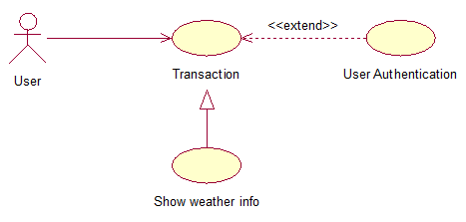
Figure 15: Show the weather information
User Case ID | mTravelling_UC_3.3
Name | Show the weather information
Goal | User wants to know the weather condition and temperature at the area.
Actors | User
Pre-conditions | N/A
Post-conditions | Show the weather information on the map.
Main Flow | 1. Click on the button “Weather info”. | 2. Display the weather information on the table.
Exception | N/A
Open Issues | N/A

Search and change location
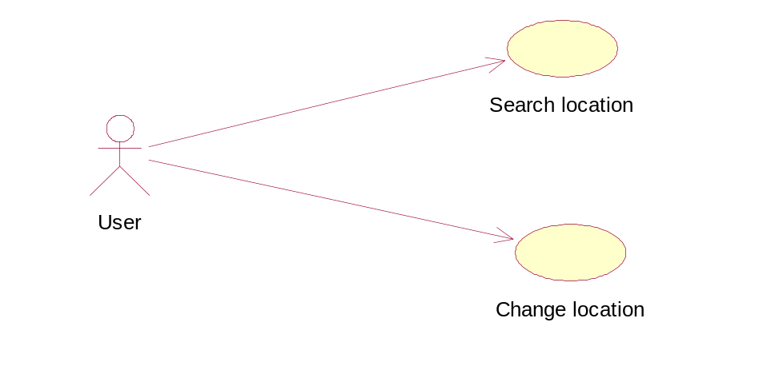
Figure 16: Search and change location

Search location_mTravelling_UC_4.1
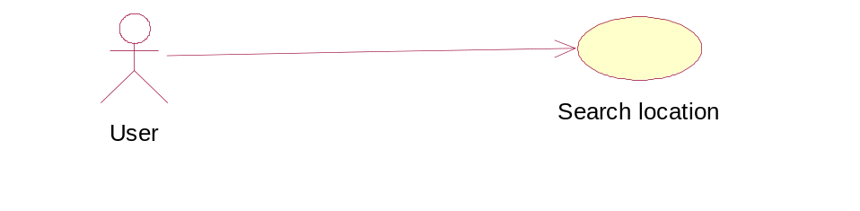
Figure 17: Search location
User Case ID | mTravelling_UC_4.1
Name | Search location
Goal | Search location information on map.
Actors | User
Include | N/A
Extended | N/A
Pre-conditions | Must have Android Mobile and mTravelling app
Post-conditions | N/A
Main Flow | - Select “Search and change location” tab.  2. Select “Search and change location” tab.  4. Type information of location which wants to search. | 3. Show pop up search location.  5. Show result.
Exception | N/A
Open Issues | N/A

Change location _ mTravelling_UC_4.2
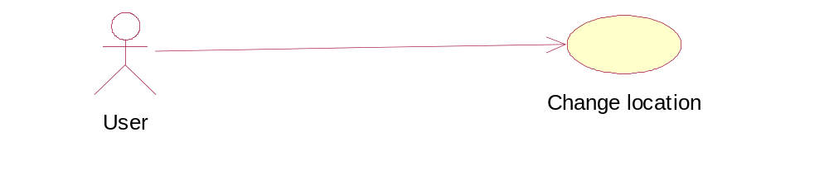
Figure 18: Change location
User Case ID | mTravelling_UC_4.2
Name | Change location
Goal | Change location information such as: banks, hotels, places, ATMs, Restaurants, Airport, Cab& Taxi, Gas station.
Actors | User
Include | N/A
Extended | N/A
Pre-conditions | Must have Android Mobile and mTravelling app
Post-conditions | N/A
Main Flow | 1. Select “Search and change location” tab.  3. Show pop up of change location.  5. Choose “change” button. | 2. Choose “Change location” button.  - Type location which want to change into textbox.  - Show result change location successful.
Exception | N/A
Open Issues | N/A

Map View
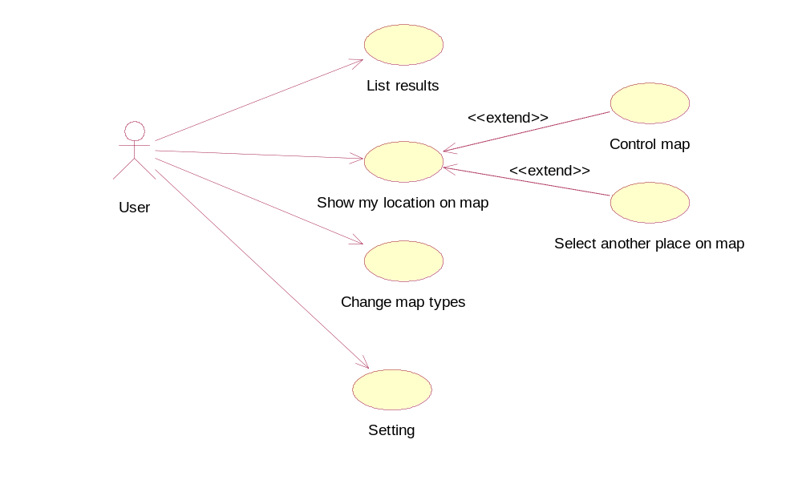
Figure 19: Map View

List results _ mTravelling_UC_5.1
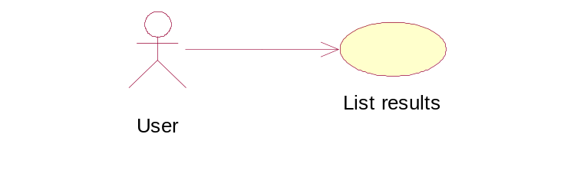
Figure 20: List results
User Case ID | mTravelling_UC_5.1
Name | List results
Goal | List all results of the category has chosen near user’s location.
Actors | User
Include | N/A
Extended | N/A
Pre-conditions | User must choose one category on list categories
Post-conditions | N/A
Main Flow | 1. Select one item in list categories.  3. Select one of all results in list | 2. Display all results near user’s location.
Exception | N/A
Open Issues | N/A

Show my location on map _ mTravelling_UC_5.2
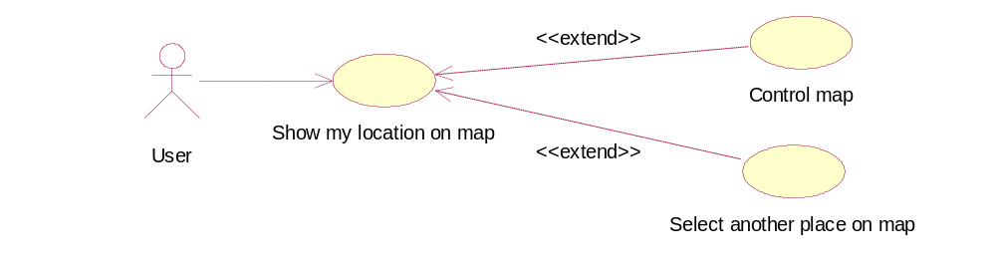
Figure 21: Show my location on map
User Case ID | mTravelling_UC_5.2
Name | Show my location on map
Goal | Show user’s location on map
Actors | User
Include | N/A
Extended | Control map  Select another place on map
Pre-conditions | N/A
Post-conditions | N/A
Main Flow | 1. Select “show my location” button.  3.Zoom map, rotate map  5.Tap another place on map | 2. Display user’s location on the map and places near this location.  4. Map zoom, map rotate  6. Display name of this location on the map and places near there.
Exception | N/A
Open Issues | N/A

Change map types _ mTravelling_UC_5.3
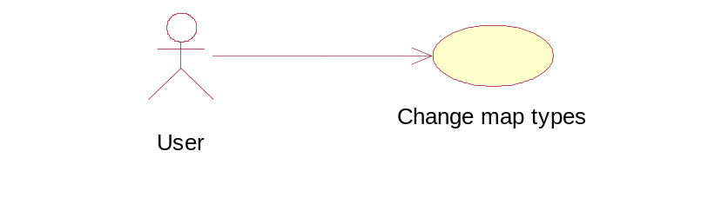
Figure 22: Change map types
User Case ID | mTravelling_UC_5.3
Name | Change map types
Goal | Change the map type of map such as: “Satellite, Terrain, Normal”
Actors | User
Include | N/A
Extended | N/A
Pre-conditions | User must on viewing map mode
Post-conditions | N/A
Main Flow | 1. Select “map types” button  3. Select one map type on the list | 2. Display list map types : “Satellite, Terrain, Normal”  - Map change type view.
Exception | N/A
Open Issues | N/A

Setting _ mTravelling_UC_5.4
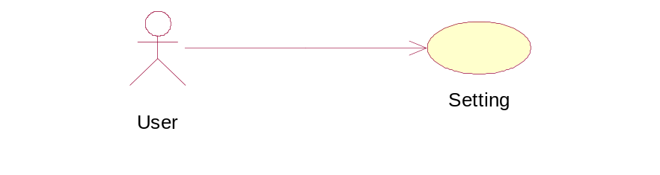
Figure 23: Setting
User Case ID | mTravelling_UC_5.4
Name | Setting
Goal | Configure setting allows distance and change temperature unit
Actors | User
Include | N/A
Extended | N/A
Pre-conditions | N/A
Post-conditions | N/A
Main Flow | 1. Select “Setting” button  3.Select temperature unit (Fahrenheit Or Celsius)  4.Check/uncheck on distance checkbox  5.Tap “OK” button | 2. Display setting activity.  6. Successful change
Exception | N/A
Open Issues | N/A

Non-Functional Requirements

Usability
The application users are assumed to have very basic knowledge at using android mobile or smart phone.
The mTravelling application shall have clear and easy to use interface so that system users have to spend no more than 5 minutes learning to use the app.
The mTravelling application shall allow users to find location information of banks, hotels, places, ATMs, Restaurants, Airport, Cab& Taxi, Gas stations.
The mTravelling application shall allow users to share location information to SMS or email easily.

Reliability
The application can be used like “always on” in android mobile.
There is no requirement for system maintenance task from the user.
Mean Time Between Failures (MTBF): more than 6 months.
Mean Time To Repair (MTTR): less than 24 hours.
Accuracy: 100%
Maximum Bugs and Defect Rate: 0.3 bugs per thousand lines of code (0.3 bugs/KLOC).
Critical bugs:
+ loss of all data: not any
+ unable to use part of the system’s functionality: not any

Performance
Response time for a search:
+ average: 100 millisecond/search
+ maximum: 250 millisecond/search
Memory process:
+ 256kb of RAM
Space:
+ 10mb of memory

Supportability
3 years working hour phone call technical support:
+ 5:00 to 17:00 (local time) every day, from Monday to Friday every week.

Interface Requirements
<Introduction/description>
No. | Interface Process Name | Import / Export | Functional Affected | Purpose | Frequency

Security Requirements
None

Reports and Form templates Requirements
None

Reports
<Introduction/description>

<Functional Name 1> Reports

No. | Report Name | Usage | Description | Input Parameter(s) | Frequency

Form Templates
<Introduction/description>

<Functional Name 1> Forms
No. | Form Name | Usage | Description

Other
<Introduction/description>

<Feature 1>

<Feature 2>

Conclusion
None.

---------- End of Document ----------

