Software Requirement Specification

Version 1.0

Business Unit:
Issue Date:
Issue Status:
Author:
Location:
Confidential Class:
Reviewer information:
Approver information: | <Approver> | <Role>

- Contents
2 Introduction 3
2.1 Overview 3
2.2 Scope 3
2.3 Assumptions 3
2.4 References 3
3 Deliverables 3
4 Functional Requirements 4
4.1 Feature/Component #1 :Start Screen 4
4.1.1 User Interfaces 4
4.1.2 Functional Requirements 4
4.2 Feature/Component #2: Video Screen Displays Information of videos Tab 5
4.2.1 User Interfaces 5
4.2.2 Functional Requirements 6
4.3 Feature/Component #3: Video Screen Displays Relative videos Tab 7
4.3.1 User Interfaces 7
4.3.2 Functional Requirements 7
4.4 Feature/Component #4: Video Screen Displays Comments Tab 8
4.4.1 User Interfaces 8
4.4.2 Functional Requirements 8
4.5 Feature/Component #5: Search Screen. 9
4.5.1 User Interfaces 9
4.5.2 Functional Requirements 9
4.6 Feature/Component #6: Login Screen. 10
4.6.1 User Interfaces 10
4.6.2 Functional Requirements 10
5 Revision History 11

Introduction

Overview
This application allows users view video by connect to YouTube. Beside, users can comment, like on the video, or save the video on sdcard.

Scope
- Android
- Android OS: 2.1, 2.2, 2.3

Assumptions
- YouTube Apis and Tools are available

References

 | Title | Author | Date | Version
1.
2.

Deliverables
- Binary application files
- Software design documents
- Source code
- Release notes
- Test reports

Functional Requirements

Feature/Component #1 :Start Screen

User Interfaces
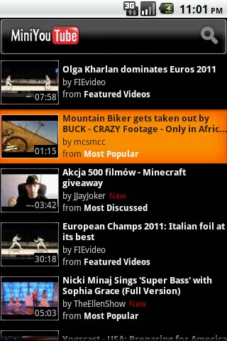

Functional Requirements

Current screen | Description | Action | Next screen
Start screen | Display the list of latest videos. Users can scroll to view others videos.  The number of suggestion items is 40.  If the user scroll over 40, the application will automatically retrieve next 40 suggestion items. | Tap a video to view. | Video screen.
 |  | Tap on seach icon to display seach text field and bring keyboard up. | Search screen

Feature/Component #2: Video Screen Displays Information of videos Tab

User Interfaces
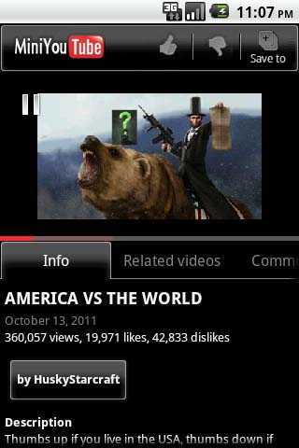

Functional Requirements

Current screen | Description | Action | Next screen
Màn hình xem video | Display the video that users chose in Start screen.  Under the video, application displays options for users to see info of this video, related videos, or comments. | Tap on MiniYouTube icon | Start screen
 |  | Tap on video | Pause video
 |  | Tap on “like” icon to like video
 |  | Tap on “dislike” icon to dislike video
 |  | Tap on Save icon to save the video on sdcard\video\MiniYouTube\
 |  | Tap on info tap | info of video screen.
 |  | Tap on related video tab | related video screen.
 |  | Tap on comments tab | Comments screen.

Feature/Component #3: Video Screen Displays Relative videos Tab

User Interfaces
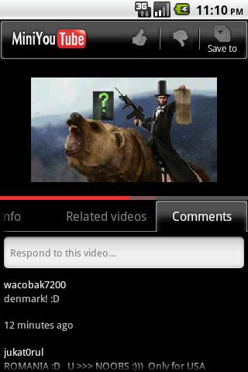

Functional Requirements

Current screen | Description | Action | Next screen
Related videos tab | Display the list of videos that related to the current video  The number of suggestion items is 10.  If the user scroll over 10, the application will automatically retrieve next 10 suggestion items. | Tap a video to view. | Video screen.

Feature/Component #4: Video Screen Displays Comments Tab

User Interfaces

Functional Requirements

Current screen | Description | Action | Next screen
Comments tab | Display comments of the video and the Text field for users comment, If users signed in.Or not, It will display login screen.  The number of the comments is 10.  If the user scroll over 10, the application will automatically retrieve next 10 comments. | Focus on comment text field, and User hasn’t signed in. | Login screen.
 |  | Focus on comment text field, and User signed in. | Display keyboard for users comment.

Feature/Component #5: Search Screen.

User Interfaces
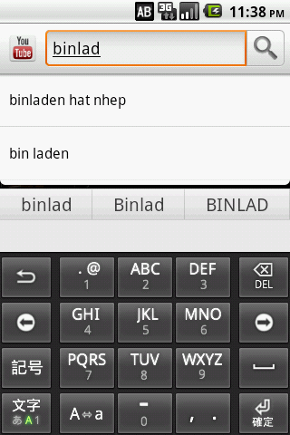

Functional Requirements

Current screen | Description | Action | Next screen
Search Screen. | Display the text field and keyboard for users enter words related to the video that they want to search.  When the users enter 6 characters, the application will find automatically 2 contents related to the word(s) that pressed.  Max length of searching text field is 20. | Tap on search icon | Start screen with videos related to searching contents.
 |  | Tap on contents that application suggested. | Start screen with videos related to suggested contents.

Feature/Component #6: Login Screen.

User Interfaces
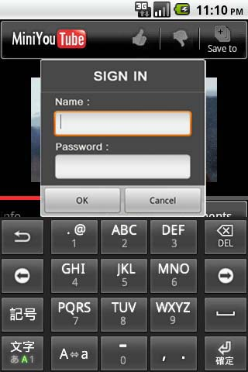

Functional Requirements

 | Current screen | Description |  | Action |  | Next screen
 | Login Screen. | Focus on Name or Password, bring the keyboard up for user to enter. |  | Tap on OK button |  | The screen that application calls Login Screen.
 |  |  |  | Tap on Cancel button. |  | The screen that application calls Login Screen.
Message ID |  |  | Messages |  | Description
Msg001 |  |  | The username or password you entered is incorrect. Please try again |  | Display when User enter wrong username or password.
Msg002 |  |  | Saved video successfully. |  | Display when User saved the video successfully.
Msg003 |  |  | Saved video unsuccessfully. |  | Display when User saved the video unsuccessfully.

Revision History
Date | Version | Description | Revised by
Oct 11,2011 | 1.0 | First version | Tran Hong Ngoc  Pham Quoc Trung
Oct 18, 2011 |  | - Start Screen  - Video Screen Displays information of videos Tab  - Video Screen Displays Relative videos Tab  - Video Screen Displays Comments Tab | Tran Hong Ngoc  Pham Quoc Trung
Oct 23, 2011 |  | - Search Screen  - Login Screen | Tran Hong Ngoc  Pham Quoc Trung

---------- End of Document ----------

