Assignment 1 - Sell Near Expired Foods (SNEF)

1 - Usecase diagram

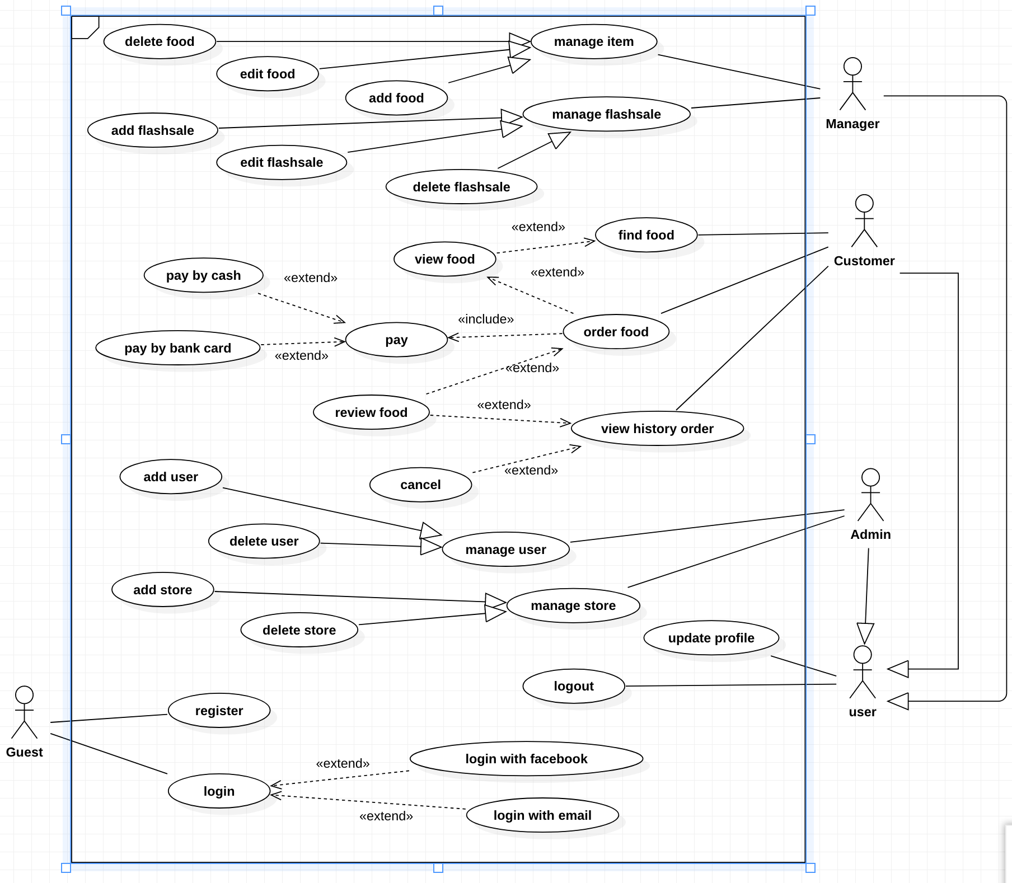

2. Use case detail - Add Food

|  |  |  |  |
| --- | --- | --- | --- |
| USE CASE -A1 | | | |
| Use Case No. | A1 | Use Case Version | 1.0 |
| Use Case Name | Add Food |  |  |
| Author | Vo Hoang Tuan |  |  |
| Date | 03-10-2019 |  |  |
| Actor:  - Manager  Summary:  - This use case allows managers add food into system.  Goal:  - New food will update into the system.  Triggers:  -Manager clicks on “add” button.  Preconditions:  -User must login to system with manager role.  Post Conditions:  - Success: new food will be added into the system.  - Fail: Show error message.  Main Success Scenario: | | | |
| Step | Actor Action | System Respornse | |
| 1 | Manager clicks on “add” button and goes to add view | System requires information from manager  -Name: Free text input, required, length 5-30.  -Price: Free text input, required, length 5-250.  -Quantity: Free text input, required, length 5-250.  -DateOfManufacture: Free text input, required, length 5-250.  -ExpiryDate: Free text input, require, length 5-250  -KindOfFood: Free text input, required, length 5-250. | |
| 2 | Manager inputs food information |  | |
| 3 | Manager clicks on “finish” button to add new food. | System validates information, display food details and request for confirmation. | |
| 4 | Manager clicks on “OK” button to confirm. | Add new food into the system and show successful message. | |
| Alternative Scenario: N/A | | | |
| Exceptions: | | | |
| Step | Actor Action | System Respornse | |
| 1 | Manager clicks on “finish” button without input data. | System shows errors message and ask manager input missing required field. | |
| 2 | Network problem. | System shows error message: “Please check your connection.” | |
| 3 | If manager inputs foods that is existed in the system. | Show message to notify manager that the food is existed in the system. | |
| Relationships: N/A  Business Rule:  -New food will be added into the system with inputed information.  -System must ensure has no duplicated food.  -Expiry date must be later than manufacture date and current date.  -Manufacture date must be earlier than current date.  -Quantity and price must be greater than 0. | | | |

3. Usecase Detail - Find Food

|  |  |  |  |
| --- | --- | --- | --- |
| USE CASE -001 | | | |
| Use Case No. | A2 | Use Case Version | 1.0 |
| Use Case Name | Find Food |  |  |
| Author | TuanVH |  |  |
| Date | 03-10-2019 |  |  |
| Actor:  - Customer  Summary:  - This use case allows customers find out food they want.  Goal:  - Customer can see foods according to their input.  Triggers:  - Customer clicks “search” button.  Preconditions:  - User must login with customer role.  Post Conditions:  - Success:Customer can see foods according to their input.  - Fail: Show error message.  Main Success Scenario: | | | |
| Step | Actor Action | System Respornse | |
| 1 | Customer go to search view | System requires flash sale/food information from customer | |
| 2 | Customer input flash sale/food info |  | |
| 3 | Customer clicks on “search” button. | System validates information, display flash sale/food details | |
| Alternative Scenario: | | | |
| Step | Actor Action | System Respornse | |
| 1 | Customer choose direct flash sale/ food on app interface. | Show flash sale/food information. | |
| Exceptions: | | | |
| Step | Actor Action | System Respornse | |
| 1 | Network problem. | System shows error message: “Please check your connection.” | |
| 2 | Customer clicks on “search” button without input data. | System asks manager input missing required field. | |
| Relationships: N/A  Business Rule:  -System must show food/flash sale details with the input from user. | | | |

4. Class diagram

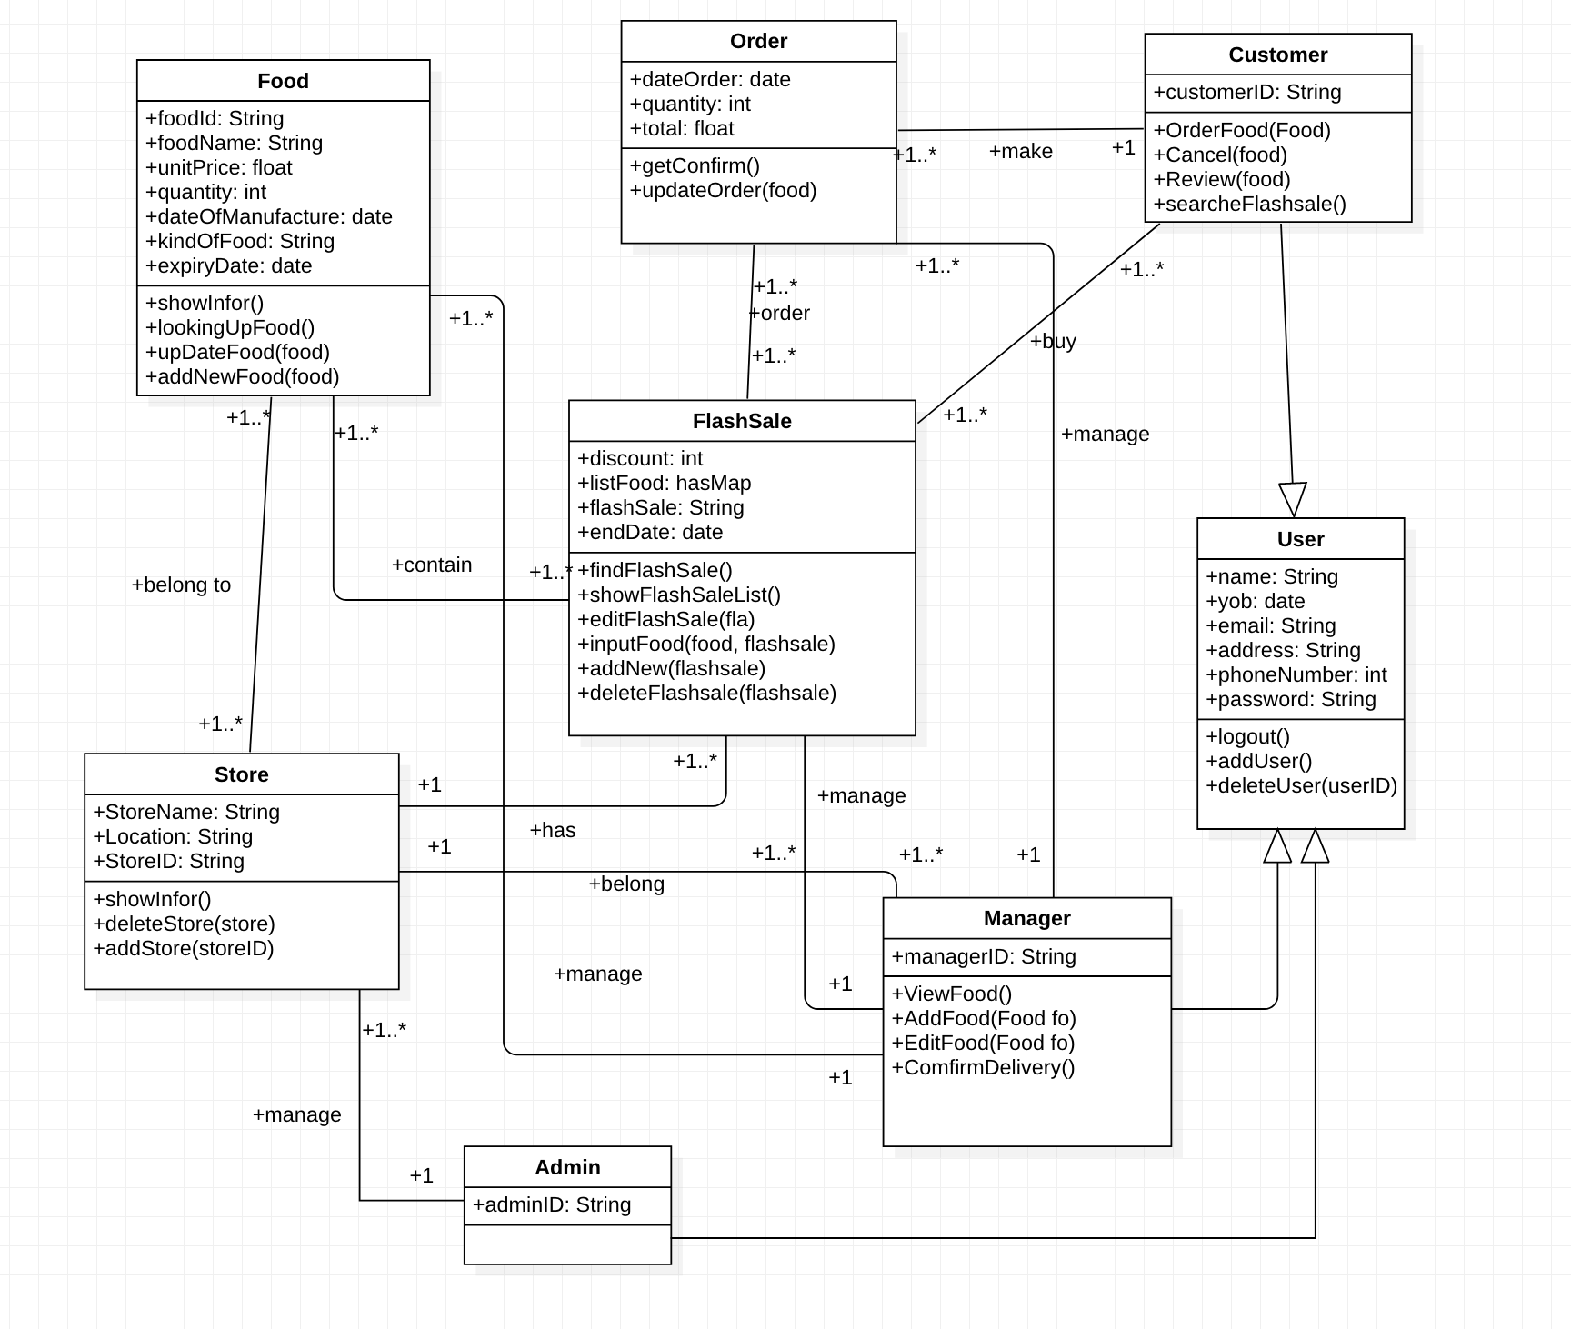

5 . Sequence diagram - Delete User

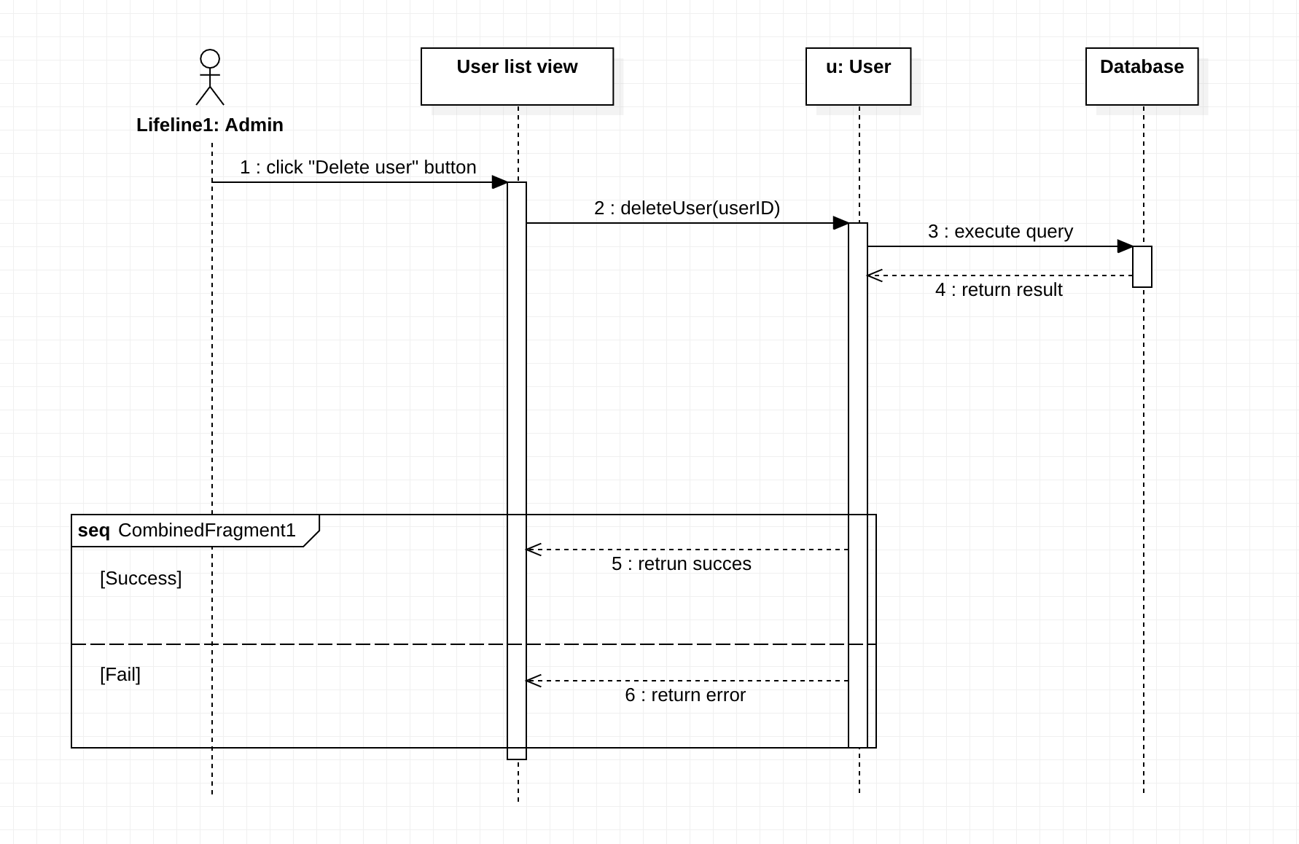

6. Sequence diagram - Add flash sale

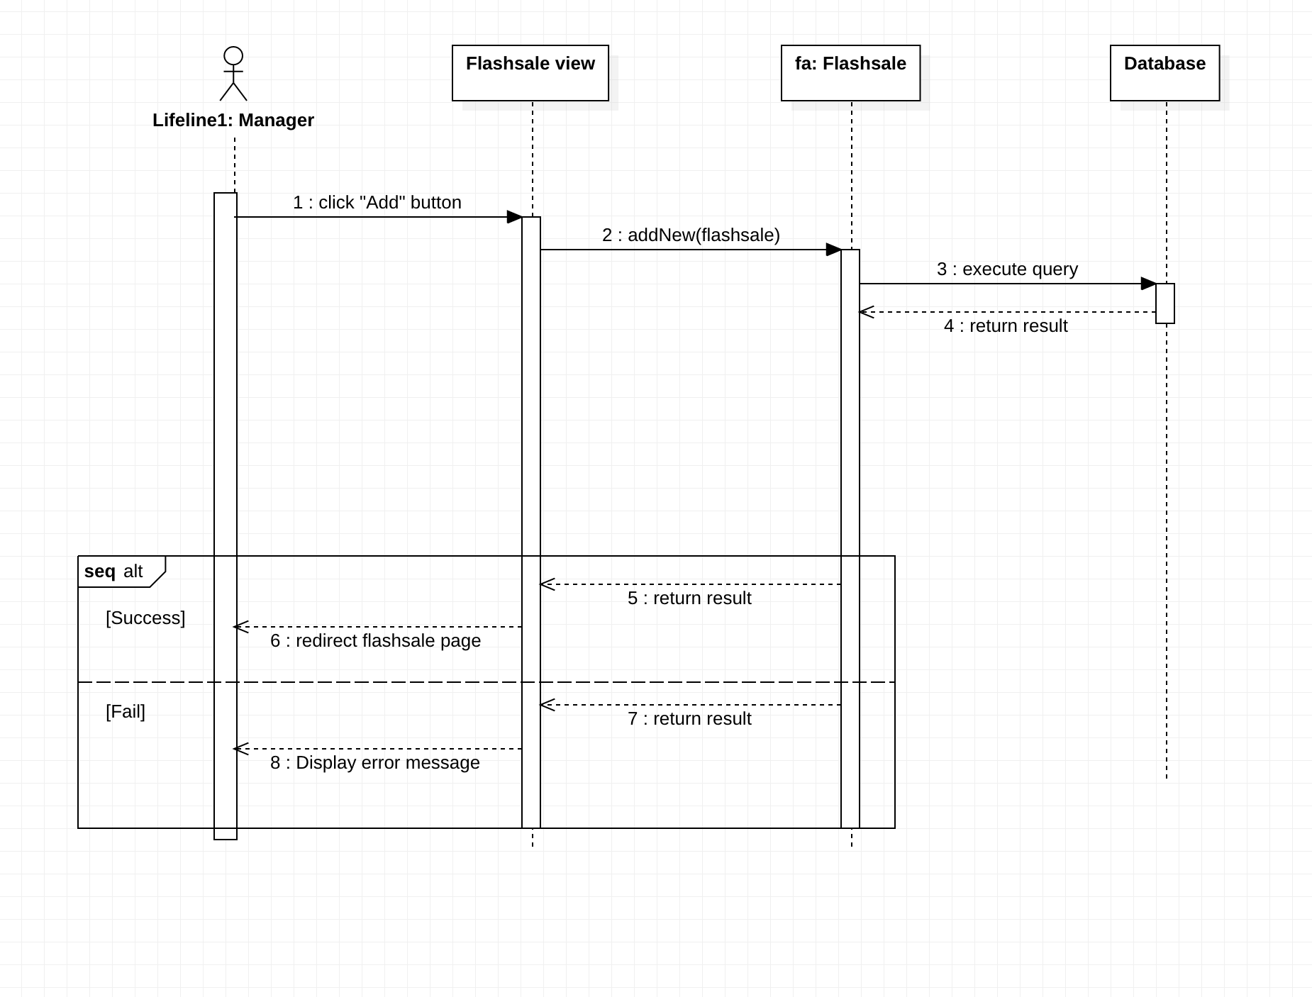

7. Sequence diagram - Delete Flash sale

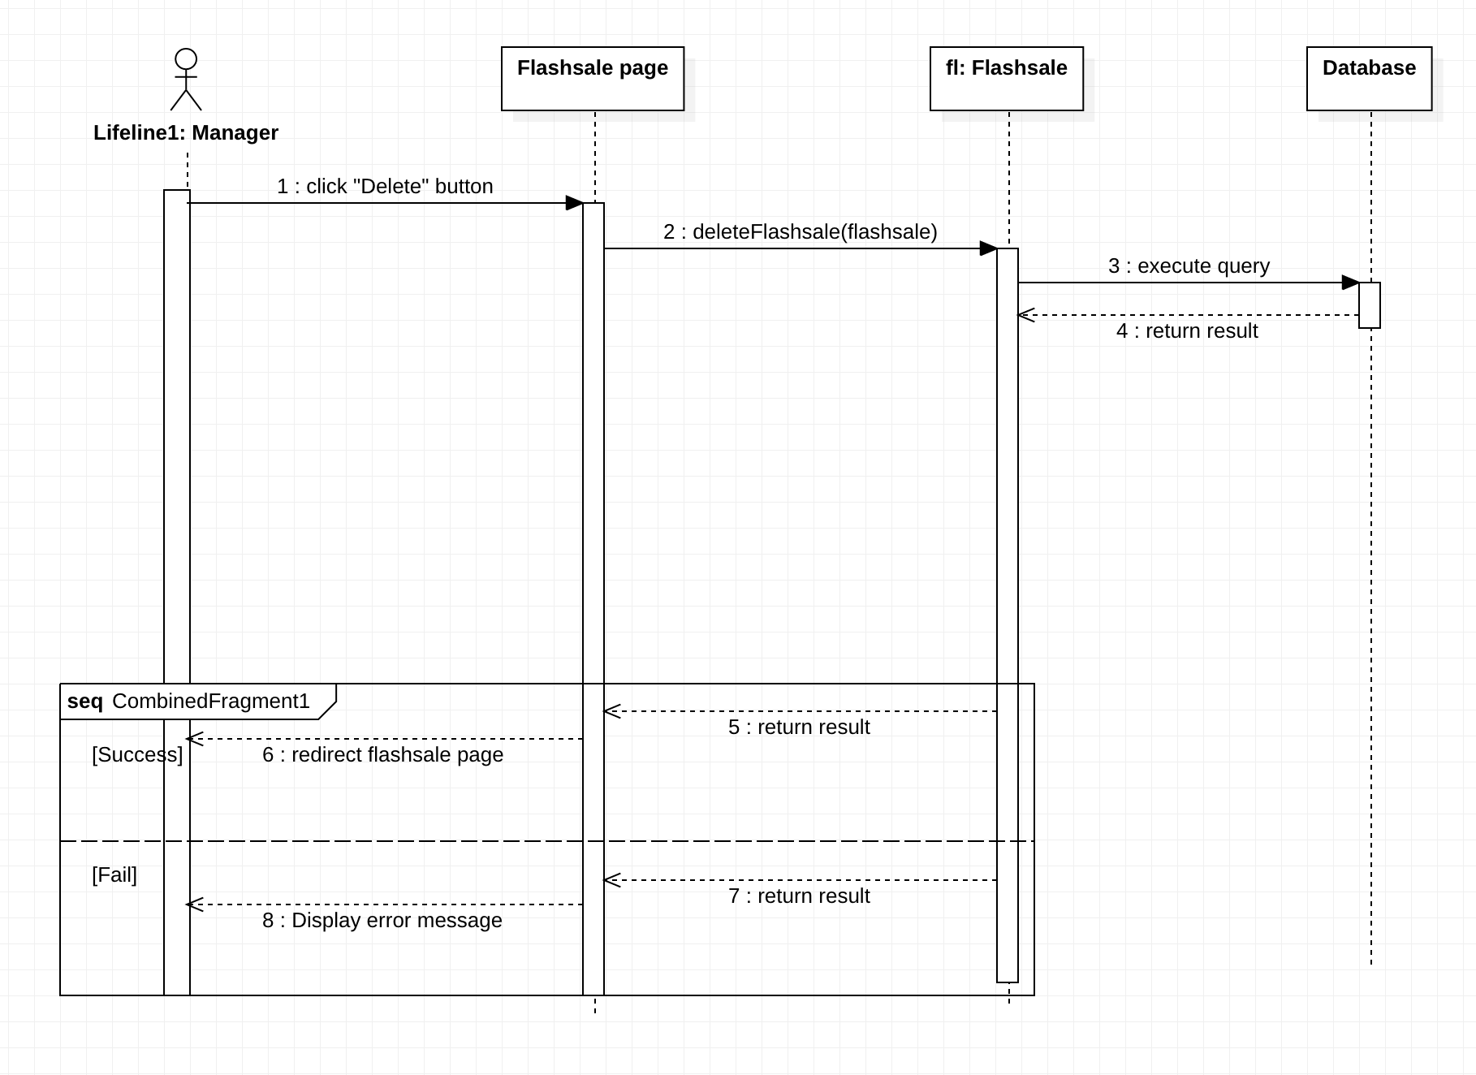

8. Statemachine diagram - Food

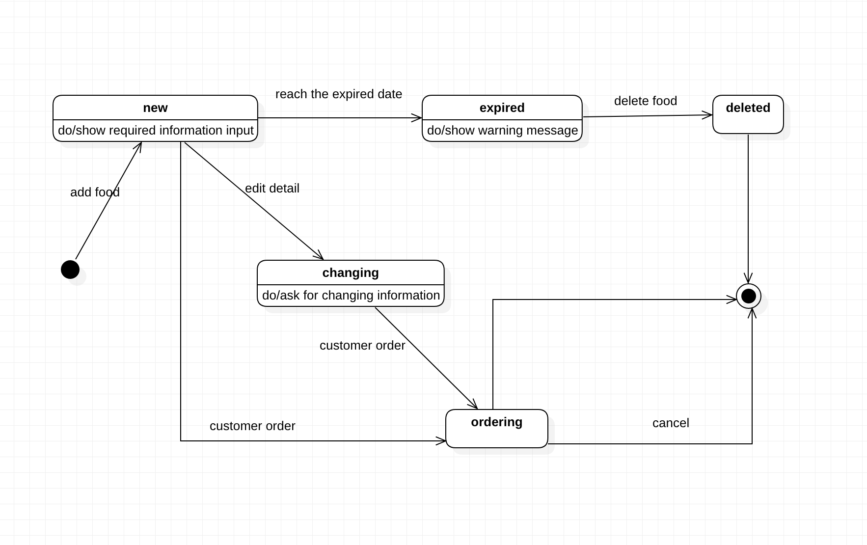

9. Statemachine diagram - Order

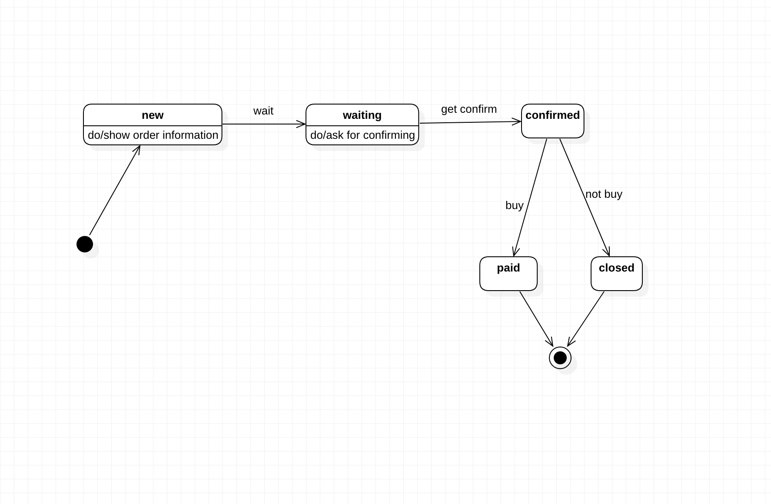

10. Database

