Reproducible Computational Drosophila Locomotion Phenotype Framework
Milestone F | Final Submission Package
Canonical manuscript source: docs/report/final_report.md
Source commit: 004488cf7fd5e980137a209d360b977716865e1a
Scope: Computational and phenomenological model only
Evidence status: E6 frozen evidence synthesis
PARTIAL_PHENOTYPE_CONCORDANCE remains qualitative; this package does not claim Parkinson's disease validation.

Contents
Reproducible Computational Drosophila Locomotion Phenotype Framework
Abstract
1. Introduction
2. Methods
3. Results
4. Discussion
5. Limitations
6. Reproducibility
7. Conclusion
References
Appendix A. Frozen evidence chain
Appendix B. Reproduction commands
Appendix C. Evidence traceability

Abstract

Motivation
Locomotor output provides a compact computational readout for studying how controlled changes in a Drosophila simulation alter movement, coordination, and body-state metrics. This work establishes a staged evidence framework in which software state, simulation behavior, response surfaces, robustness, qualitative literature comparison, and reversibility are kept separate.

Approach
The workflow used NeuroMechFly with FlyGym and MuJoCo to establish an unperturbed flat-ground locomotion baseline. Two phenomenological computational proxies were then applied through explicit interfaces: global scaling of joint-angle commands and scaling of CPG inter-leg coupling. Response surfaces were measured in controlled paired conditions, followed by a fixed combined candidate, five-seed validation, a qualitative adult walking comparison, and a preregistered computational reversibility experiment. An evidence-only synthesis validated the frozen reports, provenance, and generated artifacts.

Findings
The unperturbed baseline used a 0.5 s simulation with a 0.0001 s timestep and 5000 steps. It produced 6.284186050286936 mm planar displacement, 12.568372100573873 mm/s mean planar speed, and a compiled control dimension of 48, consisting of 42 position and 6 adhesion actuators. Motor-command scaling produced a graded locomotor-output response and exact action-magnitude scaling. CPG coupling reduction had modest intermediate effects and a large output loss and yaw deviation at zero coupling. The frozen computational candidate used motor_scale = 0.8 and coupling_scale = 0.75. Across seeds 0 through 4, its displacement and speed deltas were negative in every paired comparison.
The selected adult walking comparisons were directionally concordant for four speed or distance endpoints, while other endpoints remained incomparable or insufficiently supported. The resulting E4 status is PARTIAL_PHENOTYPE_CONCORDANCE. Computational restoration was more consistent along the motor axis than for coordination-only restoration.

Boundary
These results characterize a reproducible computational phenotype framework. They do not establish a biologically validated Parkinson's disease model, dopamine depletion, neuron loss, disease severity, mechanistic equivalence, biological rescue, or statistical significance. The candidate is frozen for further validation as a computational configuration only.

1. Introduction
This report presents a reproducible computational framework for measuring Drosophila locomotion phenotypes in simulation. Locomotor output is useful here because the configured model exposes movement, directional, action, adhesion, and body-height observables under controlled software conditions. The purpose is to make those observations reproducible before assigning them any biological interpretation.
The framework is staged because a simulation result depends on more than the parameter being studied. Fly construction, joint materialization, actuator compilation, controller timing, world configuration, random seed, observation collection, and metric definitions must be checked separately. The repository therefore treats the unperturbed baseline, controlled perturbations, parameter-response experiments, multi-seed validation, literature comparison, computational reversibility, and evidence synthesis as distinct evidence layers.
The literature layer is deliberately limited to selected adult walking observations already curated in the repository. Riemensperger et al. reported lower walking speed and covered distance in an adult dopamine-deficiency context [1]. Chen et al. reported reduced walking measures in old adult A30P flies, including walking velocity and total moving distance [2]. The current framework compares directions qualitatively; it does not fit simulation parameters to those measurements.
The scope of this report is computational reproducibility and phenotype characterization. It does not define a biological disease condition.

2. Methods

2.1 Software and simulation environment
The frozen simulation evidence was generated in Google Colab with Python 3.12.13, FlyGym 2.1.0, and MuJoCo 3.9.0. The canonical pipeline uses NeuroMechFly, post-materialization joints, FlyGym FlatGroundWorld, Simulation, PreprogrammedSteps, and the official CPG controller source used by the baseline. E6 itself is an evidence-only analysis layer and does not execute FlyGym or MuJoCo.

2.2 Unperturbed locomotion baseline
The unperturbed baseline creates a fresh fly, materializes the required locomotor joints through the canonical gate, adds 42 position actuators and 6 adhesion actuators, creates the flat-ground world and simulation, and records finite observations and derived metrics. The frozen protocol uses a 0.5 s duration, a 0.0001 s timestep, and 5000 simulation steps. Rendering is not required for numerical baseline validation.
Table 1. Canonical computational conditions and parameters.
Condition or analysis | Computational settings | Primary outputs or purpose
Unperturbed baseline | 0.5 s; timestep 0.0001 s; 5000 steps; 42 position actuators; 6 adhesion actuators; nu = 48 | Baseline locomotor output and finite metrics
Motor-vigor response | Global joint-angle command scales 1.00, 0.90, 0.80, 0.70, 0.60 | Displacement, speed, yaw, height, action response
Coordination response | CPG coupling scales 1.00, 0.75, 0.50, 0.25, 0.00 | Displacement, speed, yaw, height, action response
Frozen candidate robustness | motor_scale = 0.8; coupling_scale = 0.75; 1.0 s; seeds 0-4; paired fresh state | Multi-seed displacement, speed, path, efficiency, yaw, height
Computational reversibility | Fixed midpoint restorations; primary endpoints speed and path length | Movement toward the unperturbed computational control

2.3 Controlled perturbation framework
Each paired condition creates a fresh fly, world, and simulation. Seed, duration, timestep, world, spawn, baseline controller, skeleton, actuator architecture, adhesion configuration, and metric definitions are held constant within a comparison. Perturbations are applied through explicit interfaces and recorded in the resulting JSON evidence.
An identity condition verified that the paired pipeline preserves the baseline. The action-scale condition applied a global scale of 0.8 to the 42 joint-angle commands, preserved adhesion commands, and reported a zero command-transform error. This is a software control check, not a biological intervention.

2.4 Motor-vigor computational proxy
The motor-vigor proxy scales the global joint-angle command vector. The E1 response surface sampled scales 1.00, 0.90, 0.80, 0.70, and 0.60. The proxy is a computational action transformation. It is not a calibrated measurement of dopamine, neuron loss, or any biological severity variable.

2.5 Coordination computational proxy
The coordination proxy scales the CPG inter-leg coupling weights. The E1 response surface sampled coupling scales 1.00, 0.75, 0.50, 0.25, and 0.00. This changes controller coordination while leaving global action magnitude largely unchanged in the recorded response. It is likewise a computational proxy rather than a biological mapping.

2.6 Parameter-response analysis
E1 measured displacement, mean speed, yaw change, body height, and action magnitude across each proxy family. E2 evaluated a nine-condition combined matrix containing the unperturbed control, motor-only conditions, coordination- only conditions, and combined conditions. Combined response effects were compared with the corresponding single-proxy responses, with particular care given to nonlinear directional effects.

2.7 Combined candidate selection
The frozen candidate was selected from the E2 response surface before the E3 run. It uses motor_scale = 0.8 and coupling_scale = 0.75. No E3, E4, E5, or E6 step tunes this candidate. It remains a computational candidate for further validation, not a disease designation.

2.8 Multi-seed robustness validation
E3 ran the unperturbed and candidate conditions for seeds [0, 1, 2, 3, 4], using the same seed within each pair, fresh simulation state per condition, and a 1.0 s duration. The candidate transformation, controlled variables, finite observations, and finite derived metrics were checked. The frozen classification ROBUST means computational/software robustness under these tested seeds only.

2.9 Literature-grounded concordance
E4 mapped selected adult walking endpoints to the closest available simulation metrics using direction-only qualitative comparisons. Walking speed and walking velocity were compared with mean planar speed. Covered or total moving distance was compared primarily with planar path length and secondarily with planar displacement. Distance per movement, angular velocity, centrophobism, and body height were not treated as directly validated endpoints. No direct numeric calibration or aggregate disease score was created.

2.10 Computational reversibility experiment
E5 used fixed midpoint restorations from the frozen candidate toward the unperturbed control. Its primary endpoints were mean planar speed and planar path length. The motor partial condition used 0.9/0.75, coordination partial used 0.8/0.875, combined partial used 0.9/0.875, and the full restoration reference used 1.0/1.0. Recovery fractions describe movement toward the computational control in the tested configuration. They are not biological recovery measurements.

2.11 Evidence synthesis and reproducibility
E6 reads exactly eight frozen JSON reports, validates schemas, pass states, provenance, candidate identity, SHA-256 hashes, scientific-boundary wording, and artifact inventory, then generates four figures and five CSV tables. It passed 56 checks. The frozen synthesis records its source commit and the known dirty historical Session 02 notebook in provenance; that notebook was not used as a scientific input and was preserved unchanged.

3. Results

3.1 Unperturbed locomotion baseline
The unperturbed baseline passed its Colab integration checks. It produced 6.284186050286936 mm planar displacement and 12.568372100573873 mm/s mean planar speed. Heading yaw change was 0.2342730946151257 rad. Thorax height was 0.7660532202481788 mm at its minimum, 0.946592192150494 mm on average, and 1.0115140447050612 mm at the final recorded value. Observations and derived metrics were finite.

3.2 Controlled perturbations behaved as specified
The identity comparison passed with zero deltas across the recorded scalar and adhesion metrics. The global action-scale condition transformed the 42 joint-angle commands with scale 0.8 and preserved adhesion commands. Relative to its paired baseline, it changed planar displacement by -0.6714494674507625 mm and mean planar speed by -1.342898934901525 mm/s. The absolute joint-action mean changed by -0.20487402724275616, while adhesion duty-factor deltas were zero. These checks establish controlled software behavior for the later response experiments.

3.3 Motor-vigor and coordination response curves
Motor-command scaling produced a graded decrease in displacement and speed from the scale-1.00 control to the scale-0.60 condition. At scale 0.80, the recorded displacement was 5.612736582836174 mm, mean speed was 11.225473165672348 mm/s, and action absolute mean was 0.8194961089710263. At scale 0.60, displacement was 4.665347652380944 mm and mean speed was 9.330695304761887 mm/s. Action magnitude followed the commanded scaling exactly. Body height changed nonlinearly and yaw was not monotonic.
Coordination reductions had modest intermediate effects. At coupling 0.75, displacement was 6.21723627703009 mm and mean speed was 12.43447255406018 mm/s. At coupling 0.50, displacement was 6.105537853973774 mm and mean speed was 12.211075707947549 mm/s. At zero coupling, displacement fell to 3.405436197366035 mm, mean speed to 6.81087239473207 mm/s, and yaw change rose to 2.2263880793047 rad. Action absolute mean remained 1.0239380323964007 at zero coupling, consistent with the proxy changing coordination rather than global action amplitude.
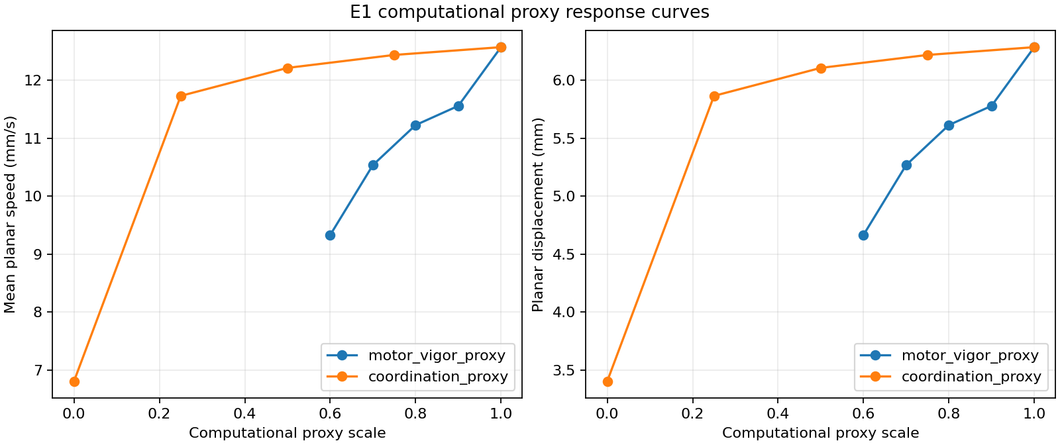
Figure 1. Simulated displacement, speed, yaw, height, and action response across motor-vigor and coordination computational proxy scales. Motor scaling produces a graded locomotor-output response with exact action scaling; coupling reduction is modest at intermediate values and has a large output and yaw effect at zero coupling. These are computational response surfaces, not biological severity curves.

3.4 Combined perturbations and candidate selection
The nine-condition E2 matrix showed that the combined effects on speed and displacement were mostly close to additive. Directional effects were more nonlinear. The combined candidate 0.8/0.75 produced 5.513499489822533 mm displacement, 11.026998979645066 mm/s mean speed, 0.30259921850584254 rad yaw change, and 1.478905964396374 mm mean height. The 0.7/0.75 and 0.7/0.5 conditions produced 5.136531853151933 mm and 5.029479715627041 mm displacement, respectively. The candidate was retained for further validation without assigning it a biological label.
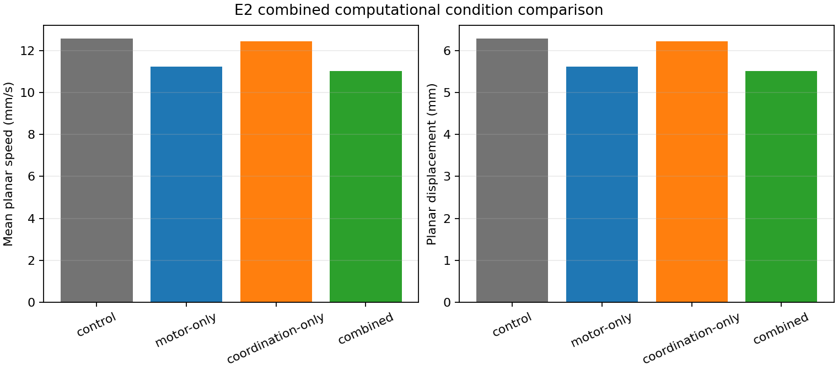
Figure 2. Control, single-proxy, and combined computational conditions. Speed and displacement responses are mostly close to additive, while yaw responses are more nonlinear. The figure does not identify a disease condition.

3.5 Multi-seed robustness
For the frozen candidate, mean displacement was 13.751281674590993 mm in the paired baseline and 12.302040063313584 mm in the candidate, a relative delta of -10.53649998704906%. Mean speed had the same aggregate values and relative delta because the E3 duration was fixed at 1.0 s. Mean path length changed from 19.31485503067457 mm to 17.308442670909542 mm, a relative delta of -10.386359062038664%.
Trajectory efficiency changed from 0.7119806020699851 to 0.7107636180753024, a relative delta of -0.16292589177790413%. Joint action absolute mean changed from 1.0256368082597096 to 0.820559121832831, a relative delta of -19.995156821323032%. Mean body height changed from 0.9465522152698778 mm to 1.4910686043526398 mm, and absolute yaw change changed from 0.10385794490113649 rad to 0.21120580249246884 rad.
All five displacement and speed deltas were negative. Trajectory-efficiency deltas were mixed, absolute-yaw-change delta was positive in four of five seeds, and body height remained an important confound.
Table 2. E3 aggregate robustness summary.
Metric | Baseline mean | Candidate mean | Relative delta
Displacement (mm) | 13.751281674590993 | 12.302040063313584 | -10.53649998704906%
Mean speed (mm/s) | 13.751281674590993 | 12.302040063313584 | -10.53649998704906%
Path length (mm) | 19.31485503067457 | 17.308442670909542 | -10.386359062038664%
Trajectory efficiency | 0.7119806020699851 | 0.7107636180753024 | -0.16292589177790413%
Joint action absolute mean | 1.0256368082597096 | 0.820559121832831 | -19.995156821323032%

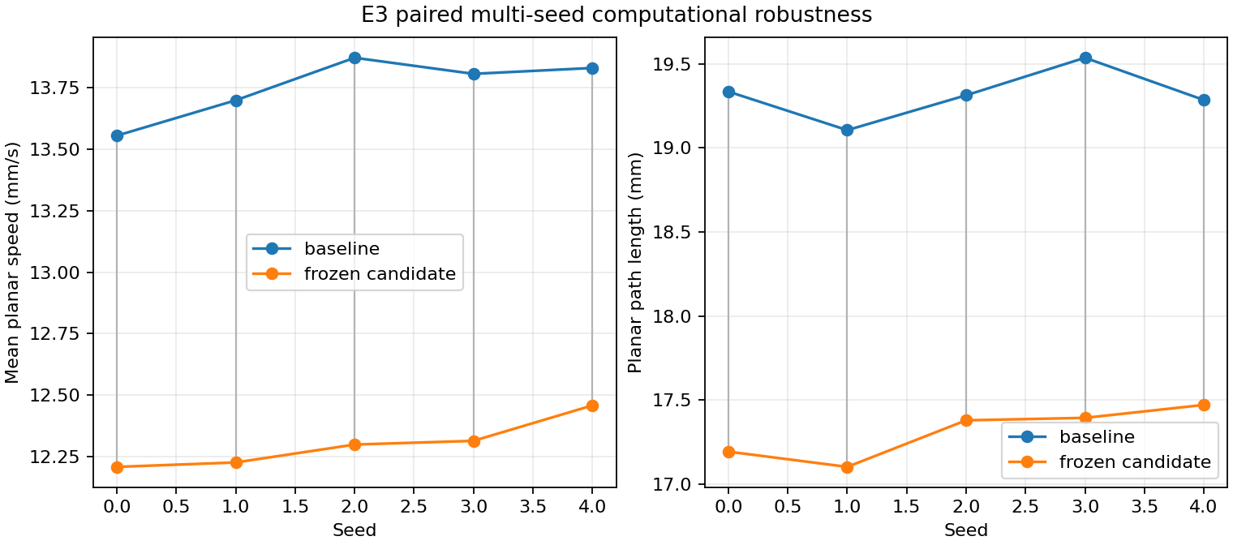
Figure 3. Baseline and frozen-candidate speed and path-length outputs for paired seeds 0 through 4. Each pair shares a seed and each condition uses fresh simulation state. Candidate displacement and speed deltas are negative for all five seeds. ROBUST denotes computational/software robustness under the tested seeds only.

3.6 Qualitative adult walking concordance
E4 classified the comparison as PARTIAL_PHENOTYPE_CONCORDANCE. Four selected adult speed or distance endpoints were directionally concordant, three were not comparable, and one was insufficiently supported. The concordance was direction-only: the simulation candidate's lower speed and distance outputs were compared with the lower directions documented in the selected adult walking evidence. No direct numerical calibration was used.
Table 3. E4 endpoint concordance summary.
Literature endpoint group | Simulation metric | Classification | Interpretation
Walking speed / velocity | Mean planar speed | CONCORDANT | Directionally comparable only
Covered / total moving distance | Path length; displacement supplemental | CONCORDANT | Directionally comparable only
Distance per movement | None | NOT_COMPARABLE | Movement bouts are not segmented
Angular velocity | Yaw change | NOT_COMPARABLE | Yaw change is not angular velocity
Centrophobism | None | NOT_COMPARABLE | Open-field center avoidance is not modeled
Thorax/body height | Body-height mean | INSUFFICIENT_EVIDENCE | No selected matching target

This classification is a literature-grounded qualitative layer, not biological validation.

3.7 Computational reversibility
E5 tested fixed partial returns toward the unperturbed control. Motor partial restoration had speed recovery fraction 0.34260277654496735 and path recovery fraction 0.3769885932181204, with DIRECTIONALLY_RESCUED classification on both primary endpoints. Coordination-only restoration had speed recovery 0.05819831544405736 and path recovery 0.007263689687290947, with MIXED classification. Combined partial restoration had speed recovery 0.36014860249643493 and path recovery 0.35399358544714715, with DIRECTIONALLY_RESCUED classification. The full computational restoration reference reproduced the control configuration and is classified as a reference, not a rescue condition.
Table 4. E5 computational reversibility summary.
Restoration condition | Speed mean | Speed recovery | Path mean | Path recovery | Classification
Motor partial (0.9/0.75) | 12.798554263221726 | 0.34260277654496735 | 18.06483724383281 | 0.3769885932181204 | DIRECTIONALLY_RESCUED
Coordination partial (0.8/0.875) | 12.38638348376136 | 0.05819831544405736 | 17.32301662767562 | 0.007263689687290947 | MIXED
Combined partial (0.9/0.875) | 12.823982404294824 | 0.36014860249643493 | 18.018699776028235 | 0.35399358544714715 | DIRECTIONALLY_RESCUED
Full computational reference (1.0/1.0) | 13.751281674590993 | 1.0 | 19.31485503067457 | 1.0 | REFERENCE

Motor-axis restoration was more consistent than coordination-only restoration for the primary endpoints. These are computational movements toward a control configuration, not biological recovery measurements.
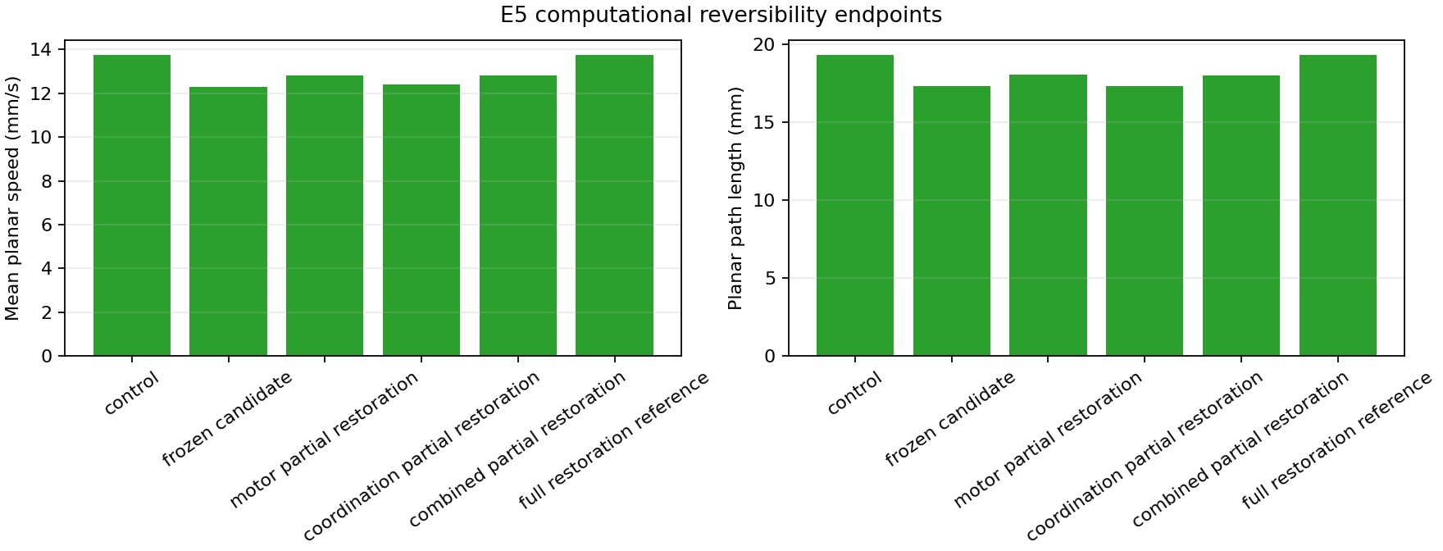
Figure 4. Primary speed and path-length endpoints for the frozen candidate, partial restorations, and full computational restoration reference. Motor and combined restorations move endpoints toward control in the tested conditions; coordination-only restoration is mixed. This is computational reversibility, not biological rescue or treatment response.

3.8 Evidence synthesis
The E6 evidence-only synthesis passed all 56 checks. It represented exactly eight upstream frozen reports, verified their SHA-256 manifest and provenance, and generated four figures and five CSV tables. E4 remained PARTIAL_PHENOTYPE_CONCORDANCE; E5 remained computational reversibility only. No statistical-significance claim was introduced.

4. Discussion

4.1 Supported computational interpretation
The frozen evidence supports three computational observations. First, global scaling of joint-angle commands generated a graded locomotor-output response and changed action magnitude as specified. Second, CPG coupling manipulation generated a distinct coordination and directional response, with modest intermediate effects and a pronounced response at zero coupling. Third, the combined 0.8/0.75 candidate reduced displacement, speed, and path length relative to paired baselines across all five tested seeds.
The response surfaces also show why locomotor output cannot be reduced to one number. Body height changed substantially under motor-command scaling, yaw was nonlinear, and trajectory-efficiency changes were mixed across seeds. These quantities are part of the computational phenotype and constrain simple interpretation of displacement or speed alone.

4.2 Qualitative literature concordance
The selected adult walking evidence records decreased speed or distance in the contexts described by Riemensperger et al. [1] and Chen et al. [2]. The frozen candidate showed decreased simulated speed and distance, so E4 records directional qualitative concordance for those selected endpoints. The explicit status is PARTIAL_PHENOTYPE_CONCORDANCE because distance per movement, angular velocity, centrophobism, and body-height interpretation remain unavailable, non-comparable, or insufficiently supported.

4.3 Computational reversibility and unresolved observations
E5 indicates that fixed computational restoration along the motor axis and the combined axis moved the primary endpoints toward control more consistently than coordination-only restoration. This result is useful for characterizing the software response surface and the separability of the two proxies. It does not identify a biological recovery mechanism.
The large body-height response, nonlinear yaw response, mixed efficiency changes, and differences between net displacement and path length remain important unresolved features. They should be reported alongside locomotor output rather than treated as noise without further study.

4.4 Requirements for future biological validation
Further biological interpretation would require literature-backed definitions of the target fly phenotypes, measurements comparable to the simulation endpoints, a defensible biological interpretation of controller and actuator changes, and a prespecified uncertainty and replication plan. In particular, the project would need to distinguish a computational action transformation from a biological perturbation and to test any proposed mapping against independent experimental evidence.
None of the present results establishes a mechanistically validated Parkinson's disease model.

5. Limitations

5.1 Proxy design and biological scope
The motor-vigor and coordination variables are phenomenological computational proxies. There is no dopamine-level calibration, neuron-loss mapping, or Parkinson's disease severity mapping. No pharmacological or L-DOPA model is implemented. E5 is computational reversibility only and does not establish biological rescue or treatment response. No mechanistic equivalence between a proxy and a biological disease process is claimed.

5.2 Endpoint and model limitations
The metrics are outputs of the configured FlyGym model and controller. Body height changes substantially in some conditions and may confound locomotor interpretation. Yaw change is angular displacement over the run, not angular velocity. The current model does not provide movement-bout distance, centrophobism, negative geotaxis, pause, or freezing endpoints. The selected literature scope is limited to the adult walking evidence curated for E4.

5.3 Robustness and inference limitations
E3 tested five paired seeds for one frozen candidate. The ROBUST classification therefore means computational/software robustness under those tested seeds only. It does not mean biological robustness or statistical significance. The frozen evidence contains no inferential statistical significance claim, and no arbitrary biological threshold was introduced.

5.4 Duration and software dependence
The baseline and validation protocols characterize their specified short simulation durations and do not cover all timescales or environmental conditions. Reproduction depends on the pinned Python 3.12.13, FlyGym 2.1.0, and MuJoCo 3.9.0 stack. Upstream simulation reports require the documented Colab environment, while E6 synthesis is evidence-only and does not require a new simulation.

6. Reproducibility
The repository is the source of truth for reusable code, configurations, frozen evidence, and this manuscript. Google Colab is the execution environment for the upstream FlyGym/MuJoCo reports. The E6 synthesis can be rebuilt with:
python scripts/run_evidence_synthesis.py \
--config configs/analysis/milestone_e6.yaml \
--output results/analysis/milestone_e6_synthesis.json
The E6 report records synthesis commit 53e41d17365f56509ca708ba3352ddf724b0e89a, eight input reports, SHA-256 provenance, 56 passing checks, four figures, and five tables. Detailed stage commands, input commits, artifact paths, and verification commands are in reproducibility.md. Claim-level mappings are in evidence_traceability.md.

7. Conclusion
This work provides a reproducible computational Drosophila locomotion phenotype framework with an unperturbed baseline, explicit perturbation interfaces, response surfaces, multi-seed validation, qualitative adult walking concordance, computational reversibility, and evidence synthesis. The frozen candidate motor_scale = 0.8, coupling_scale = 0.75 is a computational configuration with directionally robust simulated locomotor output under the tested protocol. E4 remains PARTIAL_PHENOTYPE_CONCORDANCE, and E5 remains computational reversibility only. The framework is not a validated Parkinson's disease model, and further biological interpretation requires external evidence.

References
- Riemensperger T, Isabel G, Coulom H, Neuser K, Seugnet L, Kume K, Iche-Torres M, Cassar M, Strauss R, Preat T, Hirsh J, Birman S. Behavioral consequences of dopamine deficiency in the Drosophila central nervous system. Proceedings of the National Academy of Sciences of the United States of America. 2011;108(2):834-839. DOI: 10.1073/pnas.1010930108. PMID: 21187381.
- Chen AY, Wilburn P, Hao X, Tully T. Walking deficits and centrophobism in an alpha-synuclein fly model of Parkinson's disease. Genes, Brain and Behavior. 2014;13(8):812-820. DOI: 10.1111/gbb.12172. PMID: 25113870.

Appendix A. Frozen evidence chain
The frozen evidence chain is:
- Pre-materialization anatomy audit and reproduction.
- Explicit joint materialization and post-materialization validation.
- Unperturbed locomotion baseline.
- Controlled identity and action perturbation checks.
- Motor-vigor and coordination parameter-response experiments.
- Combined perturbation experiment and candidate selection.
- Five-seed candidate robustness validation.
- Qualitative adult walking concordance.
- Preregistered computational reversibility.
- Evidence-only synthesis and artifact validation.
The detailed milestone identifiers and frozen input paths are preserved in reproducibility.md.

Appendix B. Reproduction commands
The canonical E6 command is shown in Section 6. Upstream commands for the baseline, controlled perturbations, response surfaces, robustness, concordance, and reversibility experiments are maintained in reproducibility.md. This manuscript assembly did not rerun those simulations.

Appendix C. Evidence traceability
The claim-to-report mapping, source fields, scientific boundaries, and numerical consistency rules are maintained in evidence_traceability.md. The modular documents methods.md, results.md, discussion.md, limitations.md, figure_captions.md, and README.md remain the supporting report components.

