**Vi du ve Backpropagation ( BG)**

Backpropagation la mot giai thuat pho bien de huan luyen 1 neural network.

Muc dich cua viec training la tim ra tap weights va biases de giam error sao cho ket qua dau ra co gia tri gan giong voi ket qua mong muon tuong ung voi gia tri dau vao.

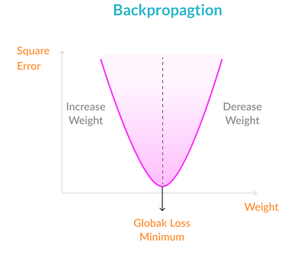

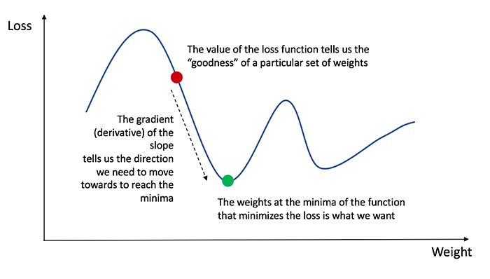

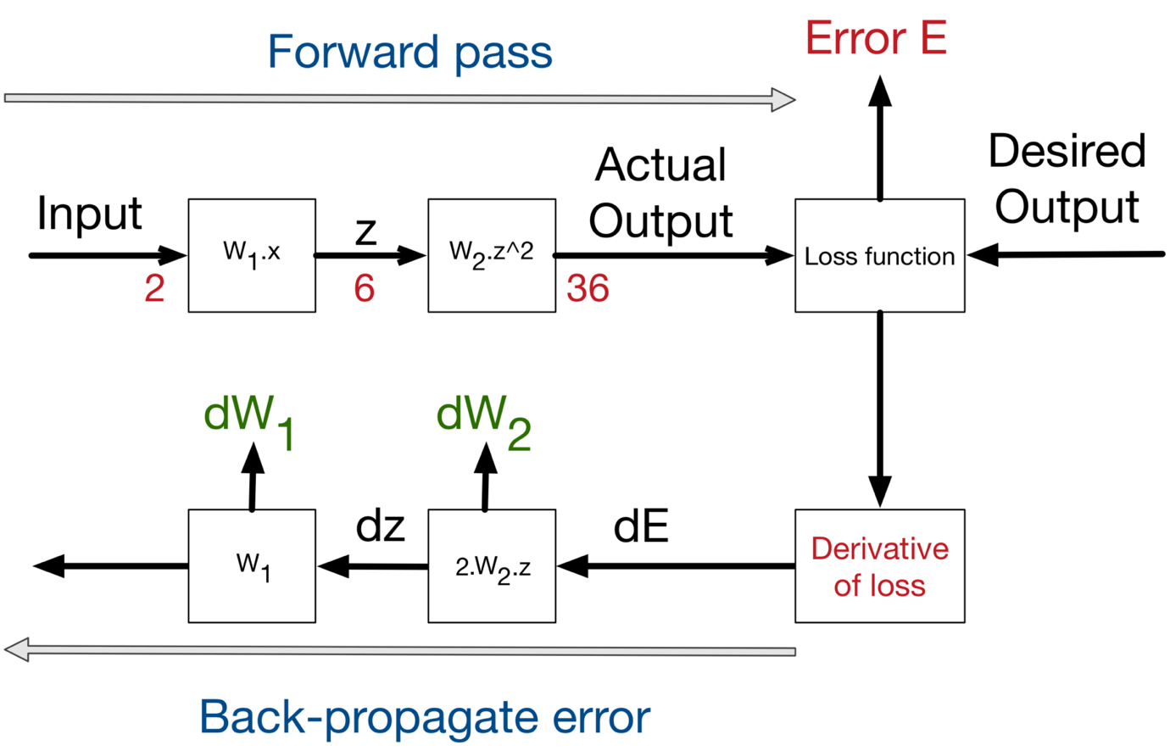

Vi du : 1 mang gom 02 inputs , 02 hidden perceptrons , 02 bias, 02 outputs nhu hinh ve :

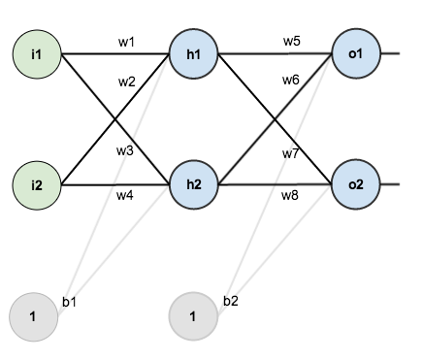

Cac gia tri khoi dong ( weights , biases va inputs , outputs ) de mang co the van hanh :

i1 = 0.05 ; w1 = 0.15 ; w2 = 0.2

i2 = 0.1 ; w3 = 0.2 ; w4 = 0.3

b1 = 0.35

b2 = 0.6

o1 = 0.1

o2 = 0.99

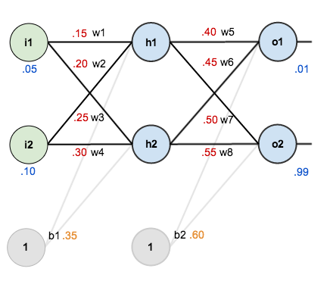

Trong vi du nay : input : i1 = 0.05 , i2 = 0.10 🡺 mong muon output : o1=0.01 va o2 = 0.99

Step 1 : **Forward pass**

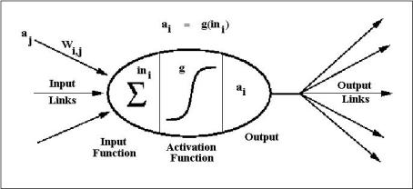

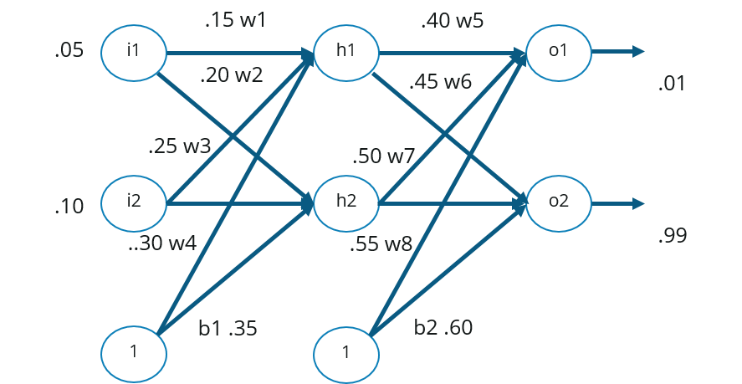

Tong gia tri dau vao\ra tai 1 perceptron duoc tinh theo cong thuc :

net = http://staff.itee.uq.edu.au/janetw/cmc/chapters/BackProp/sum.gifiwiIi. + bi\*1

( ham activation sigmoid )

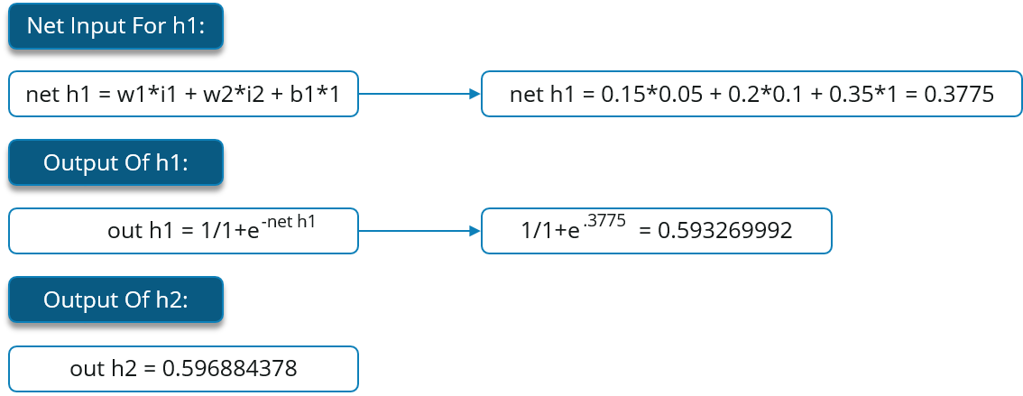

Tuong tu cho lop hidden :

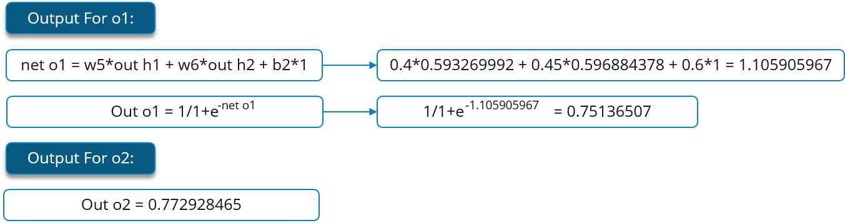

Ta tinh duoc **Total error** theo cong thuc **squared error** function :

E_ {tá»ng} = \ sum \ frac {1} {2} (má»¥c tiÃªu - Äáº§u ra) ^ {2}

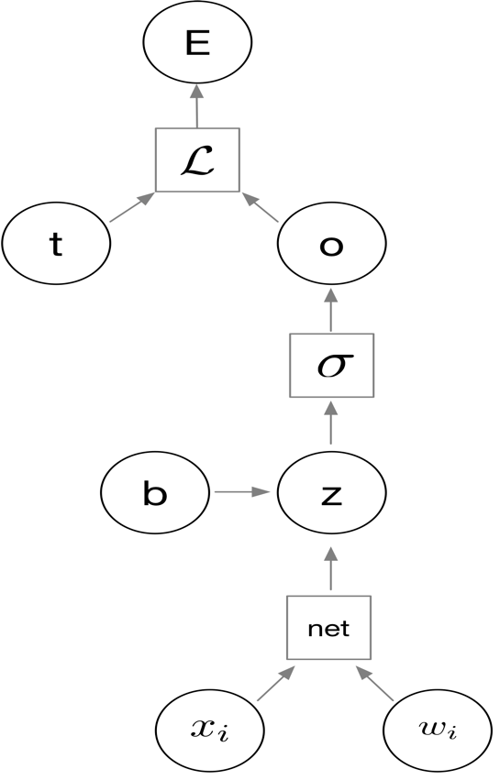

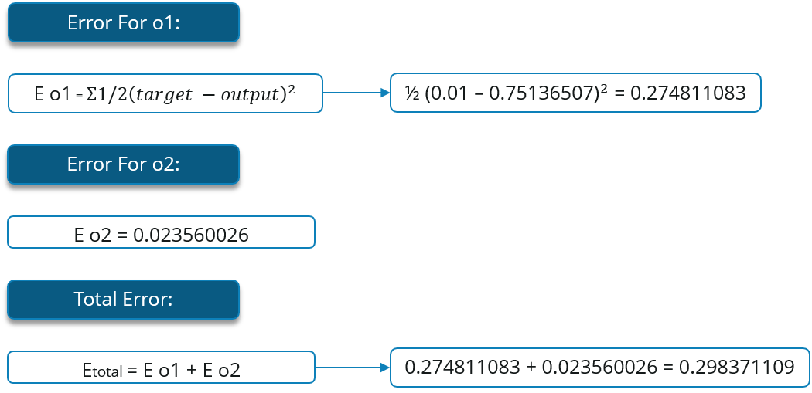

Step 2 : Cap nhat bien trong so ( **Backwards pass** )

Muc dich cua BG la thai do va cap nhat moi trong so ( weights) trong mang sao hoc hung tao ra output gan giong voi gia tri thuc ( mong muon ) bang cach giam error o moi dau ra va toan mang

1. Tai lop dau ra ( Output Layer ) : xem xet tai w5 : thay doi w5 bao nhieu de anh huong den tong error \frac{\partial E_{total}}{\partial w_{5}}

\frac{\partial E_{total}}{\partial w_{5}} goi la dao ham 1 phan cua of E_{total} voi bien thien theo w_{5}“. (Hay con goi la do doc theo w5)

Ung dung chain rule :

Truc quan bang hinh anh :

1. Dao ham Total error doi voi bien o1:

E_{total} = \frac{1}{2}(target_{o1} - out_{o1})^{2} + \frac{1}{2}(target_{o2} - out_{o2})^{2}

\frac{\partial E_{total}}{\partial out_{o1}} = 2 * \frac{1}{2}(target_{o1} - out_{o1})^{2 - 1} * -1 + 0

\frac{\partial E_{total}}{\partial out_{o1}} = -(target_{o1} - out_{o1}) = -(0.01 - 0.75136507) = 0.74136507

1. Dao ham ouput o1 doi voi bien net 1:

out_{o1} = \frac{1}{1+e^{-net_{o1}}}

\frac{\partial out_{o1}}{\partial net_{o1}} = out_{o1}(1 - out_{o1}) = 0.75136507(1 - 0.75136507) = 0.186815602

1. Dao ham input net 1 doi voi bien w5 :

net_{o1} = w_5 * out_{h1} + w_6 * out_{h2} + b_2 * 1

\frac{\partial net_{o1}}{\partial w_{5}} = 1 * out_{h1} * w_5^{(1 - 1)} + 0 + 0 = out_{h1} = 0.593269992

Ket qua :

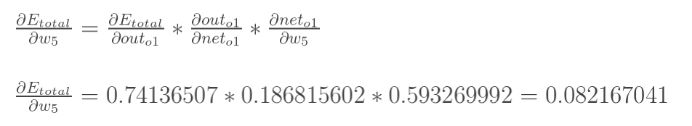

Vay gia tri cap nhat cua trong so weight w5 la :

Voi n = learning rate = 0.5

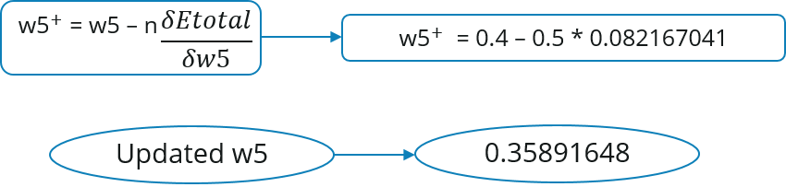

Tuong tu cho w6,7,8 : ta tinh duoc :

w_6^{+} = 0.408666186

w_7^{+} = 0.511301270

w_8^{+} = 0.561370121

1. Lop an ( Hidden Layer ) : ta tiep tuc tinh new w1,2,3,4

* New w1 :

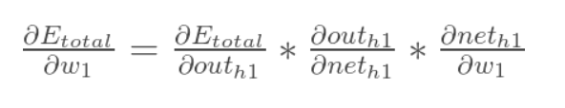

Truc quan bang hinh anh :

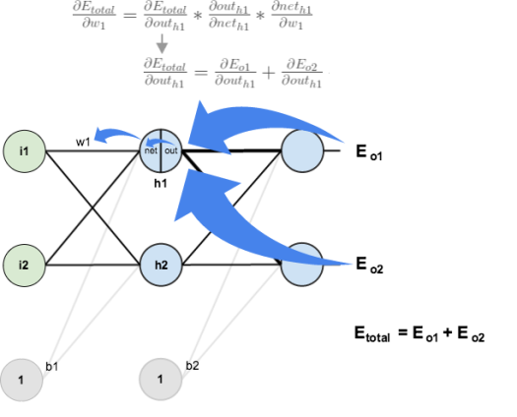

Qua trinh tinh toan tuong tu nhung co chut xiu khac do output cua lop hidden phan phoi den output cua cac perceptrons phia sau nen ta phai tach ra nhu sau :

Voi :



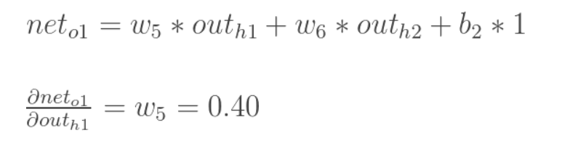

Bay gio , ta tinh phan con lai :

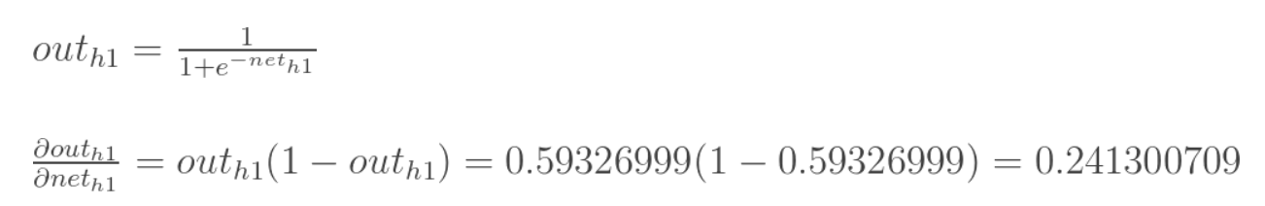

Ket qua cuoi cung :

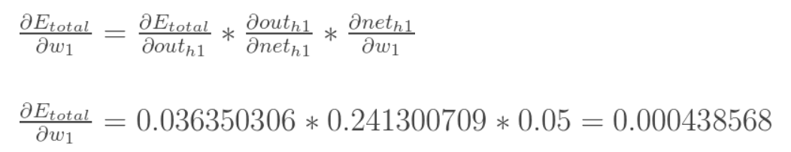

Bay gio , new w1 : voi n= learnig rate = 0.5

Tuong tu , ta cung tinh duoc :

Tong ket , sua khi ta cap nhat tat ca cac trong so weights vao fordward pass , error tu 0,298371109 giam con 0.298371109 . Lap lai 10.000 lan . Error giam manh xuong con 0.0000351085 va output la 0.015912196 (so voi 0.01 target) va 0.984065734 (so voi 0.99 target).