Student Academic Performance Dashboard Report

1. Dashboard Overview
The Student Academic Performance Dashboard was developed in Tableau to provide an interactive overview of student performance and the factors that influence academic achievement. The dashboard helps users identify learning patterns and understand how different variables relate to students' final grades.
The main dashboard includes the following visualizations:
- KPI Cards – Display key metrics such as average final grade and overall student performance.
- Grade Trend – Shows changes in student grades across G1, G2, and G3 to illustrate academic progress.
- Gender Distribution – Compares the number of male and female students in the dataset.
- Absence vs. Grade – Examines the relationship between student absences and final grades.
- Study Time Impact – Analyzes how study time influences academic performance.
- School Performance – Compares average grades between different schools.
These visualizations allow users to quickly identify trends and better understand the factors associated with student achievement.
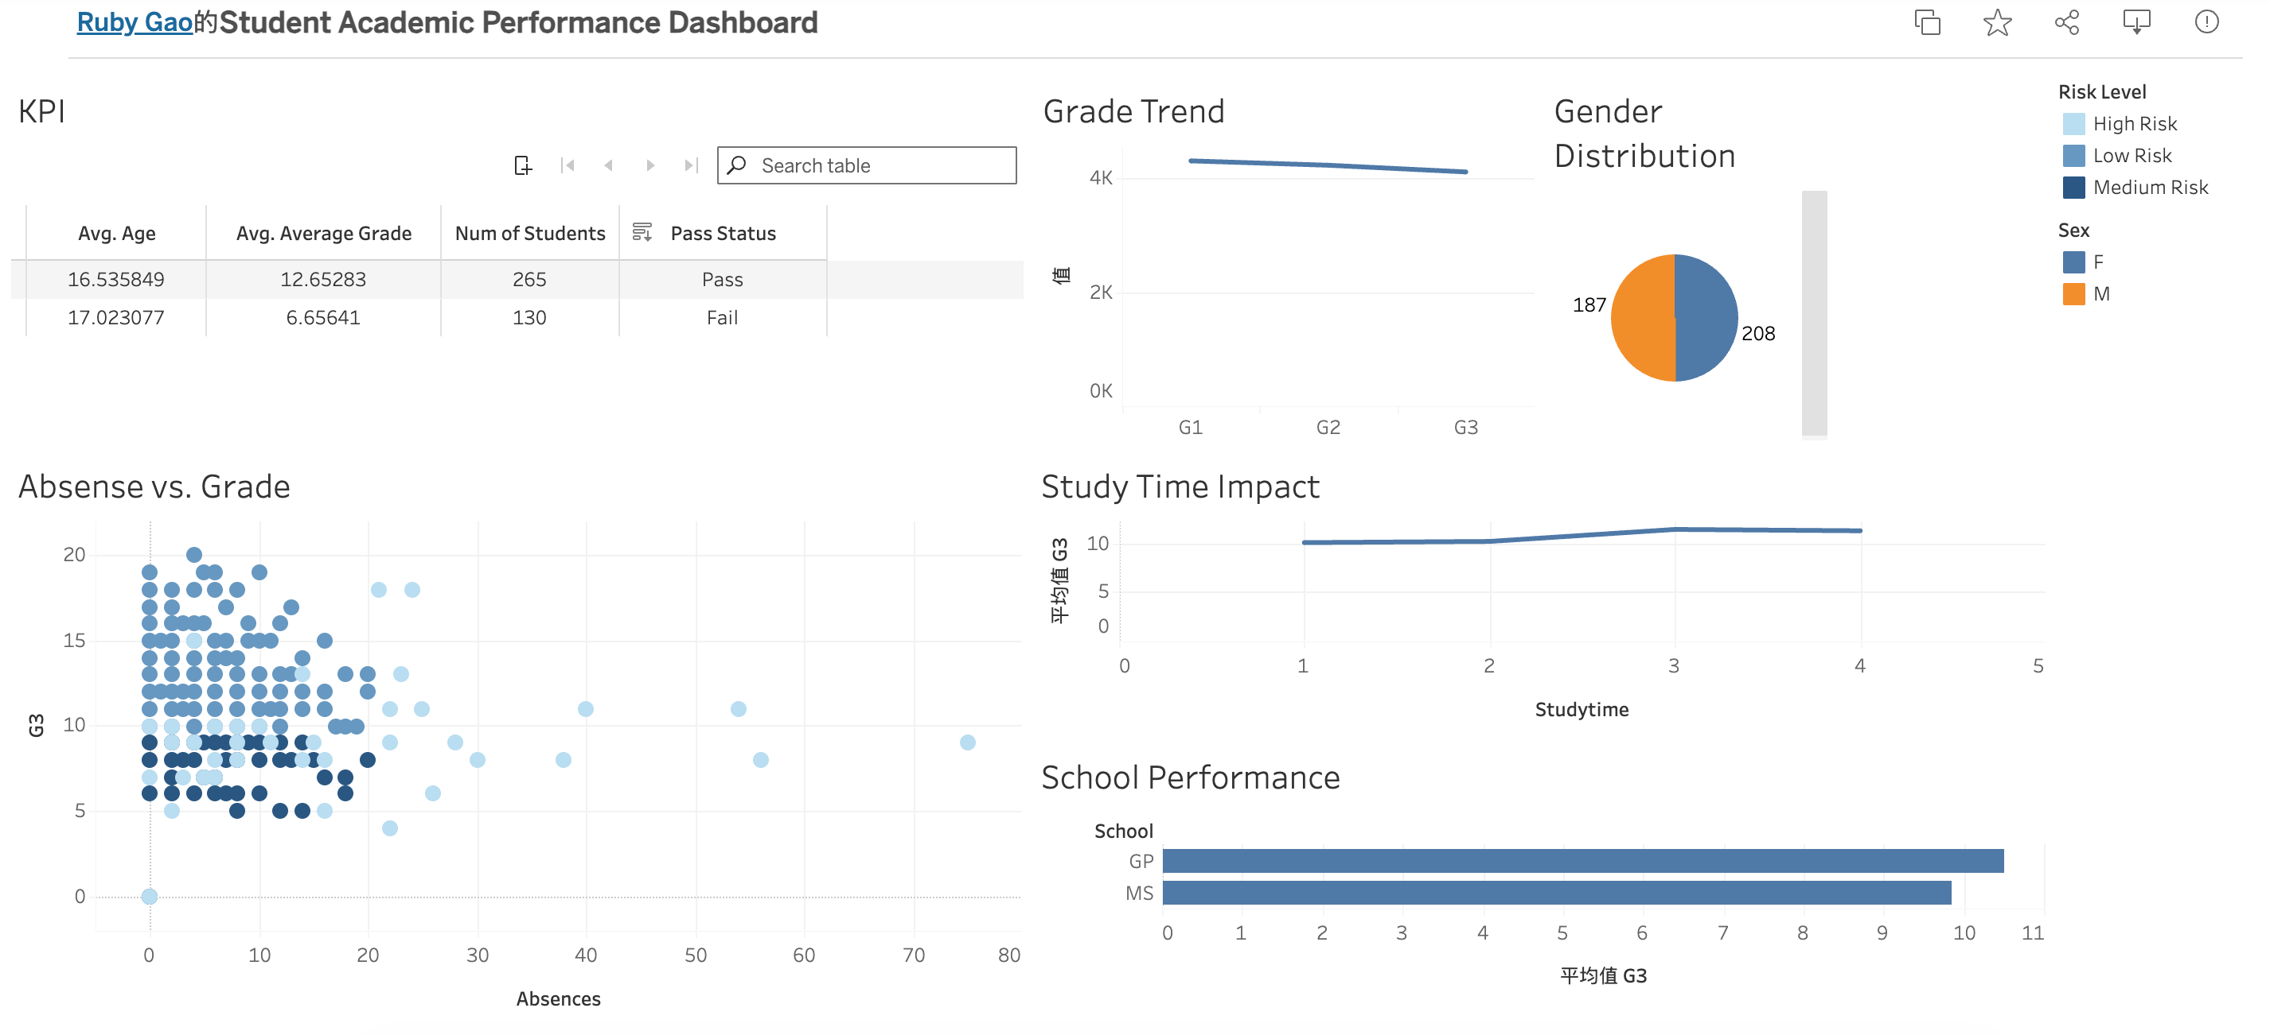
https://public.tableau.com/app/profile/ruby.gao/viz/StudentAcademicPerformanceDashboard_17840913151540/Dashboard1?publish=yes

2. Proposed Enhancement Features
To extend the functionality of the dashboard, three enhancement features were designed.

Enhancement 1: Student Learning Recommendation
This feature provides personalized learning recommendations based on students' academic performance and learning behaviors.
Recommendation rules are generated using indicators such as:
- Final grade (G3)
- Study time
- Number of failures
- Absences
Students are grouped into recommendation categories such as:
- Increase Study Hours
- Attendance Support
- Academic Tutoring
- Maintain Performance
The purpose of this enhancement is to provide actionable guidance rather than only displaying historical performance data.

Enhancement 2: Family Background Analysis
This enhancement explores the relationship between family background and academic performance.
The analysis focuses on variables including:
- Mother's education level (Medu)
- Father's education level (Fedu)
- Family support (famsup)
- Guardian information
The visualization compares the average final grade across different family background categories, helping users understand whether parental education and family support are associated with better academic outcomes.
This feature provides educators with additional insights into external factors that may influence student performance.

Enhancement 3: Learning Behavior Analysis
This enhancement investigates how students' learning behaviors relate to academic achievement.
It focuses on variables such as:
- Study time
- Previous failures
- Learning habits
The visualization helps identify common behavior patterns among students with different academic outcomes, allowing teachers to better understand which learning behaviors contribute to stronger performance.
