**HO CHI MINH UNIVERSITY OF UNIVERSAL SCIENCE FACULTY OF INFORMATION TECHNOLOGY**



**INDIVIDUAL LAB 1**

**Practice Lecturer: Hồ Tuấn Thanh**

**Student:Nguyễn Ngọc Tuấn**

**Student ID:20127658**

**Role: Backend devs**

**Ho Chi Minh City, 16thJuly, 2022**

Contents

1)Group member information

2)Assignment

3)References

I)Project Description

This tutorial I have done is Building a simple REST API with Node JS and Express.

-What's an API?

An API is a set of definitions and protocols for building and integrating application software. It’s sometimes referred to as a contract between an information provider and an information user—establishing the content required from the consumer (the call) and the content required by the producer (the response). For example, the API design for a weather service could specify that the user supply a zip code and that the producer reply with a 2-part answer, the first being the high temperature, and the second being the low.

REST

REST is a set of architectural constraints, not a protocol or a standard. API developers can implement REST in a variety of ways.

When a client request is made via a RESTful API, it transfers a representation of the state of the resource to the requester or endpoint. This information, or representation, is delivered in one of several formats via HTTP: JSON (Javascript Object Notation), HTML, XLT, Python, PHP, or plain text. JSON is the most generally popular file format to use because, despite its name, it’s language-agnostic, as well as readable by both humans and machines.

Something else to keep in mind: Headers and parameters are also important in the HTTP methods of

a RESTful API HTTP request, as they contain important identifier information as to the request's metadata, authorization, uniform resource identifier (URI), caching, cookies, and more. There are request headers and response headers, each with their own HTTP connection information and status codes.

In order for an API to be considered RESTful, it has to conform to these criteria:

* A client-server architecture made up of clients, servers, and resources, with requests managed through HTTP.
* [Stateless](https://www.redhat.com/en/topics/cloud-native-apps/stateful-vs-stateless) client-server communication, meaning no client information is stored between get requests and each request is separate and unconnected.
* Cacheable data that streamlines client-server interactions.
* A uniform interface between components so that information is transferred in a standard form. This requires that:

o resources requested are identifiable and separate from the representations sent to the client. o resources can be manipulated by the client via the representation they receive because the

representation contains enough information to do so.

o self-descriptive messages returned to the client have enough information to describe how the client should process it.

o hypertext/hypermedia is available, meaning that after accessing a resource the client should be able to use hyperlinks to find all other currently available actions they can take.

* A layered system that organizes each type of server (those responsible for security, load-balancing, etc.) involved the retrieval of requested information into hierarchies, invisible to the client.
* Code-on-demand (optional): the ability to send executable code from the server to the client when requested, extending client functionality.

In this project I have build simple Node JS program that can send,handle request and data via Postman

II)Project

The tutorial I have followed:

https://www.youtube.com/watch?v=W1Kttu53qTg&ab_channel=DailyTuition

My github project link:

https://github.com/tuanzzfds/Crud-app

Some commits I have created:

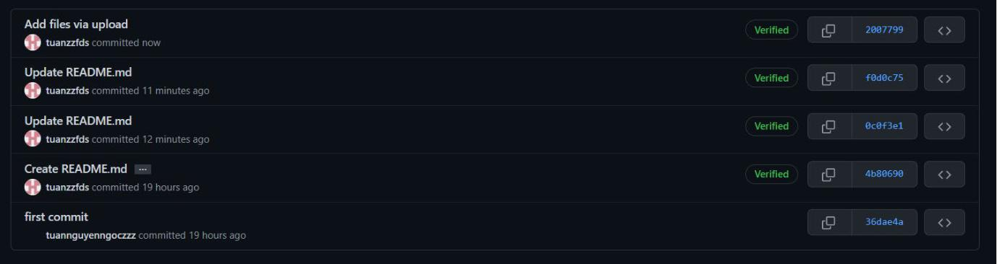

Some simple APIs I have created to test the program

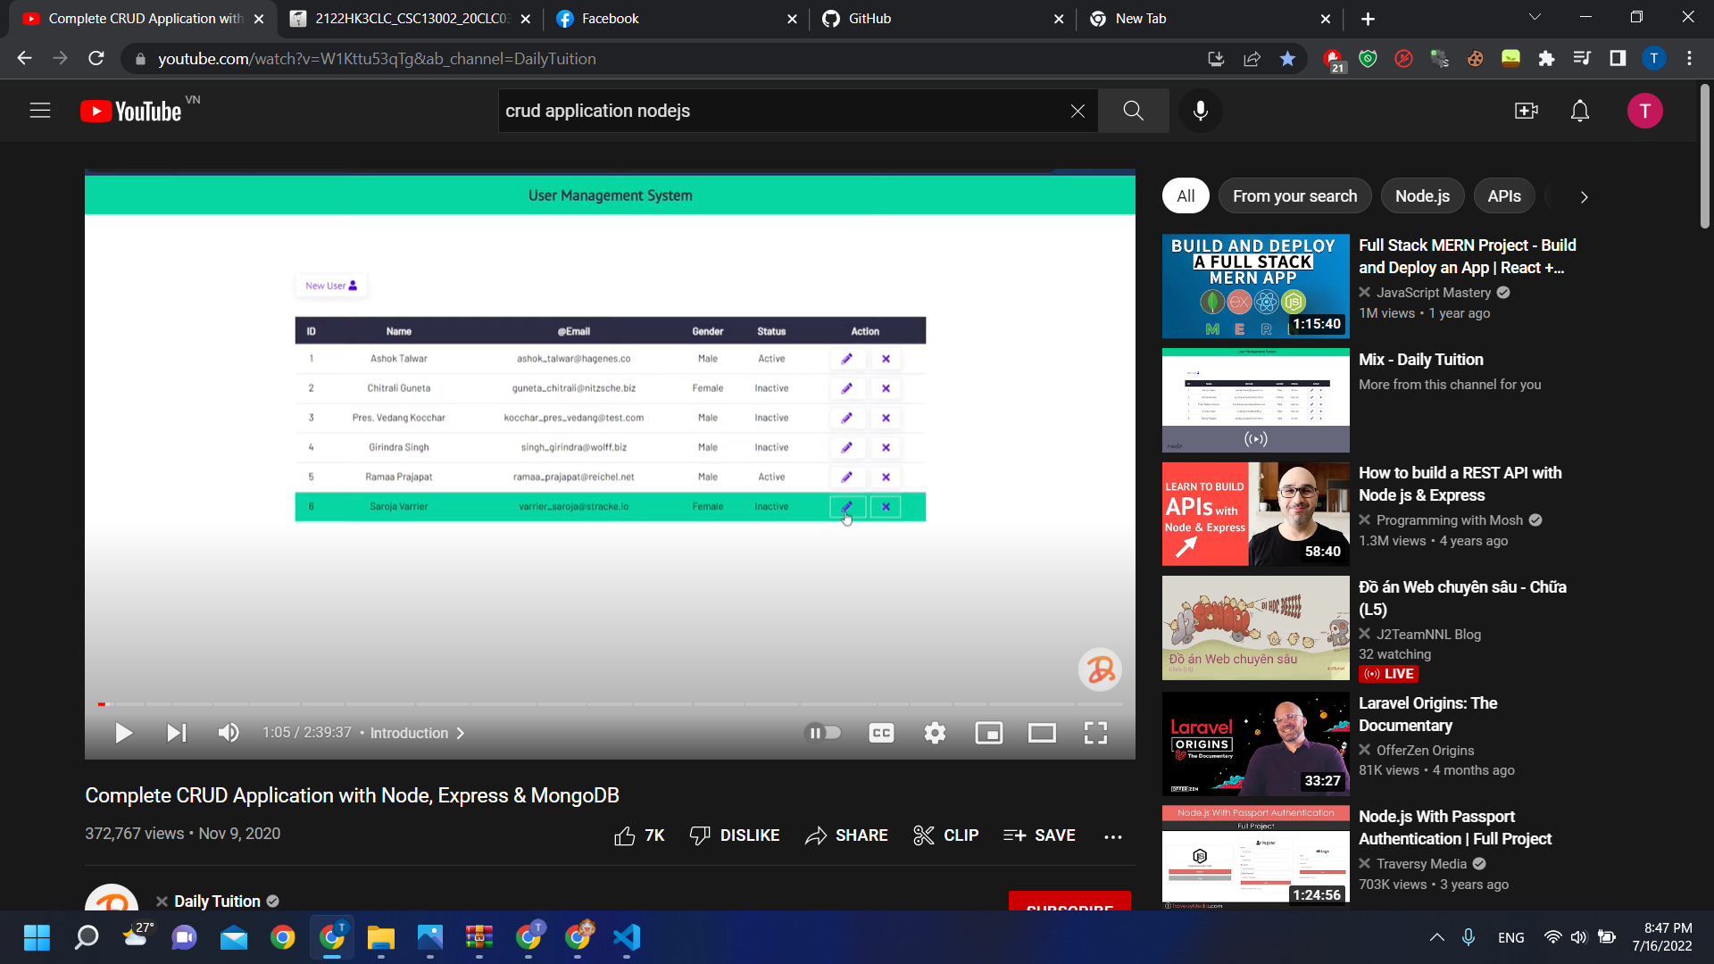

III)References

-https://stackoverflow.com/

-https://www.youtube.com/

-https://docs.npmjs.com/