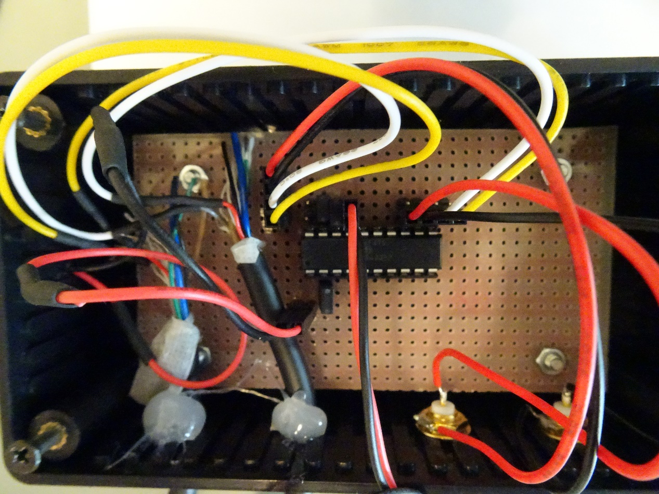**Triggerbox**

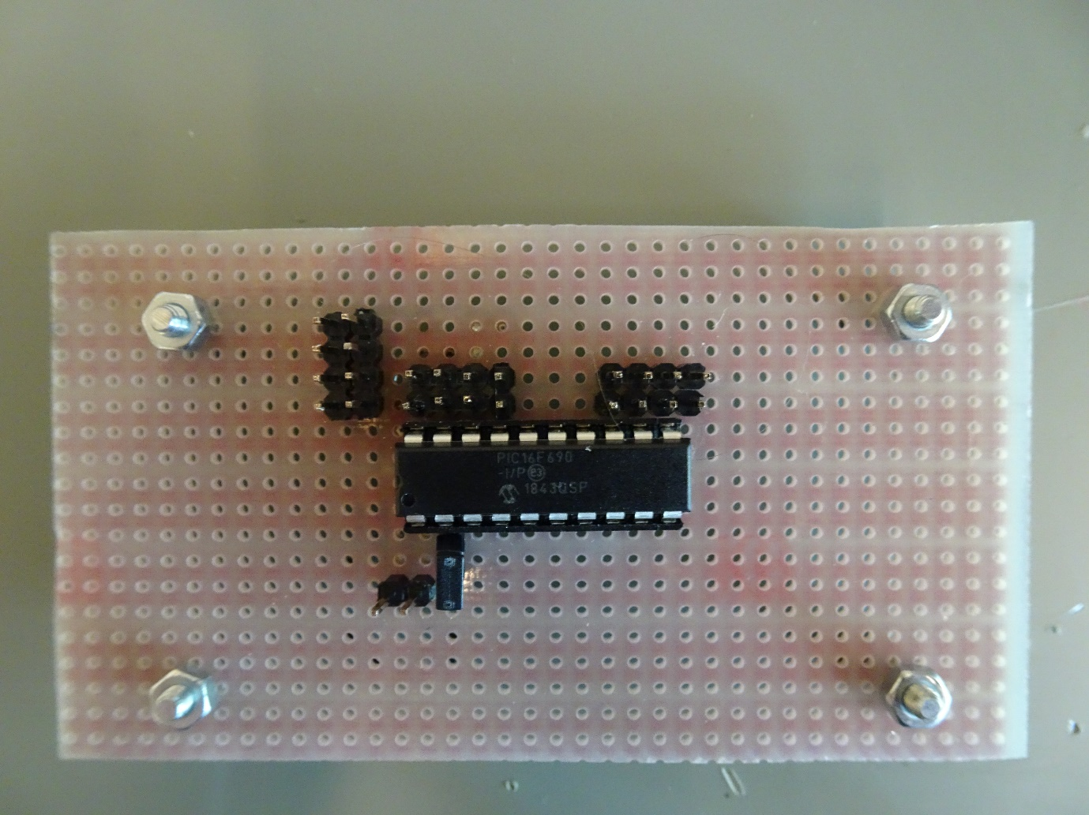

**OUT D**

**OUT C**

**OUT B**

**OUT A**

**INPUT RA5**

**JMP B**

**JMP A**

**SWITCHRA2**

**+3.3V**

**GND**

**GND**

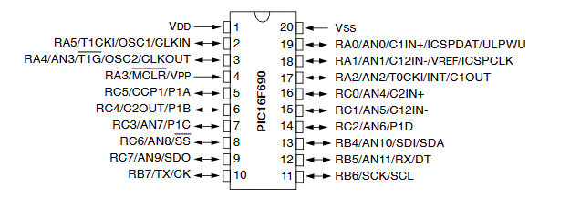

|  |  |  |
| --- | --- | --- |
| **JMP A** | **JMP B** | **Frequency [Hz]** |
| **shorted** | **shorted** | **30** |
| **open** | **shorted** | **60** |
| **shorted** | **open** | **90** |
| **open** | **open** | **120** |

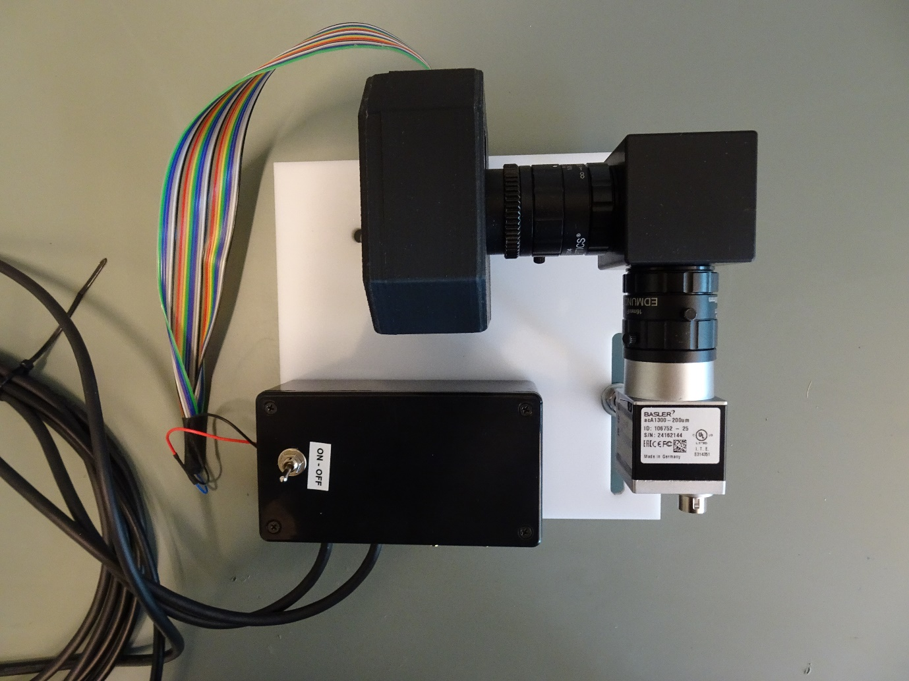

**/\***

**\* File: TriggerBox.c**

**\* Author: stru_ro**

**\***

**\* Date: 2022-03-11 13:48**

**\*/**

**#pragma config FOSC = INTRCIO // Oscillator Selection bits (INTOSCIO oscillator: I/O function on RA4/OSC2/CLKOUT pin, I/O function on RA5/OSC1/CLKIN)**

**#pragma config WDTE = OFF // Watchdog Timer Enable bit (WDT disabled)**

**#pragma config PWRTE = OFF // Power-up Timer Enable bit (PWRT disabled)**

**#pragma config MCLRE = ON // MCLR Pin Function Select bit (MCLR pin function is MCLR)**

**#pragma config CP = OFF // Code Protection bit (Program memory code protection is disabled)**

**#pragma config CPD = OFF // Data Code Protection bit (Data memory code protection is disabled)**

**#pragma config BOREN = ON // Brown-out Reset Selection bits (BOR enabled)**

**#pragma config IESO = OFF // Internal External Switchover bit (Internal External Switchover mode is enabled)**

**#pragma config FCMEN = OFF // Fail-Safe Clock Monitor Enabled bit (Fail-Safe Clock Monitor is disabled)**

**#include <xc.h>**

**#include <stdbool.h>**

**#define _XTAL_FREQ 4000000**

**const unsigned short FREQ_LUT[4] = {0xBEE5, 0xDF72, 0xEA4C, 0xEFB9}; //timer1 values for 30Hz, 60Hz, 90Hz, 120Hz**

**unsigned short timer_load_value;**

**unsigned char freq, pulse, dummy;**

**void main(void)**

**{**

**// Set interrupt enable bits**

**GIE = 1; // Global Interrupt Enable Bit**

**RABIE = 1; // PORTA/PORTB Change Interrupt Enable bit**

**PEIE = 1; // Peripherals Interrupt Enable Bit**

**TMR1IE = 1; //enable timer1**

**IOCA2 = 1; //enable interrupt on change of RA2 pin**

**IOCA5 = 1; //enable interrupt on change of RA5 pin**

**T1CON = 0x00; //turn off Timer1**

**ANSEL = 0; //configure I/O pins as 'digital function', not 'analog input'**

**ANSELH = 0; //configure I/O pins as 'digital function', not 'analog input'**

**TRISA0 = 1; //configure RA0 as input**

**TRISA1 = 1; //configure RA1 as input**

**TRISA2 = 1; //configure RA2 as input**

**TRISA5 = 1; //configure RA5 as input**

**TRISB4 = 0; //configure RB4 as output**

**TRISB5 = 0; //configure RB5 as output**

**TRISB6 = 0; //configure RB6 as output**

**TRISB7 = 0; //configure RB7 as output**

**TRISC7 = 0; //for testing purposes**

**nRABPU = 0; //pull-ups are enabled by individual port latches**

**WPUA0 = 1; //enable RA0 weak pull-up**

**WPUA1 = 1; //enable RA1 weak pull-up**

**WPUA2 = 1; //enable RA2 weak pull-up**

**//pull-up of RA5 is not enabled. RA5 is configured as an input for a signal from the event-camera**

**timer_load_value = FREQ_LUT[0];**

**TMR1 = timer_load_value; //set initial timer1 load value**

**pulse = 0;**

**if(RA2 == 0) T1CON = 0x01; //if RA2==0 initially (switch is already closed), then turn on timer1**

**if(RA5 == 1) T1CON = 0x01; //if RA5==1 initially (input is already high), then turn on timer1**

**while(1)**

**{**

**freq = RA1 << 1;**

**freq |= RA0;**

**timer_load_value = FREQ_LUT[freq];**

**}**

**}**

**void interrupt ISR(void)**

**{**

**if(TMR1IF)**

**{**

**pulse ^= 0x1; //toggle pulse**

**if (pulse==0x0) PORTB = 0x00;**

**if (pulse==0x1) PORTB = 0xFF;**

**TMR1 = timer_load_value; //set timer1 load value**

**TMR1IF = 0; //clear timer1 interrupt**

**}**

**if(RABIF)**

**{**

**//read PORTA to end the mismatch condition**

**dummy = PORTA;**

**__delay_ms(10); //wait 10ms until switch-bouncing is finished**

**//read RA2 and RA5 again after delay**

**if((RA2 == 0) || (RA5 == 1)){**

**T1CON = 0x01; //turn on timer1**

**TMR1 = timer_load_value; //set timer1 load value**

**}else{**

**T1CON = 0x00; //turn off timer1**

**TMR1IF = 0; //clear timer1 interrupt**

**PORTB = 0x00;**

**}**

**RABIF = 0; //clear IOC interrupt flag**

**}**

**}**