

Assignment: 01
Assignment Title: Git, Gitea, GitHub, Git LFS, and GitHub Pages
Name: Tuba Zainab
Registration No: FA24B1-SE-006
Course Code: SE-665
Section: B
GitHub Username: tuba-zainab

Task 01: Install Gitea and Push a Repository from the Ubuntu Server
Step 1.1: Install and Run Gitea on the Ubuntu Server
Docker and Docker Compose are installed on the Ubuntu server, and the provided Gitea configuration is used to start the service. The server and containers are checked to ensure Gitea is running correctly.
Step 1.2: Create and Push the Initial Repository
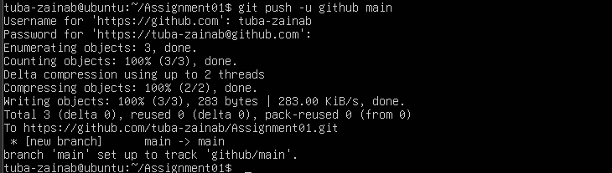
A local Git repository named Assignment01 is created with a README containing the student's information. The repository is connected to Gitea, and its initial commit is uploaded using a personal access token.
Step 1.3: Verify the Gitea Repository
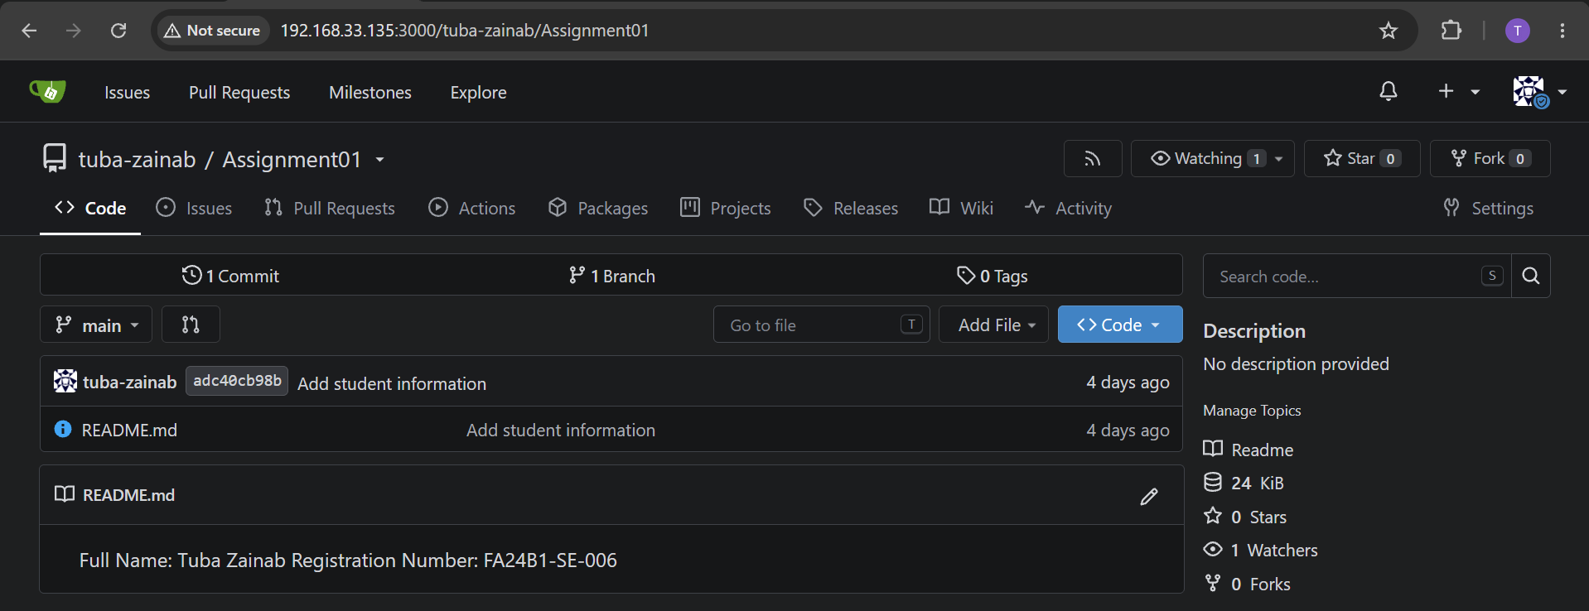
The repository is opened in Gitea to check its name, public visibility, and README content. This confirms that the repository and student information are available on the Gitea server.
Result:
Gitea is installed and running, and the local repository is pushed to Gitea using HTTP over the server's local loopback interface.
Task 02: Push the Same Repository
Step 2.1: Create the GitHub Repository and Verify Both Remotes
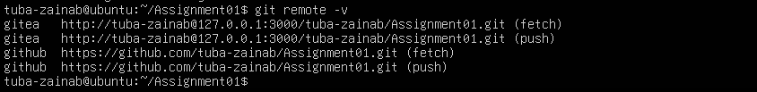
An empty public repository named Assignment01 is created on GitHub. GitHub is added as a second remote, and the remote list is checked to confirm that both Gitea and GitHub are connected.
Step 2.2: Push to GitHub
The main branch of the existing local repository is uploaded to GitHub. The terminal output is checked to confirm that the push completes successfully.
Step 2.3: Verify the GitHub Repository
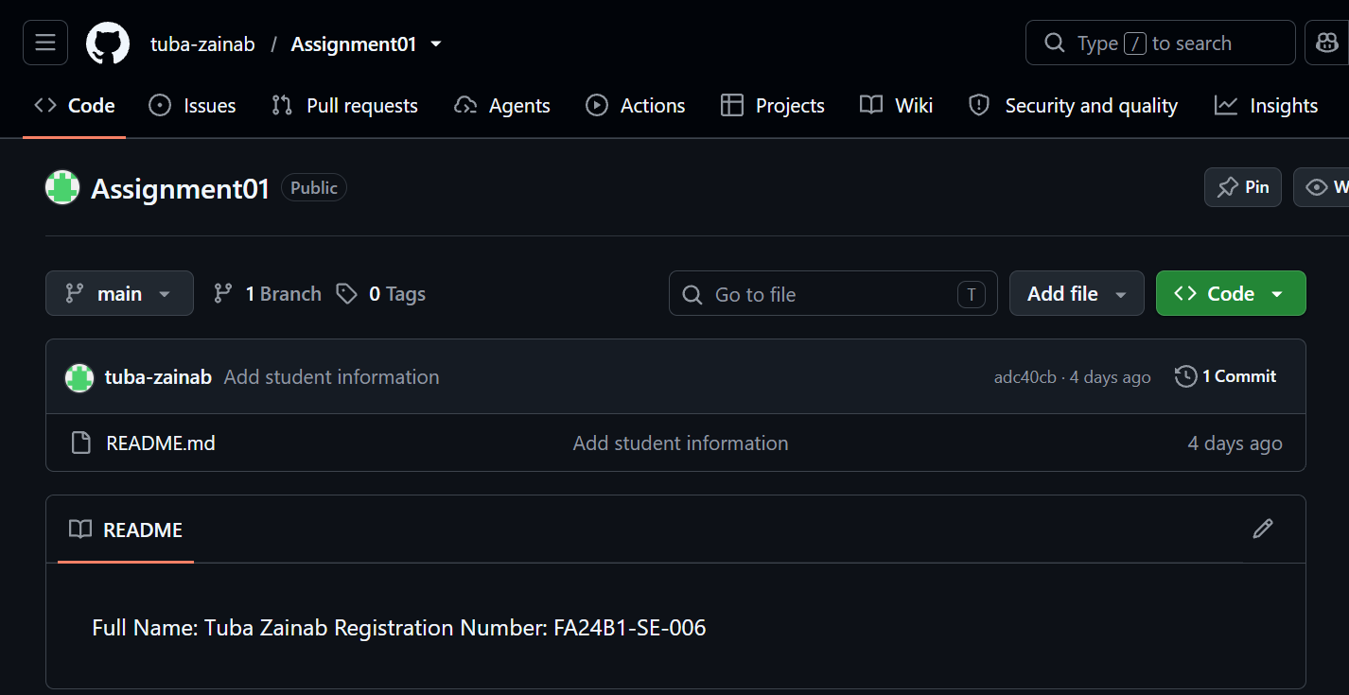
The GitHub repository is opened in a browser to check its owner, name, public visibility, and README content. This verifies that the same project is available on GitHub.
Result:
The same local repository is connected to both Gitea and GitHub and is available publicly on GitHub.
Task 03: Track Three Large files with Git LFS
Step 3.1: Configure Git LFS
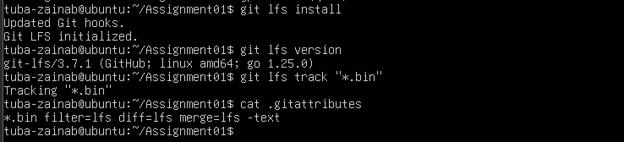
Git LFS is initialized on the Ubuntu server, and its installed version is checked. Tracking is configured for .bin files so that Git LFS can manage files of this type.
Step 3.2: Create and Verify Three LFS Files
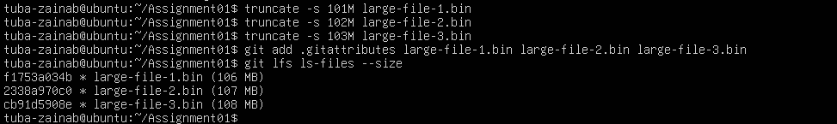
Three files larger than 100 MiB are created and added to the repository along with the tracking configuration. Git LFS commands are used to verify that all three files are tracked and display their sizes.
Step 3.3: Commit and Push the LFS Files
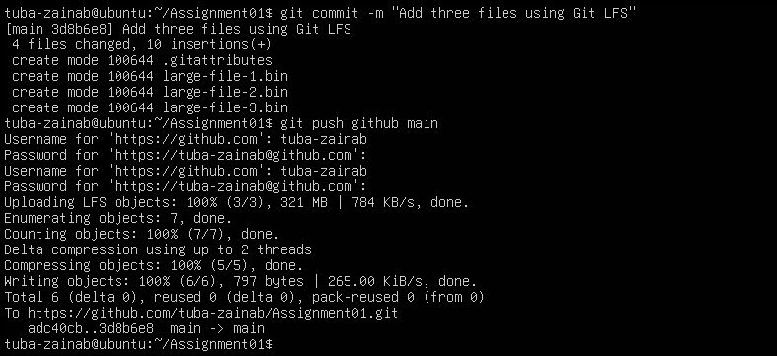
The tracking configuration and three large files are committed to Git. The changes are pushed to GitHub, and the output is checked for successful large-file uploads.
Result:
Three files larger than 100 MiB are tracked with Git LFS and pushed to the GitHub Assignment01 repository.
Task 04: Create a Portfolio or CV with GitHub Pages
Step 4.1: Create and Push the Portfolio Repository
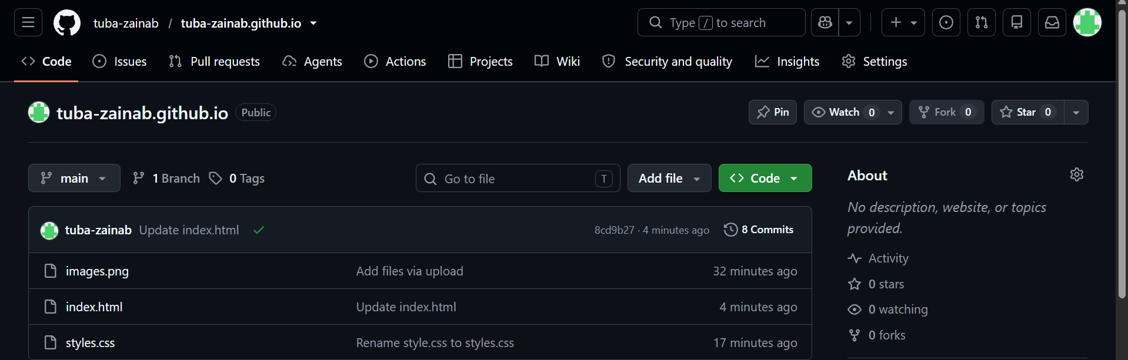
A public repository named username.github.io is created for the portfolio website. The HTML and CSS files are added with the required sections, then committed and pushed to the main branch.
Step 4.2: Publish with GitHub Pages
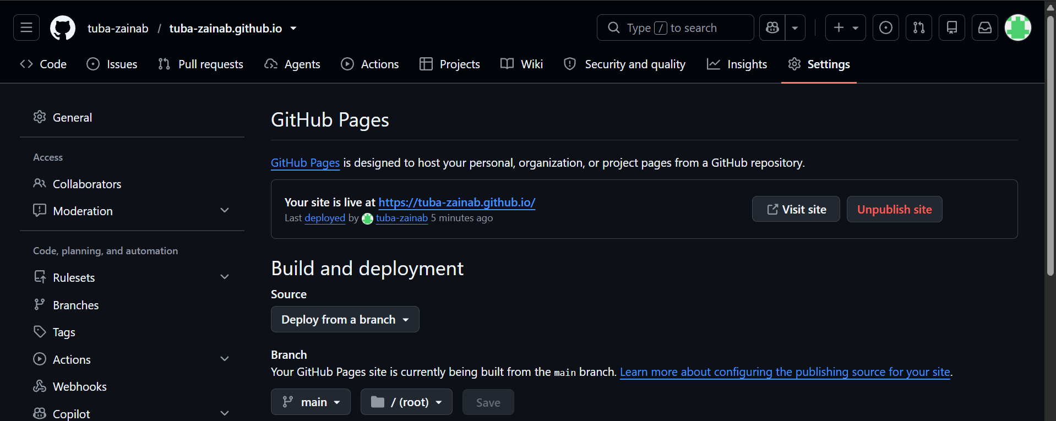
GitHub Pages is configured through the repository settings to deploy from the main branch and root folder. The deployment status and published website URL are checked.
Step 4.3: Verify the Live Portfolio
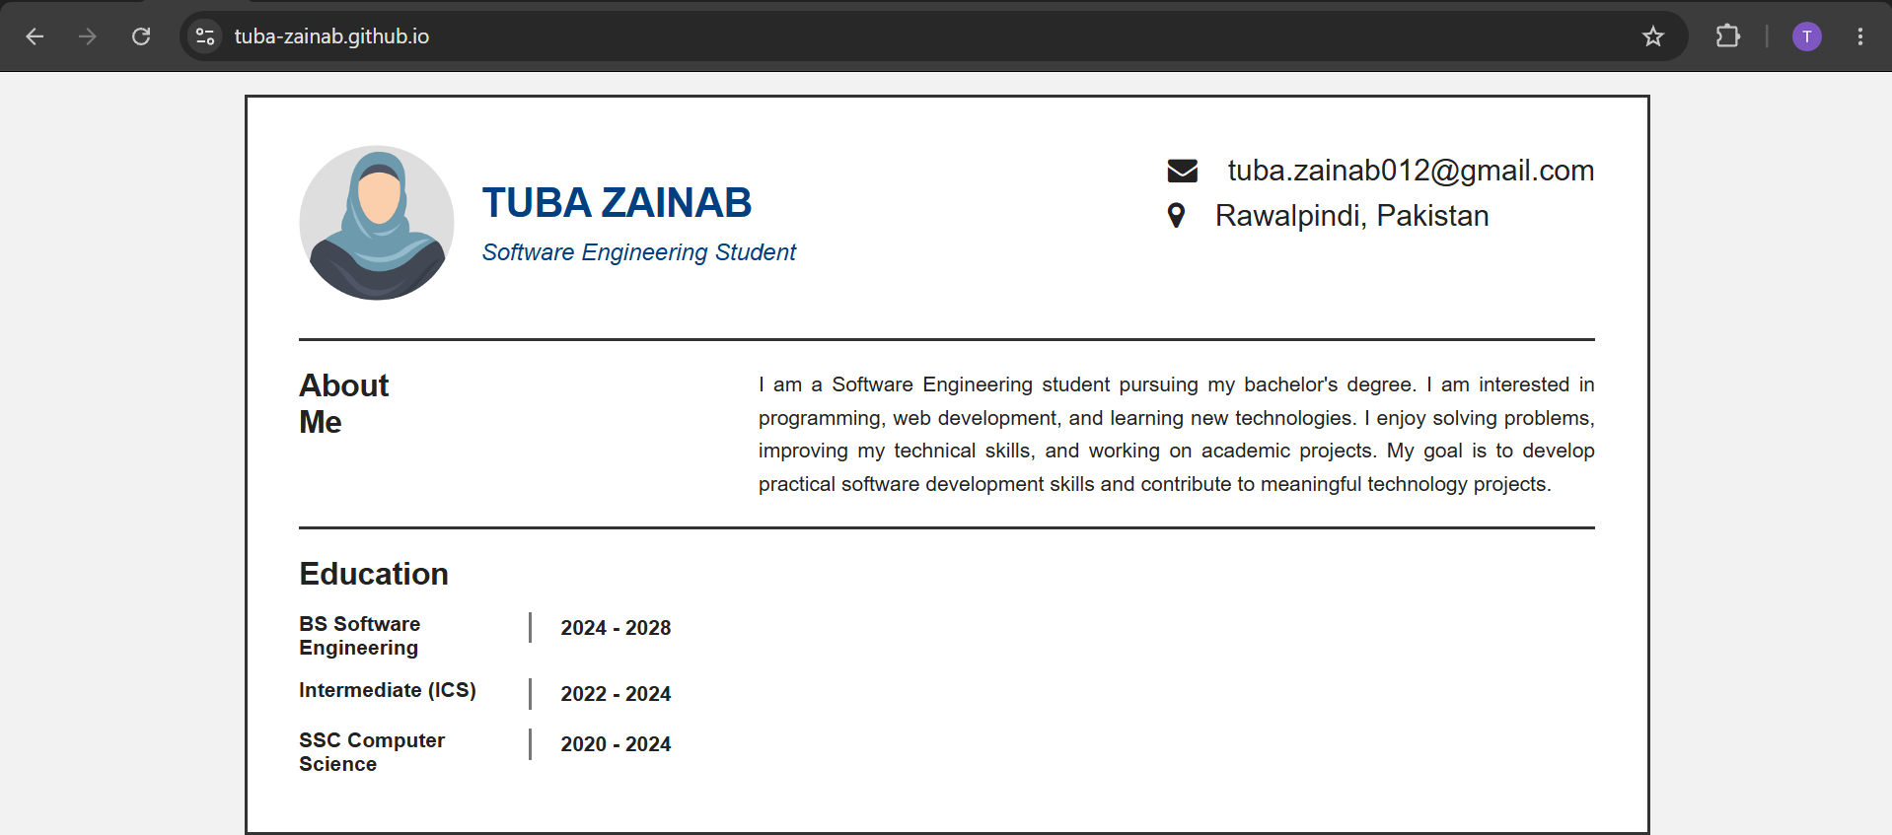
The published portfolio URL is opened in a browser to confirm that the website loads correctly. The portfolio content and website address are checked as evidence of successful publication.
Result:
The portfolio or CV is stored in a public GitHub repository and published as a live GitHub Pages site.

