

MARMARA UNIVERSITY
FACULTY OF ENGINEERING
CSE1242 COMPUTER PROGRAMMING II
(SPRING 2025)

Tower Defance Game

Submitted to: SANEM ARSLAN YILMAZ Due Date: 16.05.2025

 | Student ID Number | Name & Surname
1 | 150123021 | Ali Berkay Guven
2 | 150123036 | Fahrettin Enes Sahin
3 | 150123051 | Tuba Iskol

Table of Contents
PROBLEM DEFINITION 3
IMPLEMENTATION DETAILS 3
1. Game Class 3
2. AbstractTower Class 4
3. SingleShotTower Class 5
4. TripleShotTower Class 5
5. LaserTower Class 6
6. MissileTower Class 7
7. Enemy Class 7
8. LiveMoney Class 9
9. LevelData Class 9
10. WaveManager Class 10
TEST CASES 11

PROBLEM DEFINITION
In this project, we aim to develop a tower defense game using JavaFX. Our game includes 4 different types of towers: single shot tower, triple shot tower, missile tower, and laser tower. The single shot tower shoots projectiles at enemies. The triple shot tower can attack three different enemies at the same time. The laser tower deals damage to all enemies within its area using a laser beam. The missile tower shoots slowly but deals high area damage.
There are 5 different levels in our game, and each level has its own unique map. The path that the enemies follow and the size of the map vary between levels. Also, the number of enemies, the number of waves, and the speed at which enemies appear change from level to level.
Players place towers onto the map by dragging them from the right panel. The goal is to stop the enemies from reaching the final line. Towers cost money to place, and players earn money by defeating enemies. With limited money, players must place towers wisely. After defeating all the enemies in a level, the game moves on to the next level. When all 5 levels are completed, the game ends.

IMPLEMENTATION DETAILS

1. Game Class
This class is the main class of our game. It handles the design and functionality of the game's main screen, including the start screen, the game screen, the layout of the game screen, the panel where the towers are located, the display of the player's health and money, the map, the grid area, and the path that enemies follow.
Additionally, the game over screen (when the player runs out of health) and the next level screen (when a level is completed) are also designed in this class. The buttons on these screens are activated here.
The drag-and-drop mechanics for placing towers are implemented in this class. It also handles tower selling, placing, and repositioning by dragging. The UML diagram for this class is shown below.
Game
+  +  +  +  +  +  +  +  +  +  +  +  +  +  +  +  +  +  +  + | level: int  MAX_LEVEL: int  liveLabel: Label  nextLevelLabel: Label  continueButton: Button  waveManager: WaveManager  activeTowers: List<AbstractTower>  sstPanel: SingleShotTower  ltPanel: LaserTower  tstPanel: TripleShotTower  mltPanel: MissileLauncherTower  gamePane: Pane  gridStackPane: StackPane  stage: Stage  gameScene: Scene  opScene: Scene  backScene: Scene  nextScene: Scene  moneyLabel: Label  nextWaveLabel: Label
+  +  +  +  + | start(Stage stage): void  clearOldLevel(): void  loadLevel(): void  levelCompletion(): void  makeDragDrop(AbstractTower tower, String towerType, Label moneyLabel, boolean isPanel): void

2. AbstractTower Class
This class is the parent class of all towers. It defines common properties and behaviors such as the drag-and-drop functionality, detecting enemies within range, calculating distance to enemies, and other shared features. Everything that is common across all tower types is implemented in this class. The UML diagram of this class is shown below.
AbstarctTower
+  +  + | range: double  damage: int  shootRate: int
+  +  +  +  + | AbstractTower (range: double, damage: int, shootRate: int)  getRange(): double  getDistance(enemy: Enemy): double  isInRange(): boolean  shootEnemy(target: Enemy, gamePane: Pane, color: Color, bulletSize: int, speed: int): void

3. SingleShotTower Class
This class represents the single shot tower. It defines how the tower fires, its attack range, firing rate, and the amount of damage it deals. The UML diagram of this class is shown below.

SingleShotTower
+ | shootingTimeLine: Timeline
+  +  +  +  + | SingleShotTower ()  drawSingleShot(): void  shoot(gamePane: Pane): void  stopShoot(): void  findTarget(gamePane: Pane): Enemy

4. TripleShotTower Class
This class is different from the single shot tower in that it can fire at three different enemies at the same time, as long as they are within its range. The UML diagram of this class is shown below.

TripleShotTower
+  + | shootingTimeLine: Timeline  currentGamePane: Pane
+  +  +  +  + | TripleShotTower ()  drawTripleShot(): void  shoot(gamePane: Pane): void  stopShoot(): void  findTargets(gamePane: Pane): List<Enemy>

5. LaserTower Class
Unlike the other two towers, this tower deals damage to all enemies within its range. It continuously damages them every second by firing a laser. The UML diagram of this class is shown below.

LaserTower
+  +  +  +  + | shootTimeLine: Timeline  refreshTimeline: Timeline  activeLaserLines: Map<Enemy, Line>  refreshRateMS: int  pane: Pane
+  +  +  +  +  +  +  + | LaserTower()  drawLaserTower(): void  calcCenter(): Point2D  calcEnemyCenter(enemy: Enemy): Point2D  clearLines(gamePane: Pane): void  shoot(gamePane: Pane): void  stopShoot(): void  findEnemiesInRange(gamePane: Pane): List<Enemy>

6. MissileTower Class
Although this tower is similar to the single shot tower, it differs in terms of firing rate, damage, and the number of enemies it affects. It has a low firing rate but deals high area damage. The UML diagram of this class is shown below.

MissileLauncherTower
+ | shootingTimeLine: Timeline
+  +  +  +  +  + | MissileLauncherTower()  drawMissileTower(): void  shoot(gamePane: Pane): void  stopShoot(): void  findTarget(gamePane: Pane): Enemy  shootEnemy(target: Enemy, gamePane: Pane, bulletColor: Color, bulletSize: int, bulletSpeed: int)

7. Enemy Class
This class manages the appearance of enemies. It sets their health, creates the health bar, defines the path they will follow, and handles their movement animation. It also keeps track of the enemy's position and notifies when the enemy is destroyed. The UML diagram of this class is shown below.

Enemy
+  +  +  +  +  +  +  +  +  +  +  +  +  + | MAX_HEALTH: int  HEAD_RADIUS: double  HEALTH_BAR_WIDTH: double  HEALTH_BAR_HEIGHT: double  pathCoordinates: List<int[]  cellSize: int  X: double  Y: double  healthbar: Rectangle  currentHealth: int  finished: boolean  position: Point2D  pathTransition: PathTransition  enemyRemovedRun: Runnable
+  +  +  +  +  +  +  +  +  +  +  +  +  +  +  +  +  +  +  + | Enemy(pathCoordinates: List<int[]>,cellSize: int, offsetX: double, offsetY: double, onFinishCallback)  create(): void  initialPos(): void  createBody() : Polygon  createHead(): Circle  createHealthBar(): Rectangle  move(): void  cleanup(): void  createPath(): void  calculateCoordinate(coord: int): double  handlePathEnd(): void  removeFromParent(): void  takeDamage(damage: int): void  updateHealthBar(): void  isDead(): boolean  isFinished(): boolean  getPosition(): Point2D  getCellSize(): int  getInitialPosition(): Point2D  playDeathAnimation(): void

8. LiveMoney Class
This class keeps track of the player's health and money. It also helps determine whether the player has enough money to make a purchase. The UML diagram of this class is shown below.

LiveMoney
+  + | lives: int  money: int
+  +  +  +  +  +  +  +  + | getLives(): int  setLives(x: int): void  decreaseLives(): void  isGameOver(): boolean  getMoney(): int  setMoney(m: int): void  addMoney(amount: int): void  spendMoney(amount: int): boolean  canAfford(amount: int): boolean

9. LevelData Class
This class reads data from text files and stores information such as the level's map size, the path that enemies will follow, and the details of the enemies in each wave into ArrayLists. The UML diagram is given below.

LevelData
+  +  +  + | width: int  height: int  map: ArrayList<int[]>  waveData: ArrayList<double[]>
+  + | LevelData(int width, int height, ArrayList<int[]> map, ArrayList<double[]> waveData)  readLevelFile(String filePath): LevelData

10. WaveManager Class
This class controls the waves. It manages the time between waves, checks the number of active enemies, determines whether the level has failed, and handles the feedback when a wave ends. It also prepares the next wave. The UML diagram of this class is shown below.
WaveManager
+  +  +  +  +  +  +  +  +  +  +  +  + | pane: Pane  path: ArrayList<int[]>  x: double  y: double  waveLabel: Label  waveQueue: List<double[]>  activeEnemies: int  spawnedEnemies: int  spawnTimeline: Timeline  countdownTimeline: Timeline  levelSuccessRun: Runnable  levelFailRun: Runnable  levelEnded: boolean
+  +  +  +  +  +  +  + | WaveManager(Pane pane, ArrayList<int[]> path, int cellSize, double offsetX, double offsetY,Label waveLabel, List<double[]> waveQueue,Runnable iflevelSuccessRun, Runnable ifLevelFailRun)  startNextWave()  clearEnemies()  spawnEnemy(Pane pane,ArrayList<int[]> path, int cellSize, double offsetX, double offsetY, int totalEnemiesInWave)  ifLevelSuccess()  ifLevelFail()  stopTimelines()  startWaveCountdown(double seconds, Label label, Timeline onCompleteTimeline)

TEST CASES
1.Problem With Drag and Drop:
At the beginning of the project, we first designed the game screen. Then, we worked on making the towers in the side panel draggable and placeable on the map. One of the problems we faced was related to the special panels we used. These panels had fixed layouts, which made them unsuitable for mouse-based dragging. Because of this, we had to use features like Dragboard, snapshot, and setOnDrag. We also had to use a regular Pane without layout constraints to allow flexible dragging and placement.
2.Invisible Towers:
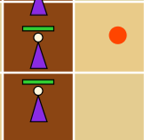

Regarding the live level logic, after advancing to the next level or after the game over screen, we noticed that the towers from the previous level were not actually removed — only their images were cleared, but they continued shooting. Because of this, we had to implement new clear, start, and stopShooting methods for our towers.

3.Inverse Enemy Path:
After successfully loading the level files, we made the enemy path follow the data from these files. When we first implemented this, we noticed that the enemy path was going from top to bottom instead of left to right. The reason was that the x and y coordinates defining the path were swapped. This was probably caused by the difference in JavaFX’s coordinate system. Once we reversed the i and j indices everywhere, the problem was resolved.

4.Enemy Path is wrong:
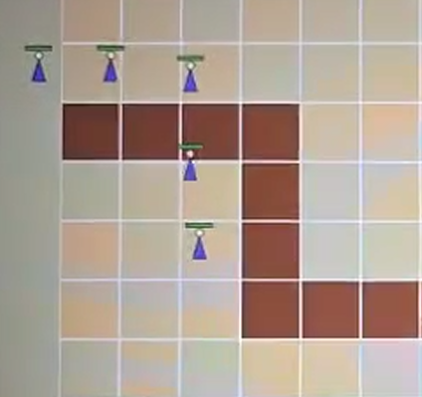

After progressing to a certain level, we wanted to move the enemies along the path, but we didn’t have a suitable path system for this. We modified the existing system somewhat and used more flexible panels again. As a result, the enemies started moving correctly from the bottom right, following the intended path.
5.Invisible Enemies:
Similar to the previous issue, after moving to the next level or after the game over screen, the enemies continued to move invisibly. This caused the live counter to decrease incorrectly, leading to an unintended game loss. To prevent this, we implemented separate clear methods for the enemies.

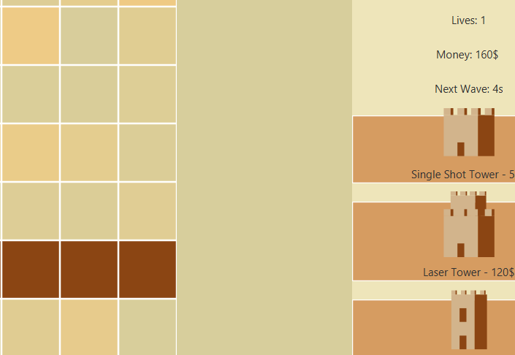

6.Laser Tower is not working properly:
We didn’t have much difficulty writing the other three towers because they were similar to each other. When it came to the laser tower, we tried to base it on the previous ones, but the tower didn’t provide a continuous laser—it kept turning the laser on and off repeatedly. To fix this, we used a separate list to keep track of the lasers. We also adjusted the number of lasers according to the number of enemies within the tower’s range.
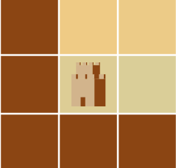

7.End of The Project:
After all this effort and hard work, we completed our project and achieved all the goals we set before starting. Below are some screenshots taken while running our game.

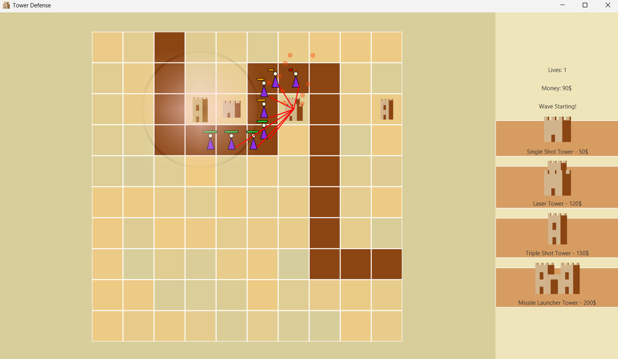
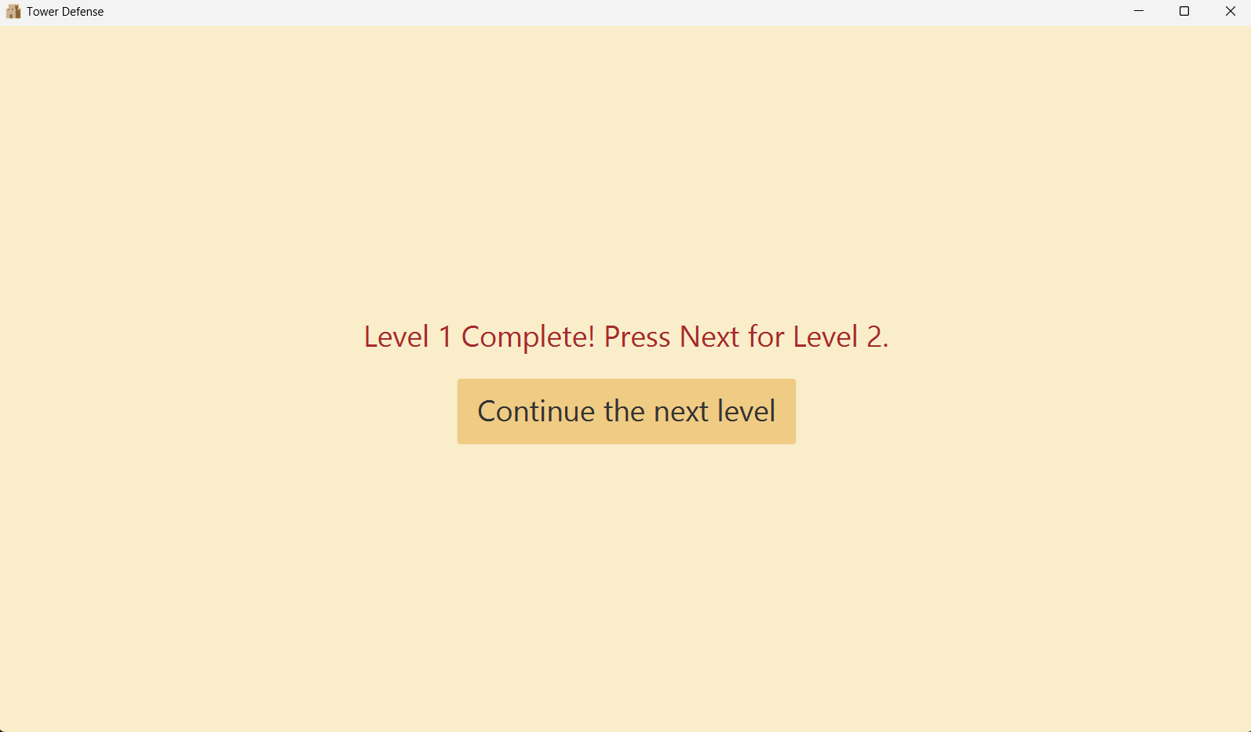

Note: Detailed explanations for all the written code are provided as comments within the code.

