IMPORTANT – before you start doing your solution, MUST do the following steps:

- Create your MS SQL database named JobDB by running code in script
JobDB.sql.
- Copy given file DBContext.java (2) to source package (src\java) folder under your web project. You might need to use and name a java package for (2), free to set the name of package.
- You MUST use DBContext.java for your all database connection.
- Set the home page/default for your project as AddJob.jsp page.

Questions:

Create a AddJob.jsp page with GUI as below figures (0.5 Point):

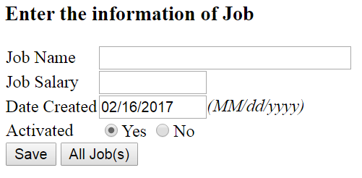
Requirements:
- Value for Date Created is calculated automatically (cannot be changed), its current system date and formatting of MM/dd/yyyy (0.5 Point).
When the users click on Save button, validate the data on the input form as rules:
- Require data for all text fields (0.5 Point - 0.25 Point for each error message).
When the validation is correct.
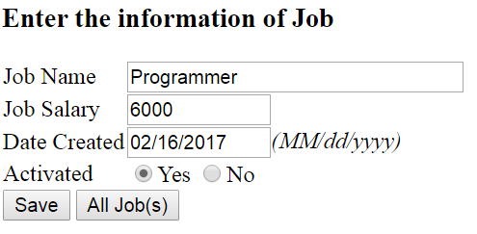
Add information on input form to Jobs table (1.5 Point) and browse to ListJobs.jsp page (0.25 Point).
When users click on the “All Job(s)” button, browse to ListJobs.jsp page (0.25 Point) which will be shown as below.
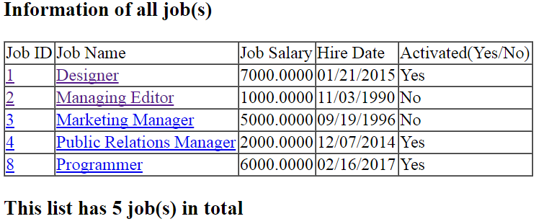
The table must have the same columns with one in above figures.
Requirements:
- Output all Jobs in Jobs table to ListJobs.jsp as above table (1.5 Point).
- Calculate and display the number of jobs of result (0.25 Point).
- Values for Activated should be as Yes (for true or 1) or No (for false or 0) (0.25 Point).
When users click on hyperlink of “Job ID” or “Job Name”, browse to EmployeeJob.jsp which will output information of all employees as check box list, check on a checkbox if the job of that employee is equals to selected job (1.5 Point), otherwise disable checkbox (0.5 Point), also output number of checked checkboxs ( number of employees are availble for selected job) (0.5 Point).
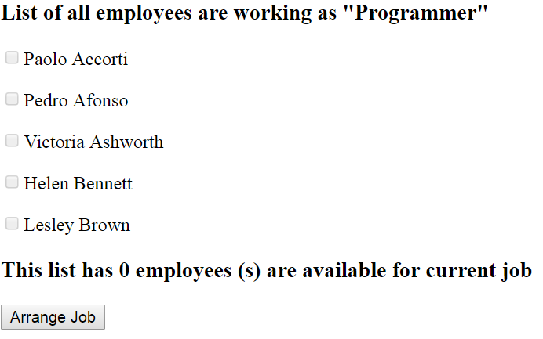
When users click on Arrange Job, browse to ArrangeJob.jsp which will assign a selected job to an employee (0.25 Point)
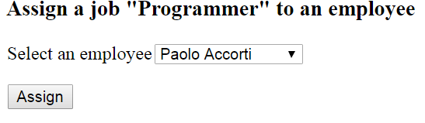
Requirements:
- Output selected job to ArrangeJob.jsp (0.5 Point).
- Output all employees to the dropdown list, display employee name (0.5 Point).
When the users select an employee from dropdown list and click on the Assgin button, save information on input form to JobEmployee (0.5 Point) table and browse to EmployeeJob.jsp page (0.25 point).
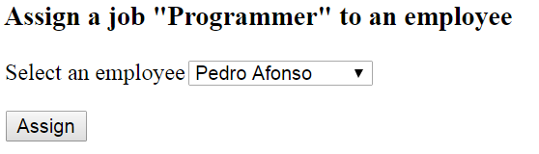 | 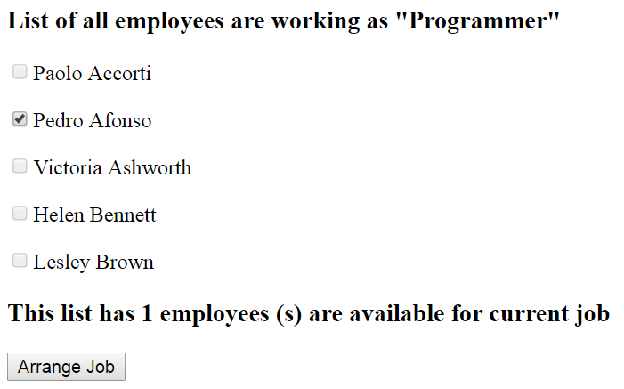
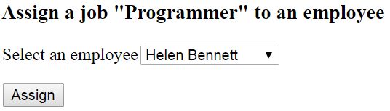 | 