电路期中考试2
本次考试共15道题，考试时间为11:00:00－－11:45:00，共计45分钟，到时系统会自动提交，请抓紧时间 Error: Reference source not foundError: Reference source not foundError: Reference source not foundError: Reference source not foundError: Reference source not foundError: Reference source not foundError: Reference source not found
考试剩余时间: Error: Reference source not found

第1题
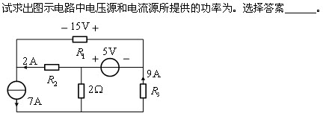A
Error: Reference source not foundA.
Error: Reference source not foundB.
Error: Reference source not foundC.
Error: Reference source not foundD.
Error: Reference source not foundE.以上答案都不对
第2题
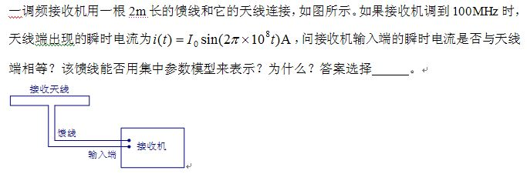B
Error: Reference source not foundA.
Error: Reference source not foundB.
Error: Reference source not foundC.
Error: Reference source not foundD.
Error: Reference source not foundE.以上答案都不对
第3题
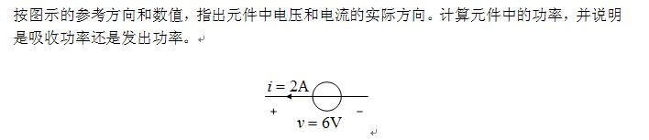C
Error: Reference source not foundA.
Error: Reference source not foundB.
Error: Reference source not foundC.
Error: Reference source not foundD.
Error: Reference source not foundE.以上答案都不对
第4题
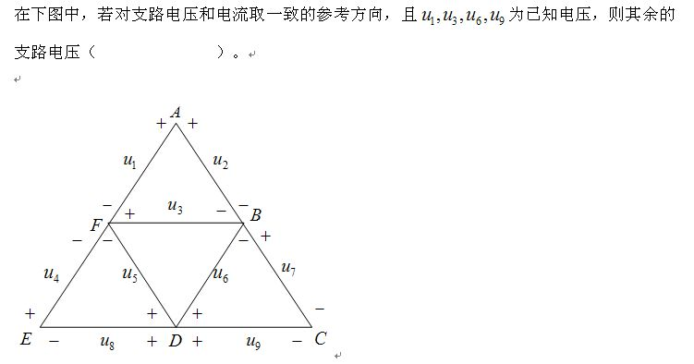B
Error: Reference source not foundA.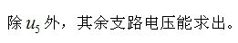
Error: Reference source not foundB.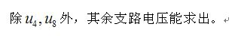
Error: Reference source not foundC.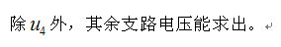
Error: Reference source not foundD.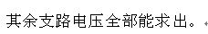
Error: Reference source not foundE.以上答案都不对
第5题
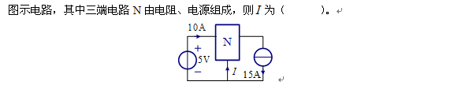D
Error: Reference source not foundA.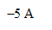
Error: Reference source not foundB.
Error: Reference source not foundC.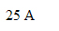
Error: Reference source not foundD.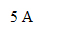
Error: Reference source not foundE.以上答案都不对
第6题
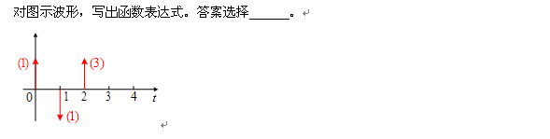C
Error: Reference source not foundA.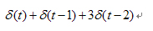
Error: Reference source not foundB.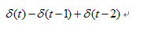
Error: Reference source not foundC.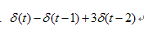
Error: Reference source not foundD.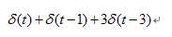
Error: Reference source not foundE.以上答案都不对
第7题
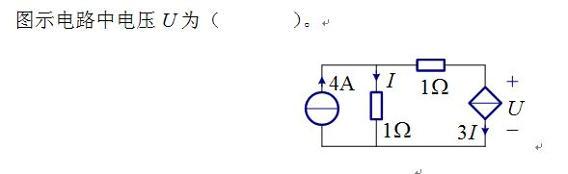B
Error: Reference source not foundA.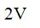
Error: Reference source not foundB.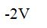
Error: Reference source not foundC.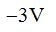
Error: Reference source not foundD.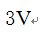
Error: Reference source not foundE.以上答案都不对
第8题
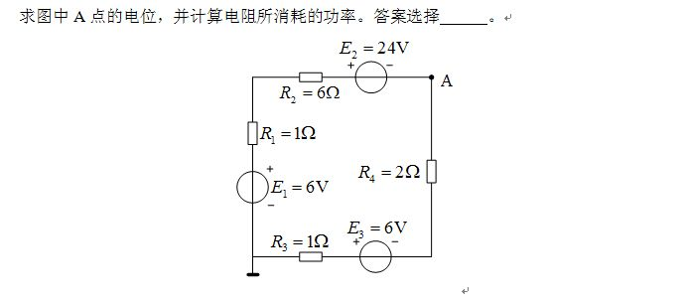
C
Error: Reference source not foundA.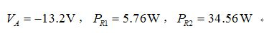
Error: Reference source not foundB.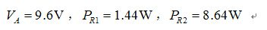
Error: Reference source not foundC.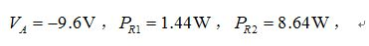
Error: Reference source not foundD.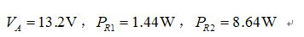
Error: Reference source not foundE.以上答案都不对
第9题
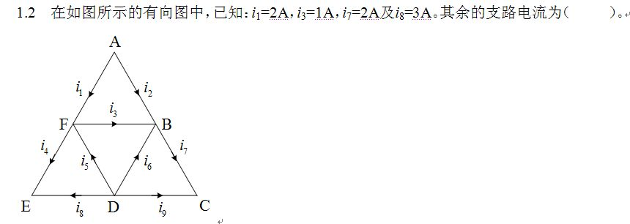E
Error: Reference source not foundA.
Error: Reference source not foundB.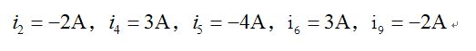
Error: Reference source not foundC.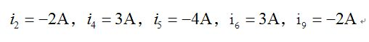
Error: Reference source not foundD.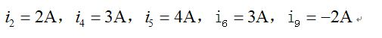
Error: Reference source not foundE.以上答案都不对
第10题
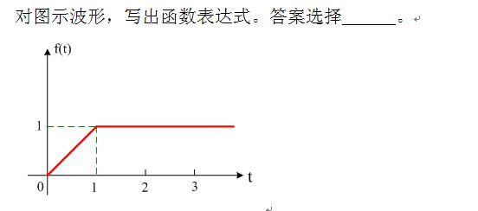
B
Error: Reference source not foundA.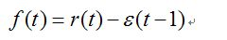
Error: Reference source not foundB.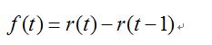
Error: Reference source not foundC.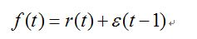
Error: Reference source not foundD.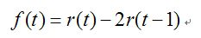
Error: Reference source not foundE.以上答案都不对
第11题
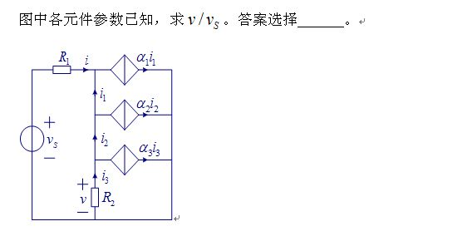
A
Error: Reference source not foundA.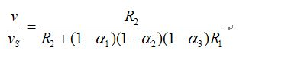
Error: Reference source not foundB.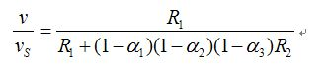
Error: Reference source not foundC.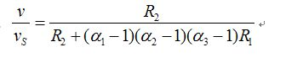
Error: Reference source not foundD.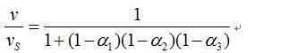
Error: Reference source not foundE.以上答案都不对
第12题
A
Error: Reference source not foundA.
Error: Reference source not foundB.
Error: Reference source not foundC.
Error: Reference source not foundD.
Error: Reference source not foundE.以上答案都不对
第13题
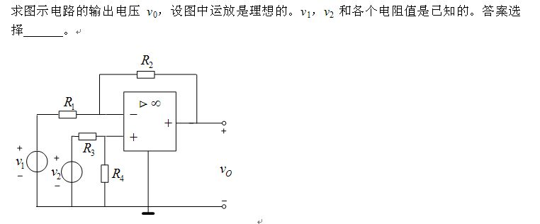A
Error: Reference source not foundA.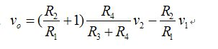
Error: Reference source not foundB.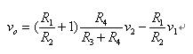
Error: Reference source not foundC.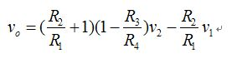
Error: Reference source not foundD.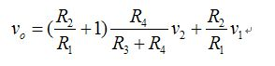
Error: Reference source not foundE.以上答案都不对
第14题
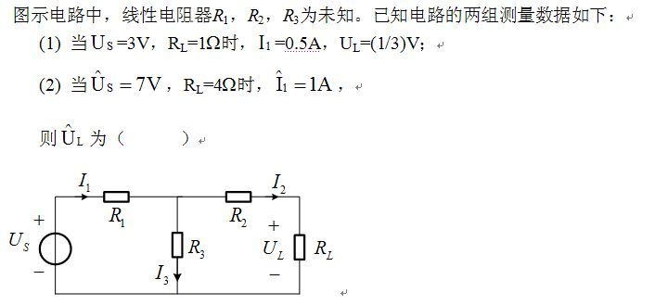
Error: Reference source not foundA.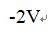
Error: Reference source not foundB.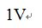
Error: Reference source not foundC.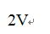
Error: Reference source not foundD.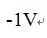
Error: Reference source not foundE.以上答案都不对
第15题
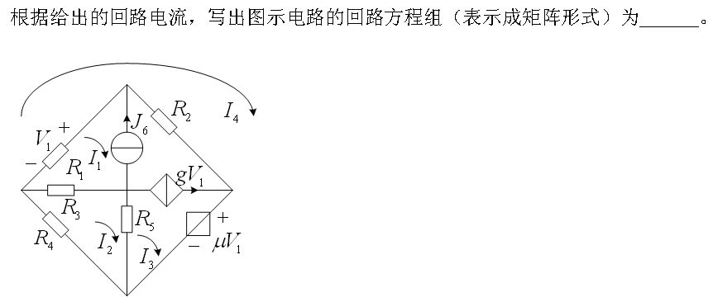C
Error: Reference source not foundA.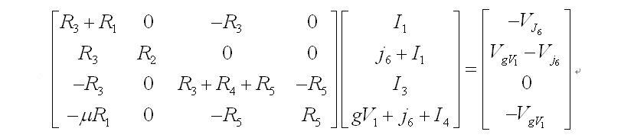
Error: Reference source not foundB.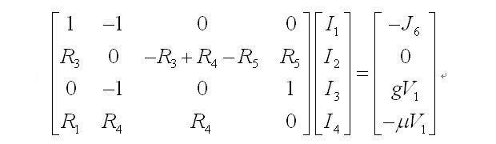
Error: Reference source not foundC.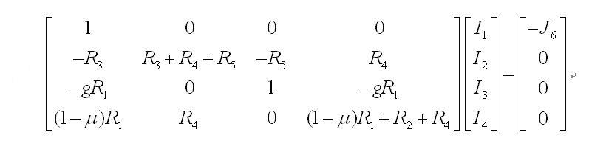
Error: Reference source not foundD.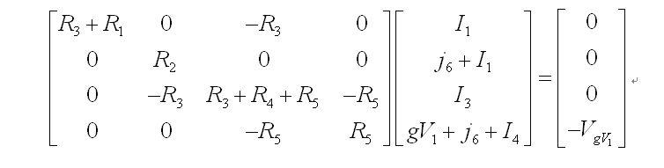
Error: Reference source not foundE.以上答案都不对

