**Brainstorms**

**Dragonfly**

Story:

- Main character is a dragonfly

- Dragonfly is gathering flowers and food

- Need to avoid enemies and obstacles such as spiders and thorns

Gameplay:

- Side scrolling shooter

- Dragonfly can fire flower seeds at enemies to defeat them

- Flowers can be collected for power ups such a rapid fire, strong projectiles, and etc

- Dragonfly can move in all four directions on screen

- Points are gain when flowers are collect and for the time when the dragonfly is still alive

- Objective of the game is to collect as many points as you can before dragonfly dies

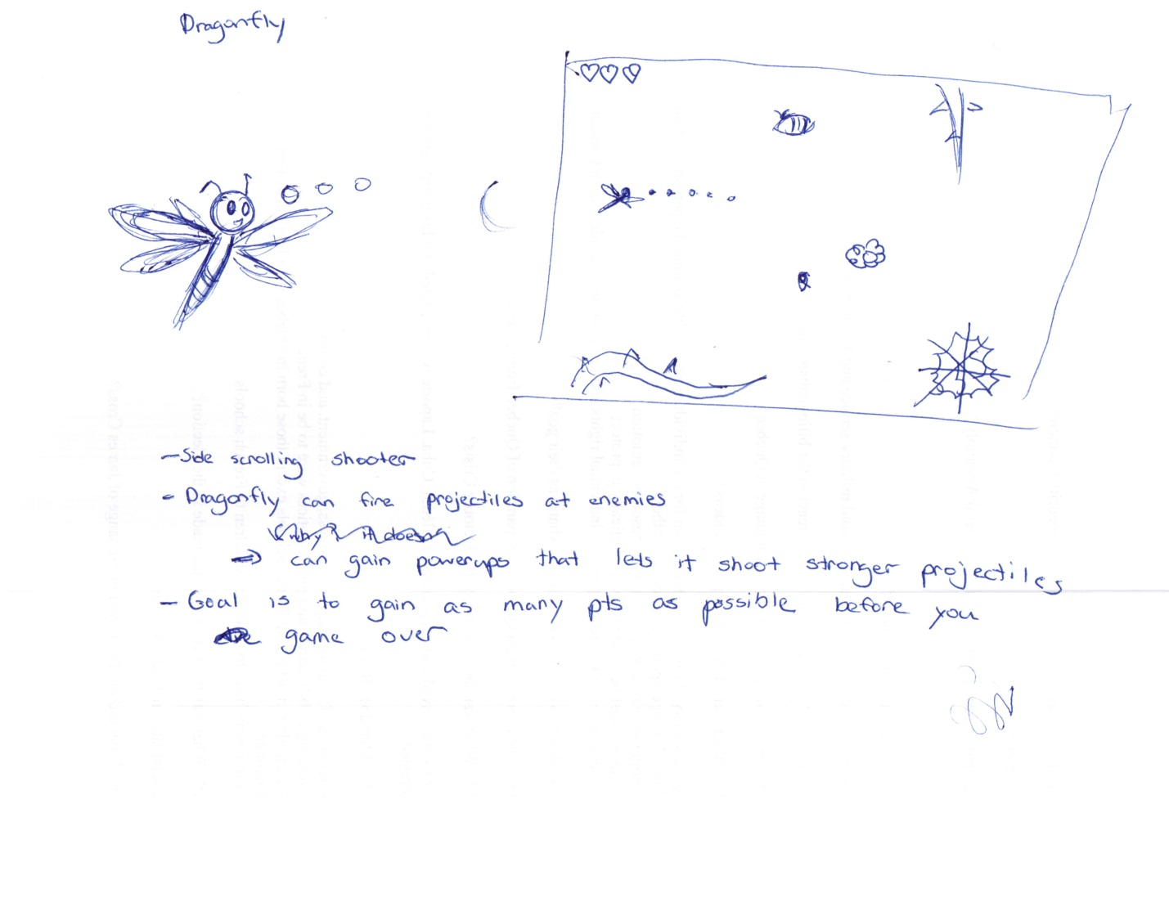

Bunny Hop

Story:

- Main character is a bunny

- Bunny stole fish from a cat and is being chased by the cat

- Player needs to guide bunny so that it won’t be caught by the cat

Gameplay

- Similar to Ninja Runner

- Bunny can jump on platforms and gain points by collecting berries

- Need to avoid running into tree stumps and landing into ponds

- Objective of the game is to collect as many points as possible before a game over

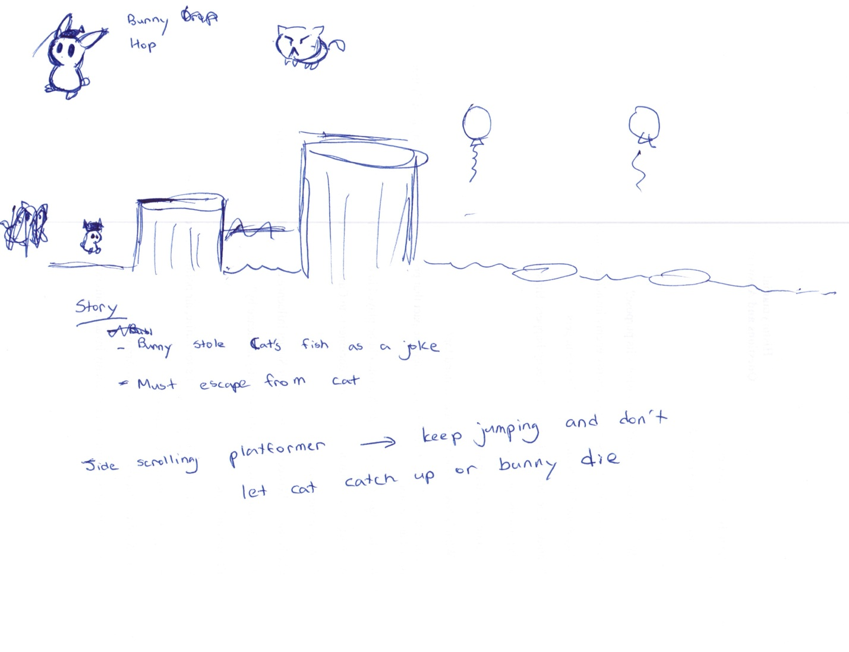

Angel

Story:

- Angel woke up in an uncanny world with no memories

- She rescues her fellow angels in the world and defeats the demon who trapped them

- Regain memories and powers as the story progress

- Eventually learns that she was kidnapped by the demon who wanted some friends

- At the end, stays in the world

Gameplay:

- Platformer, similar to Ikachan

- MC have limited flight which can increase as the storyline progress

-> flight bar decreases as she fly, restores when she lands

-> flight bar increases as story progresses, allowing her to reach to higher places

- Powers the MC have included:

- Light arrows -> destroys enemies

-> can charge arrows by holding down button

- Holy water -> destroys some obstacles and enemies

- Lethal music notes -> being creative here…

