Game: Defense the Earth

Require: Unity Engine

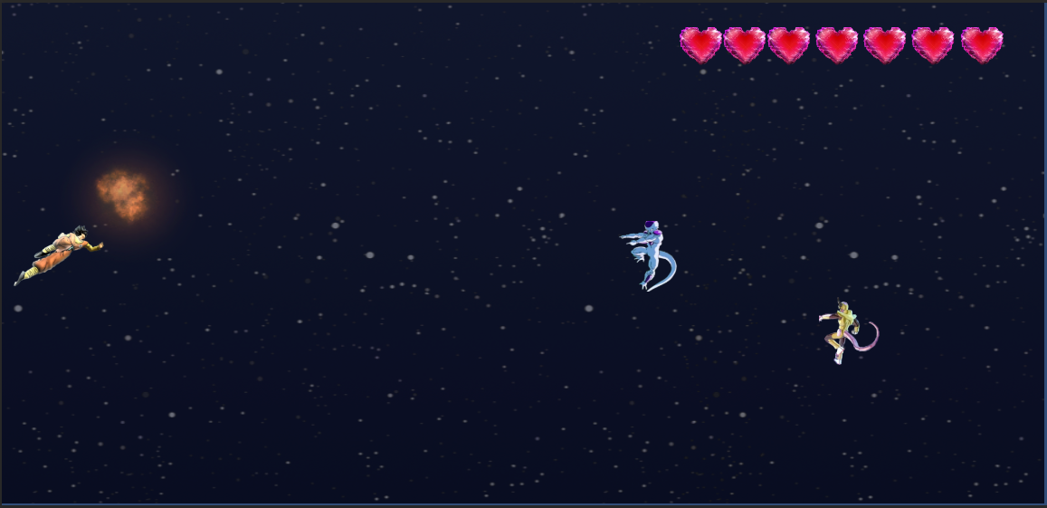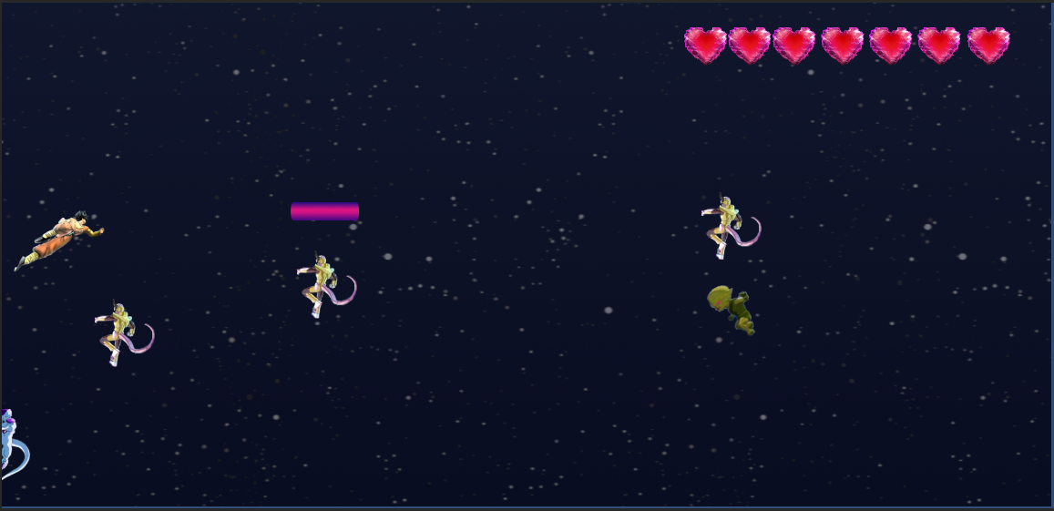

Movement Controls: Up or Down

Shoot: Keyboard K

Game description: The game begins with 7 hearts life and each time you get hit by the lasers or the enemy itself you will lose one life. The game ends when you lost all 7 lives.