Review of the IMD/AMS Latch circuit

Connectors: The spacing of the connector seems fine, however the footprint doesn´t quite match?

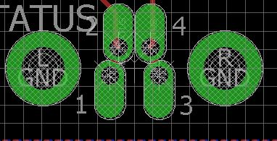

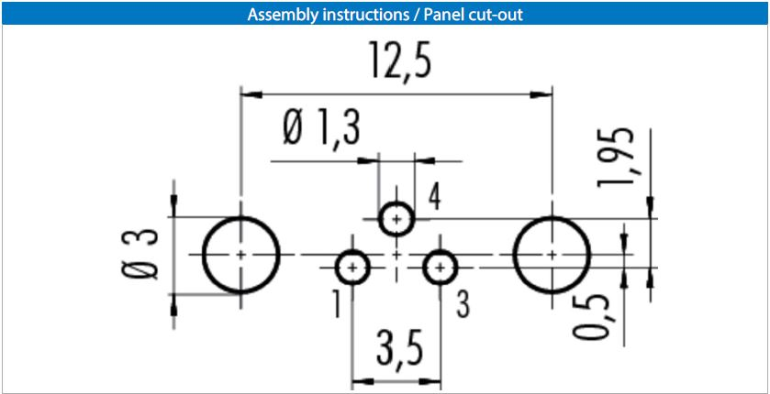

A least if this is the recommended footprint.

Layout:

The layout looks good to me. Only one thing struck my eye:

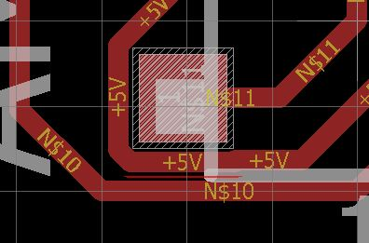

I´d recommend you to move the trace N$10 a bit, since there is enough space.

Availability of components:

C1: Available on Conrad

C2, C3: Available on Conrad

D1, D2: Available on Conrad

D3: Available on Conrad

Fuse: Available on Conrad

IC1: C´mon it’s the LM7805

IC2: Available on Conrad

K1: Available on Conrad

Q1- Q6: Available on Conrad

R2, R7, R9: If it this one <https://www.digikey.de/product-detail/de/nidec-copal-electronics/SM-42TA103/SM-42TA103CT-ND/1632364>

Then it is available on DigiKey or RS-Components

The rest of the components are just regular old 0805 resisitors. I didn´t bother to loo if we can get some of those :D.