Review of the BSPD board/circuit

Circuit: The circuit was properly thought through and simulated. This was checked with the circuits creator Thomas Walz. No further issues noted.

Layout:

Issue 1:

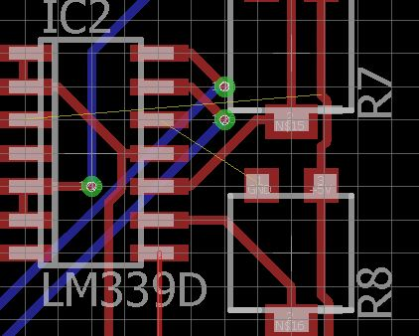

*Fig. 1: Airwires*

As seen in Figure 1, there are some Airwires, which need to be fixed.

Issue 2:

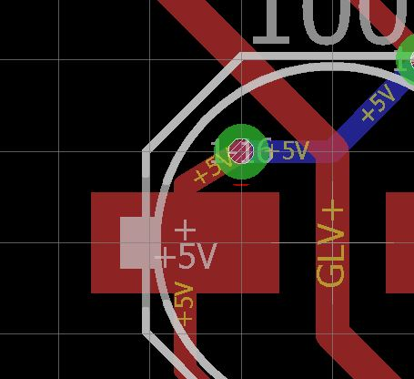

*Fig. 2: Clearance*

As seen in Figure 2, the via as a bit close to the pad of C5. It is not a critical issue, but I´d recommend the via to be moved slightly, since there is enough space. Just to eliminate possible errors in manufacturing.

Apart from that, there were no real issues, that struck my eye. I was getting DRC alerts on all(!) vias and most traces, but my guess is, that I was using different Design Rules.

Availability of components:

Resistors and Potentiometers:

* R1, R2, R3, R4, R5, R6: Regular 0805 SMD resistors, available literally anywhere
* R7, R8, STB_BF, STB_BR, STB_CUR, STG_BF, STG_BR: Available at <https://www.digikey.de/product-detail/de/nidec-copal-electronics/SM-42TA103/SM-42TA103CT-ND/1632364>

Capacitors:

Regular SMD capacitor, available literally anywhere

MOSFETS:

* Q1, Q3: Available at <https://www.mouser.de/ProductDetail/Infineon-Technologies/BSC670N25NSFDATMA1?qs=sGAEpiMZZMshyDBzk1%2fWi%2fD7Em5shE8qKgI9ZHFg3LXC42%252bsGE9MzQ%3d%3d>

Diodes:

Regular SMD diode, available literally anywhere.

Fuse: Available on Conrad <https://www.conrad.de/de/Search.html?search=smd%20sicherung%201206&searchType=REGULAR&category=%1Ft14%1Fc17392>

Relais: Available on Conrad: <https://www.conrad.de/de/Search.html?search=cma51&searchType=REGULAR&category=%1Ft14%1Fc17391#product-1503179>

ICs:

* IC1, IC2: LM339 Quad-package, available anywhere
* IC3: Good ol´LM7805

Testpins (TP1 – TP8):

I couldn´t find a specific model, since the BOM only states P1-13

The M8 connectors are known.