**SWT301 - The Sample final PE**

Your company will develop a web application for an English Center to help the managers manage their staff and students, such as individual information, class schedule, and syllabus.

When the product fully develops, students and teachers can access the system with their account to do homework, class assignments, and quiz tests and see the training material, scores, and so on.

The interface is also very user-friendly, so things are easy to find, and teachers will have no problems pulling up material and taking classes. This system's class and course management modules require some attention because they are critical.

The web application will have some Major Features:  
- A dashboard full of helpful, informative charts  
- Manage user information, including student, teacher, and staff  
- Manage course information  
- Manage class information  
- Monitor class performance with attendance system and test result

The project will use incremental development and delivery process. The schedule will have three iterations. Each iteration will develop significant functions based on their priority and value to the customer from high to low and deliver the web application to the customer to give the value added to them.

**Question 1:** The project applies test first driven approach to doing the component test. Then you are assigned to design and create the component test cases to test a Register method.

The method **Register(strUserName, strPassword, strPhone)** had three input parameters with some business rules.

* Username has the string type; 7 chars < Username <= 12 chars; the first character isn't a number; the remaining characters are not special chars. Username
* Password has more than 12 characters: one special character, one up case character, and one number character.
* The cellphone is a number type; had ten digits and the first digit with zero.

The method will return those results

* Return TRUE and show the message "Register success."
* Return FALSE and show the message "User name already exist."
* Return FALSE and show the message "Username is invalid."
* Return FALSE and show the message "Password is invalid."
* Return FALSE and show the message "Cellphone number is invalid."

**Question 2:** Assume you are assigned to do the Integration Test between the front-end and back-end of the Create Class function.

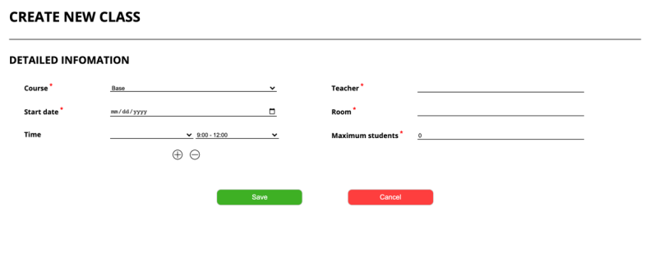

Function description:  
o Actor/Role: Staff (Manager, Coordinator)  
o Purpose: Create a new class in the center  
o Function Interface:

* Six text fields to insert information about class
* Two buttons (Save, Cancel)

Function Detail:

* The actor selects the course and then fills in information about the class.
* The system will verify all data that the actor fills in. If one of the data is not correct, the system will
* Show notification and change color to red, which field is not correct.
* If the actor clicks back will return to the list class page, and all data in create page will not save

1. Design the function test cases to test the above function using the “decision and extend the decision table” test design technique.
2. Create the high-level test-test-case with the test data for your test case designed above.

**Question 3:** Assume that you are assigned to do the System Test of the "Create class schedule" feature. The business process will include the following steps

Step 1: The Admin creates a new English class.  
Step 2: The Manager approves the new class schedule.   
Step 3: The teacher receives a notification email about the new class.  
Step 4: The teacher makes a confirmation about the assignment.  
Step 5: The system shows the new class information to students.

It would be best if you designed the test cases for normal flow and alternative flow for the above feature.

**\* Notes:**

- *Please feel free to add any assumptions needed for your answer to be more exact and clear.*