Garden measurement packet
Student copy. Distribute only the student activity.

Student activity
Read Table 1, then use Figure 1 to compare the measurements.
Table 1. Garden observations
Plant | Start height (cm) | End height (cm)
Bean | 4 | 10
Pea | 6 | 9
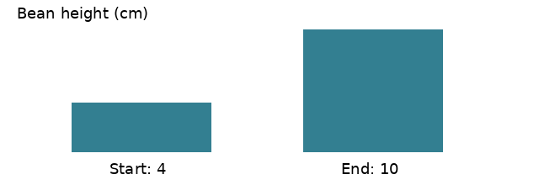
Figure 1. Bean height changes from 4 cm to 10 cm.
Q1. How many centimeters did the bean grow? Show the subtraction.
Q2. Which plant grew more? Use both differences.
Explain your reasoning.

Teacher guide
Teacher copy. Keep this complete answer key separate from student distribution.

Answer key
Table 2. Worked answers
Item | Worked answer | Common error
Q1 | 10 - 4 = 6 cm. | Subtracting in reverse order.
Q2 | Bean: 6 cm; pea: 3 cm.  Bean grew 3 cm more. | Comparing final heights instead of growth.
Rubric: 1 point for each correct difference; 1 point for comparison with units.
Explain your reasoning.

