Roof Estimate Evidence Appendix
SYNTHETIC EXAMPLE - NOT FOR SUBMISSION
Exhibits support the specified observations only. Original bytes and complete hashes are preserved in the case and run manifests.
Exhibit | Document and page | What it shows
E-BASE | D-4b7a6e9057262960-baseline p. 1 | Synthetic baseline estimate
E-PROP | D-ba2174ea0c6eca22-proposed p. 1 | Synthetic proposed estimate
E-NOTES | D-cfe89c3bb604fd9b-evidence p. 1 | Fictional scenario premises and limitations

Original document index
Document | Version | SHA256 prefix
D-4b7a6e9057262960-baseline | v1 | 4b7a6e9057262960
D-ba2174ea0c6eca22-proposed | v1 | ba2174ea0c6eca22
D-cfe89c3bb604fd9b-evidence | v1 | cfe89c3bb604fd9b

Numerical source trace
line:B1:quantity: 4; raw 4; D-4b7a6e9057262960-baseline p. 1; crop [88, 314, 1140, 354]; unit SQ.
line:B1:unit_price: 250; raw 250; D-4b7a6e9057262960-baseline p. 1; crop [88, 314, 1140, 354]; unit USD/SQ.
line:B1:reported_total: 1000.00; raw 1000.00; D-4b7a6e9057262960-baseline p. 1; crop [88, 314, 1140, 354]; unit USD.
line:P1:quantity: 6; raw 6; D-ba2174ea0c6eca22-proposed p. 1; crop [88, 314, 1140, 354]; unit SQ.
line:P1:unit_price: 250; raw 250; D-ba2174ea0c6eca22-proposed p. 1; crop [88, 314, 1140, 354]; unit USD/SQ.
line:P1:reported_total: 1500.00; raw 1500.00; D-ba2174ea0c6eca22-proposed p. 1; crop [88, 314, 1140, 354]; unit USD.
line:B2:quantity: 1; raw 1; D-4b7a6e9057262960-baseline p. 1; crop [88, 404, 1140, 444]; unit EA.
line:B2:unit_price: 180; raw 180; D-4b7a6e9057262960-baseline p. 1; crop [88, 404, 1140, 444]; unit USD/EA.
line:B2:reported_total: 180.00; raw 180.00; D-4b7a6e9057262960-baseline p. 1; crop [88, 404, 1140, 444]; unit USD.
line:P2:quantity: 1; raw 1; D-ba2174ea0c6eca22-proposed p. 1; crop [88, 404, 1140, 444]; unit EA.
line:P2:unit_price: 180; raw 180; D-ba2174ea0c6eca22-proposed p. 1; crop [88, 404, 1140, 444]; unit USD/EA.
line:P2:reported_total: 180.00; raw 180.00; D-ba2174ea0c6eca22-proposed p. 1; crop [88, 404, 1140, 444]; unit USD.
line:B3:quantity: 1; raw 1; D-4b7a6e9057262960-baseline p. 1; crop [88, 494, 1140, 534]; unit EA.
line:B3:unit_price: 100; raw 100; D-4b7a6e9057262960-baseline p. 1; crop [88, 494, 1140, 534]; unit USD/EA.
line:B3:reported_total: 100.00; raw 100.00; D-4b7a6e9057262960-baseline p. 1; crop [88, 494, 1140, 534]; unit USD.
line:P3:quantity: Unknown; raw Unknown; D-ba2174ea0c6eca22-proposed p. 1; crop [88, 494, 1140, 534]; unit EA.
line:P3:unit_price: 100; raw 100; D-ba2174ea0c6eca22-proposed p. 1; crop [88, 494, 1140, 534]; unit USD/EA.
line:P3:reported_total: Unknown; raw Unknown; D-ba2174ea0c6eca22-proposed p. 1; crop [88, 494, 1140, 534]; unit USD.
document:D-4b7a6e9057262960-baseline:reported_direct_total: 1280.00; raw 1280.00; D-4b7a6e9057262960-baseline p. 1; crop [88, 618, 1140, 662]; unit USD.
document:D-ba2174ea0c6eca22-proposed:reported_direct_total: Unknown; raw Unknown; D-ba2174ea0c6eca22-proposed p. 1; crop [88, 618, 1140, 662]; unit USD.

Evidence excerpts
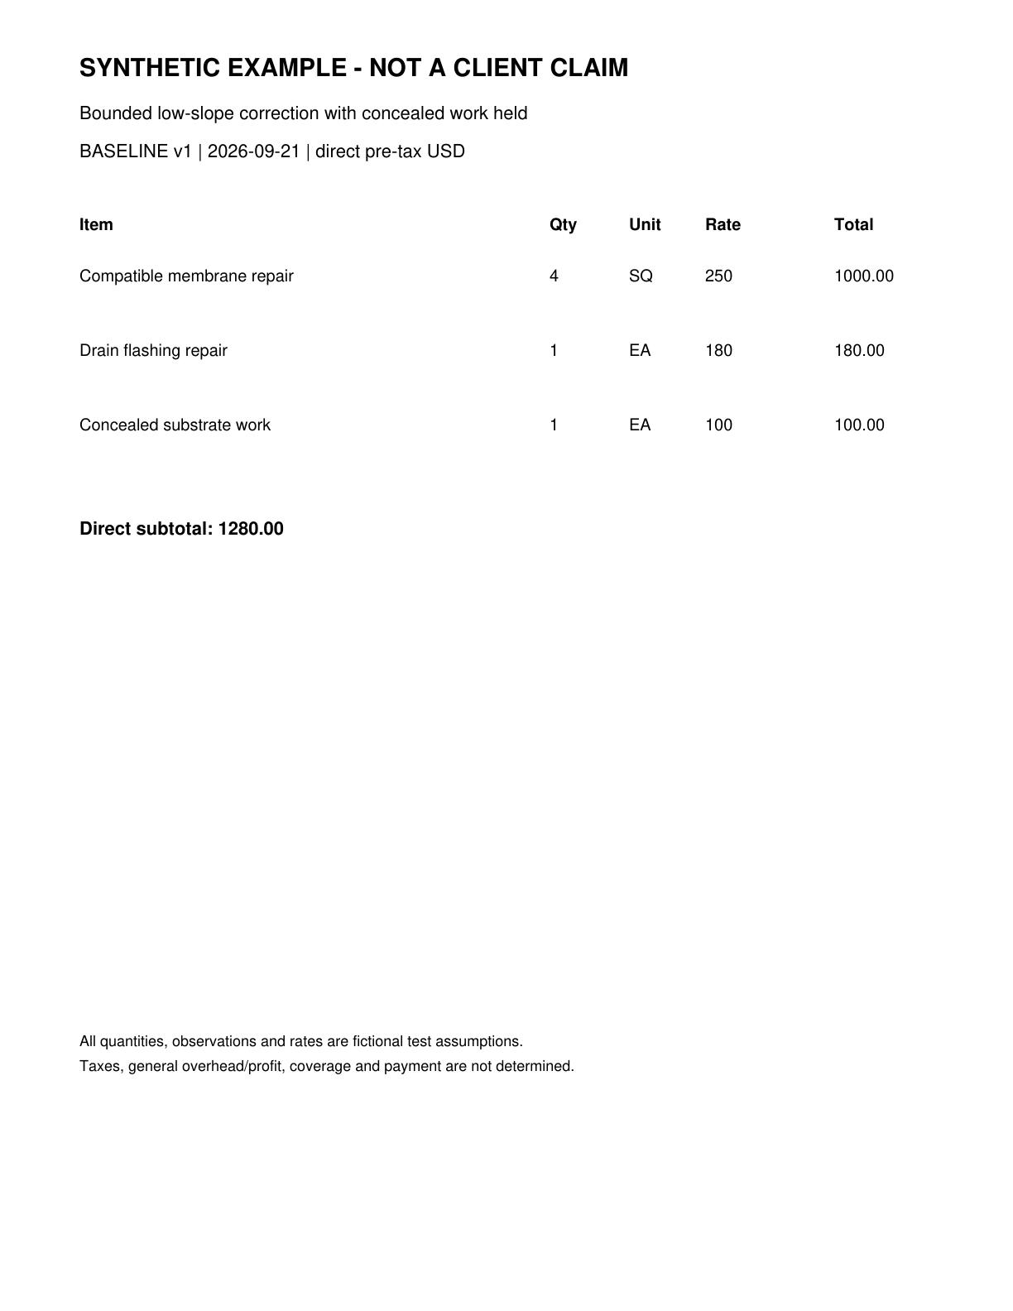
E-BASE | D-4b7a6e9057262960-baseline page 1 | Synthetic baseline estimate
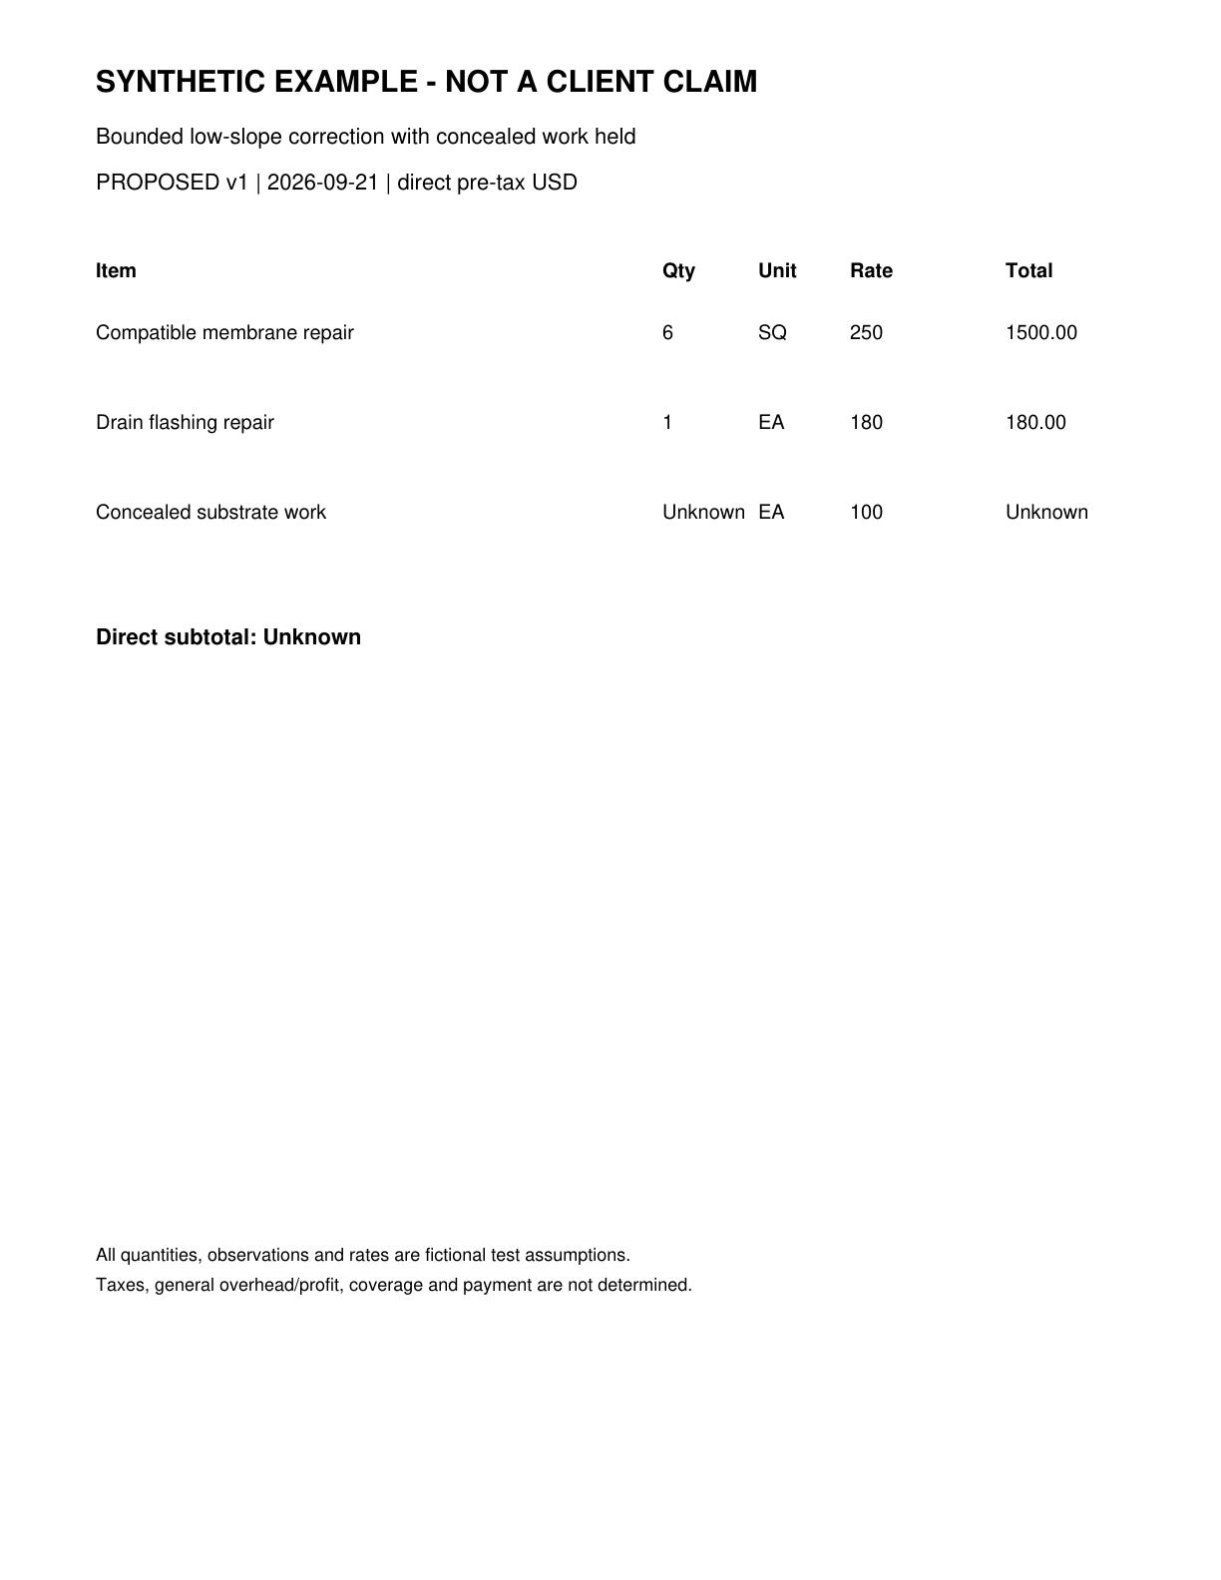
E-PROP | D-ba2174ea0c6eca22-proposed page 1 | Synthetic proposed estimate

Context packs considered
Context packs guide questions and writing. Their prices and rules are not automatically applied to this claim.
arizona-roofing-research 2026.09.21: Arizona roofing research context as of September 21 2026

