**PENIMEX** (LLC)

3/3 Urbanion (Klang Muang)

Srinakarin Road 46/1 Nong-Bon, Pravet

**BANGKOK** 10250 **THAILAND**

[](https://www.google.co.th/imgres?imgurl=http://images.freeimages.com/images/previews/5f7/telephone-icon-4-1159542.jpg&imgrefurl=http://www.freeimages.com/search/telephone-icon&docid=bUK0IP4zxK7i_M&tbnid=7Rk7mDkVDV7jyM:&w=440&h=440&bih=673&biw=1366&ved=0ahUKEwii5-jYi4_OAhVFso8KHeDdCOU4rAIQMwhFKEEwQQ&iact=mrc&uact=8) 

+66-95 915 5005 [penimex@gmail.com](mailto:penimex@gmail.com)

[](https://www.google.co.th/imgres?imgurl=http://image.shutterstock.com/z/stock-vector-airplane-truck-ship-worldwide-shipping-delivery-side-view-transportation-concept-set-296217011.jpg&imgrefurl=http://www.shutterstock.com/s/moored/search-vectors.html&docid=fjC8pMJKSd9IAM&tbnid=CW0PcgM5JocioM:&w=1500&h=1600&bih=673&biw=1366&ved=0ahUKEwiF-77K_ojOAhXDOI8KHeVtA7YQxiAIAg&iact=c&ictx=1)

[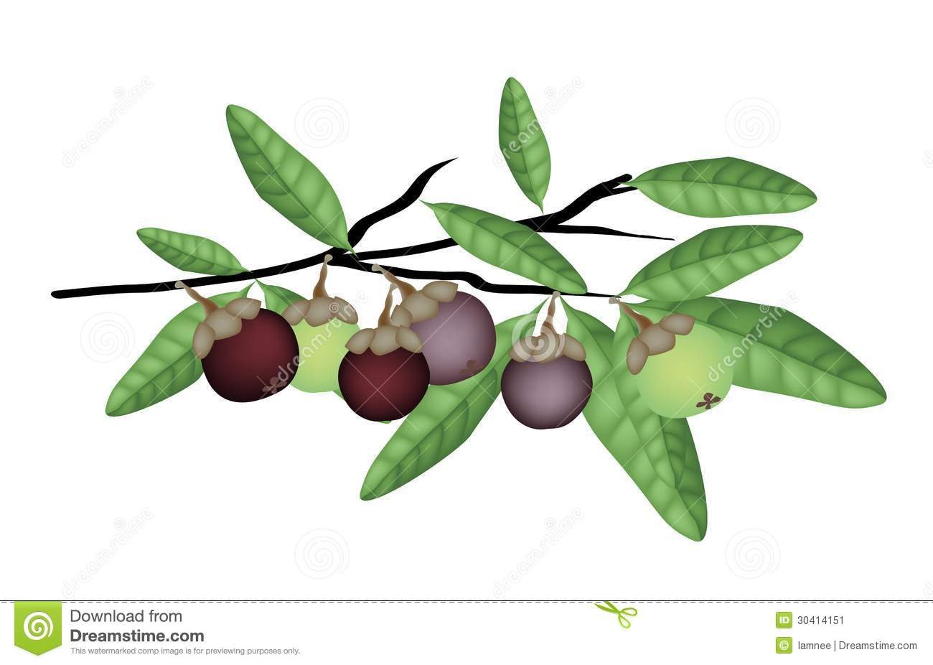](http://www.google.co.th/url?sa=i&rct=j&q=&esrc=s&source=images&cd=&cad=rja&uact=8&ved=0ahUKEwiXuaLC6IjOAhVBP48KHQrZCHsQjRwIBw&url=http://www.dreamstime.com/stock-image-fresh-purple-green-mangosteens-tree-branch-fruits-illustration-ripe-unripe-mangosteen-leaves-hanging-image30414151&psig=AFQjCNGwg_HQsRmPgPo6NVEdm-9jYU1qWg&ust=1469336677023537)

Global Shipping Mangosteens & More!

***Mangosteen – Celebrated fruit of the East***

*From the breathtaking* ***Tropics of Thailand****, freshly harvested at dawn from the Mangostana Tree*

*comes the* ***Mangosteen*** *– known as the* ***“Queen of the Fruit”*** *due to its* ***exotic & delightful***

*flavor which is as undefinable as the song of nightingale or the scent of the frangipani.*

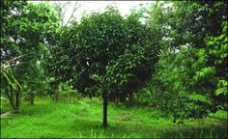

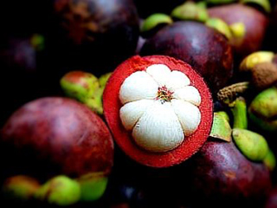



***Hand-selected and carefully packed***

*Each & every fruit is individually & carefully* ***Hand-Selected*** *by a highly-skilled-team, followed by precise* ***quality-control****, after which it’s* ***attractively-packed*** *and forwarded by* ***reliable***

***airfreight*** *to our valued* ***Global Consumers*** *on the* ***very same day****.*

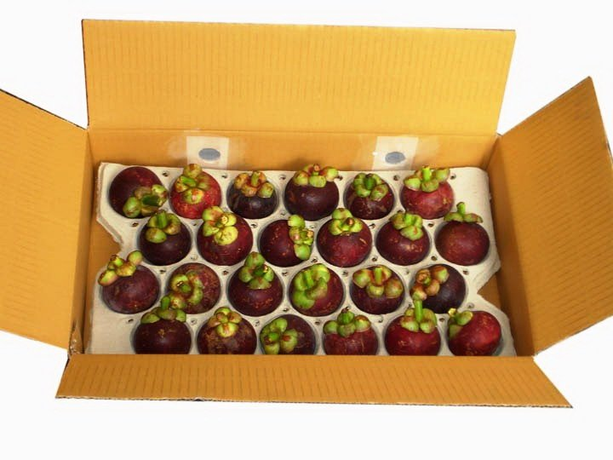

**24** Mangosteens

Net Weight **2** Kg

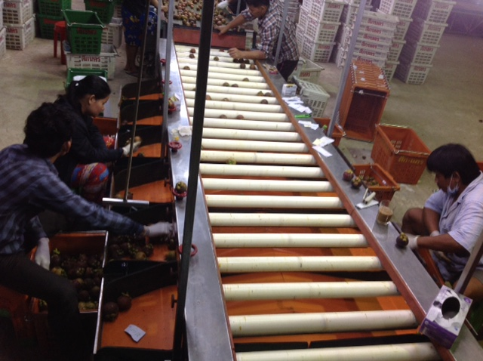

[](https://www.google.co.th/imgres?imgurl=http://image.shutterstock.com/z/stock-vector-airplane-truck-ship-worldwide-shipping-delivery-side-view-transportation-concept-set-296217011.jpg&imgrefurl=http://www.shutterstock.com/s/moored/search-vectors.html&docid=fjC8pMJKSd9IAM&tbnid=CW0PcgM5JocioM:&w=1500&h=1600&bih=673&biw=1366&ved=0ahUKEwiF-77K_ojOAhXDOI8KHeVtA7YQxiAIAg&iact=c&ictx=1)

sd

***Quality Control***

[](https://www.google.co.th/imgres?imgurl=http://pciphysics.com/site/wp-content/uploads/2014/06/13886315_ml.jpg&imgrefurl=http://pciphysics.com/site/?page_id=26&docid=tN1mH1oz9Pd9BM&tbnid=LfG-m7WfitStIM:&w=1337&h=1404&bih=673&biw=1366&ved=0ahUKEwj15sHuho_OAhXJo48KHdAhA6c4yAEQMwgWKBMwEw&iact=mrc&uact=8)

***By Top Management***

Max **24** hours

Port to Port.

For a **free quotation** kindly email the attached form to Penimex@gmail.com

P001

**SOUTHERN WAREHOUSE**

4018 Baan Cha-Aut

Nakhon Si Thammarat

Thailand

**HEAD OFFICE & DISPATCH**

3/3 Urbanion (Klang Muang)

Srinakarin Road 46/1 Bangkok

Thailand

**NORTH-EASTERN WAREHOUSE**

3158 Baan Sato

Chanthaburi

Thailand

***Eric Scheffer***

*DIRECTOR: PENIMEX (LLC)*

1. **CONTACT DETAILS**

Company Name: …………………………………………………………….. Contact Person: ………………………………………………………….

City: ………………………………… Country: …………………………….. Position: …………………………………………………………………….

Nearest Airport: ……………………………………………………………. Contact No: ………. - ………. - ………………….………………….. (Country Code - City Code- Number)

E- MAIL: ……………………………………………………………………………………………………..

**PenImex Quote Request**

1. **SIZE & QUANTITY SELECTION**

|  |  |  |  |  |  |  |  |
| --- | --- | --- | --- | --- | --- | --- | --- |
| **Grade &**  **Classification** | **Estimated Weight** | **Estimated Diameter** | **Select**  **[Related image](https://www.google.co.th/imgres?imgurl=http%3A%2F%2Fwww.iconsdb.com%2Ficons%2Fdownload%2Froyal-blue%2Fcheck-mark-3-512.jpg&imgrefurl=http%3A%2F%2Fwww.iconsdb.com%2Froyal-blue-icons%2Fcheck-mark-3-icon.html&docid=SI6JYqBOigLqoM&tbnid=kFsqqBCe1F1_MM%3A&w=512&h=512&bih=673&biw=1366&ved=0ahUKEwj3jo3dlI_OAhXFKY8KHdpuCjEQxiAIAygB&iact=c&ictx=1)** | 1  TON | 2  TONS | 2.5  TONS | 5  TONS |
| 3 A (AAA) | 75 g – 84 g | +- 30 mm |  |  |  |  |  |
| 4 A (AAAA) | 85 g – 94 g | + - 40 mm |  |  |  |  |  |
| 5 A (AAAAA) | 95 g – 105 g | + - 50 mm |  |  |  |  |  |

**\* 1 Ton orders for 1st time orders only.**

Sdf

**Estimated Dynamics**

**5 A** (AAAAA)

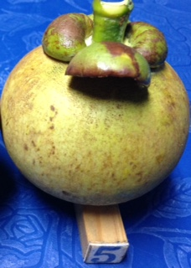

Approximate Height

50 mm

Approximate Diameter

50 mm

**3. PREFERRED RIND TYPE**

|  |  |
| --- | --- |
| **Rind** | **Select [Related image](https://www.google.co.th/imgres?imgurl=http%3A%2F%2Fwww.iconsdb.com%2Ficons%2Fdownload%2Froyal-blue%2Fcheck-mark-3-512.jpg&imgrefurl=http%3A%2F%2Fwww.iconsdb.com%2Froyal-blue-icons%2Fcheck-mark-3-icon.html&docid=SI6JYqBOigLqoM&tbnid=kFsqqBCe1F1_MM%3A&w=512&h=512&bih=673&biw=1366&ved=0ahUKEwj3jo3dlI_OAhXFKY8KHdpuCjEQxiAIAygB&iact=c&ictx=1)** |
| Smooth |  |
| Rough |  |

**\*Taste Unaffected**

**5. PREFERRED LEAF COUNT**

|  |  |
| --- | --- |
| **Leafs** | **Select [Related image](https://www.google.co.th/imgres?imgurl=http://www.iconsdb.com/icons/download/royal-blue/check-mark-3-512.jpg&imgrefurl=http://www.iconsdb.com/royal-blue-icons/check-mark-3-icon.html&docid=SI6JYqBOigLqoM&tbnid=kFsqqBCe1F1_MM:&w=512&h=512&bih=673&biw=1366&ved=0ahUKEwj3jo3dlI_OAhXFKY8KHdpuCjEQxiAIAygB&iact=c&ictx=1)** |
| 3 |  |
| 4 |  |

**\*Taste Unaffected**

**4. ACCEPTABLE RIND DAMAGE**

|  |  |
| --- | --- |
| **Damage** | **Select [Related image](https://www.google.co.th/imgres?imgurl=http%3A%2F%2Fwww.iconsdb.com%2Ficons%2Fdownload%2Froyal-blue%2Fcheck-mark-3-512.jpg&imgrefurl=http%3A%2F%2Fwww.iconsdb.com%2Froyal-blue-icons%2Fcheck-mark-3-icon.html&docid=SI6JYqBOigLqoM&tbnid=kFsqqBCe1F1_MM%3A&w=512&h=512&bih=673&biw=1366&ved=0ahUKEwj3jo3dlI_OAhXFKY8KHdpuCjEQxiAIAygB&iact=c&ictx=1)** |
| 5% |  |
| 10% |  |
| 15% |  |
| 20% |  |
| 25% |  |

For a **free quotation** kindly email the attached form to Penimex@gmail.com

**Mangosteen Facts**

Rich in water, energy, **protein**, carbohydrate and fiber. Essential nutrients such as calcium, iron, magnesium, phosphorus, potassium, sodium, zinc, copper and manganese are found in this fruit. It contains **vitamin C**, B6, B12 and A**.**

**Reduces Cholesterol**

**Boost Immunity**

**Prevents “Cellular Rust”**

**Controls blood pressure**

**Very affective Alzheimer treatment**

**High in antibacterial compound**

**Hightest Xanthone compound for skin treatment.**

**7. Additional Info Required?**

**6. Preferred maturing window**

|  |  |  |
| --- | --- | --- |
| **Appearance prior**  **to dispatch** | **Remarks** | **Select [Related image](https://www.google.co.th/imgres?imgurl=http://www.iconsdb.com/icons/download/royal-blue/check-mark-3-512.jpg&imgrefurl=http://www.iconsdb.com/royal-blue-icons/check-mark-3-icon.html&docid=SI6JYqBOigLqoM&tbnid=kFsqqBCe1F1_MM:&w=512&h=512&bih=673&biw=1366&ved=0ahUKEwj3jo3dlI_OAhXFKY8KHdpuCjEQxiAIAygB&iact=c&ictx=1)** |
| **C:\Users\NEXT Speed\AppData\Local\Microsoft\Windows\INetCache\IE\HFTVYJCI\FullSizeRender.jpg** | Approximate maturity:  5 - 7 days. |  |
| **C:\Users\NEXT Speed\AppData\Local\Microsoft\Windows\INetCache\IE\2WYW36F7\FullSizeRender (1).jpg** | Approximate maturity:  3 - 5 days. |  |
| C:\Users\NEXT Speed\AppData\Local\Microsoft\Windows\INetCache\IE\8YFRQFS8\FullSizeRender.jpg | Approximate maturity:  1 - 2 days |  |

**\*Refrigerated shelf-life up to 20 Days.**