Q-ClassCap: An End-to-End Structured Captioning Model for Classroom Activity Videos
Abstract. This study introduces a video captioning model designed for classroom surveillance videos, particularly those recorded in computer labs where student behaviors are often subtle, such as sitting still, focusing, using devices, brief interactions, or moving within the room. The model integrates visual features from VideoMAE and CLIP across three branches—Action Recognition, Object Identification, and Contextual Understanding—which are fused by Q-Former and decoded with DeepSeek-VL2Evaluated on a real-world classroom dataset, the model generates concise behavior descriptions and outperforms traditional baselines in capturing semantically meaningful micro-level behaviors, achieving a BLEU-4 score of 0.410 and a CIDEr score of 0.655.
Keywords: Video captioning, smart classroom, micro-behaviors, VideoMAE, GPT-2, DeepSeek-VL2, Q-Former.
- Introduction
With the growing use of AI in education, video captioning has emerged as a valuable tool for classroom monitoring by generating textual descriptions that support behavior analysis, anomaly detection, and pedagogical research. Yet, classroom surveillance—particularly in computer labs—often involves subtle, low-motion behaviors such as focusing on tasks, using devices, or brief interactions, which challenge conventional captioning models. To address this, we propose a classroom-tailored video captioning model with a multi-branch architecture that jointly captures action, object, and context features. Temporal action features are extracted using VideoMAE [1], while object and contextual cues are obtained via CLIP [2]. These features are subsequently fused using a Q-Former module [3], which facilitates effective cross-modal integration, and the final caption is generated using the DeepSeek-VL2 language model [4]. However, the model still relies heavily on the quality of the extracted features, making it sensitive to noisy or incomplete visual inputs. Furthermore, its computational cost during inference may limit real-time deployment in resource-constrained environments.
The main contributions include: (1) a query-based multi-head architecture for modeling fine-grained classroom behaviors; (2) compact fusion of multimodal features using Q-Former; and (3) empirical validation on classroom data showing clear gains over baselines. The remainder of this paper is organized as follows: Section 2 presents the model architecture. Section 3 describes the data. The experimental results are presented in Section 4 to demonstrate the effectiveness of our method. Section 5 includes remarks and future works.
- Model Architecture
The model architecture (Fig. 1) is designed with a modular and specialized head-based structure, aiming to fully exploit visual features that are relevant to student behaviors in classroom environments. The following types of features are utilized namely motion features, object features and contextual features (Fig. 2).

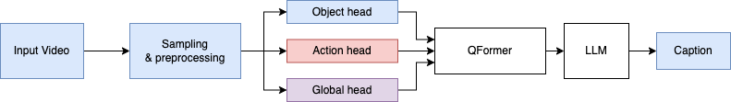
Fig. 1. Overview Architecture
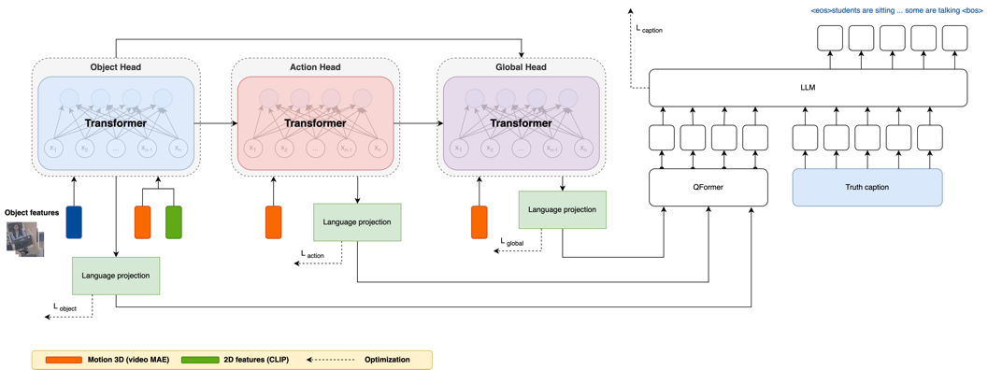
Fig. 2. The proposed Q-ClassCap works as a video encoder and language decoder that bridges the video's visual.
The outputs of the Object head, Action head, and Global head are fused using a Q-Former [3], an attention-based module that learns to integrate multi-branch inputs into a set of semantic query tokens. These tokens are then passed to a large language model (LLM) decoder - specifically, DeepSeek-VL2 [4] — to generate natural language captions for each video segment. The proposed model integrates multi-branch features (object, action, context) with Q-Former and DeepSeekVL2 to generate video captions, effectively addressing subtle behaviors in low-motion classroom environments — a largely underexplored direction.
  - Object Head: Retrieving key objects in video
The inputs to the Object Head include: Motion features $F_{\text{motion}}∈R^{B×T_1×D}$, object features $F_{\text{object}}∈R^{B×T_2×D}$ and context features $F_{\text{context}}∈R^{B×T_3×D}$: encoding the spatial and semantic layout of the classroom (Fig. 3).
These features are concatenated along the temporal axis and passed through a Transformer Encoder [5] to capture global correlations:
$F_{\text{enc}}=\text{Encoder}\left([F_{\text{motion}};F_{\text{object}};F_{\text{context}}]\right)$ (1)
Next, a set of learnable query vectors of size $P$ interacts with the encoded features through multi-head attention:
$O_{\text{raw}}=\text{Attention}(\text{queries}∈R^{P×D},F_{\text{enc}})$ (2)
Finally, the output $O_{\text{raw}}$ is projected through a linear layer to align it with the semantic space compatible with the language decoder:
$O_{\text{lang}}=\text{Project}(O_{\text{raw}})$ (3)
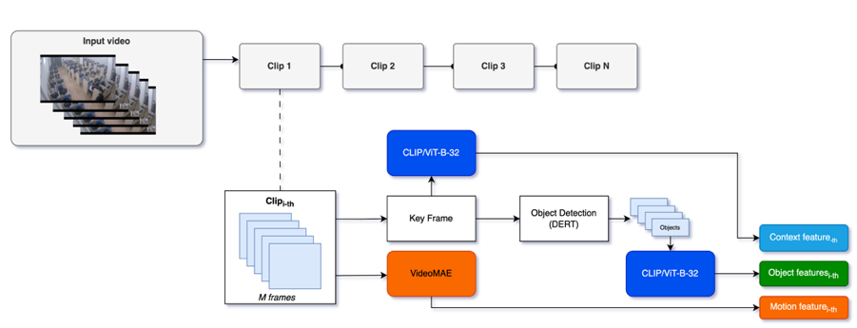
Fig. 3. The feature extraction process for objects, motion, and context.
  - Action Head: Inferring actions from objects and motion
The Action Head receives two types of features: $F_{\text{motion}}∈R^{B×N×D}$ - motion features extracted by VideoMAE and $F_{\text{object}}∈R^{B×P×D}$- output from the Object Head, representing the top important $P$ objects. First, we employ a learned attention mechanism to align motion with individual objects.
$A_{i,j}=tanh⁡(W⋅m_{i}+U⋅o_{j}+b)$ (4)
where $m_{i}$ denotes the $i$-th motion vector, $o_{j}$ denotes the $j$-th object vector, and $W,U,b$ are learnable parameters.
$F_{\text{motion}}^{'}=\text{LayerNorm}\left(\text{Linear}([F_{\text{motion}} ‖ \overset{ˆ}{O}])\right)$ (5)
$$F_{\text{action}}=\text{Attention}(\text{query}=F_{\text{object}},\text{ key}=F_{\text{motion}}^{'},\text{ value}=F_{\text{motion}}^{'})$$
Each object $p∈P$ obtains a corresponding action embedding.
$F_{\text{action-sem}}=\text{Normalize}(\text{Linear}(F_{\text{action}}))$ (6)
  - Global Head: Representing the overall video context
The Global Head takes three types of contextual features: $C∈R^{B×N×D}$, $C_{\text{obj}}∈R^{B×P×D}$ (from Object Head) and $C_{\text{act}}∈R^{B×P×D}$ (from Action Head). These features are concatenated along the sequence dimension:
$C_{\text{all}}=\text{concat}(C, C_{\text{obj}}, C_{\text{act}})∈R^{B×(N+2P)×D}$ (7)
$$H_{\text{ctx}}=\text{TransformerEncoder}(C_{\text{all}})$$
$$H_{\text{sem}}=\text{Linear}\left(H_{\text{ctx}}\right)$$
Aggregation and projection: $v_{\text{global}}=\frac{1}{T}\sum_{i=1}^{T}{ }H_{\text{sem},i} \text{with }T=N+2P$ (8)
$$v_{\text{lang}}=\text{Linear}(v_{\text{global}})$$
  - Caption Head: Generating language captions with Q-Former and DeepSeekVL2
The Caption Head is the component responsible for generating concise textual descriptions of videos, based on the semantic features extracted and organized by the preceding branches. Instead of feeding object, action, and context features directly into the decoder, Q-Former reorganizes the information into learnable query tokens. The embedding sequence $Z_{\text{query}}$ is used as a prefix embedding - visual prompt input for the LLM. A textual prompt (e.g., "describe what is happening") is encoded into input token IDs.
  - Objective function
To effectively train the model and maximize the utility of each feature branch, a multi-task learning approach namely the Hungarian Loss is used for both Object head $L_{\text{object}}$ and Action head $L_{\text{action}}$ to find the best match between predicted and reference objects/actions using reference objects/actions extracted from ground-truth captions and embedded via [6]; Cosine loss for Global head that compare the output to the caption embedding; Cross-Entropy Loss for Caption Head $L_{\text{caption}}$, the caption head is trained in an autoregressive manner using token-level cross-entropy. The final objective combines all loss terms with weighted coefficients:
$L_{\text{total}}=λ_{1}L_{\text{object}}+λ_{2}L_{\text{action}}+λ_{3}L_{\text{global}}+λ_{4}L_{\text{caption}}$ (9)
In our experiments: $λ_{1}=0.2$, $λ_{2}=0.2$ for balanced learning of object and action, $λ_{3}=0.2$ to support context modeling and $λ_{4}=0.4$ prioritizing high-quality captions.
- Model training
  - Dataset, preprocessing and training strategy
The model is trained on videos recorded in a university computer lab, each lasting 10–20 seconds and capturing typical student behaviors such as studying, typing, using devices, brief interactions, or entering/exiting. Each video is annotated with 1–3 short captions (8–15 words), written independently by three annotators and retained only if over 80% agreement is achieved. To construct the training samples, each video is divided into 15 equally spaced clips. For each clip, 16 frames are uniformly sampled to form a motion sequence, which is then fed into VideoMAE for temporal feature extraction. Additionally, the central frame of each clip is selected as a keyframe, resulting in 15 keyframes per video, which are used for object detection and spatial feature extraction via CLIP. Captions are further encoded using Sentence-BERT [7] to obtain semantic embeddings.The model is trained end-to-end, jointly updating all heads (object, action, context) and the language decoder (DeepSeekVL2) using AdamW = 1e – 5 with weight decay).
- Experiments
To comprehensively assess the effectiveness and generalizability of the proposed model, a series of experiments is conducted covering five main aspects. All experiments are evaluated using standard video captioning metrics, including BLEU-4, METEOR, CIDEr, and ROUGE-L, calculated by comparing generated captions with human-annotated references.
To ensure a fair comparison, all baseline models were trained under the same experimental settings, using identical hyperparameters (optimizer, learning rate schedule, batch size, and number of epochs). The only difference lies in the model architectures, i.e., the feature fusion strategy and language decoder design

Experiment 1: Generalization on public datasets. The models pretrain the proposed model on VATEX [8], and evaluate separately on each test set. The results are also compared to recent benchmarks without using external data. The model achieves strong performance when trained on VATEX, with BLEU-4 and CIDEr scores (0.320 and 0.533 respectively shown in Table 1) comparable to or exceeding recent models that do not rely on external data. This indicates that the combination of DeepSeekVL2 and Q-Former is capable of capturing fine-grained semantic structures from vision-language data.
Table 1. Comparison with recent benchmarks without using external data
Model | BLEU-4 | METEOR | CIDEr | ROUGE-L
NITS-VC (2020) [9] | 0.200 | 0.180 | 0.240 | 0.420
VASTA (2022) [10] | 0.362 | 0.253 | 0.650 | 0.518
CoCap (2023) [11] | 0.358 | 0.253 | 0.648 | 0.520
Ours | 0.320 | 0.242 | 0.533 | 0.410

Experiment 2: Baseline models trained on classroom data.
Various baseline architectures are fined-tune using the classroom dataset while keeping pretrained weights on VATEX and MSR-VTT (Table 2 and Fig. 4).
Table 2. Fine-tuned baseline models on classroom data (pretrained on VATEX and MSR-VTT)
Baseline Architecture | BLEU-4 | METEOR | CIDEr | ROUGE-L
VideoMAE + GPT-2 | 0.202 | 0.172 | 0.278 | 0.442
VideoMAE + DeepSeekVL2 | 0.218 | 0.179 | 0.295 | 0.456
VideoMAE + Simple Transformer | 0.180 | 0.158 | 0.242 | 0.415
CLIP keyframes + GPT-2 | 0.225 | 0.185 | 0.305 | 0.465
CLIP keyframes + DeepSeekVL2 | 0.238 | 0.191 | 0.320 | 0.472
CLIP keyframes + Simple Transformer | 0.195 | 0.165 | 0.260 | 0.428
Ours (DeepSeekVL2 + Q-Former) | 0.410 | 0.453 | 0.655 | 0.629
Ours (GPT-2 + Q-Former) | 0.350 | 0.252 | 0.515 | 0.548

Fine-tuning on classroom videos greatly enhances captioning quality, surpassing all baselines across metrics (Table 2). Q-Former enables efficient fusion of object, motion, and context features into a compact query-based representation, well-suited for subtle and sparse classroom behaviors. While CLIP keyframes with DeepSeek-VL2 perform reasonably by leveraging strong spatial features and language modeling, the lack of structured multi-head fusion limits their ability to capture micro-behaviors. Our results show that explicitly organizing modalities through dedicated heads outperforms naive concatenation or single-stream models.

Experiment 3: Ablation study. A component-wise ablation study is performed by removing individual feature heads and re-evaluating the model. Ablation results in Table 3 underscore the necessity of all three semantic heads. The removal of any head results in a consistent drop in performance, with the context head having the most significant impact on CIDEr and ROUGE-L scores. This aligns with the intuition that understanding spatial layout and background activity is essential for generating coherent captions in structured environments like classrooms.
Table 3. Component-wise ablation results: impact of removing individual feature heads
Configuration | BLEU-4 | METEOR | CIDEr | ROUGE-L
Full model | 0.410 | 0.453 | 0.655 | 0.629
w/o Object Head | 0.298 | 0.228 | 0.442 | 0.510
w/o Action Head | 0.285 | 0.221 | 0.426 | 0.498
w/o Context Head | 0.281 | 0.218 | 0.419 | 0.492
Table 4. Qualitative Ablation Examples
Setting | Example Caption
Ground-truth | The students are sitting in the computer classroom, some students are talking, a student is using a phone.
Full Model | The students are sitting in the computer classroom, some students are talking, a student is using phone.
w/o Object Head | The students are sitting in the classroom, some students are talking.
w/o Action Head | The students are sitting in the computer classroom, some students are using devices.
w/o Context Head | The students are sitting, some students are talking.
Analysis. Each semantic head contributes uniquely: the Object Head introduces fine-grained entities (e.g., phone), the Action Head provides dynamic behaviors (e.g., talking, moving), and the Context Head adds spatial grounding (e.g., in the computer classroom). Removing any head leads to incomplete or less informative captions.
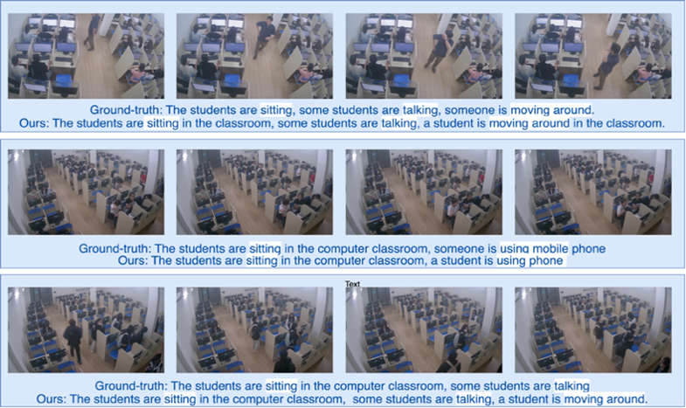
Fig. 4. Experimental evaluation of the video captioning model on classroom scenarios
- Conclusion
This paper introduces a multi-branch video captioning model for low-motion, context-specific domains such as classroom surveillance. By integrating object, action, and scene features with Q-Former and decoding captions using DeepSeekVL2, the model performs well on VATEX and MSR-VTT but struggles when applied directly to classroom videos (CIDEr: 0.158). Fine-tuning on classroom data markedly improves performance, surpassing all baselines, with Q-Former proving especially effective in visually sparse settings. While CLIP with DeepSeekVL2 provides strong spatial-language alignment, the lack of feature fusion limits detailed interaction modeling. Our architecture, with dedicated semantic heads, achieves superior results, underscoring the benefit of structured representation learning combined with powerful language modeling. Future directions include multi-view setups, temporal reasoning, and bilingual captions.

References
- Z. T. a. Y. S. a. J. W. a. L. Wang, "VideoMAE: Masked Autoencoders are Data-Efficient Learners for Self-Supervised Video Pre-Training," NeurIPS, 2022.
- A. R. e. al., "Learning Transferable Visual Models From Natural Language Supervision," ICML, 2021.
- Z. L. e. al., "BLIP-2: Bootstrapping Language-Image Pre-training with Frozen Image Encoders and Large Language Models," CVPR, 2023.
- e. a. Zhiyu Wu, "Understanding, DeepSeek-VL2: Mixture-of-Experts Vision-Language Models for Advanced Multimodal," 2024.
- Vaswani, et al., "Attention Is All You Need," Advances in Neural Information Processing Systems, p. https://arxiv.org/abs/1706.03762, 2017.
- F. M. G. S. N. U. A. K. S. Z. Nicolas Carion, "End-to-End Object Detection with Transformers," European Conference on Computer Vision, 2020.
- N. a. G. I. Reimers, "Sentence-BERT: Sentence Embeddings using Siamese BERT-Networks," Proceedings of the 2019 Conference on Empirical Methods in Natural Language Processing, 2019.
- X. a. W. J. a. C. J. a. L. L. a. W. Y.-F. a. Y. A. a. X. C. Wang, "VaTeX: A Large-Scale, High-Quality Multilingual Dataset for Video-and-Language Research," Proceedings of the IEEE/CVF International Conference on Computer Vision (ICCV), 2019.
- T. D. S. S. B. Alok Singh, "NITS-VC System for VATEX Video Captioning Challenge 2020," Workshop on Language & Vision with applications to Video Understanding (LVVU 2020) - In conjunction with CVPR 2020.
- Z. G. a. L. S. a. H. P. A. Lensch, "Diverse Video Captioning by Adaptive Spatio-temporal Attention," 2022.
- X. G. K. X. H. F. L. W. L. Z. Yaojie She, "Accurate and Fast Compressed Video Captioning," Computer Vision and Pattern Recognition, 2023.

