CURRICULUM VITEA

Personal Information
Full Name: | 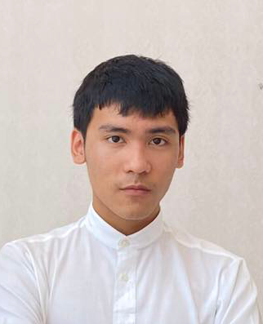  Le Duc Thang
Gender: | Male
Day of Birth: | 09/08/2001
Contact Information
Address:  Phone:  Email: | 447/25 Ton Duc Thang street, Lien Chieu district, Da Nang city.  0943409227  tudaydada@gmail.com
Education
9/2019 – Current | School: The University of Danang, University of Education  Faculty: Science of Computer  Major: Information Technology.
Work Experience
- Researching and learning personal project, it’s consisted of website system by using JSP/Servlet, Spring, ASP.NET.
- Researching and learning PythonDjango, DataMining.
Skill
Main Skill: | - Using Java, C#, HTML, CSS, Javascript, JQuery, Spring Framework…  - Using SQL Server, MySQL.
Other Skills: | - Good in listening and acquiring.  - Work independently with high responsibility.  - Can bear pressure of job.
Hobbies: | - Playing football, guitar, 8 ball pool.  - Singing.
Carrer goals
Desired place: | .NET internship
Kind of job: | Fulltime/Parttime job.
Desired job: | Access to a professional working environment and be instructed more of everyone, make more friends, improve soft skill. Join in reality project for improving specialized knowledge…

