Online Energy Utility Platform
Zaharia Tudorita
Faculty of Computer Science, Technical University of Cluj-Napoca
Requirements
An online platform should be designed and implemented to manage users, their associated smart energy metering devices, and the monitored data from each device. The system can be accessed by two types of users after a login process: administrator (manager), and clients. The administrator can perform CRUD (Create-Read-Update-Delete) operations on user accounts (defined by ID, name, role: admin/client), registered smart energy metering devices (defined by ID, description, address, maximum hourly energy consumption), and on the mapping of users to devices (each user can own one or more smart devices in different locations). After the mapping is done, for each device the energy consumption is stored on hourly basis as tuples of the form in the database.

- Conceptual Architecture
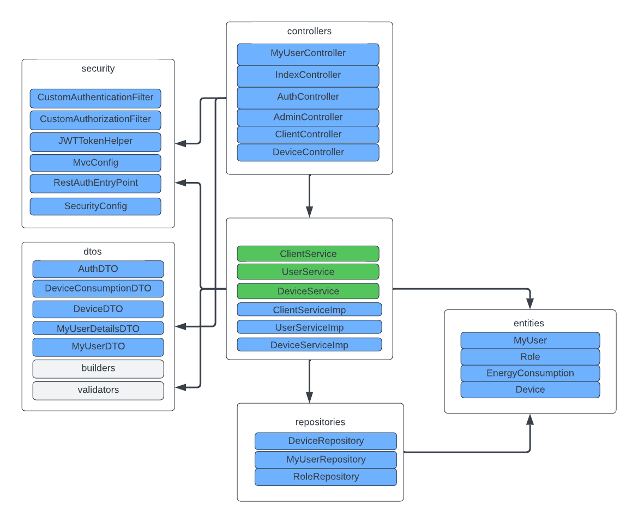
In the first figure, we present the conceptual backend architecture starting with the controllers. For authentication it was designated a controller handling authentication and authorization.
Figure 1. Backend architecture
Instead of person there is a MyUser along with Client, Admin and Device in controller package for managing class-specific requests and for ensuring better security when applying filters for authorization. In the service package, user services implements CRUD operations on user, such does the device service. Only the client service is ensuring the client specific tasks are dealt with in a separated class. For each class, there is an interface to ensure that some elementary SOLID principles are applied.

1.2. Frontend Architecture

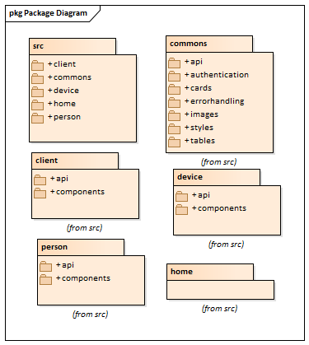
The frontend application is structured around the source package. Inside, there are all the pages for different users (person and client). To be noted that in the frontend architecture, the administrator is handled by the person package. Each user-centred package contains an api package with user-specific methods and components package with different bar charts, tables, containers etc. The home package contains the first page where the user logs in. Considering that this is a prototype, the authentication step was facilitated by choosing a wild card with either user or administrator if that is the case. The package commons has, as its name suggests, files used by all other packages, such as background images, table formats or wild card formats, but even authentication api for handling types of users and redirecting them to their designed pages (package).
Figure 2. Frontend architecture

- Database Design

In the second figure, we observe the database diagram along with all its tables.
The database contains a central user mapped to roles. A role defines its grants and permission within the application methods. An example of a role is ADMIN – he has granted all permissions.
Users have a many to many devices’ relationship. Devices as well have a 1: N relationship with energy consumption. The entire database was created because of hibernate sequences.
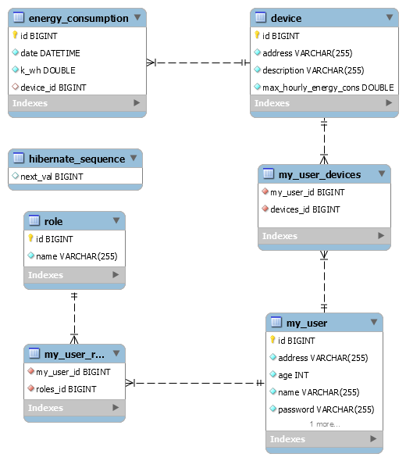

- Deployment Diagram

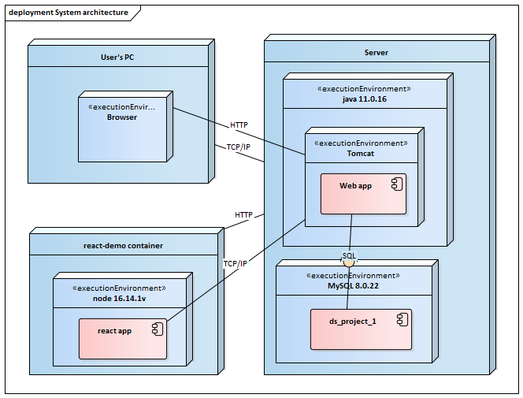
The application was deployed using docker containers. We created an image for database, frontend, and backend. Each image was afterwards configured such that it would communicate with the container images and not with localhost as we usually do in development phase. To be taken into consideration that for the spring boot application, the development used jdk 11.0.16. The frontend application was implemented using ReactJS with node 16.14.1v. The application contains a relational database in MySQL Community Server version 8.0.22. The application interacts well with the docker image for the frontend. To be noted that there are multiple errors when creating the spring container because of database connection being either refused or poorly defined.

- Conceptual Diagram
Database
React app
DTO
Controllers
Services
Repositories
Entities
Presentation Layer
Business Layer
Data Layer
In the conceptual diagram we can observe the 3-tier architecture. The presentation layer, also known as the client layer, sends a request towards backend with HTTP and a DTO object. The business layer assesses the data and applies the necessary business logic accordingly. Data layer, or database, will fetch the necessary data to perform the business functions.

