Smart Metering Device Simulator
Zaharia Tudorita
Faculty of Computer Science, Technical University of Cluj-Napoca
Requirements
It will simulate a sensor by reading energy data from a file and sends data to the Message Broker. The timestamp is taken from the local clock, the measurement value is read from the file and represents the energy measured in kWh, and the device id is unique to each instance of the Smart Metering Device Simulator and corresponds to the device id of a user from the database. A Message Consumer application will pre-process the data to compute the total hourly energy consumption and stores it in the database. If the computed total hourly energy consumption exceeds the smart device maximum value (as defined in Assignment 1) it notifies asynchronously the user on his/her web interface.

- Conceptual Architecture
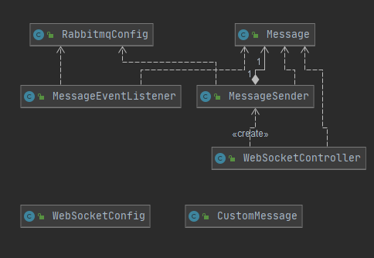
In the first figure, we present the conceptual architecture for the package RabbitMQ. In this package we have a hierarchy of classes specifically used only for the publisher-consumer pattern. First, we have a stomp socket controller to communicate between client and server. We also used two configuration classes for sockets and rabbit queue. The publisher is represented by the Message Sender and the consumer by Message Event Listener.

Figure 1. Backend architecture
- Deployment Diagram
The application was deployed using docker containers. We created an image for database, frontend, backend, and RabbitMQ. What was previously modified is that the backend communicates with the database and RabbitMQ through assigned subnet IPs. Application was locally deployed, working on localhost with port map 3001 for the client side.
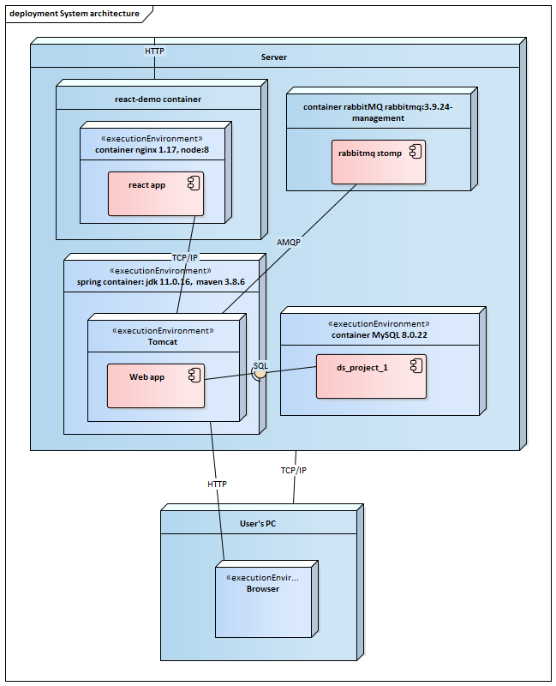

- Conceptual Diagram
Despite the total abstractization between layers, when using web sockets, the client interacts directly with the queue by listening to it every 100 ms. When the react client creates a new mapping of type (client, device) , he calls the controller from RabbitMQ package and then the producer calls the RabbitMQ topic

DTO
Controllers
Services
Repositories
Entities
Database
React Client
Presentation Layer
Business Layer
Data Layer
RabbitMQ
RabbitMQ

