/*EX. 3.A)

Am adaugat coloana numar in tabelul info_dept_gta, care tine numarul de angajati dintr-un anume departament. Am adaugat date. Acest lucru se va vedea in trigger, care update-aza coloana numar din tabel, updatand-o de fiecare data cand exista o schimbare in tabela info_emp_gta.

EX.3.B) TRIGGERUL:

*/

create or replace trigger trigger_emp_dept

after insert or update or delete on info_emp_gta

for each row

begin

if inserting then

merge into info_dept_gta c

using dual d

on (:new.id_dept = c.id_dept)

when matched then update set

c.numar = c.numar + 1

when not matched then insert (id_dept, numar)

values (:new.id_dept, 1);

elsif deleting then

update info_dept_gta c set

c.numar = c.numar - 1

where c.id_dept = :old.id_dept;

elsif updating then

if :new.id_dept <> :old.id_dept then

update info_dept_gta c set

c.numar = c.numar - 1

where c.id_dept = :old.id_dept;

merge into info_dept_gta c

using dual d

on (:new.id_dept = c.id_dept)

when matched then update set

c.numar = c.numar + 1

when not matched then insert (id_dept, numar)

values (:new.id_dept, 1);

end if;

end if;

end;

/

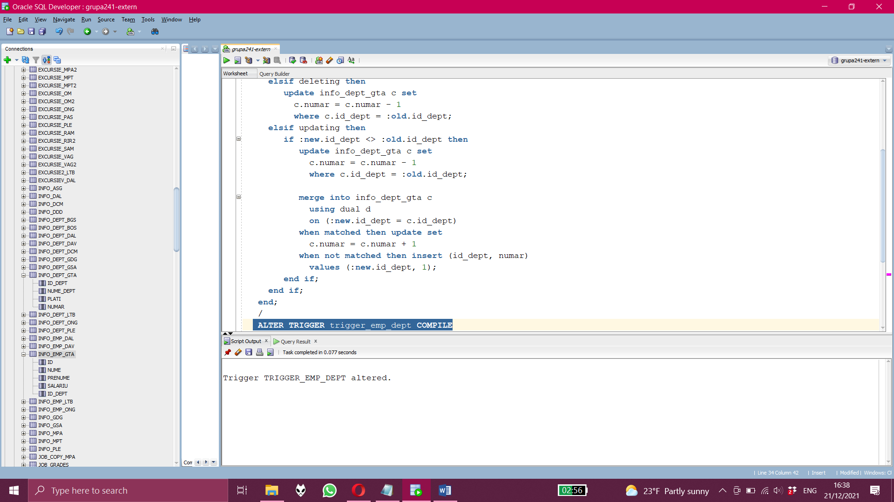

/*Aici compilez triggerul, compileaza cu succes*/

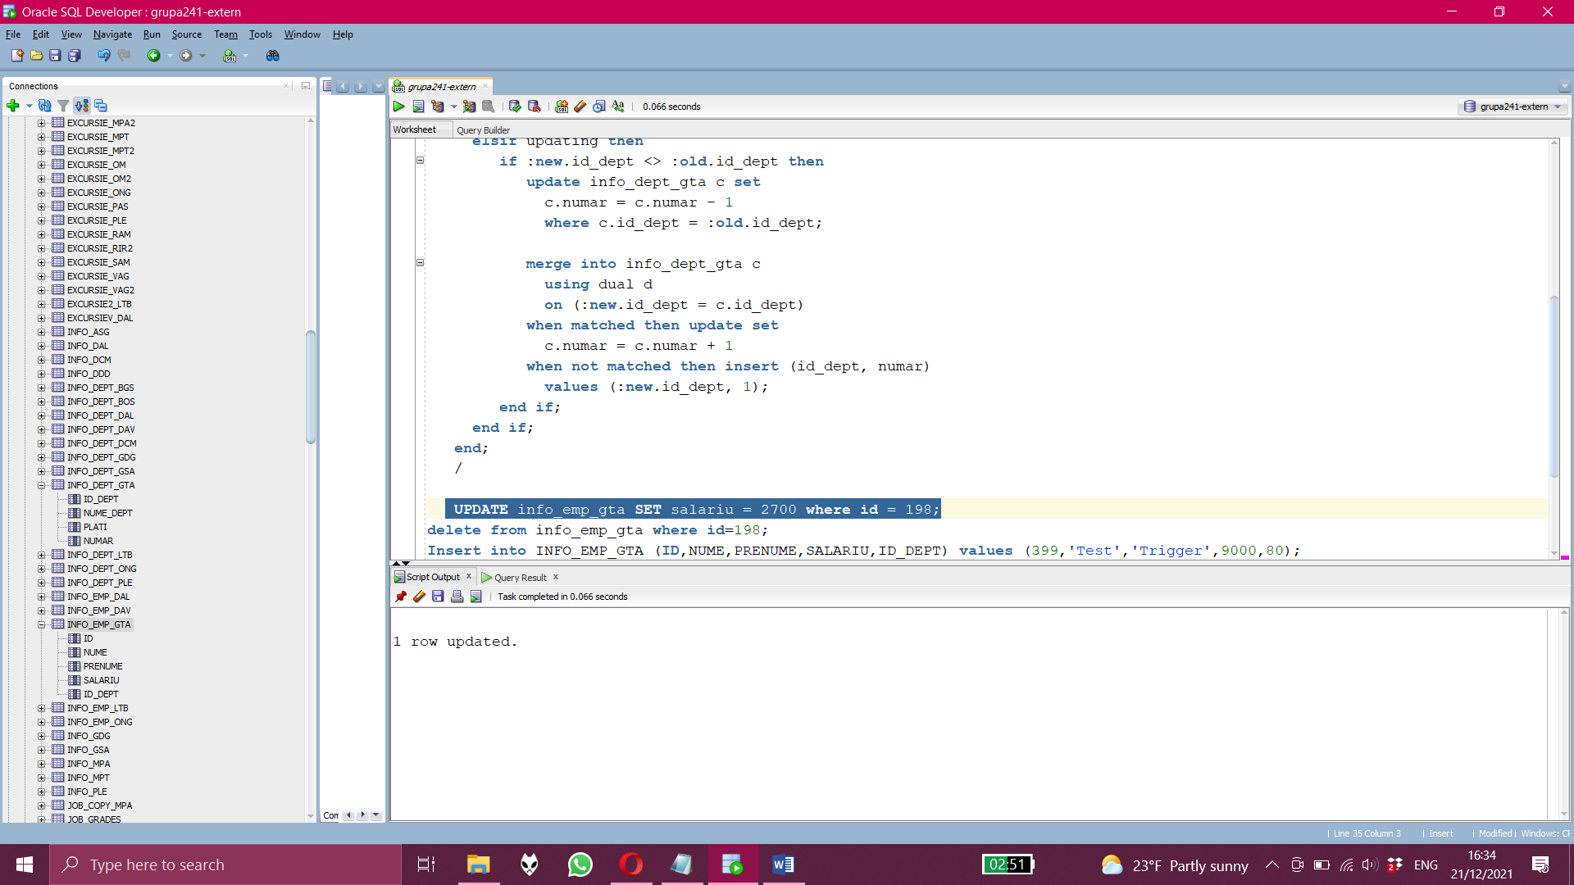

/*Aici rulez o comanda de update in tabel*/

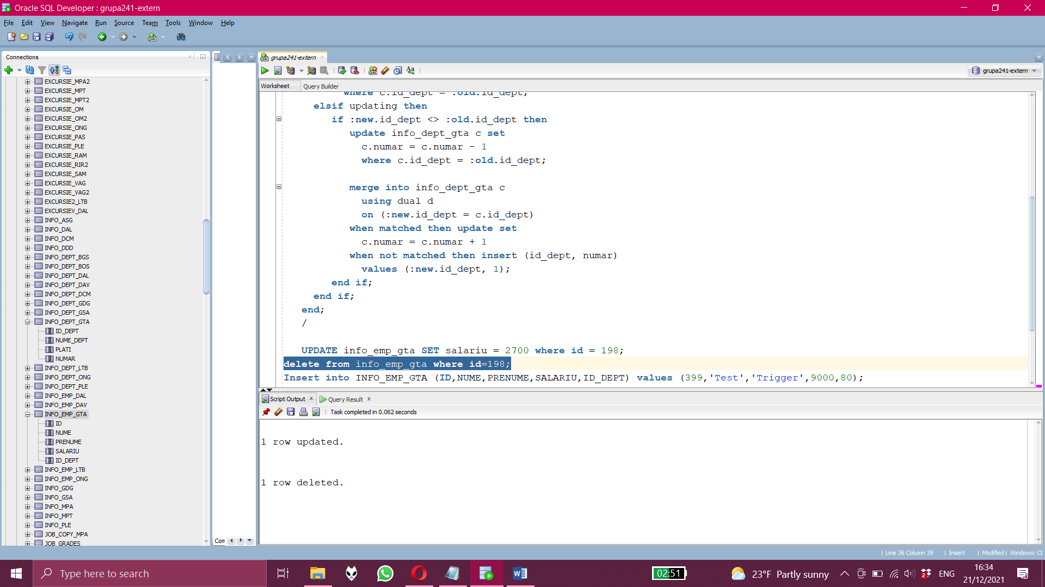

/*Aici rulez o comanda de delete in tabel*/

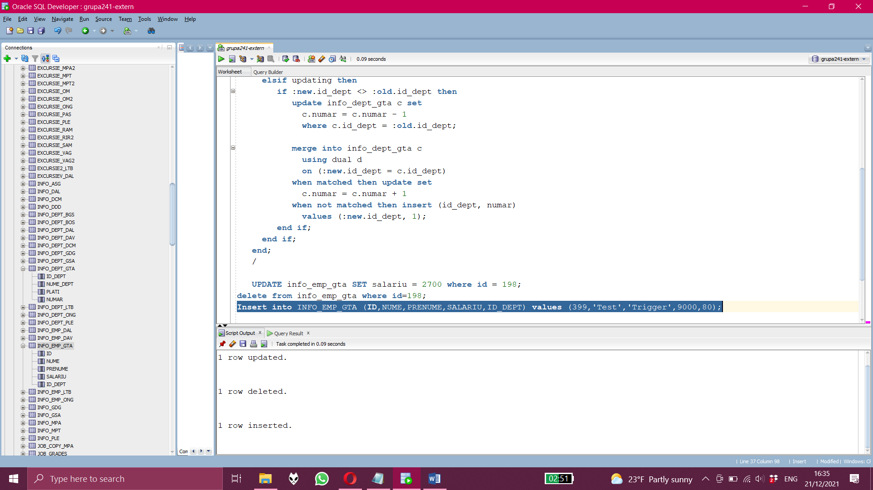/*Aici rulez o comanda de insert in tabel. Toate aceste comenzi sunt incluse in trigger astfel incat trigger-ul este apelat la fiecare astfel de comanda*/