1.       Build a procedure that receives by parameter a calendar year (e.g., 2018). The salaries of employees who brokered at least 3 orders in that year will be increased by 10%. The number of increased salaries will be returned by a parameter. If no employee has brokered orders in that year, an exception will be raised. The procedure will be called from an anonymous block where the exception raised in the procedure will be dealt with.

CREATE OR REPLACE PROCEDURE proc( p_year number,p_no OUT number) is

n number;

BEGIN

update employees

set salary=salary*1.1

where employee_id in (select sales_rep_id from orders where employee_id=sales_rep_id and p_year=EXTRACT(YEAR FROM ORDER_DATE) group by sales_rep_id having count(order_id)>=3);

p_no:=SQL%ROWCOUNT;

end;

/

set serveroutput on

declare

no_salary EXCEPTION;

n number;

begin

proc(2018,n);

SYS.dbms_output.put_line('NO. Salaries increased: '||n|| '.');

IF SQL%NOTFOUND THEN

RAISE no_salary;

end if;

EXCEPTION WHEN no_salary THEN

dbms_output.put_line('No update!');

WHEN OTHERS THEN

dbms_output.put_line('Another error!');

end;

/

select employee_id, sales_rep_id,last_name, count(order_id)

from employees, orders

where employee_id=sales_rep_id and EXTRACT(YEAR FROM ORDER_DATE)='2018'

group by employee_id, sales_rep_id, last_name having count(order_id)>=3;

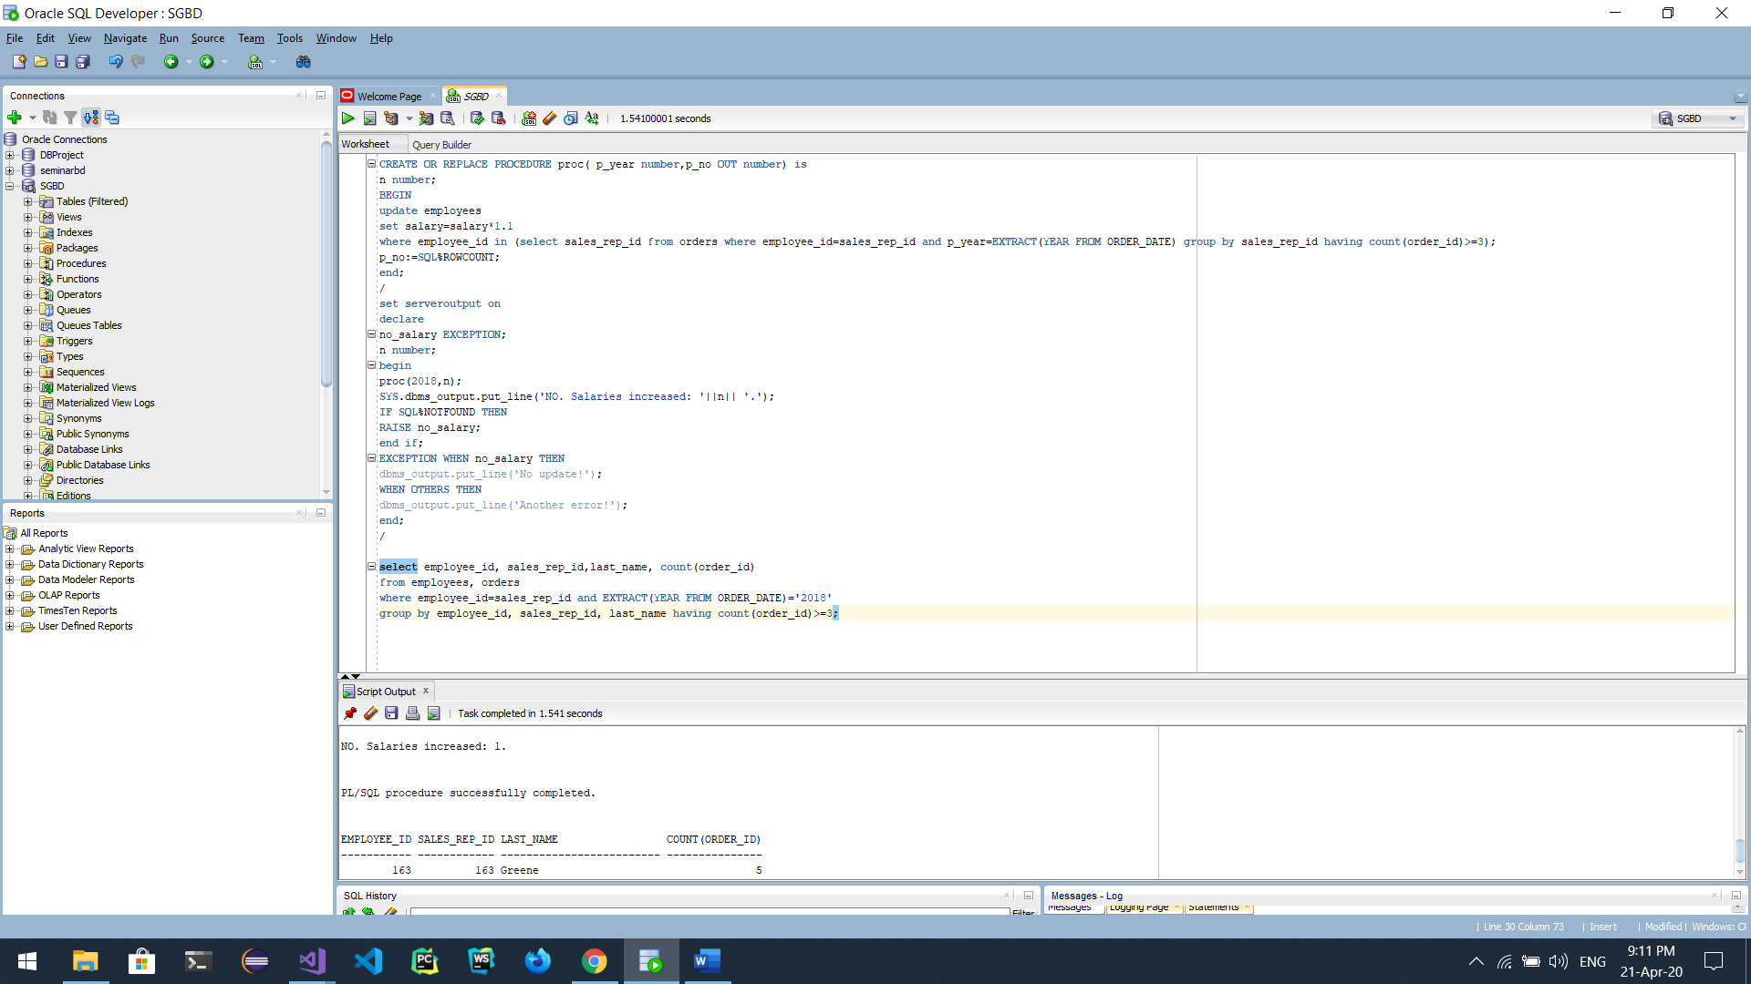

2.       Build a function that receives a product's id and deletes that product. If that product cannot be deleted because it appears on the orders, those rows (order_items) will be deleted first.  The function will return YES if the product exists and has been deleted and NO otherwise. Call the function from an anonymous block.

CREATE OR REPLACE FUNCTION DELETE_PRODUCT (P NUMBER)

RETURN VARCHAR IS

X VARCHAR2(5);

BEGIN

DELETE FROM ORDER_ITEMS WHERE PRODUCT_ID=P;

DELETE FROM PRODUCT_INFORMATION WHERE PRODUCT_ID=P;

IF SQL%ROWCOUNT=1

THEN

X:='YES';

RETURN X;

ELSE X:='NO';

RETURN X;

END IF;

END DELETE_PRODUCT;

/

SET SERVEROUTPUT ON

DECLARE

DP VARCHAR2(5);

BEGIN

DP:=DELETE_PRODUCT(55555);

DBMS_OUTPUT.PUT_LINE(DP);

END;

/

ROLLBACK;

