**Week 2**

**Chair:** Sever

**Notes:** Irtaza

**Application Components and Libraries:**

**Serverside(Back end):** Spring

**Clientside (Front end):** Spring MVC

**GUI:** JavaFX

**Server + Database:** JDBC

**Goals:**

This week:

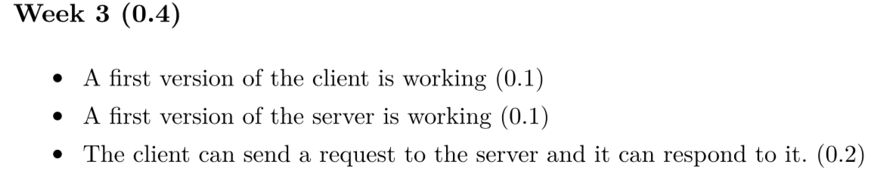

* Agenda
* Sprint plan
* Meeting notes
* Scrum review
* Checkstyle report
* Code coverage report
* The release of our current functionality

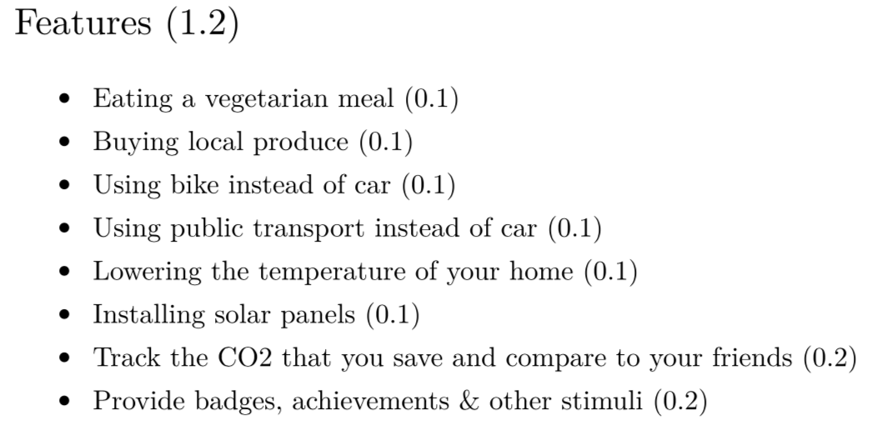

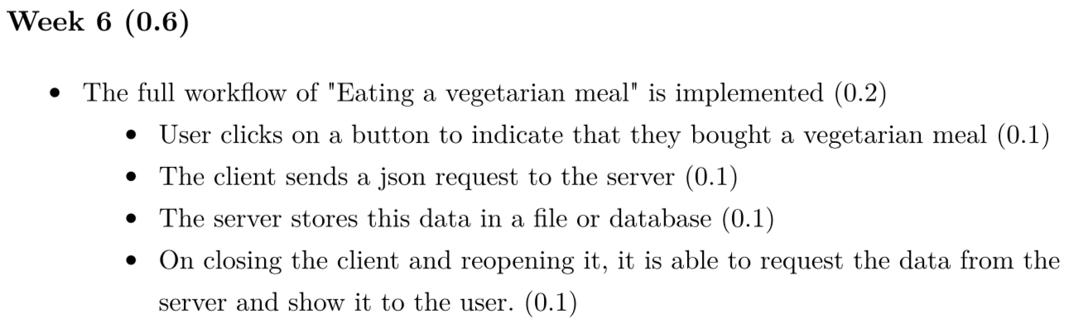

Week 8 (0.8)

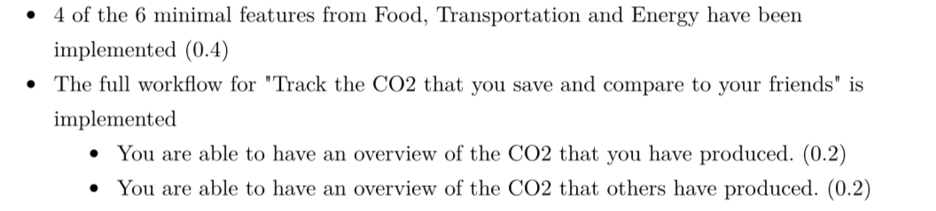

**Notetaking:**

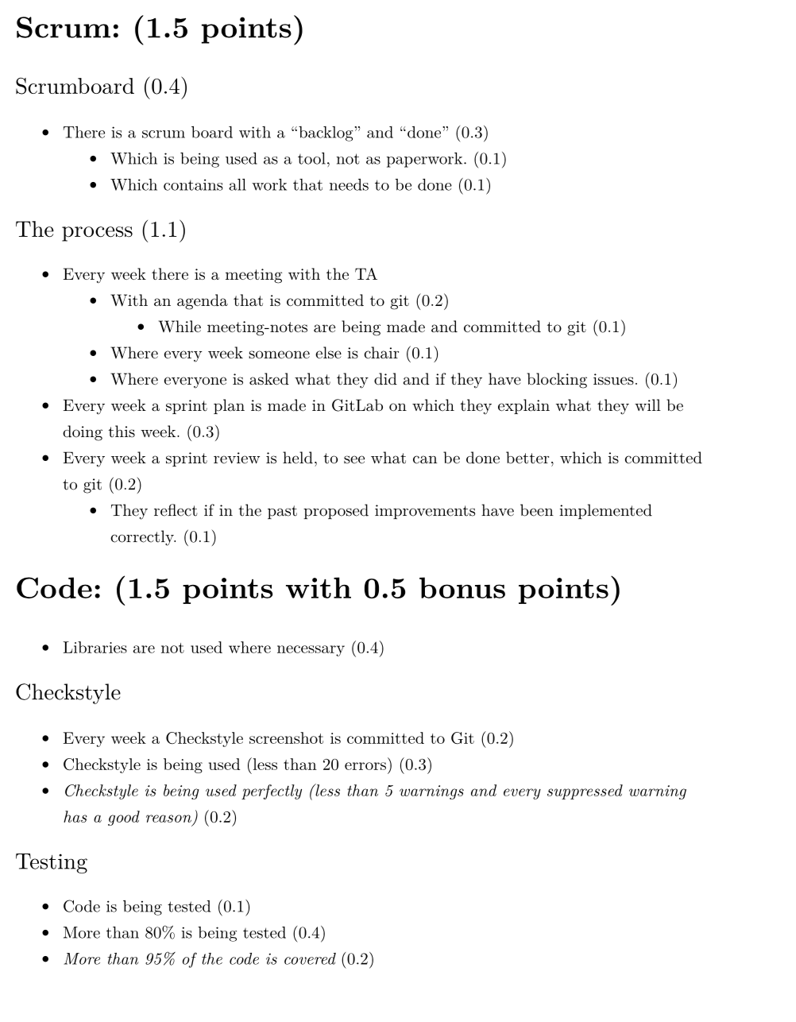

* Mockito is being used for at least 5 different classes (0.3)

