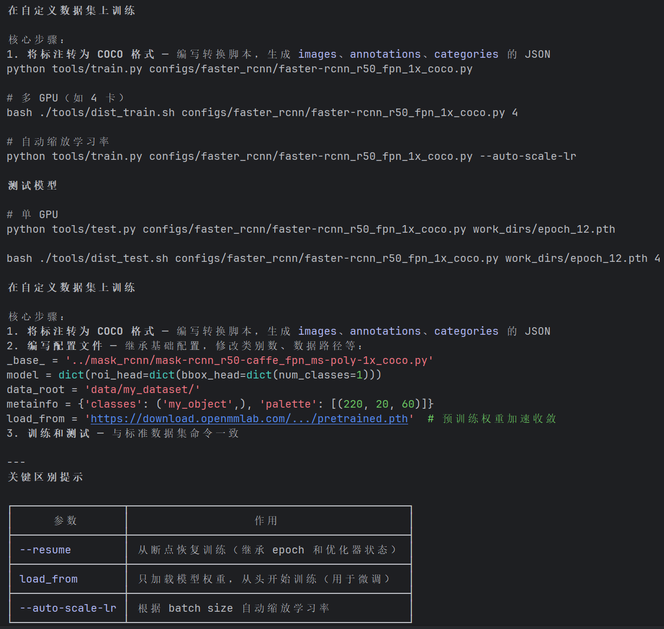
- 将数据集处理为COCO格式。
使用MFT25数据集做检测，结构如下。
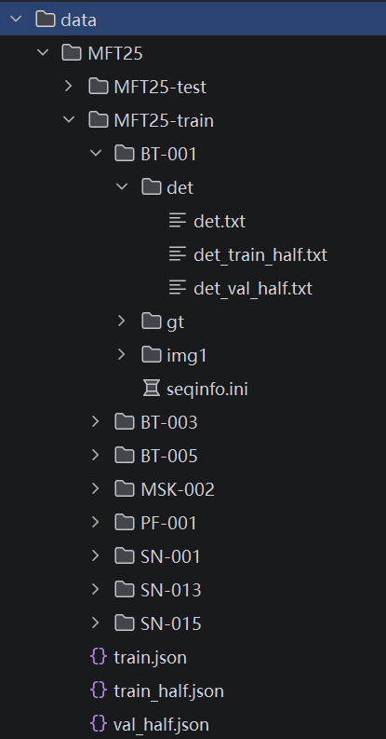
需转换成coco格式。
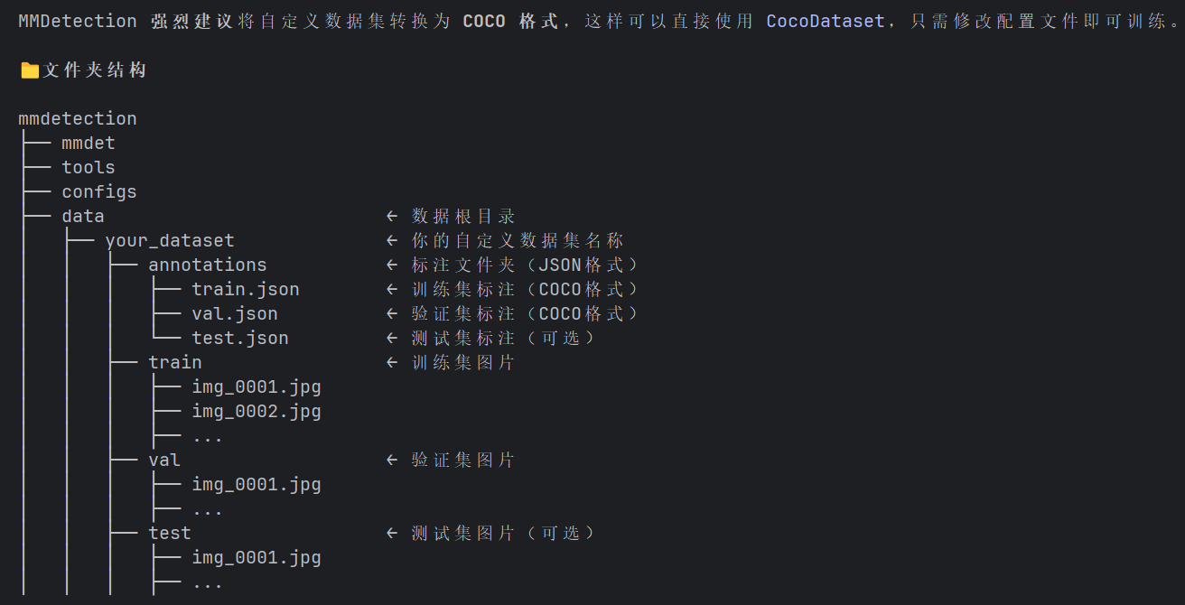
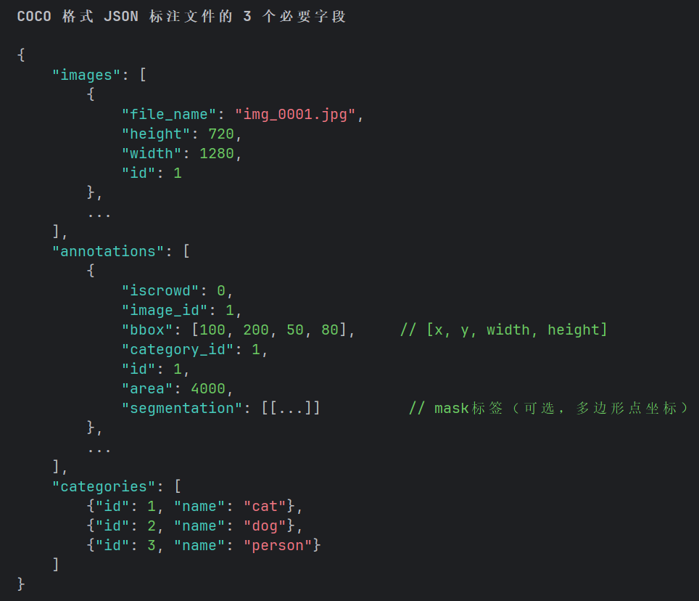
问AI：处理训练集：MFT25-train文件夹下有许多子文件夹，每个子文件夹都有det、img1文件夹，det文件夹下有det.txt，第一列表示帧，每帧对应img1文件夹下的一张图片，第3、4、5、6列表示MOT格式的检测框，请写代码将MFT25-train中的图片按顺序合并，图片名称数字顺序往后，标注文件也按顺序合并，然后按80%划分训练集和验证集，输出文件夹annotations下有train.json,val.json,图片分别输出到train，val文件夹下。并转为coco格式的数据集。类别只有‘fish’。处理测试集：将 MFT25-test 文件夹下所有子文件夹中的 img1 目录里的图片按顺序合并，并全局重命名为连续数字（如 000001.jpg），统一输出到 test 文件夹中。
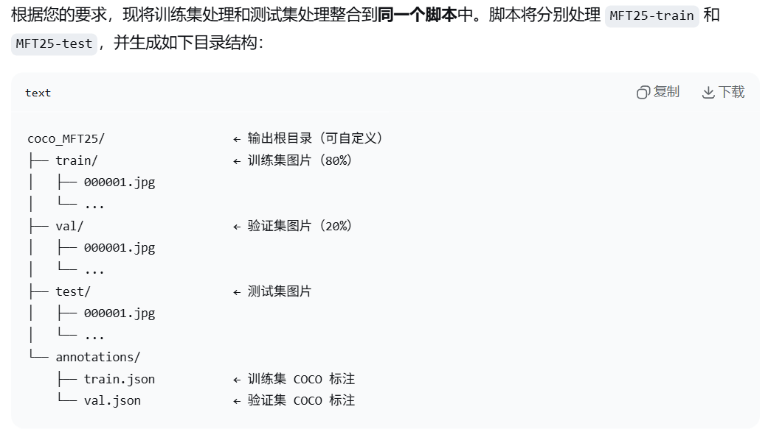
import os
import json
import re
import shutil
import cv2
import glob
import random
from collections import defaultdict

# ========== 工具函数 ==========
def natural_sort_key(s):
"""自然排序（数字优先）"""
return [int(c) if c.isdigit() else c for c in re.split(r'(\d+)', s)]

# ========== 训练集处理 ==========
def process_train_data(input_root, output_root, category_name="fish", train_ratio=0.8, seed=42):
"""
处理 MFT25-train：
- 合并所有子文件夹的图片和 det.txt 标注
- 按 train_ratio 随机划分训练/验证集（固定随机种子）
- 输出 COCO 格式标注到 annotations/train.json 和 annotations/val.json
- 图片分别输出到 train/ 和 val/ 文件夹
"""
# 创建输出目录
train_img_dir = os.path.join(output_root, 'train')
val_img_dir = os.path.join(output_root, 'val')
ann_dir = os.path.join(output_root, 'annotations')
os.makedirs(train_img_dir, exist_ok=True)
os.makedirs(val_img_dir, exist_ok=True)
os.makedirs(ann_dir, exist_ok=True)

# 获取所有子文件夹
subdirs = [d for d in os.listdir(input_root)
if os.path.isdir(os.path.join(input_root, d))]
subdirs.sort(key=natural_sort_key)

# 存储所有图片信息（全局ID为处理顺序）
all_img_info = {} # key: 全局图片ID (1~N), value: dict
global_img_id = 1

for subdir in subdirs:
sub_path = os.path.join(input_root, subdir)
det_file = os.path.join(sub_path, 'det', 'det.txt')
img_dir = os.path.join(sub_path, 'img1') # 注意是 img1

if not os.path.exists(det_file) or not os.path.exists(img_dir):
print(f"警告: 跳过 {subdir}，缺少 det.txt 或 img1 文件夹")
continue

# 按帧号读取检测框
frame_to_boxes = defaultdict(list)
with open(det_file, 'r') as f:
for line in f:
line = line.strip()
if not line:
continue
parts = line.split(',') if ',' in line else line.split()
if len(parts) < 6:
continue
try:
frame = int(parts[0])
x = float(parts[2])
y = float(parts[3])
w = float(parts[4])
h = float(parts[5])
except ValueError:
continue
frame_to_boxes[frame].append((x, y, w, h))

# 获取图片，建立帧号到路径的映射
img_files = glob.glob(os.path.join(img_dir, '*'))
frame_to_img = {}
for img_path in img_files:
basename = os.path.basename(img_path)
nums = re.findall(r'\d+', basename)
if nums:
frame = int(nums[0]) # 取第一个数字作为帧号
frame_to_img[frame] = img_path

# 取同时有检测和图片的帧，按顺序处理
common_frames = sorted(set(frame_to_boxes.keys()) & set(frame_to_img.keys()))
for frame in common_frames:
img_path = frame_to_img[frame]
img = cv2.imread(img_path)
if img is None:
print(f"警告: 无法读取 {img_path}，跳过该帧")
continue
height, width = img.shape[:2]
ext = os.path.splitext(img_path)[1]
new_filename = f"{global_img_id:06d}{ext}"

all_img_info[global_img_id] = {
'img_path': img_path,
'new_filename': new_filename,
'width': width,
'height': height,
'boxes': frame_to_boxes[frame]
}
global_img_id += 1

# 随机划分（固定种子确保可复现）
img_ids = list(all_img_info.keys())
random.seed(seed)
random.shuffle(img_ids)
split_idx = int(len(img_ids) * train_ratio)
train_ids = img_ids[:split_idx]
val_ids = img_ids[split_idx:]

# 辅助函数：构建 COCO 数据
def build_coco_data(img_ids, img_info_dict, start_img_id=1, start_ann_id=1):
images = []
annotations = []
ann_id = start_ann_id
for new_id, old_id in enumerate(img_ids, start=start_img_id):
info = img_info_dict[old_id]
images.append({
"id": new_id,
"file_name": info['new_filename'], # 只存文件名
"width": info['width'],
"height": info['height']
})
for box in info['boxes']:
x, y, w, h = box
if w <= 0 or h <= 0:
continue
annotations.append({
"id": ann_id,
"image_id": new_id,
"bbox": [x, y, w, h],
"area": w * h,
"category_id": 1,
"iscrowd": 0
})
ann_id += 1
categories = [{"id": 1, "name": category_name}]
return {"images": images, "annotations": annotations, "categories": categories}

# 生成 JSON
train_coco = build_coco_data(train_ids, all_img_info)
val_coco = build_coco_data(val_ids, all_img_info)

# 保存 JSON
with open(os.path.join(ann_dir, 'train.json'), 'w') as f:
json.dump(train_coco, f, indent=2)
with open(os.path.join(ann_dir, 'val.json'), 'w') as f:
json.dump(val_coco, f, indent=2)

# 复制图片
for old_id in train_ids:
shutil.copy2(all_img_info[old_id]['img_path'],
os.path.join(train_img_dir, all_img_info[old_id]['new_filename']))
for old_id in val_ids:
shutil.copy2(all_img_info[old_id]['img_path'],
os.path.join(val_img_dir, all_img_info[old_id]['new_filename']))

print(f"[训练集] 完成！训练图片 {len(train_ids)} 张，标注 {len(train_coco['annotations'])} 个框")
print(f" 验证图片 {len(val_ids)} 张，标注 {len(val_coco['annotations'])} 个框")

# ========== 测试集处理 ==========
def process_test_data(input_root, output_dir):
"""
处理 MFT25-test：
合并所有子文件夹的 img1 中的图片，按顺序重命名为 000001.jpg ...，
输出到 output_dir 文件夹（默认 'test'）
"""
os.makedirs(output_dir, exist_ok=True)

subdirs = [d for d in os.listdir(input_root)
if os.path.isdir(os.path.join(input_root, d))]
subdirs.sort(key=natural_sort_key)

global_img_id = 1
img_extensions = {'.jpg', '.jpeg', '.png', '.bmp', '.tif', '.tiff'}

for subdir in subdirs:
img_dir = os.path.join(input_root, subdir, 'img1')
if not os.path.exists(img_dir):
print(f"警告: {img_dir} 不存在，跳过 {subdir}")
continue

img_files = glob.glob(os.path.join(img_dir, '*'))
# 仅保留图片文件
img_files = [f for f in img_files if os.path.splitext(f)[1].lower() in img_extensions]
img_files.sort(key=natural_sort_key)

if not img_files:
print(f"警告: {img_dir} 中无图片，跳过 {subdir}")
continue

for img_path in img_files:
ext = os.path.splitext(img_path)[1]
new_filename = f"{global_img_id:06d}{ext}"
shutil.copy2(img_path, os.path.join(output_dir, new_filename))
global_img_id += 1

print(f"[测试集] 完成！共合并 {global_img_id - 1} 张图片到 {output_dir}")

# ========== 主程序 ==========
if __name__ == "__main__":
# ----- 请根据实际情况修改以下路径 -----
TRAIN_INPUT = "../MFT25/MFT25-train" # 训练集根目录
TEST_INPUT = "../MFT25/MFT25-test" # 测试集根目录
OUTPUT_ROOT = "./coco_MFT25" # 所有输出将放在此目录下
# -------------------------------------

print("开始处理训练集...")
process_train_data(TRAIN_INPUT, OUTPUT_ROOT, category_name="fish", train_ratio=0.8, seed=42)

print("\n开始处理测试集...")
process_test_data(TEST_INPUT, os.path.join(OUTPUT_ROOT, "test"))

print("\n全部处理完成！")
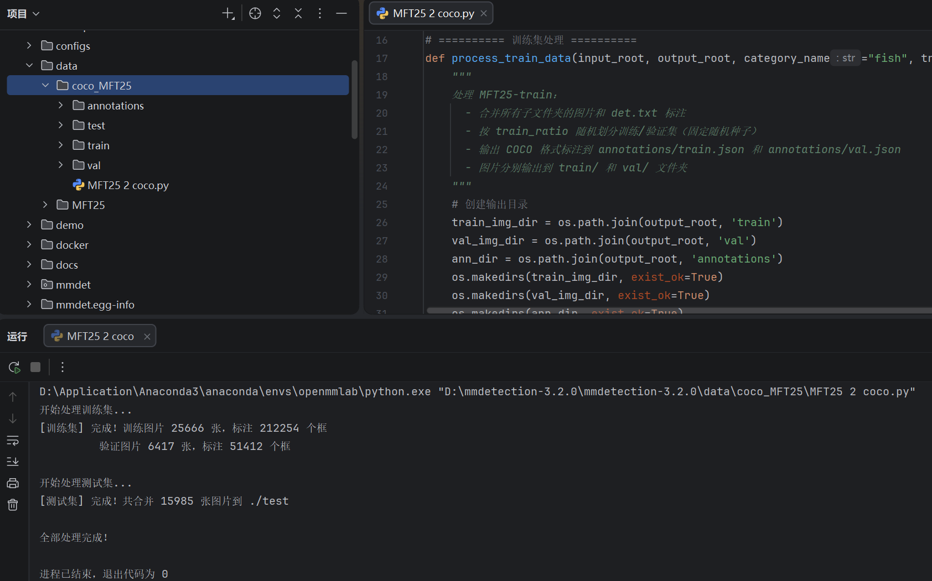
- 修改配置文件
我选用yolox。
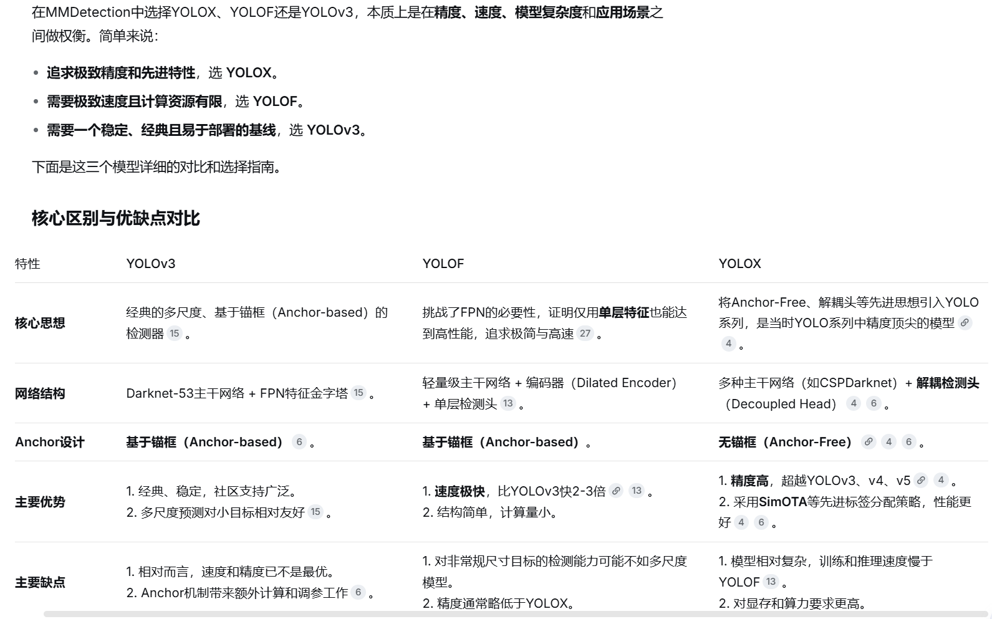
选用配置文件yolox_s_8xb8-300e_coco.py
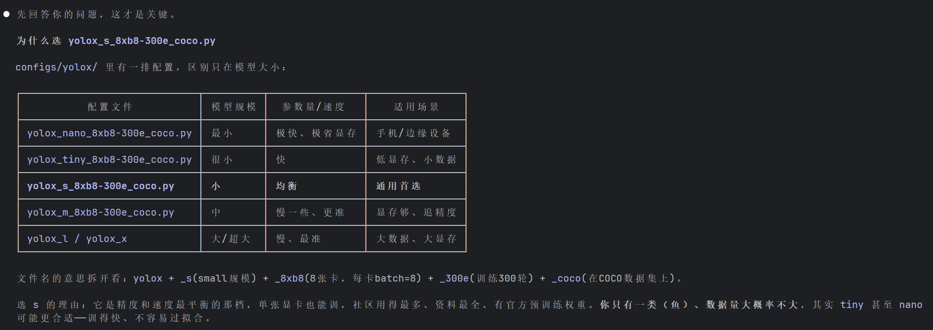
开始修改配置文件
修改路径
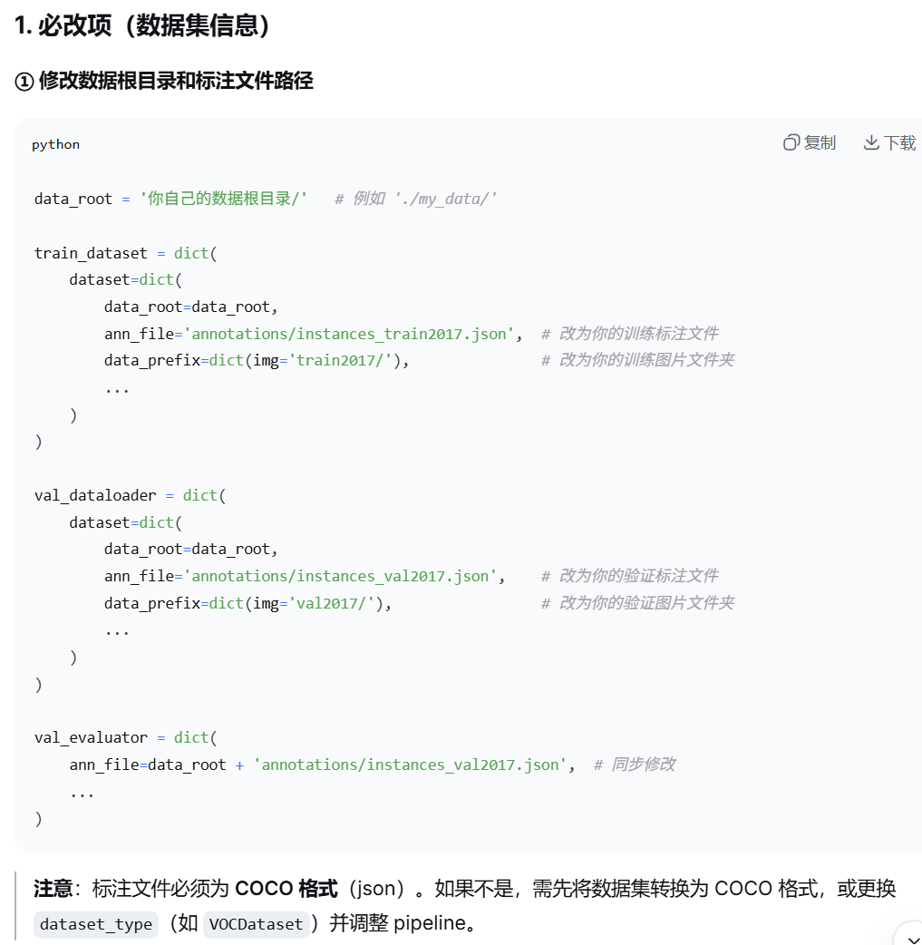
改为如下
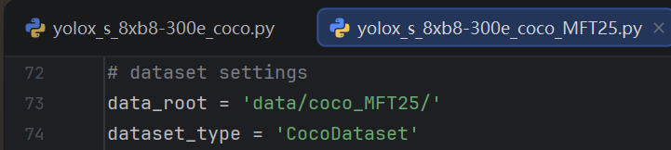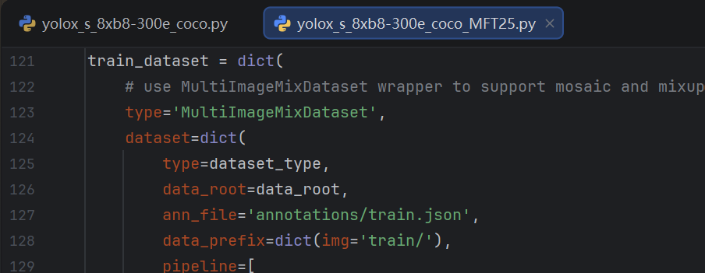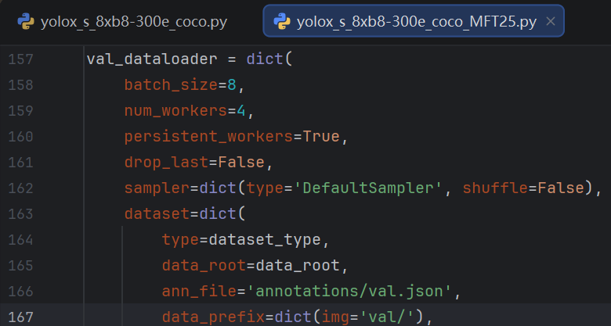
修改类别数
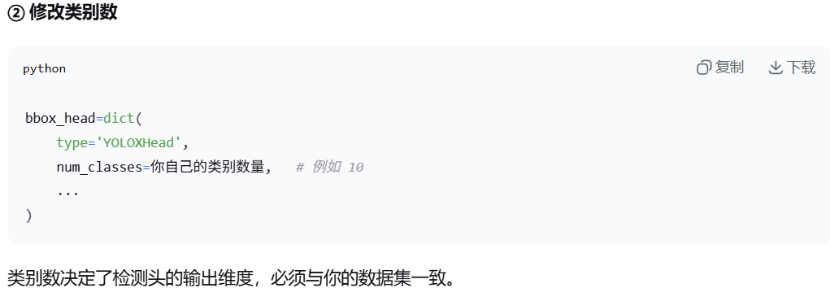
改为1
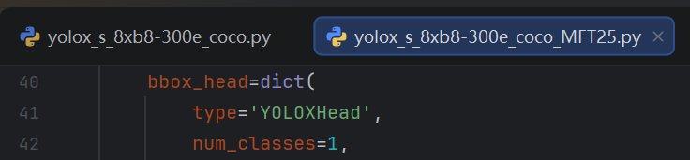
下面没改
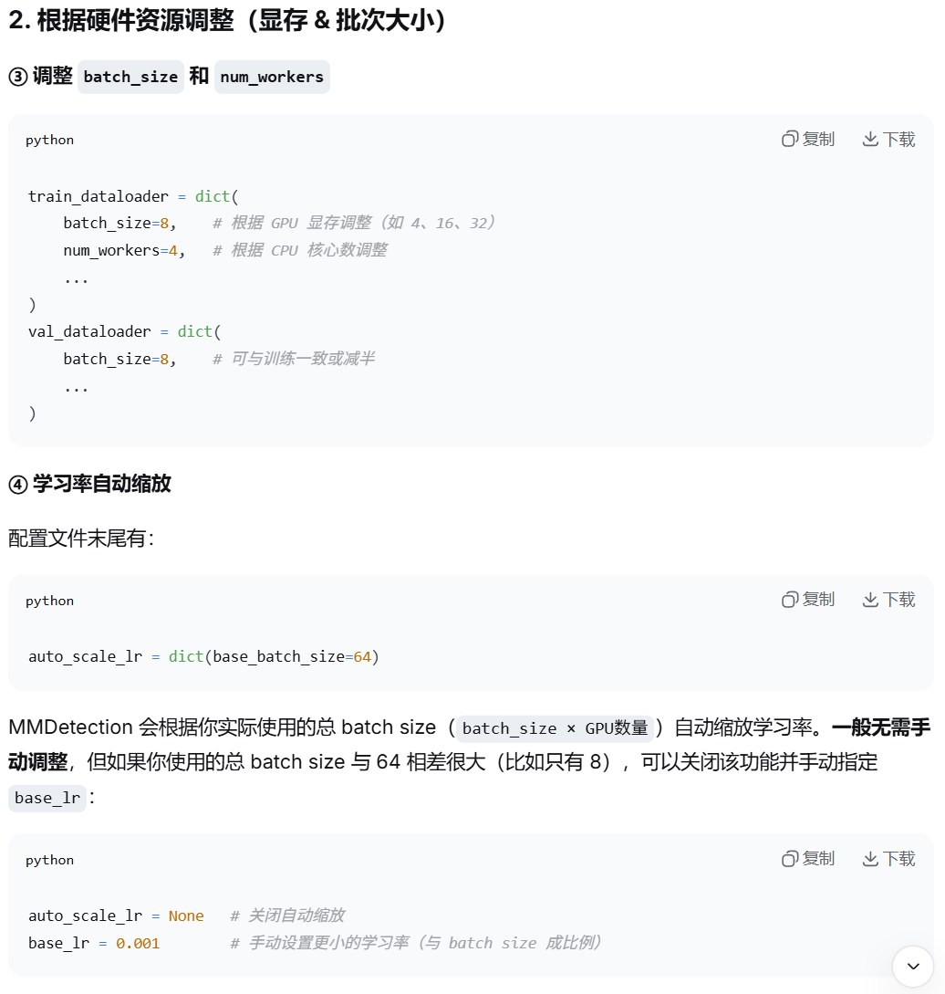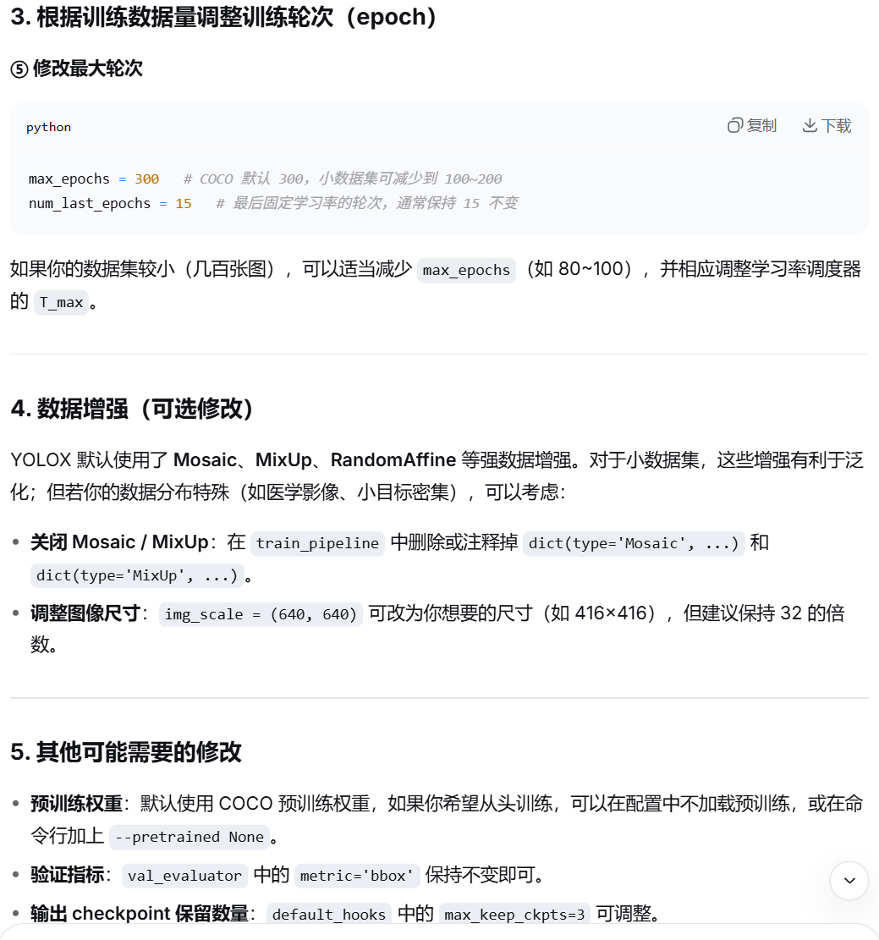
我说我训练集有25000张左右。
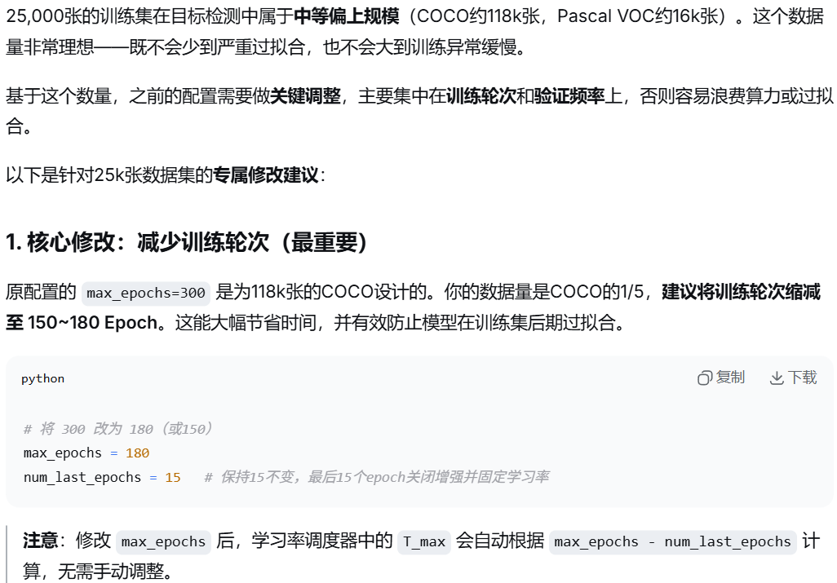
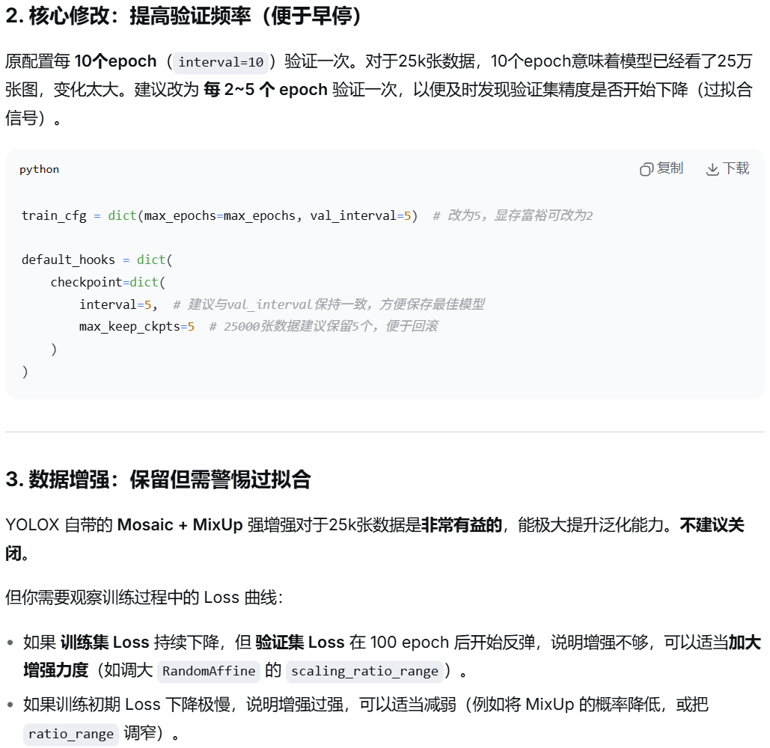
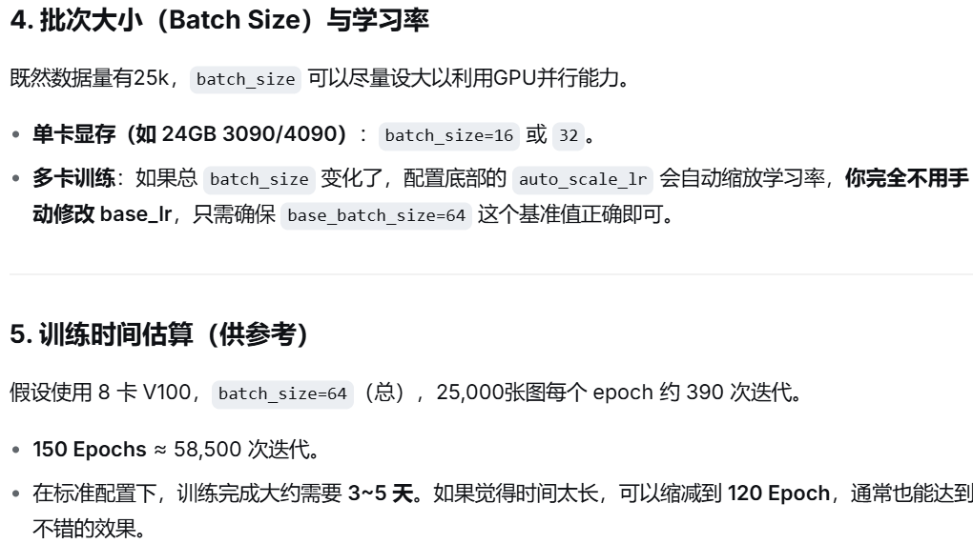
（要这么久，还是去autodl用云服务器跑吧，又要重搭环境！！！了）
最终创建配置文件yolox_s_8xb8-300e_coco_MFT25.py代码如下：
_base_ = [
'../_base_/schedules/schedule_1x.py', '../_base_/default_runtime.py',
'./yolox_tta.py'
]

img_scale = (640, 640) # width, height

# model settings
model = dict(
type='YOLOX',
data_preprocessor=dict(
type='DetDataPreprocessor',
pad_size_divisor=32,
batch_augments=[
dict(
type='BatchSyncRandomResize',
random_size_range=(480, 800),
size_divisor=32,
interval=10)
]),
backbone=dict(
type='CSPDarknet',
deepen_factor=0.33,
widen_factor=0.5,
out_indices=(2, 3, 4),
use_depthwise=False,
spp_kernal_sizes=(5, 9, 13),
norm_cfg=dict(type='BN', momentum=0.03, eps=0.001),
act_cfg=dict(type='Swish'),
),
neck=dict(
type='YOLOXPAFPN',
in_channels=[128, 256, 512],
out_channels=128,
num_csp_blocks=1,
use_depthwise=False,
upsample_cfg=dict(scale_factor=2, mode='nearest'),
norm_cfg=dict(type='BN', momentum=0.03, eps=0.001),
act_cfg=dict(type='Swish')),
bbox_head=dict(
type='YOLOXHead',
num_classes=1,
in_channels=128,
feat_channels=128,
stacked_convs=2,
strides=(8, 16, 32),
use_depthwise=False,
norm_cfg=dict(type='BN', momentum=0.03, eps=0.001),
act_cfg=dict(type='Swish'),
loss_cls=dict(
type='CrossEntropyLoss',
use_sigmoid=True,
reduction='sum',
loss_weight=1.0),
loss_bbox=dict(
type='IoULoss',
mode='square',
eps=1e-16,
reduction='sum',
loss_weight=5.0),
loss_obj=dict(
type='CrossEntropyLoss',
use_sigmoid=True,
reduction='sum',
loss_weight=1.0),
loss_l1=dict(type='L1Loss', reduction='sum', loss_weight=1.0)),
train_cfg=dict(assigner=dict(type='SimOTAAssigner', center_radius=2.5)),
# In order to align the source code, the threshold of the val phase is
# 0.01, and the threshold of the test phase is 0.001.
test_cfg=dict(score_thr=0.01, nms=dict(type='nms', iou_threshold=0.65)))

# dataset settings
data_root = 'data/coco_MFT25/'
dataset_type = 'CocoDataset'

# Example to use different file client
# Method 1: simply set the data root and let the file I/O module
# automatically infer from prefix (not support LMDB and Memcache yet)

# data_root = 's3://openmmlab/datasets/detection/coco/'

# Method 2: Use `backend_args`, `file_client_args` in versions before 3.0.0rc6
# backend_args = dict(
# backend='petrel',
# path_mapping=dict({
# './data/': 's3://openmmlab/datasets/detection/',
# 'data/': 's3://openmmlab/datasets/detection/'
# }))
backend_args = None

train_pipeline = [
dict(type='Mosaic', img_scale=img_scale, pad_val=114.0),
dict(
type='RandomAffine',
scaling_ratio_range=(0.1, 2),
# img_scale is (width, height)
border=(-img_scale[0] // 2, -img_scale[1] // 2)),
dict(
type='MixUp',
img_scale=img_scale,
ratio_range=(0.8, 1.6),
pad_val=114.0),
dict(type='YOLOXHSVRandomAug'),
dict(type='RandomFlip', prob=0.5),
# According to the official implementation, multi-scale
# training is not considered here but in the
# 'mmdet/models/detectors/yolox.py'.
# Resize and Pad are for the last 15 epochs when Mosaic,
# RandomAffine, and MixUp are closed by YOLOXModeSwitchHook.
dict(type='Resize', scale=img_scale, keep_ratio=True),
dict(
type='Pad',
pad_to_square=True,
# If the image is three-channel, the pad value needs
# to be set separately for each channel.
pad_val=dict(img=(114.0, 114.0, 114.0))),
dict(type='FilterAnnotations', min_gt_bbox_wh=(1, 1), keep_empty=False),
dict(type='PackDetInputs')
]

train_dataset = dict(
# use MultiImageMixDataset wrapper to support mosaic and mixup
type='MultiImageMixDataset',
dataset=dict(
type=dataset_type,
data_root=data_root,
ann_file='annotations/train.json',
data_prefix=dict(img='train/'),
pipeline=[
dict(type='LoadImageFromFile', backend_args=backend_args),
dict(type='LoadAnnotations', with_bbox=True)
],
filter_cfg=dict(filter_empty_gt=False, min_size=32),
backend_args=backend_args),
pipeline=train_pipeline)

test_pipeline = [
dict(type='LoadImageFromFile', backend_args=backend_args),
dict(type='Resize', scale=img_scale, keep_ratio=True),
dict(
type='Pad',
pad_to_square=True,
pad_val=dict(img=(114.0, 114.0, 114.0))),
dict(type='LoadAnnotations', with_bbox=True),
dict(
type='PackDetInputs',
meta_keys=('img_id', 'img_path', 'ori_shape', 'img_shape',
'scale_factor'))
]

train_dataloader = dict(
batch_size=8,
num_workers=4,
persistent_workers=True,
sampler=dict(type='DefaultSampler', shuffle=True),
dataset=train_dataset)
val_dataloader = dict(
batch_size=8,
num_workers=4,
persistent_workers=True,
drop_last=False,
sampler=dict(type='DefaultSampler', shuffle=False),
dataset=dict(
type=dataset_type,
data_root=data_root,
ann_file='annotations/val.json',
data_prefix=dict(img='val/'),
test_mode=True,
pipeline=test_pipeline,
backend_args=backend_args))
test_dataloader = val_dataloader

val_evaluator = dict(
type='CocoMetric',
ann_file=data_root + 'annotations/val.json',
metric='bbox',
backend_args=backend_args)
test_evaluator = val_evaluator

# training settings
max_epochs = 180
num_last_epochs = 15
interval = 5

train_cfg = dict(max_epochs=max_epochs, val_interval=interval)

# optimizer
# default 8 gpu
base_lr = 0.01
optim_wrapper = dict(
type='OptimWrapper',
optimizer=dict(
type='SGD', lr=base_lr, momentum=0.9, weight_decay=5e-4,
nesterov=True),
paramwise_cfg=dict(norm_decay_mult=0., bias_decay_mult=0.))

# learning rate
param_scheduler = [
dict(
# use quadratic formula to warm up 5 epochs
# and lr is updated by iteration
# TODO: fix default scope in get function
type='mmdet.QuadraticWarmupLR',
by_epoch=True,
begin=0,
end=5,
convert_to_iter_based=True),
dict(
# use cosine lr from 5 to 285 epoch
type='CosineAnnealingLR',
eta_min=base_lr * 0.05,
begin=5,
T_max=max_epochs - num_last_epochs,
end=max_epochs - num_last_epochs,
by_epoch=True,
convert_to_iter_based=True),
dict(
# use fixed lr during last 15 epochs
type='ConstantLR',
by_epoch=True,
factor=1,
begin=max_epochs - num_last_epochs,
end=max_epochs,
)
]

default_hooks = dict(
checkpoint=dict(
interval=interval,
max_keep_ckpts=5 # only keep latest 3 checkpoints
))

custom_hooks = [
dict(
type='YOLOXModeSwitchHook',
num_last_epochs=num_last_epochs,
priority=48),
dict(type='SyncNormHook', priority=48),
dict(
type='EMAHook',
ema_type='ExpMomentumEMA',
momentum=0.0001,
update_buffers=True,
priority=49)
]

# NOTE: `auto_scale_lr` is for automatically scaling LR,
# USER SHOULD NOT CHANGE ITS VALUES.
# base_batch_size = (8 GPUs) x (8 samples per GPU)
auto_scale_lr = dict(base_batch_size=64)

