- 创建服务器。
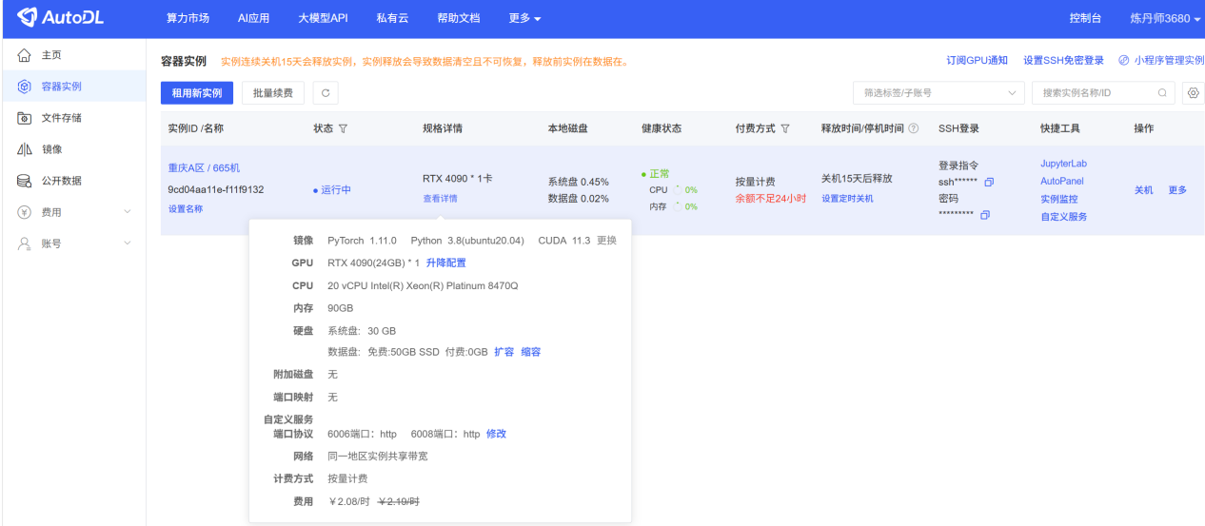
- 先把数据集拿出来，再把项目同步。数据集压缩包单独用FileZilla传输，然后解压就完成了。
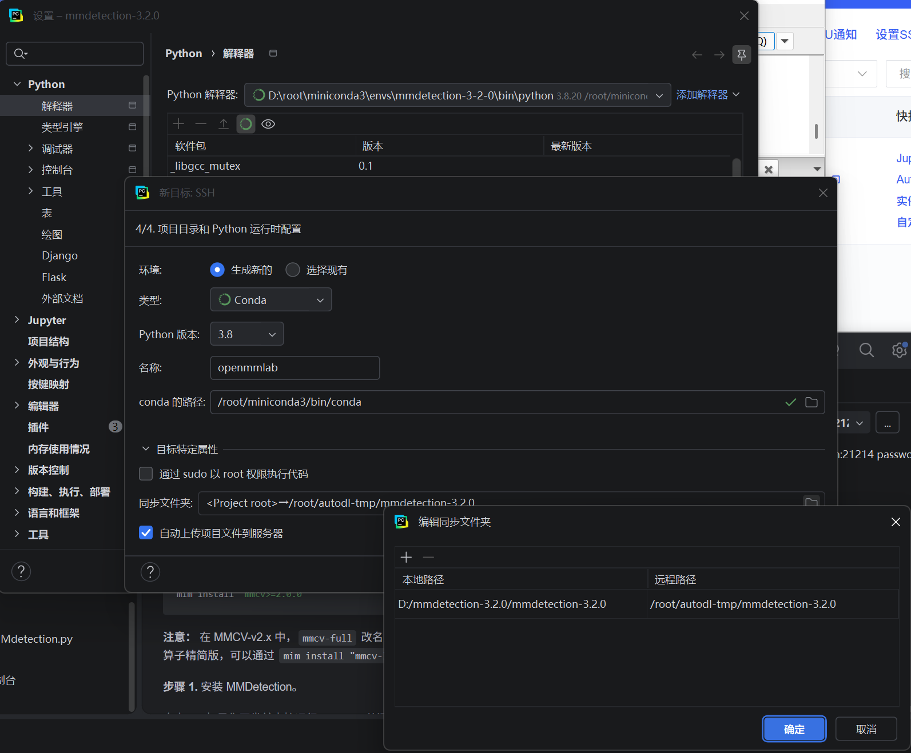
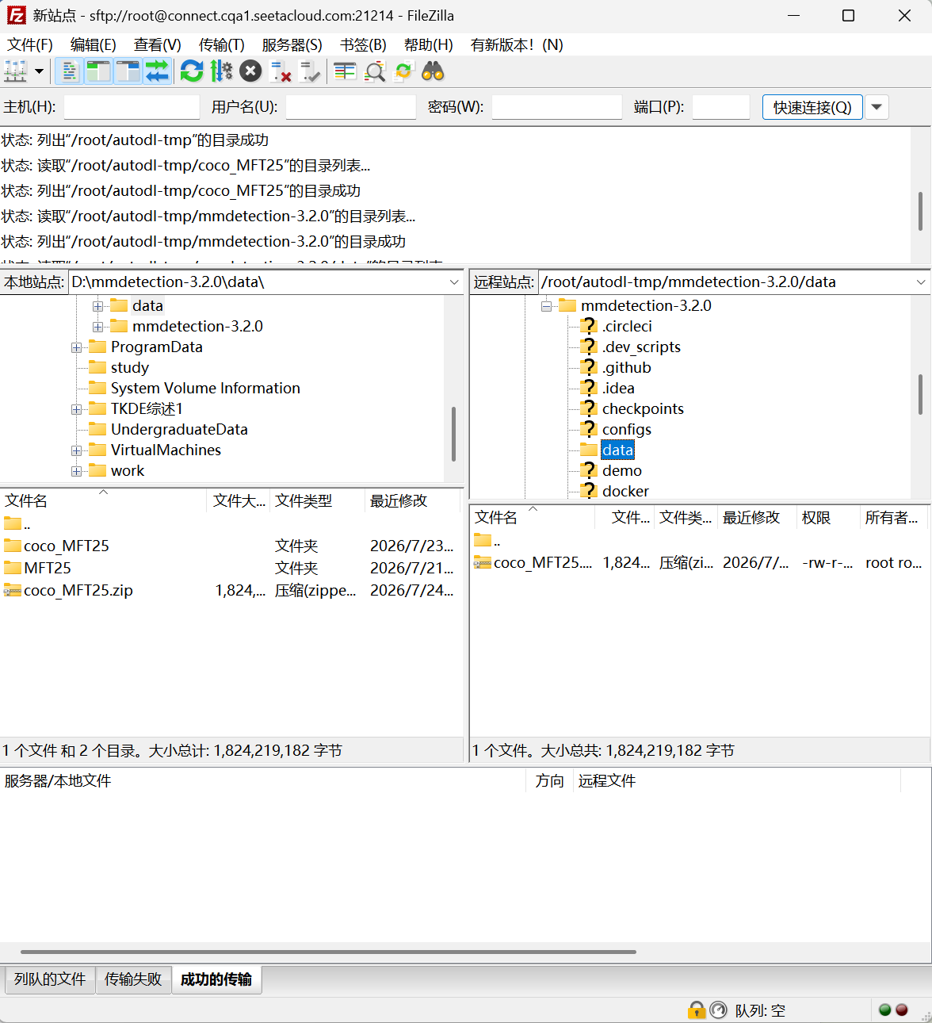
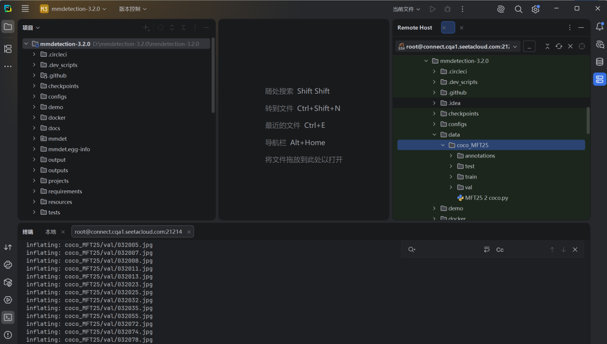
- 训练模型：python tools/train.py configs/yolox/yolox_s_8xb8-300e_coco_MFT25.py。
提示未安装mmengine，试着安装也有很多依赖问题。
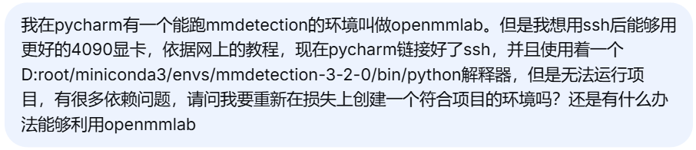
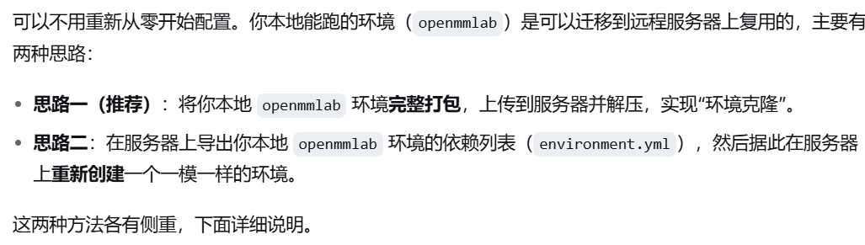
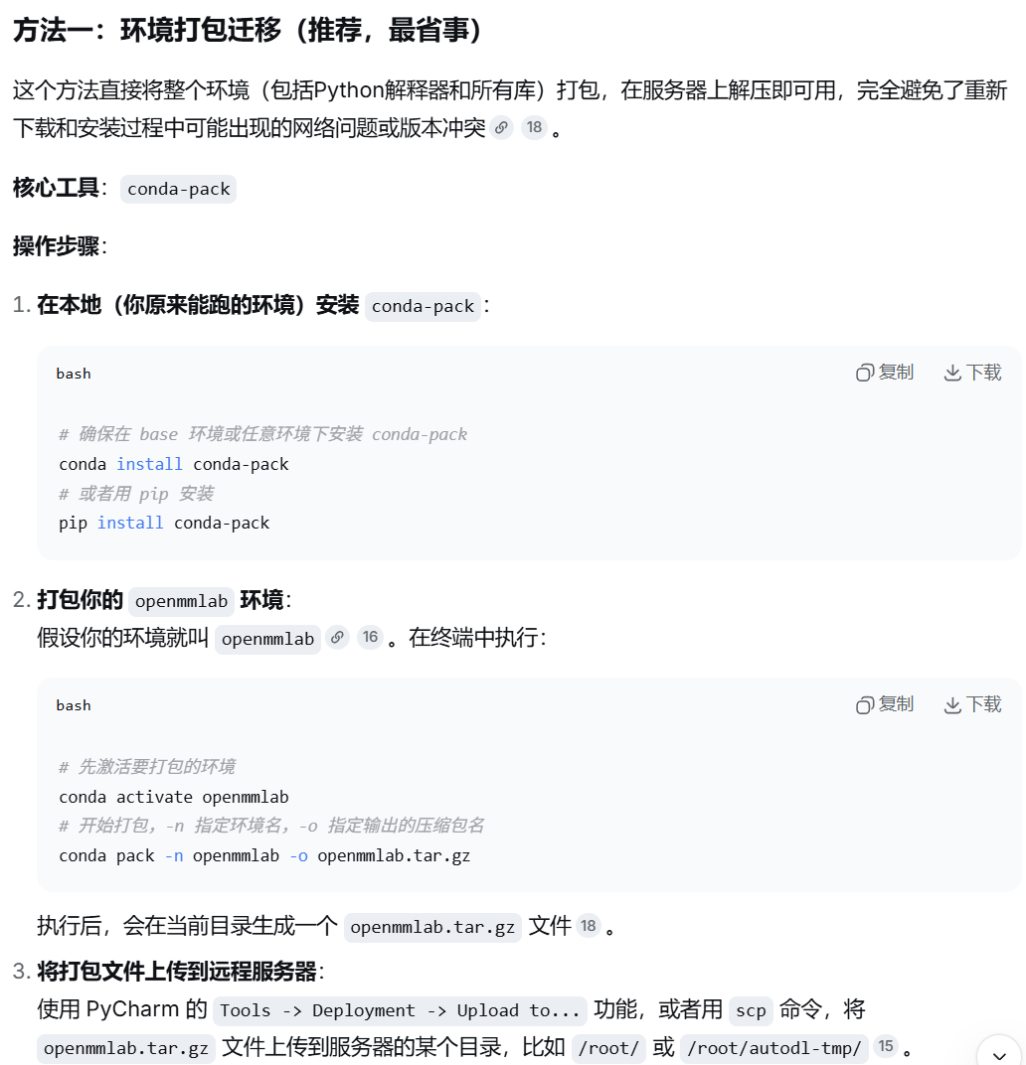
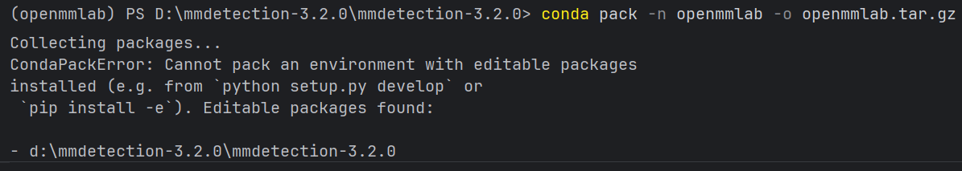
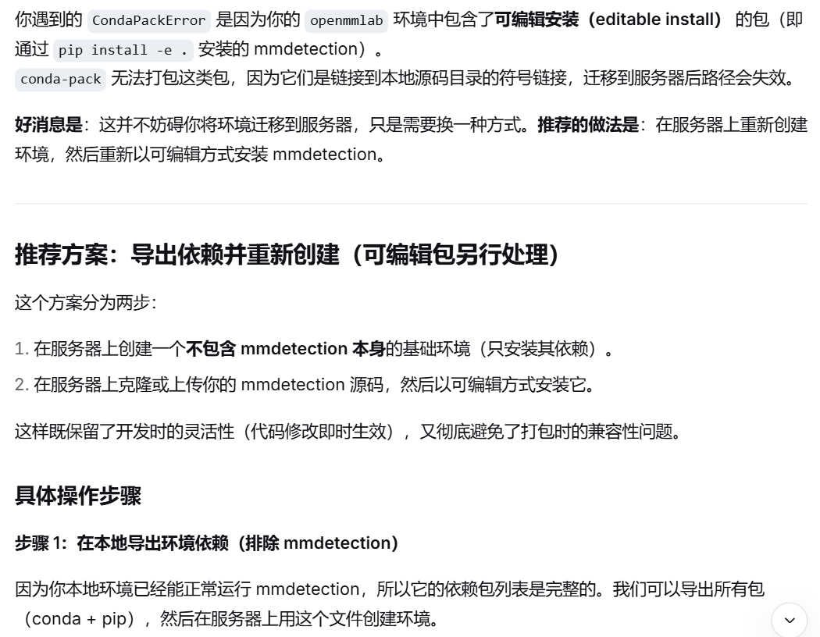
还是重新创个环境更方便。
- 在ssh上创建新环境openmmlab。
conda create -n openmmlab python=3.8
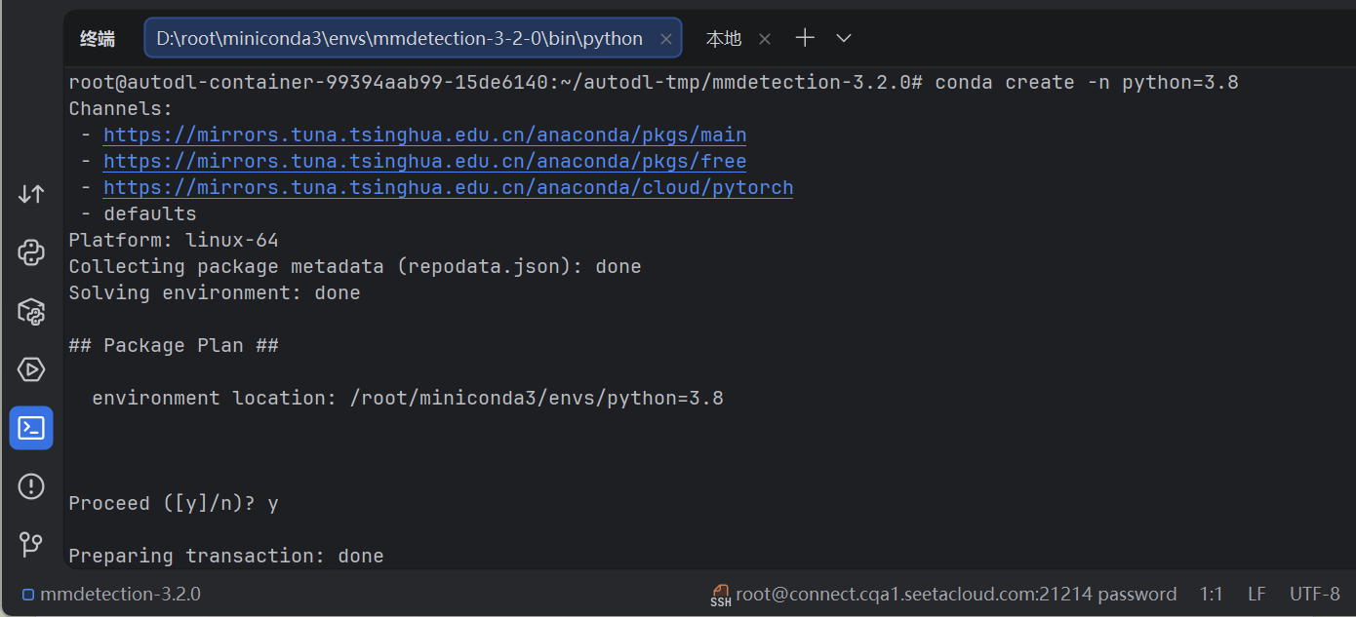
- 按照mmdetection-3.2.0/docs/zh_cn/get_started.md进行环境配置，pip install -U openmim成功，但mim install mmengine报错显示没安装torch。
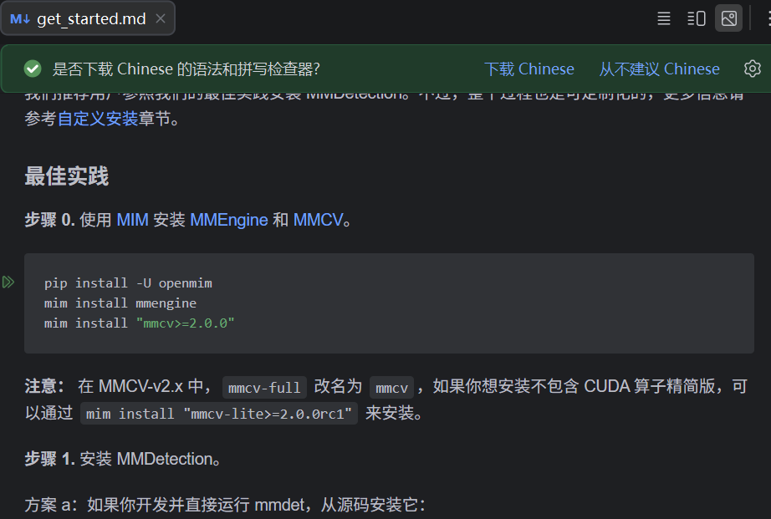
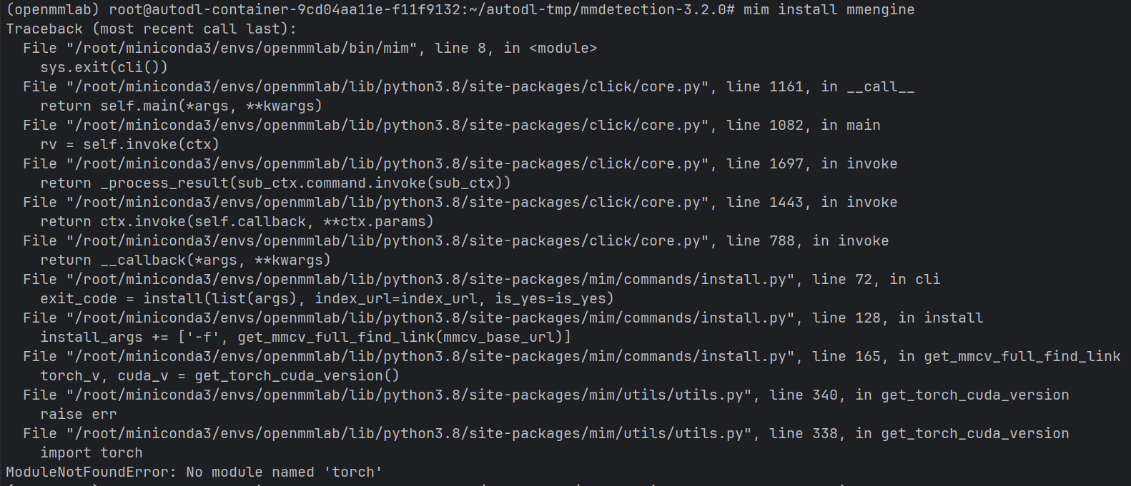
- 安装torch。先conda deactivate退出conda环境回到命令行。
nvidia-smi，cuda版本12.8
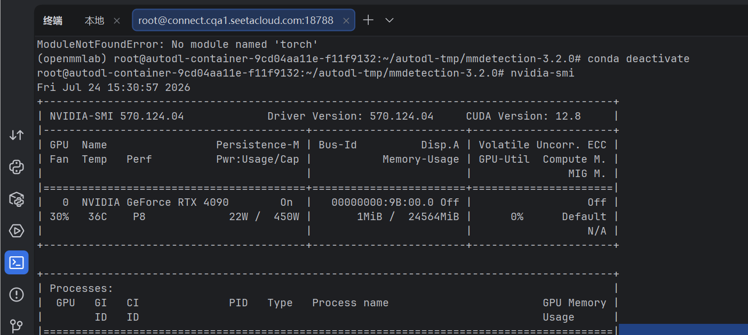
进入python环境，查看torch版本，1.11.0+cu113，按照这个版本去官网查找安装命令，CUDA小于12.8都可以。
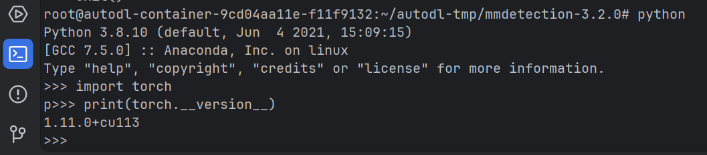
Pytorch官网查找安装版本，进入历史版本查找界面，查找到安装命令conda install pytorch==1.11.0 torchvision==0.12.0 torchaudio==0.11.0 cudatoolkit=11.3 -c pytorch，激活openmmlab环境进行安装。
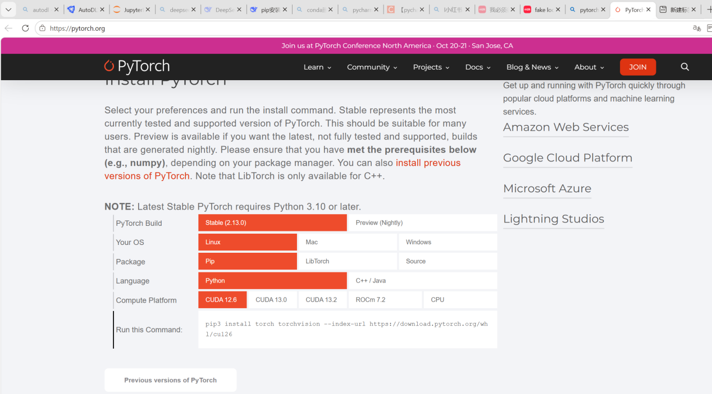
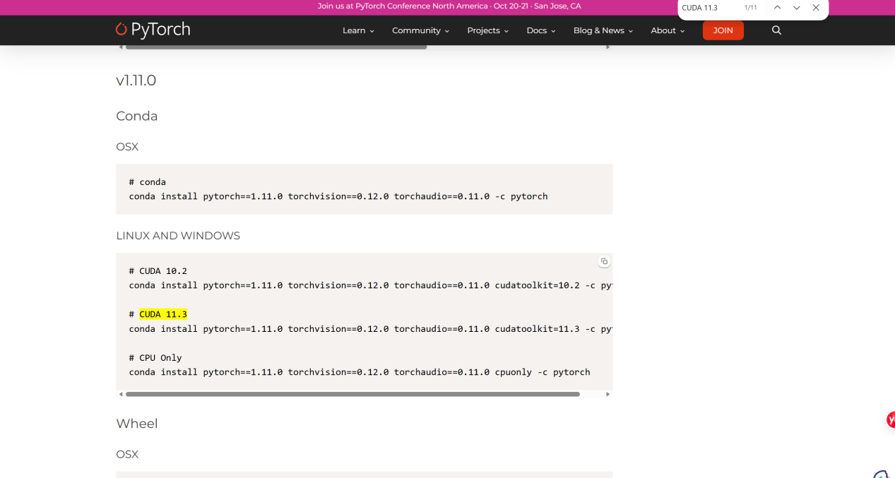
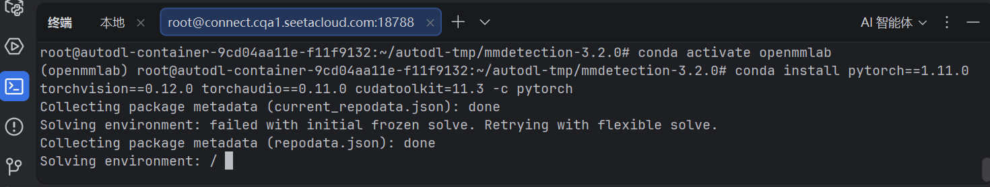
- 接着运行mim install mmengine和pip install mmcv==2.1.0和pip install -v -e .

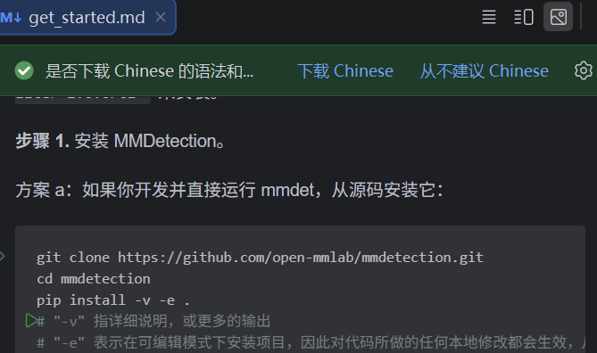
- python tools/train.py configs/yolox/yolox_s_8xb8-300e_coco_MFT25.py开始训练
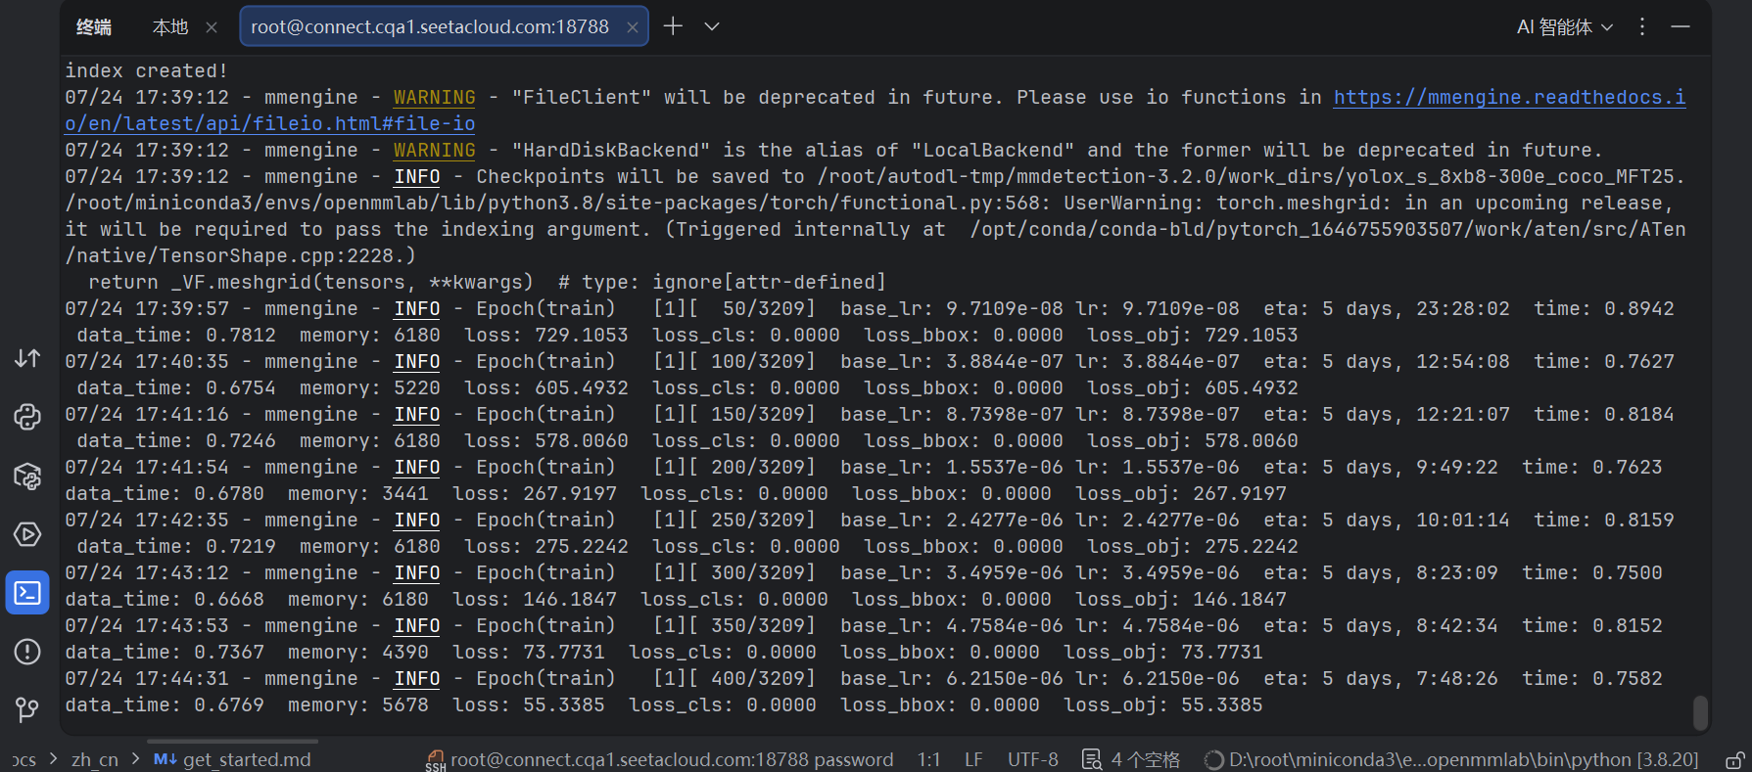
- 数据集太大了比较慢，就用MFT25-BT-001做训练集，MFT25-BT-002做测试集然后在自己电脑上跑吧。数据集处理代码和配置文件如下。
MFT25-BT 2 coco.py
import os
import json
import random
import shutil
from collections import defaultdict
from PIL import Image
import argparse

def parse_det_txt(det_path):
"""读取det.txt，返回 {帧号: [[x,y,w,h], ...]}"""
frames = defaultdict(list)
with open(det_path, 'r') as f:
for line in f:
line = line.strip()
if not line:
continue
# 尝试按空白分割，若不足6项则按逗号分割
parts = line.split()
if len(parts) < 6:
parts = line.split(',')
if len(parts) < 6:
continue
try:
frame_id = int(parts[0])
x = float(parts[2])
y = float(parts[3])
w = float(parts[4])
h = float(parts[5])
frames[frame_id].append([x, y, w, h])
except ValueError:
continue
return frames

def get_image_mapping(img_dir):
"""扫描img1，返回 {帧号: 文件名}"""
mapping = {}
for fname in os.listdir(img_dir):
name, ext = os.path.splitext(fname)
if name.isdigit():
mapping[int(name)] = fname
return mapping

def build_coco(split_frames, frames_dict, img_dir, img_mapping, out_img_dir, split_name):
"""为指定帧集合生成COCO images和annotations，并复制图片"""
images = []
annotations = []
img_id = 1
ann_id = 1

for frame in split_frames:
fname = img_mapping[frame]
src = os.path.join(img_dir, fname)
dst = os.path.join(out_img_dir, fname)
shutil.copy2(src, dst)

# 获取图片尺寸
with Image.open(src) as img:
width, height = img.size

# 【修改点1】file_name 只存纯文件名，不加 split_name 前缀
images.append({
'id': img_id,
'file_name': fname,
'width': width,
'height': height
})

# 该帧所有检测框
for box in frames_dict[frame]:
x, y, w, h = box
annotations.append({
'id': ann_id,
'image_id': img_id,
'category_id': 1,
'bbox': [x, y, w, h],
'area': w * h,
'iscrowd': 0
})
ann_id += 1
img_id += 1

return images, annotations

def main():
parser = argparse.ArgumentParser()
# 【修改点2】默认路径改用正斜杠，避免 Windows 转义问题
parser.add_argument('--input', type=str, default='data/MFT25/MFT25-train/BT-001')
parser.add_argument('--output', type=str, default='data/coco_MFT25-BT-001')
args = parser.parse_args()

det_file = os.path.join(args.input, 'det', 'det.txt')
img_dir = os.path.join(args.input, 'img1')

if not os.path.exists(det_file):
print(f"错误：未找到 {det_file}")
return

# 解析检测框
frames_dict = parse_det_txt(det_file)
if not frames_dict:
print("错误：det.txt 无有效数据")
return

# 建立图片映射
img_mapping = get_image_mapping(img_dir)
# 仅保留有对应图片的帧
valid_frames = [f for f in frames_dict if f in img_mapping]
if not valid_frames:
print("错误：无匹配图片的帧")
return

# 随机划分
random.seed(42)
random.shuffle(valid_frames)
split_idx = int(0.8 * len(valid_frames))
train_frames = set(valid_frames[:split_idx])
val_frames = set(valid_frames[split_idx:])

# 创建输出目录
train_img_dir = os.path.join(args.output, 'train')
val_img_dir = os.path.join(args.output, 'val')
ann_dir = os.path.join(args.output, 'annotations')
os.makedirs(train_img_dir, exist_ok=True)
os.makedirs(val_img_dir, exist_ok=True)
os.makedirs(ann_dir, exist_ok=True)

# 生成训练集
train_imgs, train_anns = build_coco(
train_frames, frames_dict, img_dir, img_mapping, train_img_dir, 'train'
)
# 生成验证集
val_imgs, val_anns = build_coco(
val_frames, frames_dict, img_dir, img_mapping, val_img_dir, 'val'
)

categories = [{'id': 1, 'name': 'fish'}]

# 写入JSON
with open(os.path.join(ann_dir, 'train.json'), 'w') as f:
json.dump({'images': train_imgs, 'annotations': train_anns, 'categories': categories}, f)
with open(os.path.join(ann_dir, 'val.json'), 'w') as f:
json.dump({'images': val_imgs, 'annotations': val_anns, 'categories': categories}, f)

print(f"完成！训练帧数: {len(train_frames)}，验证帧数: {len(val_frames)}")
print(f"训练标注数: {len(train_anns)}，验证标注数: {len(val_anns)}")
print(f"输出目录: {os.path.abspath(args.output)}")

if __name__ == '__main__':
main()
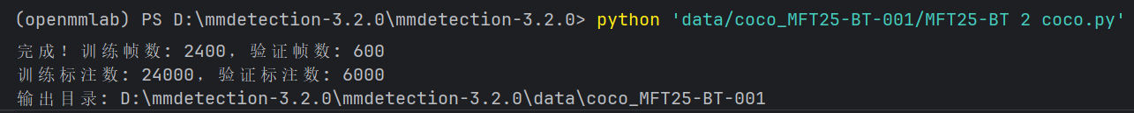
然后把BT-002中的图片粘贴到test。
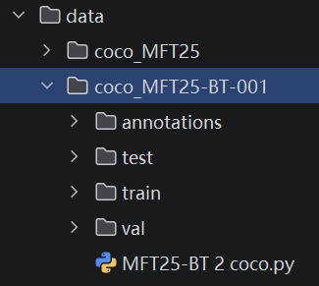
yolox_s_8xb8-300e_coco_MFT25-BT.py
_base_ = [
'../_base_/schedules/schedule_1x.py', '../_base_/default_runtime.py',
'./yolox_tta.py'
]

img_scale = (640, 640) # width, height

# model settings
model = dict(
type='YOLOX',
data_preprocessor=dict(
type='DetDataPreprocessor',
pad_size_divisor=32,
batch_augments=[
dict(
type='BatchSyncRandomResize',
random_size_range=(480, 800),
size_divisor=32,
interval=10)
]),
backbone=dict(
type='CSPDarknet',
deepen_factor=0.33,
widen_factor=0.5,
out_indices=(2, 3, 4),
use_depthwise=False,
spp_kernal_sizes=(5, 9, 13),
norm_cfg=dict(type='BN', momentum=0.03, eps=0.001),
act_cfg=dict(type='Swish'),
),
neck=dict(
type='YOLOXPAFPN',
in_channels=[128, 256, 512],
out_channels=128,
num_csp_blocks=1,
use_depthwise=False,
upsample_cfg=dict(scale_factor=2, mode='nearest'),
norm_cfg=dict(type='BN', momentum=0.03, eps=0.001),
act_cfg=dict(type='Swish')),
bbox_head=dict(
type='YOLOXHead',
num_classes=1,
in_channels=128,
feat_channels=128,
stacked_convs=2,
strides=(8, 16, 32),
use_depthwise=False,
norm_cfg=dict(type='BN', momentum=0.03, eps=0.001),
act_cfg=dict(type='Swish'),
loss_cls=dict(
type='CrossEntropyLoss',
use_sigmoid=True,
reduction='sum',
loss_weight=1.0),
loss_bbox=dict(
type='IoULoss',
mode='square',
eps=1e-16,
reduction='sum',
loss_weight=5.0),
loss_obj=dict(
type='CrossEntropyLoss',
use_sigmoid=True,
reduction='sum',
loss_weight=1.0),
loss_l1=dict(type='L1Loss', reduction='sum', loss_weight=1.0)),
train_cfg=dict(assigner=dict(type='SimOTAAssigner', center_radius=2.5)),
# In order to align the source code, the threshold of the val phase is
# 0.01, and the threshold of the test phase is 0.001.
test_cfg=dict(score_thr=0.01, nms=dict(type='nms', iou_threshold=0.65)))

# dataset settings
data_root = 'data/coco_MFT25-BT-001/'
dataset_type = 'CocoDataset'

# Example to use different file client
# Method 1: simply set the data root and let the file I/O module
# automatically infer from prefix (not support LMDB and Memcache yet)

# data_root = 's3://openmmlab/datasets/detection/coco/'

# Method 2: Use `backend_args`, `file_client_args` in versions before 3.0.0rc6
# backend_args = dict(
# backend='petrel',
# path_mapping=dict({
# './data/': 's3://openmmlab/datasets/detection/',
# 'data/': 's3://openmmlab/datasets/detection/'
# }))
backend_args = None

train_pipeline = [
dict(type='Mosaic', img_scale=img_scale, pad_val=114.0),
dict(
type='RandomAffine',
scaling_ratio_range=(0.1, 2),
# img_scale is (width, height)
border=(-img_scale[0] // 2, -img_scale[1] // 2)),
dict(
type='MixUp',
img_scale=img_scale,
ratio_range=(0.8, 1.6),
pad_val=114.0),
dict(type='YOLOXHSVRandomAug'),
dict(type='RandomFlip', prob=0.5),
# According to the official implementation, multi-scale
# training is not considered here but in the
# 'mmdet/models/detectors/yolox.py'.
# Resize and Pad are for the last 15 epochs when Mosaic,
# RandomAffine, and MixUp are closed by YOLOXModeSwitchHook.
dict(type='Resize', scale=img_scale, keep_ratio=True),
dict(
type='Pad',
pad_to_square=True,
# If the image is three-channel, the pad value needs
# to be set separately for each channel.
pad_val=dict(img=(114.0, 114.0, 114.0))),
dict(type='FilterAnnotations', min_gt_bbox_wh=(1, 1), keep_empty=False),
dict(type='PackDetInputs')
]

train_dataset = dict(
# use MultiImageMixDataset wrapper to support mosaic and mixup
type='MultiImageMixDataset',
dataset=dict(
type=dataset_type,
data_root=data_root,
ann_file='annotations/train.json',
data_prefix=dict(img='train/'),
pipeline=[
dict(type='LoadImageFromFile', backend_args=backend_args),
dict(type='LoadAnnotations', with_bbox=True)
],
filter_cfg=dict(filter_empty_gt=False, min_size=32),
backend_args=backend_args),
pipeline=train_pipeline)

test_pipeline = [
dict(type='LoadImageFromFile', backend_args=backend_args),
dict(type='Resize', scale=img_scale, keep_ratio=True),
dict(
type='Pad',
pad_to_square=True,
pad_val=dict(img=(114.0, 114.0, 114.0))),
dict(type='LoadAnnotations', with_bbox=True),
dict(
type='PackDetInputs',
meta_keys=('img_id', 'img_path', 'ori_shape', 'img_shape',
'scale_factor'))
]

train_dataloader = dict(
batch_size=8,
num_workers=4,
persistent_workers=True,
sampler=dict(type='DefaultSampler', shuffle=True),
dataset=train_dataset)
val_dataloader = dict(
batch_size=8,
num_workers=4,
persistent_workers=True,
drop_last=False,
sampler=dict(type='DefaultSampler', shuffle=False),
dataset=dict(
type=dataset_type,
data_root=data_root,
ann_file='annotations/val.json',
data_prefix=dict(img='val/'),
test_mode=True,
pipeline=test_pipeline,
backend_args=backend_args))
test_dataloader = val_dataloader

val_evaluator = dict(
type='CocoMetric',
ann_file=data_root + 'annotations/val.json',
metric='bbox',
backend_args=backend_args)
test_evaluator = val_evaluator

# training settings
max_epochs = 50
num_last_epochs = 15
interval = 5

train_cfg = dict(max_epochs=max_epochs, val_interval=interval)

# optimizer
# default 8 gpu
base_lr = 0.00125
optim_wrapper = dict(
type='OptimWrapper',
optimizer=dict(
type='SGD', lr=base_lr, momentum=0.9, weight_decay=5e-4,
nesterov=True),
paramwise_cfg=dict(norm_decay_mult=0., bias_decay_mult=0.))

# learning rate
param_scheduler = [
dict(
# use quadratic formula to warm up 5 epochs
# and lr is updated by iteration
# TODO: fix default scope in get function
type='mmdet.QuadraticWarmupLR',
by_epoch=True,
begin=0,
end=5,
convert_to_iter_based=True),
dict(
# use cosine lr from 5 to 285 epoch
type='CosineAnnealingLR',
eta_min=base_lr * 0.05,
begin=5,
T_max=max_epochs - num_last_epochs,
end=max_epochs - num_last_epochs,
by_epoch=True,
convert_to_iter_based=True),
dict(
# use fixed lr during last 15 epochs
type='ConstantLR',
by_epoch=True,
factor=1,
begin=max_epochs - num_last_epochs,
end=max_epochs,
)
]

default_hooks = dict(
checkpoint=dict(
interval=interval,
max_keep_ckpts=5 # only keep latest 3 checkpoints
))

custom_hooks = [
dict(
type='YOLOXModeSwitchHook',
num_last_epochs=num_last_epochs,
priority=48),
dict(type='SyncNormHook', priority=48),
dict(
type='EMAHook',
ema_type='ExpMomentumEMA',
momentum=0.0001,
update_buffers=True,
priority=49)
]

# NOTE: `auto_scale_lr` is for automatically scaling LR,
# USER SHOULD NOT CHANGE ITS VALUES.
# base_batch_size = (8 GPUs) x (8 samples per GPU)
auto_scale_lr = dict(base_batch_size=8)

- python tools/train.py configs/yolox/yolox_s_8xb8-300e_coco_MFT25-BT.py开始训练
