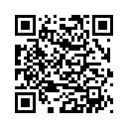
Amigo Mobile UI

To open the App in a browser, go to http://192.168.2.91:8000/src/ or scan the Qr code below. On the iPhone you can save the App to your home screen. This also works with the newest version of Chrome on android.

