Austin Beller
IST 652
December 11, 2019
Market Basket Analysis
The dataset we chose the market basket analysis in the kaggle competition which was released by Instacart an online grocery shopping company. This dataset is a relation set of csv files regarding customers orders over time. The dataset contained over 3 million grocery orders with a sequence of products purchased for each order from a total of 200,000 customers. Each of these customers orders have between four and one hundred orders for each customer. Time week and hours of the day each order was placed and a relative measure of time between each order.
For our analysis we decided to input the data into the panda’s database. The data that was imported was already cleaned and did not require any necessary pruning of zero values or NA’s. The only change to the data that was imported to the data type by using D-types which allows use to state more specifically if we would like to import an int32 or int64.
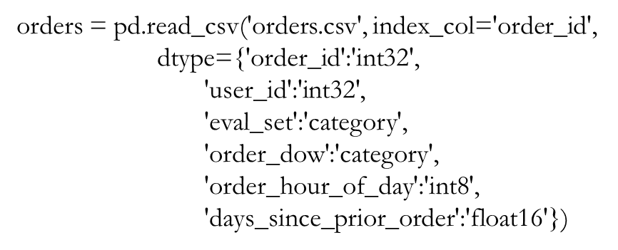
Above is an sample code showing how d values were selected
In order to give direction to the project we decided that we would answer the following questions.
- What time is it most popular to order items?
- What day of the week is most popular?
- When do people order again?
- How many items are in an order?
- What are the top 10 items order?
- Can we make association rules for this dataset?

For our analysis we decided that graphing was the best tool to use in order best communicate the analysis and results. The following figures displayed below are the output of our code which was created using matlab and association rules mining. What was generated where some bar graphs and some association rules.
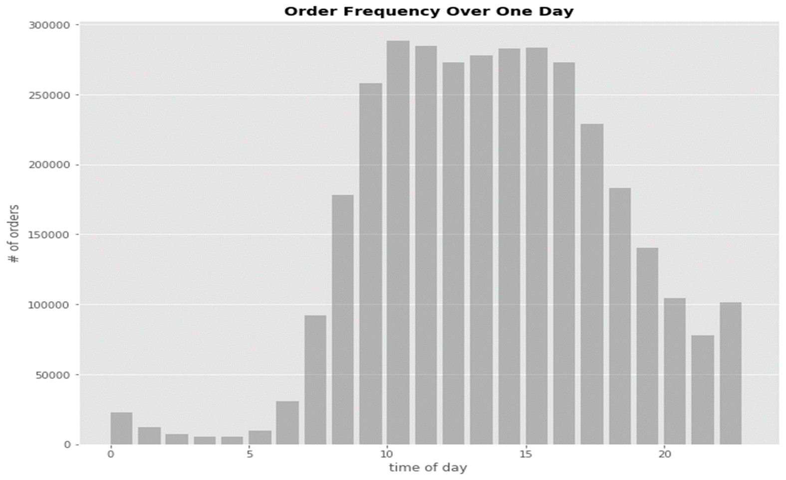
Figure 1: Order frequency over one day
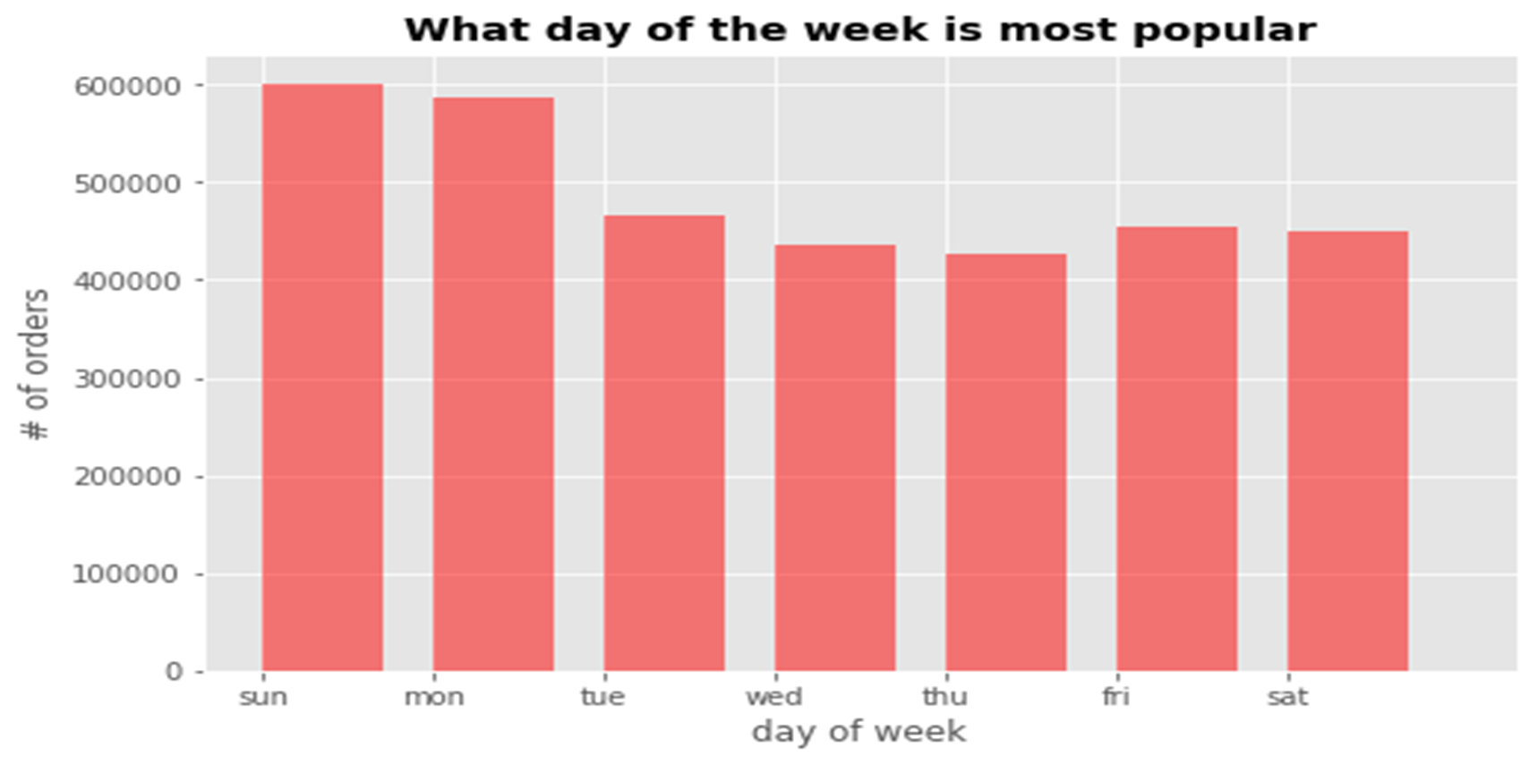
Figure 2: What day of the week is most popular to order
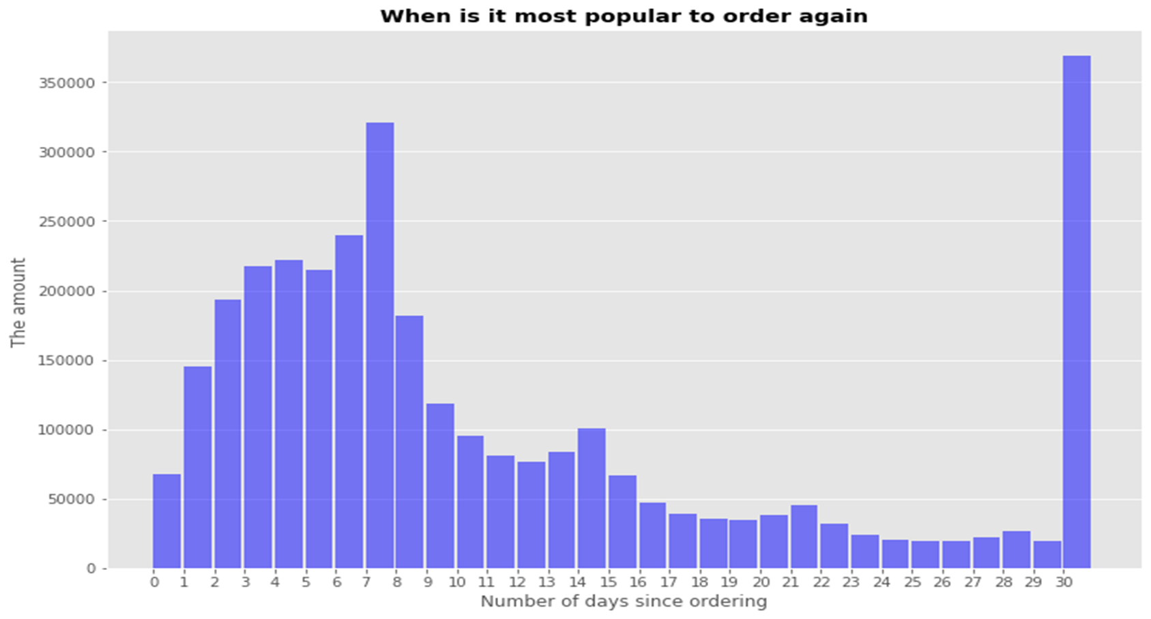
Figure 3: When is it most popular to order again
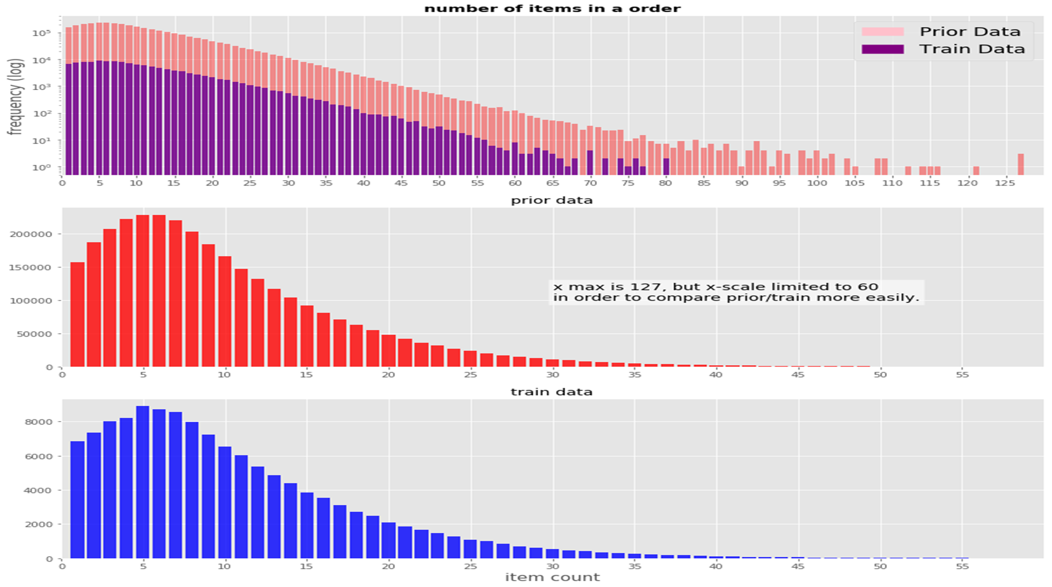
Figure 4: The number of items in an order in two datasets.
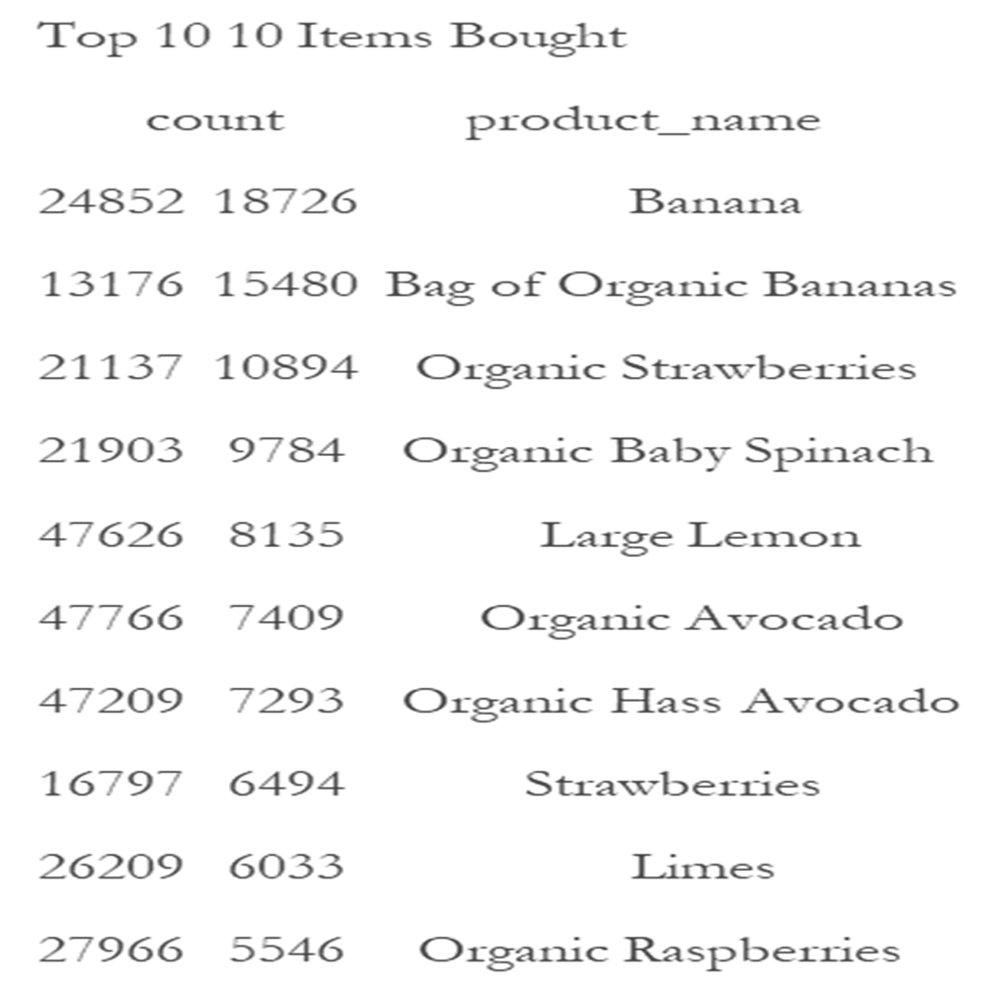
Figure 5: List of the top 10 items bought
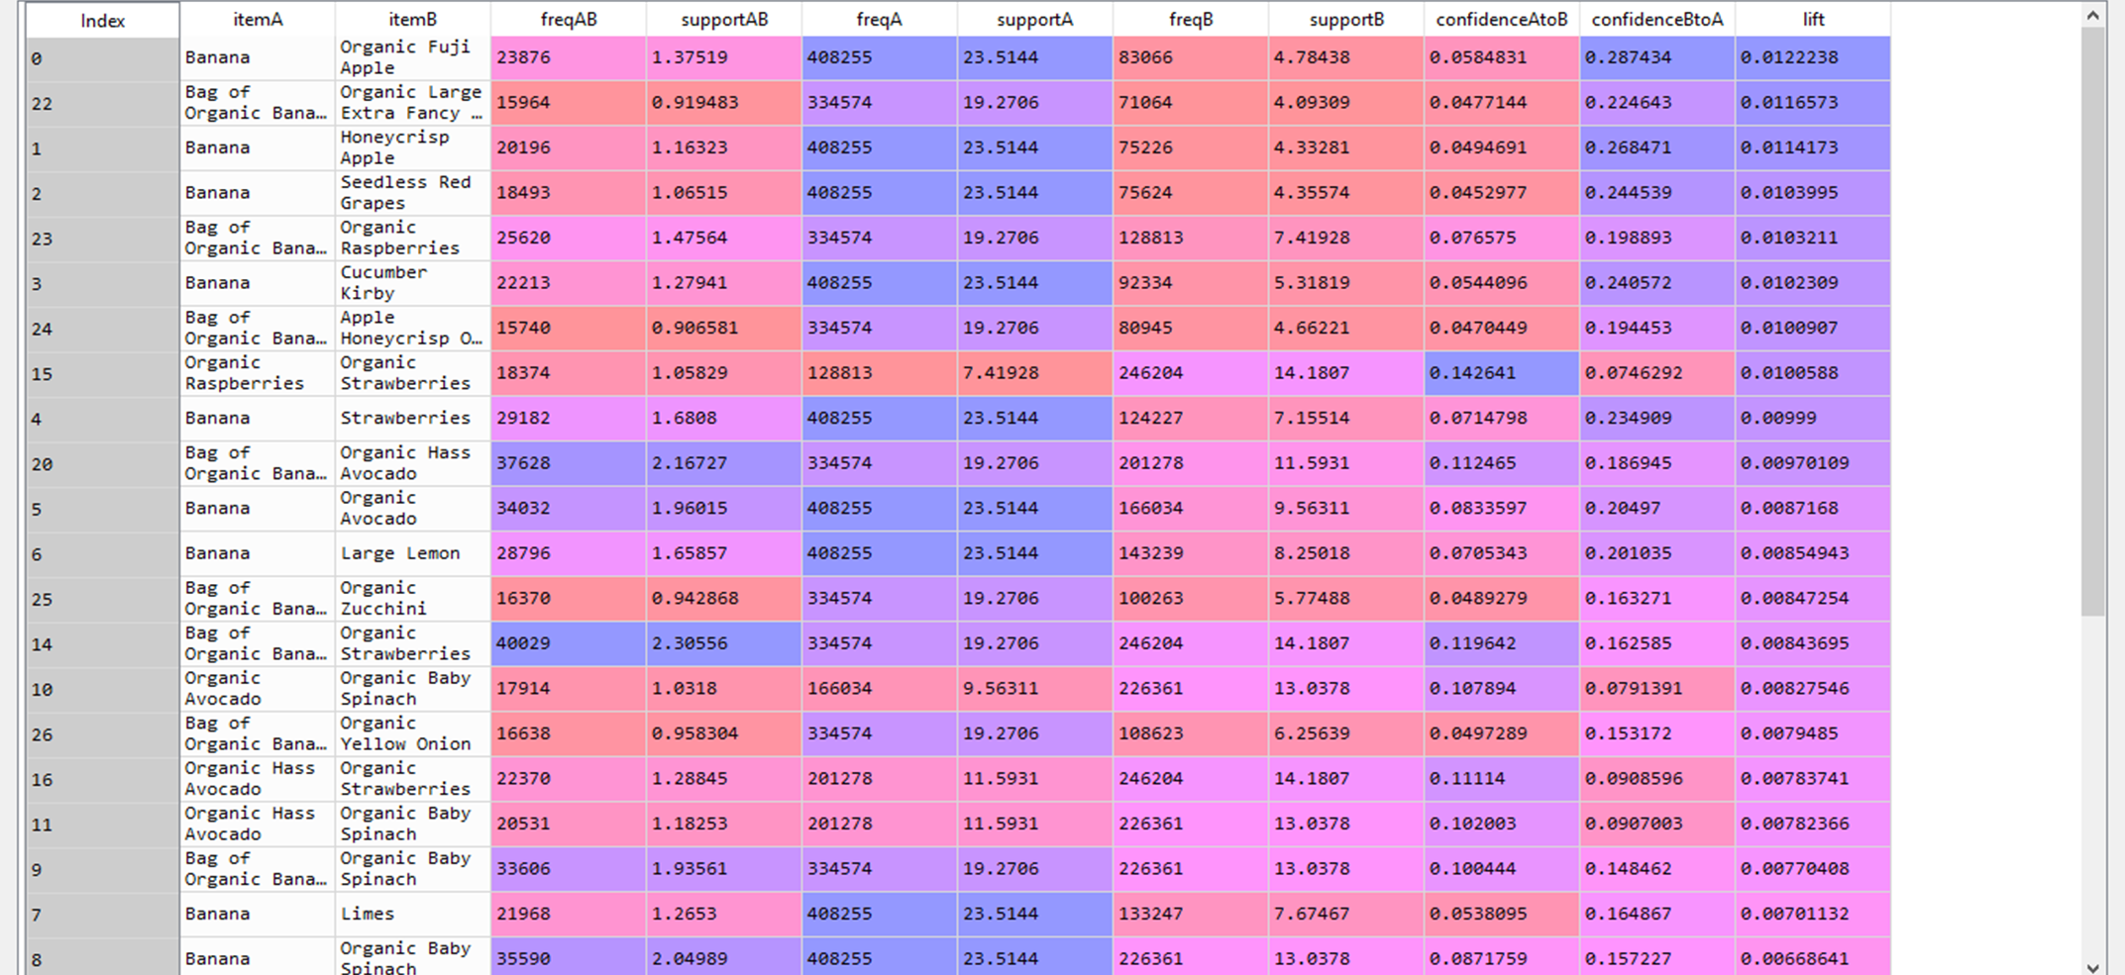
Figure 6: These are association rules
The analysis gathered some interesting results the last figure shows some association rules mining. These rules have parameters and, in this case, it was organized by those rules with the highest lift value which means that A = B also when B = A. The support was 0.9 this was due to the fact that the data set was so large and our own computational power was so low that this was the closest to what our hardware could handle. In order to create this program we used python generators which returns an iterable sequecnce of items. What makes them different from regular functions is that they return one value at a time as opposed to a list all at once. This function makes it a very good fit to create item pairs.
The conclusion we can draw from the data and the figures that were generated are that it is important to write good code but also efficient code which matches to the capabilities of the hardware you are using and to understand the limitations of the hardware in order to be more efficient. It was also found between 10am and 10pm on a Sunday or Monday with about 5 items is what the average consumer will buy. There is a large range of number of items order in the figure. The top 10items showed that Bananas were the most bought item of all the product. The items most likely to be paired up are banana and organic fuji apples with a 0.9 support.

Appendix A: Resources
Source 1
https://www.kaggle.com/hiramfoster/exploratory-analysis-r-to-python-translation
Source 2
https://www.kaggle.com/datatheque/association-rules-mining-market-basket-analysis
Appendix B:The code
# -*- coding: utf-8 -*-
"""
Created on Mon Dec 2 20:39:25 2019
Source 1
#https://www.kaggle.com/hiramfoster/exploratory-analysis-r-to-python-translation
Source 2
#https://www.kaggle.com/datatheque/association-rules-mining-market-basket-analysis
@author: Austin Beller
"""
import pandas as pd
import numpy as np
import matplotlib.pyplot as plt
import matplotlib.patches as mpatches
import sys
from IPython.display import display
from itertools import combinations, groupby
from collections import Counter
#Here is a style that you can use to display your graphs in this case we stayed with
#our source and choose GGplot
plt.style.use('ggplot')
#This was taken from source one who was playing with dtype arrays
#I left it untouched since it likly has weight when adjusted
#this was just the sources way of declaring the specific type of intiger
orders = pd.read_csv('orders.csv', index_col='order_id',
dtype={'order_id':'int32',
'user_id':'int32',
'eval_set':'category',
'order_dow':'category',
'order_hour_of_day':'int8',
'days_since_prior_order':'float16'})
products = pd.read_csv('products.csv', index_col='product_id',
dtype={'product_id':'int32',
'product_name':'object',
'aisle_id':'int16',
'department_id':'int16'})
order_products_train = pd.read_csv('order_products__train.csv',
dtype={'order_id':'int32',
'product_id':'int32',
'add_to_cart_order':'int8',
'reordered':'uint8'})
order_products_prior = pd.read_csv('order_products__prior.csv',
dtype={'order_id':'int32',
'product_id':'int32',
'add_to_cart_order':'int8',
'reordered':'uint8'})
aisles = pd.read_csv('aisles.csv', index_col='aisle_id',
dtype={'aisle_id':'int16', 'aisle':'category'})
departments = pd.read_csv('departments.csv', index_col='department_id',
dtype={'department_id':'int8', 'department':'category'})

#Here we will look over some basic models built to evaluted the data which we imported
#the data imported uses different graphs to display consumer behavior

#In the fist graph we will present a bar graph to see
#what time of the day do most people order?
#In this case we set up bins at 24 since there are 24hours in a day
plt.figure(figsize=(11, 9))
plt.title('Order Frequency Over One Day', fontweight='bold')#here we can make the text bold
plt.ylabel('# of orders')
plt.xlabel('time of day')
plt.hist(orders.order_hour_of_day, bins=np.arange(24), width=0.8, facecolor='grey', alpha=0.5)
plt.grid(axis='x')
plt.show()

#Is there a certain day in which all of the orders take place.
#in this case we made a days np.array and plotted with days of the week
plt.clf()
days=['sun', 'mon', 'tue', 'wed', 'thu', 'fri', 'sat']
plt.figure(figsize=(8,5))
plt.hist(orders.order_dow.astype('int8'), bins=np.arange(8), width=0.7, facecolor='red', alpha=0.5)
plt.xticks(np.arange(7), ('sun', 'mon', 'tue', 'wed', 'thu', 'fri', 'sat'))
plt.title('What day of the week is most popular', fontweight='bold')
plt.xlabel('day of week')
plt.ylabel('# of orders')
plt.show()

#When is the next time someone orders.
#Is it the same day?
#in case I forgot to explain teh figsize determines the size of the image
plt.figure(figsize=(12, 8))
plt.title('When is it most popular to order again', fontweight='bold')
plt.ylabel('The amount ')
plt.xlabel('Number of days since ordering')
plt.hist(orders.days_since_prior_order.dropna(), bins=np.arange(32), width=0.9, facecolor='Blue', alpha=0.5)
plt.grid(axis='x')
plt.xticks(np.arange(31))#this adds tickmarks to the graph
plt.show()

#How many different items do people buy?
#Then we will see how many how many items are in each pearsons cart
#Do the train data a prior data match?

#The data shows shows there is some difference between the two sets.
#Namely, the prior dataset shows some orders have a very large number of items.
#Since we did not normalize this would skew the results

y_bartrain = order_products_train.groupby('order_id').add_to_cart_order.max().value_counts().sort_index().values
x_bartrain = order_products_train.groupby('order_id').add_to_cart_order.max().value_counts().sort_index().index.values
y_barprior = order_products_prior.groupby('order_id').add_to_cart_order.max().value_counts().sort_index().values
x_barprior = order_products_prior.groupby('order_id').add_to_cart_order.max().value_counts().sort_index().index.values
plt.clf()

fig, (a1, a2, a3) = plt.subplots(3,1, figsize=(15,15))

a1.bar(x_bartrain, y_bartrain, color='b', alpha=0.8)
a1.set_title('number of items in a order', fontweight='bold')
a1.set_ylabel('frequency (log)', fontsize=15)

a1.set_xlim(0,130)
a1.set_yscale('log')
a1.set_xticks(np.arange(0,130, 5))
a1.bar(x_barprior, y_barprior, color='r', alpha=0.4)
pink_patch = mpatches.Patch(color='pink', label='Prior Data')
purple_patch = mpatches.Patch(color='purple', label='Train Data')
a1.legend(handles=[pink_patch, purple_patch], fontsize='xx-large')

a2.bar(x_barprior, y_barprior, color='r', alpha=0.8)
a2.set_title('prior data')
a2.set_xlim(0,60)
a2.set_xticks(np.arange(0,60, 5))
a2.text(30,100000,
'x max is 127, but x-scale limited to 60 \nin order to compare prior/train more easily.',
bbox=dict(facecolor='white', alpha=0.6), fontsize='x-large')

a3.bar(x_bartrain, y_bartrain, color='blue', alpha=0.8)
a3.set_title('train data')
a3.set_xlim(0, 60)
a3.set_xticks(np.arange(0,60,5))
a3.set_xlabel('item count', fontsize=15)

plt.show()

#Bestsellers
#What are the top 10 items sold?

top=10
print ('Top {0} 10 Items Bought'.format(top))
top10 = pd.merge(left=order_products_train.product_id.value_counts().nlargest(top).to_frame('count'), right=products[['product_name']], left_index=True, right_index=True)

display(top10)
top10.plot(x='product_name', y='count', kind='bar', figsize=(12,8), width=.9, fontsize='large', alpha=0.8)

#So now that we know what are the top 10 items bought are lets see if we can create some association
#rules for the dataset now that we are done exploring

#Exploring Customer Habits
#Customers reordering only
#Here i look for customers who just reorder the same products again all the time. To search those I look at all orders (excluding the first order) and their total reorder rate.

#I got different values than @phillippsp. He cutoff his order_number at >2, I set my cutoff at >1. My table also shows the reorder_rates for all users, not just those with a 100% reorder rate.

temp = pd.merge(left=order_products_prior[['order_id', 'product_id', 'reordered']],
right=orders[['user_id', 'order_number']][orders.order_number > 1],
left_on='order_id', right_index=True)
temp = pd.merge(left=orders[orders.order_number > 1].user_id.value_counts().to_frame('count'),
right=temp.groupby('user_id').reordered.mean().to_frame('reorder_rate'),
left_index=True, right_index=True)
temp.index.names = ['user_id']
print('temp is a DataFrame with user_id as index, number of orders per user, and reorder_rate for user')

temp[temp.reorder_rate==1].sort_values('count', ascending=False).nlargest(10, 'count')

def size(obj):
return "{0:.2f} MB".format(sys.getsizeof(obj) / (1000 * 1000))

def get_user(user_id):
return pd.merge(left= pd.merge(left=orders[(orders.user_id==user_id) & (orders.eval_set=='prior')],
right=order_products_prior,
left_index=True,
right_on='order_id'),
right= products[['product_name']],
left_on='product_id',
right_index=True).sort_values(['order_number', 'add_to_cart_order']).drop(['user_id', 'product_id'], axis=1).reset_index(drop=True)
get_user(99753).head()

for i in temp[temp.reorder_rate==1].sort_values('count', ascending=False).nlargest(10, 'count').index.values:
print(get_user(i).product_name.unique())

orders = pd.read_csv('order_products__prior.csv')
print('orders -- dimensions: {0}; size: {1}'.format(orders.shape, size(orders)))
display(orders.head())

# Convert from DataFrame to a Series, with order_id as index and item_id as value
orders = orders.set_index('order_id')['product_id'].rename('item_id')
display(orders.head(10))
type(orders)

print('dimensions: {0}; size: {1}; unique_orders: {2}; unique_items: {3}'
.format(orders.shape, size(orders), len(orders.index.unique()), len(orders.value_counts())))

# Returns frequency counts for items and item pairs
def freq(iterable):
if type(iterable) == pd.core.series.Series:
return iterable.value_counts().rename("freq")
else:
return pd.Series(Counter(iterable)).rename("freq")

# Returns number of unique orders
def order_count(order_item):
return len(set(order_item.index))

# Returns generator that yields item pairs, one at a time
def get_item_pairs(order_item):
order_item = order_item.reset_index().as_matrix()
for order_id, order_object in groupby(order_item, lambda x: x[0]):
item_list = [item[1] for item in order_object]

for item_pair in combinations(item_list, 2):
yield item_pair

# Returns frequency and support associated with item
def merge_item_stats(item_pairs, item_stats):
return (item_pairs
.merge(item_stats.rename(columns={'freq': 'freqA', 'support': 'supportA'}), left_on='item_A', right_index=True)
.merge(item_stats.rename(columns={'freq': 'freqB', 'support': 'supportB'}), left_on='item_B', right_index=True))

# Returns name associated with item
def merge_item_name(rules, item_name):
columns = ['itemA','itemB','freqAB','supportAB','freqA','supportA','freqB','supportB',
'confidenceAtoB','confidenceBtoA','lift']
rules = (rules
.merge(item_name.rename(columns={'item_name': 'itemA'}), left_on='item_A', right_on='item_id')
.merge(item_name.rename(columns={'item_name': 'itemB'}), left_on='item_B', right_on='item_id'))
return rules[columns]

def association_rules(order_item, min_support):

print("Starting order_item: {:22d}".format(len(order_item)))

# Calculate item frequency and support
item_stats = freq(order_item).to_frame("freq")
item_stats['support'] = item_stats['freq'] / order_count(order_item) * 100

# Filter from order_item items below min support
qualifying_items = item_stats[item_stats['support'] >= min_support].index
order_item = order_item[order_item.isin(qualifying_items)]

print("Items with support >= {}: {:15d}".format(min_support, len(qualifying_items)))
print("Remaining order_item: {:21d}".format(len(order_item)))

# Filter from order_item orders with less than 2 items
order_size = freq(order_item.index)
qualifying_orders = order_size[order_size >= 2].index
order_item = order_item[order_item.index.isin(qualifying_orders)]

print("Remaining orders with 2+ items: {:11d}".format(len(qualifying_orders)))
print("Remaining order_item: {:21d}".format(len(order_item)))

# Recalculate item frequency and support
item_stats = freq(order_item).to_frame("freq")
item_stats['support'] = item_stats['freq'] / order_count(order_item) * 100

# Get item pairs generator
item_pair_gen = get_item_pairs(order_item)

# Calculate item pair frequency and support
item_pairs = freq(item_pair_gen).to_frame("freqAB")
item_pairs['supportAB'] = item_pairs['freqAB'] / len(qualifying_orders) * 100

print("Item pairs: {:31d}".format(len(item_pairs)))

# Filter from item_pairs those below min support
item_pairs = item_pairs[item_pairs['supportAB'] >= min_support]

print("Item pairs with support >= {}: {:10d}\n".format(min_support, len(item_pairs)))

# Create table of association rules and compute relevant metrics
item_pairs = item_pairs.reset_index().rename(columns={'level_0': 'item_A', 'level_1': 'item_B'})
item_pairs = merge_item_stats(item_pairs, item_stats)

item_pairs['confidenceAtoB'] = item_pairs['supportAB'] / item_pairs['supportA']
item_pairs['confidenceBtoA'] = item_pairs['supportAB'] / item_pairs['supportB']
item_pairs['lift'] = item_pairs['supportAB'] / (item_pairs['supportA'] * item_pairs['supportB'])

# Return association rules sorted by lift in descending order
return item_pairs.sort_values('lift', ascending=False)

# Replace item ID with item name and display association rules
rules = association_rules(orders, 0.9)
item_name = pd.read_csv('products.csv')
item_name = item_name.rename(columns={'product_id':'item_id', 'product_name':'item_name'})
rules_final = merge_item_name(rules, item_name).sort_values('lift', ascending=False)
display(rules_final)

