

Record Management System – Phase 3
Business Requirement Document
Tài liệu mô tả yêu cầu nghiệp vụ
Restricted
DEPARTMENT: OPERATIONS
PRUDENTIAL VIETNAM FINANCE COMPANY LIMITED

01-04-2015

Table of Contents
I. VERSION CONTROL / QUẢN LÝ PHIÊN BẢN 3
II. PROJECT COMMITTEE / THÀNH PHẦN THAM GIA DỰ ÁN 3
III. BACKGOUND / THỰC TRẠNG 3
IV. NEW REQUIREMENT / YÊU CẦU THAY ĐỔI 4
V. ROLEBASE ACCESS MATRIX / PHÂN QUYỀN TRUY CẬP HỆ THỐNG 7
APPENDIX A: USER REQUIREMENT TRACEABILITY LOG SHEET 7
Approval Sign-off 7

VERSION CONTROL / QUẢN LÝ PHIÊN BẢN

Version | Component | Created /  Updated by | Date | Comment

PROJECT COMMITTEE / THÀNH PHẦN THAM GIA DỰ ÁN

Role | PIC
Business Owner /  Sở hữu thông tin và/hoặc qui trình  (Usually is HoD / Trưởng bộ phận) | LƯU NGỌC DIỆP
System Owner /  Sở hữu ứng dụng  (Usually is Head of Technology) | BÙI XUÂN KHẢI
Functional Users /  Nhân viên tác nghiệp  (Usually is End-Users) | VÕ MỸ PHƯƠNG
Project Manager /
Quản lý dự án
(Usually is IT)
Business Analysis Manager /  Quản lý phân tích yêu cầu  (Usually is IT-BA) | NGUYỄN ĐỨC PHƯƠNG
Developer Manager /  Quản lý phát triển ứng dụng | HÀ CÔNG ÁNH
IRSM / ITSM /  Quản lý Rủi ro và Bảo mật thông tin | ĐỖ TRƯƠNG TÙNG
Testers /  Người thử nghiệm  (Usually is End-Users) | VÕ MỸ PHƯƠNG

BACKGOUND / THỰC TRẠNG

We use Record Management System not only as a tool to check in receiving daily Loan agreement from Branch Networks, but also as a tool to manage all loan documents including MRC of Sales Finance, collateral documents of Home Loan. Currently, we use excel files to manage the ralated information about these productions. RMS – Phrase 3 will be built up to replace for them.

We want to change logic in RMS to adapt to new procedure and add some functions into RMS such as: update status, enquiry screen.

NEW REQUIREMENT / YÊU CẦU THAY ĐỔI

1/ MRC & Home Loan into RMS: Input information into RMS such as:
- MRC: block, sequence number, loan agreement, disbursal date, customer name, MRC number, received date, 1st copy date, tenure, maturity date, orginal MRC return, attached document - VAT invoce (if any), remark.

Block | No. | Loan No. | Disb. Date | Customer Name | Cert. No. | Rcvd Date | 1st copy | Tenure | Maturity date | Org. return | HÓA ĐƠN
A | 1 | 10028705 | 11-08-2008 | TRẦN HOÀNG ÂN | 013497 | 27-08-2008 | 27-08-2008 | 12 | 01-08-2009
A | 2 | 10031595 | 26-08-2008 | ĐÀO DUY TRƯỜNG | 013628 | 17-09-2008 | 19-09-2008 | 24 | 05-08-2010
A | 3 | 10032074 | 28-08-2008 | TRẦN VĂN TÂM | 026442 | 17-09-2008 | 19-09-2008 | 24 | 05-08-2010
A | 4 | 10054546 | 12-12-2008 | VÕ THANH SƠN | 017044 | 17-12-2008 | 24-12-2008 | 12 | 01-12-2009 |  | Y
A | 1 | 10056769 | 25-12-2008 | ĐOÀN VĂN TOÀN | 036764 | 31-12-2008 | 02-01-2009 | 24 | 05-12-2010 |  | Y
A | 3 | 10064164 | 19-01-2009 | PHẠM HUY CƯỜNG | 039264 | 22-01-2009 | 23-01-2009 | 24 | 01-01-2011 |  | Y

- Home loan: Loan agreement, customer name, order date, execution date, file folder number, 1st seal, 2nd seal, 3rd seal, original document returning date
Loan No. | Customer's Name | Order Date | Execution Date | File folder | 1st seal | 2nd seal | 3rd seal | Return  Original document
10008246 | Nguyễn Tiến Dũng | 05/05/2008 (3:7 pm) | 06/05/2008 (3:20 pm) | H006502 | 002481
10009532 | Nguyễn Ngọc Thịnh | 30/06/2008 (2.45 pm) | 1/7/2008 (10:20 am) | H010106 | 002535 | 002579 | 002602
10018357 | Phan Tấn Đạt | 30/06/2008 (2.45 pm) | 1/7/2008 (10:20 am) | H010105 | 002534 | 002807
10031037 | Nguyễn Thanh Toàn | 21/11/08 | 25/11/08 | H023006 | 002561
10044983 | Bùi Thị Hồng Hoa | 21/11/08 | 25/11/08 | H023018 | 002544
-> RMS will automatically update status from LMS: closed
-> Remark returned date into RMS include: MRC & Home Loan
2/ Change procedure:
- Old logic:
Branch Networks send Record Management Team (RMT) the Disbursal loan, which is moved to ‘Disbursal loan RMT’. At this stage, RMT receives it and move to stage ‘Loan received’, and then move to ‘Loan kit verify’ if the loan is qualified; if not qualified, RMT will remark in the system the reason (For example: Need more information: thieu bien lai thu phi BH,…). Now the loan is moved to ‘Loan waiting’. After completed the supplementation, the loan is moved to ‘Loan kit verify’ and to the next stage.
Disbursal loan

Disbursal loan RMT
Loan receive
Loan kit verified
Loan waiting
Loan kit prepare
Insurance Certificate Completed
Loan Kit Ready List

Complteted
- Change logic:
Branch Networks send Record Management Team (RMT) the Disbursal loan, which is moved to ‘Disbursal loan RMT’. At this stage, all loans are received and moved parallel to 2 separate stages: Loan kit verify and Loan received. From ‘Loan received’, RMT will move to the stage ‘prepare to scan’ if the loan is qualified; if not qualified, it is moved to ‘Loan waiting’ with the reason as same as in the old logic. After completing the stage ‘Loan waiting’, RMT will move to stage ‘prepare to scan’ and then ‘Scan loan document’ and ‘store’.
Notes: Maintain the detail of old screen in RMS
Disbursal loan

Disbursal loan RMT
Loan kit verified
Loan kit prepare
Loan Kit Ready List
Prepare to scan

Scan loan document
Store
Insurance Certificate Completed
Loan waiting
Loan receive

completed

3/Update status:
a/- TB6 letter: Upload the list of TB6 letters receiving from CS
CS uploads the list of TB6 letters into RMS through upload TB6 document function. RMT receives it at stage ‘ReceiveTB6 document’. If it is qualified, RMT remarks as check all and move to the stage ‘completed’; if not qualified, RMT remarks as not qualified and moves to document waiting and then exports the list for checking as a excel file. After completeing ‘Document waiting’ stage, RMT move to ‘completed’ and exports the list as a excel file.
- The list of TB6 letters imported & exported on RMS includes: loan agreement number, application form number, customer’s name
Upload TB6 document

Receive TB6 document

Completed
Document waiting

b/- Foreclosure: Upload the list of foreclosure receiving from XPU
Use the logic as same as at TB6 letter receiving from CS for this function.
Upload foreclosure list
document

Receive foreclosure list

Completed
Document waiting

c/- Cancel insurance: Remark/upload all insurance cases cancelled by customer
4/ Enquiry screen: User can search from one of some information: loan ID, Application form number
- System will show detail about the loan: Loan agreement, Application form number, Customer name, tenure.
- User can check detail of the loan transaction from Branch Networks to Record Management Team
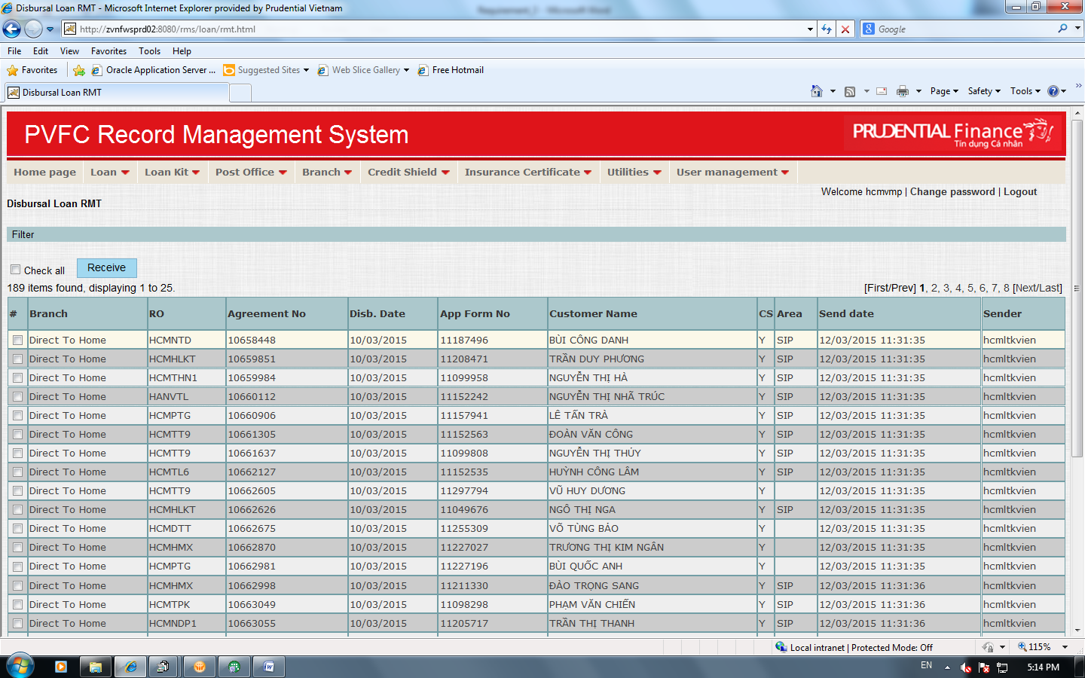

ROLEBASE ACCESS MATRIX / PHÂN QUYỀN TRUY CẬP HỆ THỐNG

(Describe WHO can access to WHICH FUNCTION and can do WHAT (R: Read/view - C: Create - U: Update - D: Delete - A: Approve/Reject) / Mô tả AI có thể sử dụng CHỨC NĂNG nào và có thể LÀM GÌ (R: xem - C: Tạo mới - U: cập nhật - D: Xóa - A: Xác nhận/Từ chối))

- CS can access to upload TB6 Letter & document waiting (C,U,R)
- XPU can access to upload Foreclosure list & document waiting (C,U,R)
- RMT can acess to receive TB6 Letter & Foreclosure and remain the old functions (C,U,R,A)
- All users can access to Enquiry (R)

APPENDIX A: USER REQUIREMENT TRACEABILITY LOG SHEET
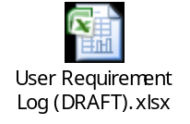

Approval Sign-off
Role | Signature
Business Owner
(Usually is HoD)

Project Manager
(Usually is IT)

Business Analysis Manager
(Usually is IT-BA)

