**(All are open sources)**

**Hardware Requirements:**

Intel Pentium IV or V with min. 8 GB RAM, 10 GB HDD Free Space and Windows 10/11 OS

**Software Requirements:**

**Java Development Kit version 20**

Access the following link to download JDK 21

<https://www.oracle.com/java/technologies/javase/jdk21-archive-downloads.html>

**Download and install JDK 21**

**Eclipse IDE for Java EE**

Eclipse IDE for Enterprise Java and Web Developers (includes Incubating components)

Version: 2024-06 (4.31.0)

Build id: 20240307-1437

Access the following link to install Eclipse IDE for Java EE

<https://www.eclipse.org/downloads/packages/release/2024-03/r>

** Important: select second option **“Eclipse IDE for Enterprise Java and Web Developers”**

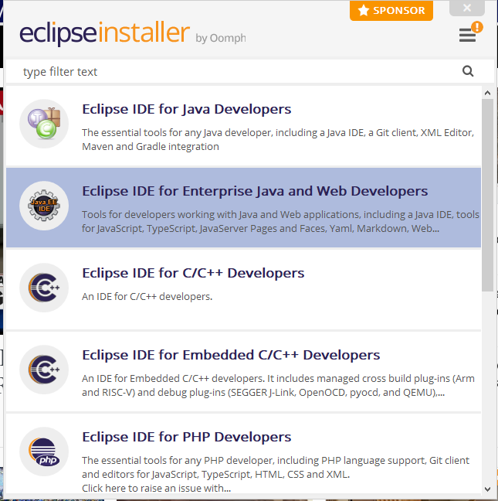

1. Download Postman:

Go to the Postman website.

<https://www.postman.com/downloads/>

**Lab Setup for**

**Angular JS, Node JS and React JS”**

**(All are open sources)**

1. **Download and Install VSCode:**

**Download and extract .zip file into local folder (c:\** VSCode**) from** [**https://code.visualstudio.com/Download**](https://code.visualstudio.com/Download)

**Visit the website** <https://code.visualstudio.com/Download>

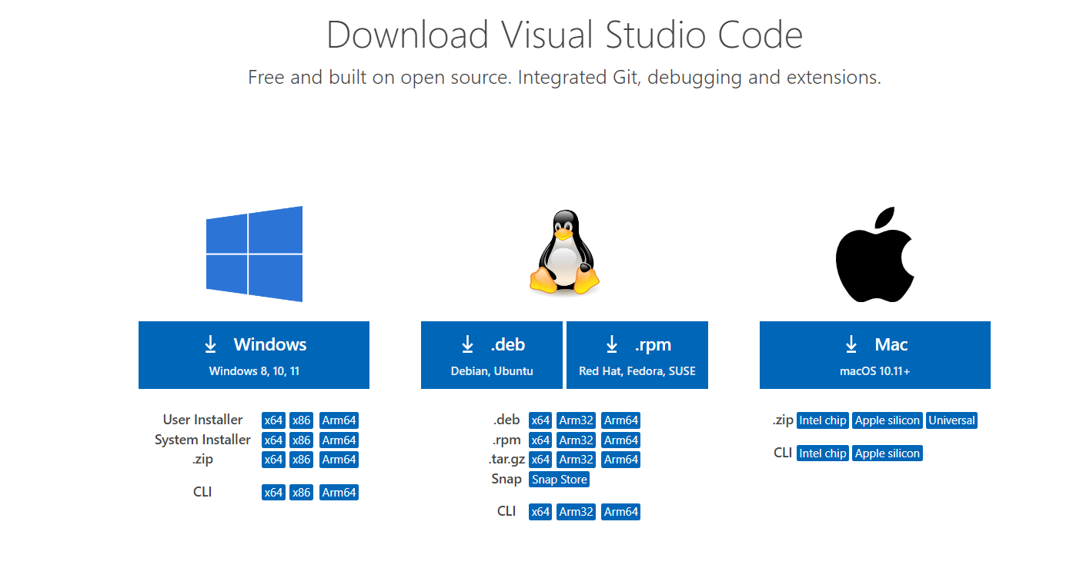

**Click on .zip file (64 bit)**

**It will download** VSCode-win32-x64-1.89.0.zip **in “downloads” folder**

**Unzip to c:\ or d:\ drive**

**Right click and unzip.**

**After unzip successful, go to the folder “**VSCode-win32-x64-1.89.0.zip**”, you can see “code.exe”, double click on this and the VSCode editor will op**

**Download and install latest version of Node JS**

**Visit the website:** <https://nodejs.org/en/download/>

**Select and download Windows Binary (.zip) 64-bit as shown in the following diagram:**

**Click on Download… Prebuilt binaries…Click Download Node.js v20.13.1**

