**INSTALLING NOTEPAD++ (EDITOR)**

1. Notepad++ is a freeware and can be downloaded from the following website:- <https://notepad-plus-plus.org/downloads/>
2. Click on the latest version whichever is available.
3. Download 64 bit installer.
4. Screenshots are already provided, and action is highlighted in blue)
5. It will download an .exe setup file.
6. Run the setup- and select English language
7. 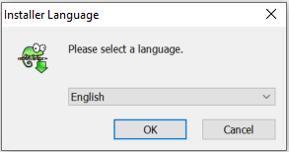
8. Follow steps in the screen to finish the installation.

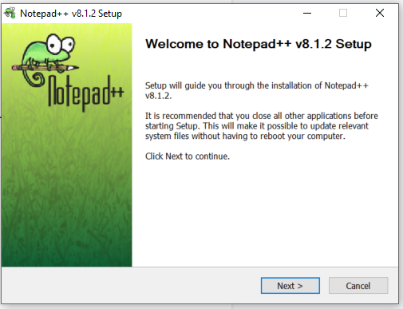

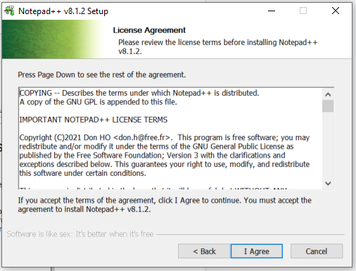

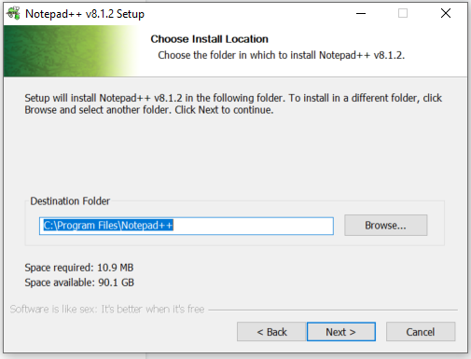

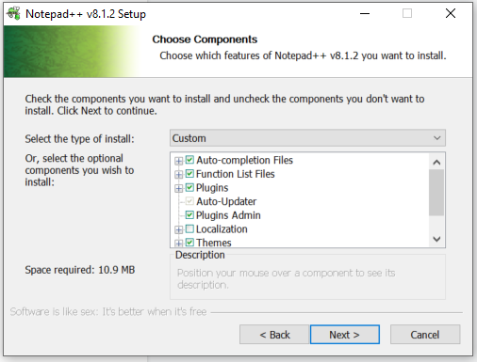

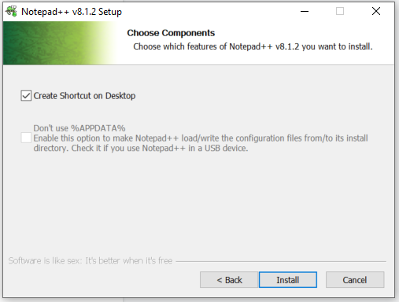

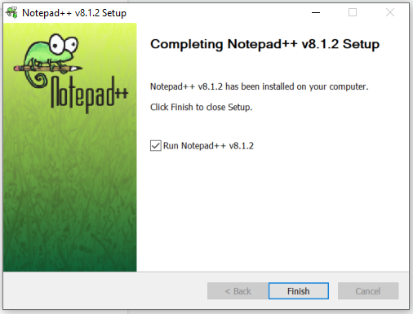

Download Oracle 21c

Step 1

Download Oracle 21c : <https://www.oracle.com/in/database/technologies/xe-downloads.html>

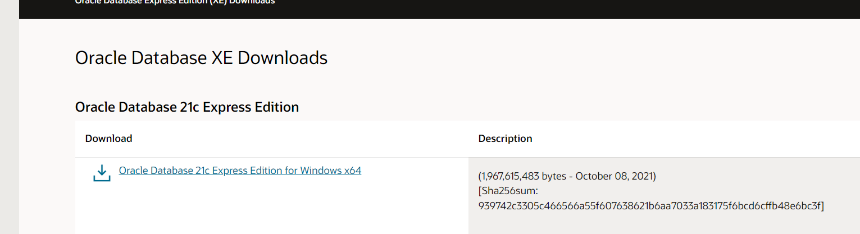

Step 2: Once downloaded , unzip the folder

Step 3: Navigate to the OracleXE213_Win64 folder and click setup.exe

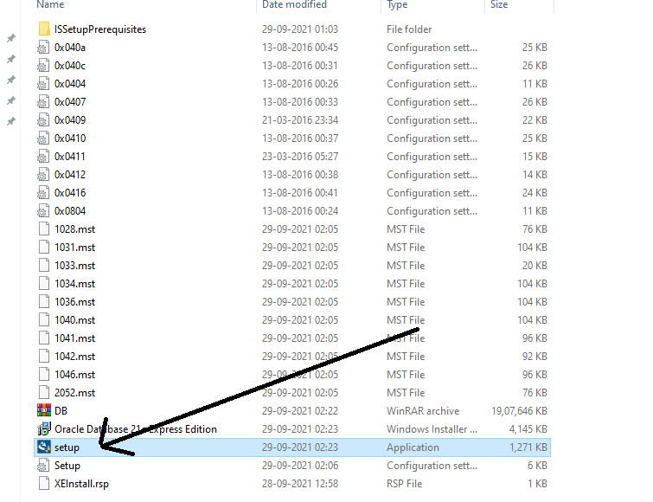

Step 4: Enter your new password (Do memorize it /write down anywhere)

** Ideally give password as **root**

Click Next

Step 5: It will take some time and installation completed.

2. Download SQL Plus

<https://www.oracle.com/database/sqldeveloper/technologies/download/>

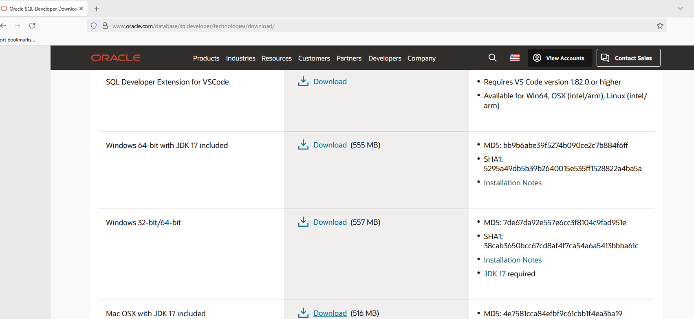

Download and Unzip