1.下载ActiveMQ   
去官方网站下载：[http://activemq.apache.org/](http://activemq.apache.org/" \t "https://www.cnblogs.com/wyh3721/p/_blank)   
我下载的时候是 ActiveMQ 5.14.0 Release版   
  
2.运行ActiveMQ   
解压缩apache-activemq-5.14.0-bin.zip，然后双击apache-activemq-5.14.0-bin\apache-activemq-5.14.0\bin\win64\activemq.bat运行ActiveMQ程序。   
  
启动ActiveMQ以后，登陆：http://localhost:8161/admin/，创建一个Queue，命名为FirstQueue。   
  
3.创建Eclipse项目并运行   
创建java project：ActiveMQ-5.14，新建lib文件夹   
打开apache-activemq-5.14.0-bin\apache-activemq-5.14.0\lib目录   
拷贝如下6个jar包：

activemq-broker-5.14.0.jar

activemq-client-5.14.0.jar

activemq-all-5.14.0.jar

geronimo-j2ee-management_1.1_spec-1.0.1.jar

geronimo-jms_1.1_spec-1.1.1.jar

slf4j-api-1.7.13.jar

这6个jar文件到lib文件夹中,并Build Path->Add to Build Path

结构如图:

Sender.java

Receiver.java

5.测试过程   
先运行:Receiver.java   
再运行:Sender.java

可以看到结果   
Sender运行后:   
发送消息：ActiveMq 发送的消息1   
发送消息：ActiveMq 发送的消息2   
发送消息：ActiveMq 发送的消息3   
发送消息：ActiveMq 发送的消息4   
发送消息：ActiveMq 发送的消息5

Receiver运行后:   
收到消息ActiveMq 发送的消息1   
收到消息ActiveMq 发送的消息2   
收到消息ActiveMq 发送的消息3   
收到消息ActiveMq 发送的消息4   
收到消息ActiveMq 发送的消息5

 要想看到不同的输出内容,通过点击如下图的按钮切换console

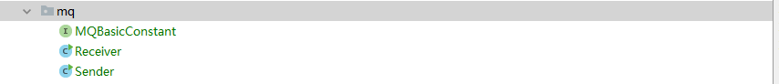

ActiveMQ是可很好用的消息中间件，一边生产，一边消费，最近我们项目也用到了，过程中碰到了一个比较有意思的问题，想着可能还会有人遇到，所以就想着记下来，万一有人能用的到呢。

正文：

ActiveMQ的安装就不在说了，网上相关的安装教程很多，我安装的是5.15.0版本。

安装好之后，就是启动MQ了，一般都是说直接双击avtivemq.bat脚本就直接能起动MQ了，如下图。

但是，我一双击就闪退，一双击就闪退，怎么都不行，然后就开始闷着去搜ActiveMQ启动闪退怎么解决，搜了半天，也没见解决我的问题，最后回到安装目录下研究了下，原来bin目录下还有两个文件夹。win32和win64

瞬间跟发现新大陆一般，我电脑是64位系统，果断点进win64，如下

发现，这里面也有个activemq.bat脚本，直接双击， 然后，然后就正式启动mq了，启动好后，浏览器输入

localhost:8161/admin/ 登录ActiveMQ本地监控控制台，默认用户名和密码都是admin，默认端口是8161，当然，这个可以通过conf/jetty-realm.properties文件修改，具体信息查看docs/WebConsole-README.txt文件。

ActiveMQ5.14.5下载地址：http://activemq.apache.org/activemq-5145-release.html

下载后加压zip到自己的路径，解压后得到的目录结构如下：

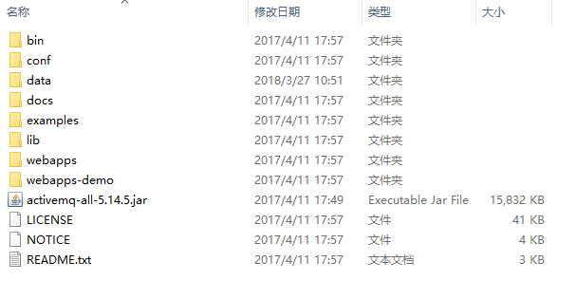

启动activemq之前，首先要确保本地环境已经配置好了jdk，而且要保证下载的activemq的版本适配于jdk的版本。

一切准备就绪后，进入apache-activemq-5.14.5\bin，得到如下目录：

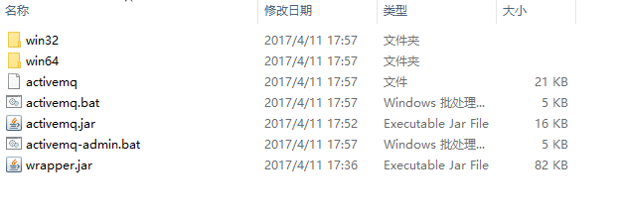

根据自己的操作系统，选择进入那个文件夹就可以，我是64位操作系统，就进入win64目录,双击activemq.bat这时activemq就启动了，如果黑色窗口一闪而过，那么就是jdk的环境变量没有配置的原因。

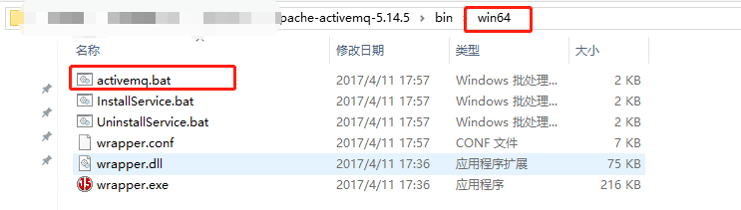

然后打开浏览器访问http://localhost:8161/admin/  弹出登录窗口

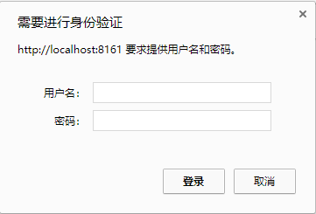

用户名密码配置在apache-activemq-5.14.5\conf\jetty-realm.properties文件，格式是用户名 : 密码 ,角色名

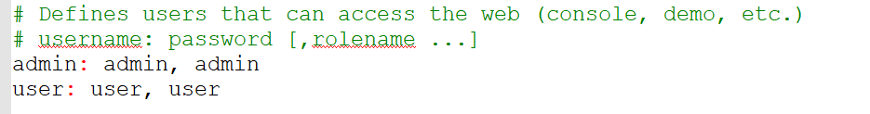

 用户名权限配置信息记录在apache-activemq-5.14.5\conf\jetty.xml

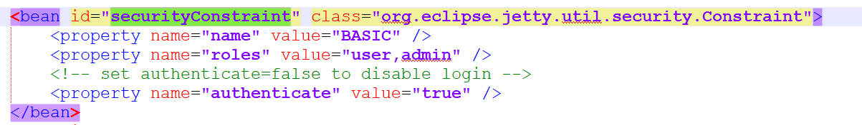

登录成功后，进入activeMQ的欢迎页

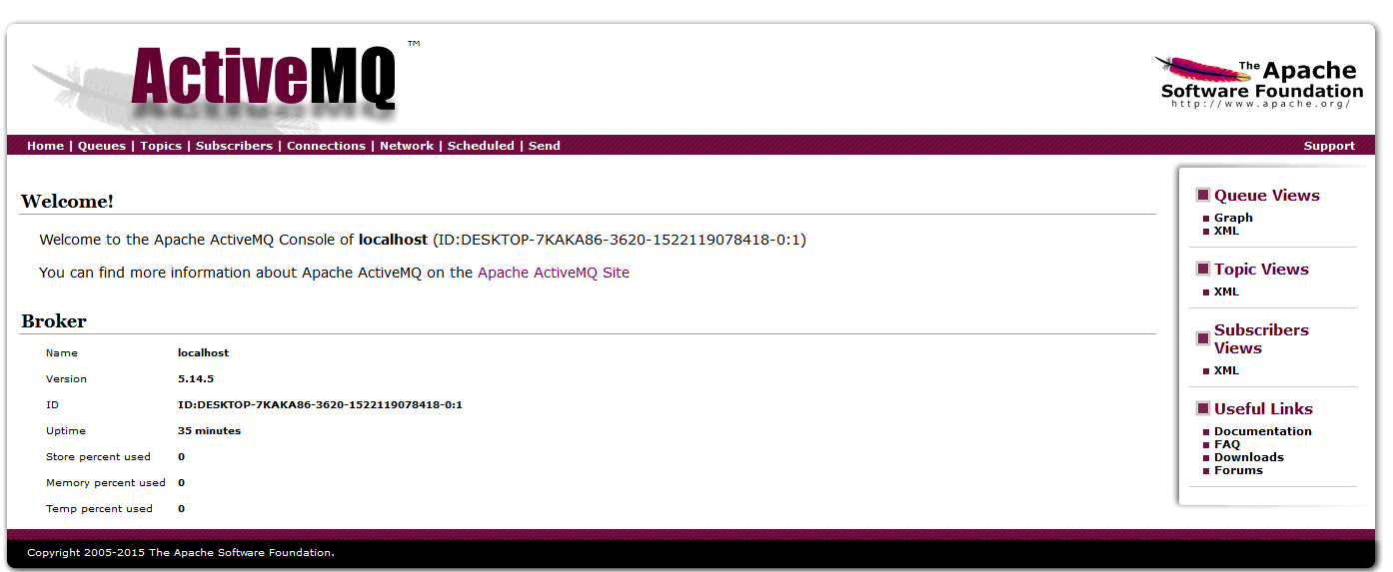

启动报错：

ActiveMQ启动报错:java.lang.IllegalStateException: LifecycleProcessor not initialized - call 'refresh' be

ERROR: java.lang.RuntimeException: Failed to execute start task. Reason: java.lang.IllegalStateException: BeanFactory not initialized or already closed - call 'refresh' before accessing beans via the ApplicationContext

jvm 1 | java.lang.RuntimeException: Failed to execute start task. Reason: java.lang.IllegalStateException: BeanFactory not initialized or already closed - call 'refresh' before accessing beans via the ApplicationContext

jvm 1 | at org.apache.activemq.console.command.StartCommand.runTask(StartCommand.java:91)

jvm 1 | at org.apache.activemq.console.command.AbstractCommand.execute(AbstractCommand.java:63)

jvm 1 | at org.apache.activemq.console.command.ShellCommand.runTask(ShellCommand.java:154)

jvm 1 | at org.apache.activemq.console.command.AbstractCommand.execute(AbstractCommand.java:63)

jvm 1 | at org.apache.activemq.console.command.ShellCommand.main(ShellCommand.java:104)

jvm 1 | at sun.reflect.NativeMethodAccessorImpl.invoke0(Native Method)

jvm 1 | at sun.reflect.NativeMethodAccessorImpl.invoke(NativeMethodAccessorImpl.java:62)

jvm 1 | at sun.reflect.DelegatingMethodAccessorImpl.invoke(DelegatingMethodAccessorImpl.java:43)

jvm 1 | at java.lang.reflect.Method.invoke(Method.java:498)

jvm 1 | at org.apache.activemq.console.Main.runTaskClass(Main.java:262)

jvm 1 | at org.apache.activemq.console.Main.main(Main.java:115)

jvm 1 | at sun.reflect.NativeMethodAccessorImpl.invoke0(Native Method)

jvm 1 | at sun.reflect.NativeMethodAccessorImpl.invoke(NativeMethodAccessorImpl.java:62)

jvm 1 | at sun.reflect.DelegatingMethodAccessorImpl.invoke(DelegatingMethodAccessorImpl.java:43)

jvm 1 | at java.lang.reflect.Method.invoke(Method.java:498)

jvm 1 | at org.tanukisoftware.wrapper.WrapperSimpleApp.run(WrapperSimpleApp.java:240)

jvm 1 | at java.lang.Thread.run(Thread.java:748)

jvm 1 | Caused by: java.lang.IllegalStateException: BeanFactory not initialized or already closed - call 'refresh' before accessing beans via the ApplicationContext

jvm 1 | at org.springframework.context.support.AbstractRefreshableApplicationContext.getBeanFactory(AbstractRefreshableApplicationContext.java:170)

jvm 1 | at org.springframework.context.support.AbstractApplicationContext.destroyBeans(AbstractApplicationContext.java:1030)

jvm 1 | at org.springframework.context.support.AbstractApplicationContext.refresh(AbstractApplicationContext.java:556)

jvm 1 | at org.apache.xbean.spring.context.ResourceXmlApplicationContext.<init>(ResourceXmlApplicationContext.java:64)

jvm 1 | at org.apache.xbean.spring.context.ResourceXmlApplicationContext.<init>(ResourceXmlApplicationContext.java:52)

jvm 1 | at org.apache.activemq.xbean.XBeanBrokerFactory$1.<init>(XBeanBrokerFactory.java:104)

jvm 1 | at org.apache.activemq.xbean.XBeanBrokerFactory.createApplicationContext(XBeanBrokerFactory.java:104)

jvm 1 | at org.apache.activemq.xbean.XBeanBrokerFactory.createBroker(XBeanBrokerFactory.java:67)

jvm 1 | at org.apache.activemq.broker.BrokerFactory.createBroker(BrokerFactory.java:71)

jvm 1 | at org.apache.activemq.broker.BrokerFactory.createBroker(BrokerFactory.java:54)

jvm 1 | at org.apache.activemq.console.command.StartCommand.runTask(StartCommand.java:87)

jvm 1 | ... 16 more

jvm 1 | ERROR: java.lang.IllegalStateException: BeanFactory not initialized or already closed - call 'refresh' before accessing beans via the ApplicationContext

jvm 1 | java.lang.IllegalStateException: BeanFactory not initialized or already closed - call 'refresh' before accessing beans via the ApplicationContext

jvm 1 | at org.springframework.context.support.AbstractRefreshableApplicationContext.getBeanFactory(AbstractRefreshableApplicationContext.java:170)

jvm 1 | at org.springframework.context.support.AbstractApplicationContext.destroyBeans(AbstractApplicationContext.java:1030)

jvm 1 | at org.springframework.context.support.AbstractApplicationContext.refresh(AbstractApplicationContext.java:556)

jvm 1 | at org.apache.xbean.spring.context.ResourceXmlApplicationContext.<init>(ResourceXmlApplicationContext.java:64)

jvm 1 | at org.apache.xbean.spring.context.ResourceXmlApplicationContext.<init>(ResourceXmlApplicationContext.java:52)

jvm 1 | at org.apache.activemq.xbean.XBeanBrokerFactory$1.<init>(XBeanBrokerFactory.java:104)

jvm 1 | at org.apache.activemq.xbean.XBeanBrokerFactory.createApplicationContext(XBeanBrokerFactory.java:104)

jvm 1 | at org.apache.activemq.xbean.XBeanBrokerFactory.createBroker(XBeanBrokerFactory.java:67)

jvm 1 | at org.apache.activemq.broker.BrokerFactory.createBroker(BrokerFactory.java:71)

jvm 1 | at org.apache.activemq.broker.BrokerFactory.createBroker(BrokerFactory.java:54)

jvm 1 | at org.apache.activemq.console.command.StartCommand.runTask(StartCommand.java:87)

jvm 1 | at org.apache.activemq.console.command.AbstractCommand.execute(AbstractCommand.java:63)

jvm 1 | at org.apache.activemq.console.command.ShellCommand.runTask(ShellCommand.java:154)

jvm 1 | at org.apache.activemq.console.command.AbstractCommand.execute(AbstractCommand.java:63)

jvm 1 | at org.apache.activemq.console.command.ShellCommand.main(ShellCommand.java:104)

jvm 1 | at sun.reflect.NativeMethodAccessorImpl.invoke0(Native Method)

jvm 1 | at sun.reflect.NativeMethodAccessorImpl.invoke(NativeMethodAccessorImpl.java:62)

jvm 1 | at sun.reflect.DelegatingMethodAccessorImpl.invoke(DelegatingMethodAccessorImpl.java:43)

jvm 1 | at java.lang.reflect.Method.invoke(Method.java:498)

jvm 1 | at org.apache.activemq.console.Main.runTaskClass(Main.java:262)

jvm 1 | at org.apache.activemq.console.Main.main(Main.java:115)

jvm 1 | at sun.reflect.NativeMethodAccessorImpl.invoke0(Native Method)

jvm 1 | at sun.reflect.NativeMethodAccessorImpl.invoke(NativeMethodAccessorImpl.java:62)

jvm 1 | at sun.reflect.DelegatingMethodAccessorImpl.invoke(DelegatingMethodAccessorImpl.java:43)

jvm 1 | at java.lang.reflect.Method.invoke(Method.java:498)

jvm 1 | at org.tanukisoftware.wrapper.WrapperSimpleApp.run(WrapperSimpleApp.java:240)

jvm 1 | at java.lang.Thread.run(Thread.java:748)

wrapper | <-- Wrapper Stopped

---------------------

二、解决方法

查看data目录下的日志

发现一个关键字: JVM_Bind

java.io.IOException: Transport Connector could not be registered in JMX: java.io.IOException: Failed to bind to server socket: amqp://0.0.0.0:5672?maximumConnections=1000&wireFormat.maxFrameSize=104857600 due to: java.net.BindException: Address already in use: JVM_Bind

端口冲突。。然后通过TCPVIEW关闭该进程就行了。

---------------------