PA1_template.R

TCTKASAPOGULLARI

Mon May 18 01:31:16 2015

setwd("D:/Data Scientist/Reproducible Reasearch")  
  
library(knitr)

## Warning: package 'knitr' was built under R version 3.1.3

opts_chunk$set(echo = TRUE, results = 'hold')  
  
library(ggplot2) # we shall use ggplot2 for plotting figures

## Warning: package 'ggplot2' was built under R version 3.1.3

rdata <- read.csv('activity.csv', header = TRUE, sep = ",",  
 colClasses=c("numeric", "character", "numeric"))  
  
rdata$date <- as.Date(rdata$date, format = "%Y-%m-%d")  
rdata$interval <- as.factor(rdata$interval)  
  
str(rdata)

## 'data.frame': 17568 obs. of 3 variables:  
## $ steps : num NA NA NA NA NA NA NA NA NA NA ...  
## $ date : Date, format: "2012-10-01" "2012-10-01" ...  
## $ interval: Factor w/ 288 levels "0","5","10","15",..: 1 2 3 4 5 6 7 8 9 10 ...

steps_per_day <- aggregate(steps ~ date, rdata, sum)  
colnames(steps_per_day) <- c("date","steps")  
head(steps_per_day)

## date steps  
## 1 2012-10-02 126  
## 2 2012-10-03 11352  
## 3 2012-10-04 12116  
## 4 2012-10-05 13294  
## 5 2012-10-06 15420  
## 6 2012-10-07 11015

ggplot(steps_per_day, aes(x = steps)) +   
 geom_histogram(fill = "green", binwidth = 1000) +   
 labs(title="Histogram of Steps Taken per Day",   
 x = "Number of Steps per Day", y = "Number of times in a day(Count)") + theme_bw()

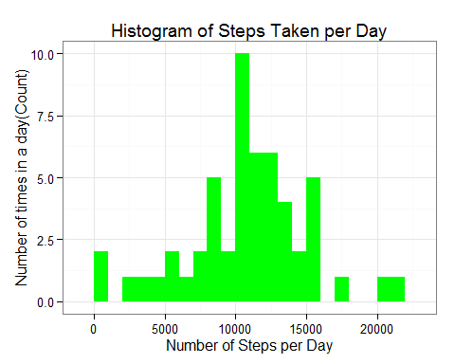

steps_mean <- mean(steps_per_day$steps, na.rm=TRUE)  
steps_median <- median(steps_per_day$steps, na.rm=TRUE)  
  
steps_per_interval <- aggregate(rdata$steps,   
 by = list(interval = rdata$interval),  
 FUN=mean, na.rm=TRUE)  
#convert to integers  
##this helps in plotting  
steps_per_interval$interval <-   
 as.integer(levels(steps_per_interval$interval)[steps_per_interval$interval])  
colnames(steps_per_interval) <- c("interval", "steps")  
  
ggplot(steps_per_interval, aes(x=interval, y=steps)) +   
 geom_line(color="orange", size=1) +   
 labs(title="Average Daily Activity Pattern", x="Interval", y="Number of steps") +   
 theme_bw()

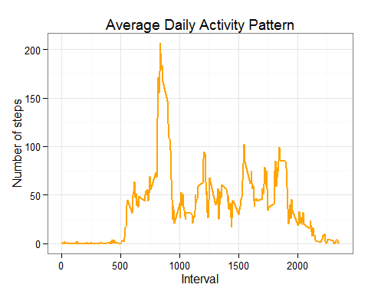

max_interval <- steps_per_interval[which.max(   
 steps_per_interval$steps),]  
  
missing_vals <- sum(is.na(rdata$steps))  
  
  
na_fill <- function(data, pervalue) {  
 na_index <- which(is.na(data$steps))  
 na_replace <- unlist(lapply(na_index, FUN=function(idx){  
 interval = data[idx,]$interval  
 pervalue[pervalue$interval == interval,]$steps  
 }))  
 fill_steps <- data$steps  
 fill_steps[na_index] <- na_replace  
 fill_steps  
}  
  
rdata_fill <- data.frame(   
 steps = na_fill(rdata, steps_per_interval),   
 date = rdata$date,   
 interval = rdata$interval)  
str(rdata_fill)

## 'data.frame': 17568 obs. of 3 variables:  
## $ steps : num 1.717 0.3396 0.1321 0.1509 0.0755 ...  
## $ date : Date, format: "2012-10-01" "2012-10-01" ...  
## $ interval: Factor w/ 288 levels "0","5","10","15",..: 1 2 3 4 5 6 7 8 9 10 ...

sum(is.na(rdata_fill$steps))

## [1] 0

fill_steps_per_day <- aggregate(steps ~ date, rdata_fill, sum)  
colnames(fill_steps_per_day) <- c("date","steps")  
  
##plotting the histogram  
ggplot(fill_steps_per_day, aes(x = steps)) +   
 geom_histogram(fill = "blue", binwidth = 1000) +   
 labs(title="Histogram of Steps Taken per Day",   
 x = "Number of Steps per Day", y = "Number of times in a day(Count)") + theme_bw()

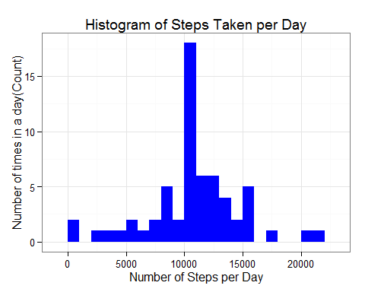

steps_mean_fill <- mean(fill_steps_per_day$steps, na.rm=TRUE)  
steps_median_fill <- median(fill_steps_per_day$steps, na.rm=TRUE)  
  
weekdays_steps <- function(data) {  
 weekdays_steps <- aggregate(data$steps, by=list(interval = data$interval),  
 FUN=mean, na.rm=T)  
 # convert to integers for plotting  
 weekdays_steps$interval <-   
 as.integer(levels(weekdays_steps$interval)[weekdays_steps$interval])  
 colnames(weekdays_steps) <- c("interval", "steps")  
 weekdays_steps  
}  
  
data_by_weekdays <- function(data) {  
 data$weekday <-   
 as.factor(weekdays(data$date)) # weekdays  
 weekend_data <- subset(data, weekday %in% c("Cumartesi","Pazar"))  
 weekday_data <- subset(data, !weekday %in% c("Cumartesi","Pazar"))  
   
 weekend_steps <- weekdays_steps(weekend_data)  
 weekday_steps <- weekdays_steps(weekday_data)  
   
 weekend_steps$dayofweek <- rep("weekend", nrow(weekend_steps))  
 weekday_steps$dayofweek <- rep("weekday", nrow(weekday_steps))  
   
 data_by_weekdays <- rbind(weekend_steps, weekday_steps)  
 data_by_weekdays$dayofweek <- as.factor(data_by_weekdays$dayofweek)  
 data_by_weekdays  
}  
  
data_weekdays <- data_by_weekdays(rdata_fill)  
  
  
ggplot(data_weekdays, aes(x=interval, y=steps)) +   
 geom_line(color="violet") +   
 facet_wrap(~ dayofweek, nrow=2, ncol=1) +  
 labs(x="Interval", y="Number of steps") +  
 theme_bw()

