## Screen Mock-ups

## Main Menu

When application begins to run, Player will see main menu screen. Main menu screen shows six options to Player which are play game, change settings, view credits, view own statistics, view help and exit game. (Figure 5.2.1)

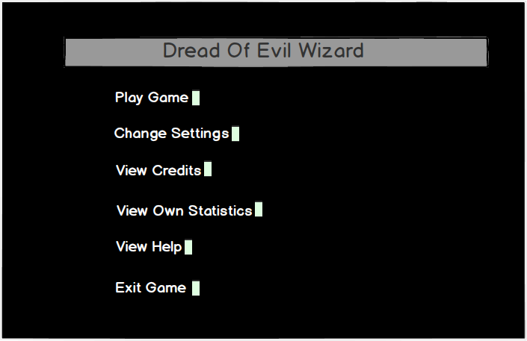

**Figure 5.2.1 Screen shot of Main Menu**

**Play Game:** If Player selects Play Game, player will select either New Game or Load Game. Figure 5.2.1.1 is a screen shot from Play Game Menu. Player can go to main menu by clicking on the Back button.

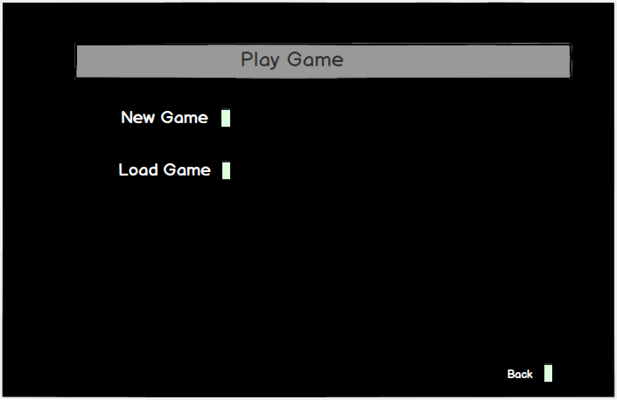

**Figure 5.2.1.1 Screen shot of Play Game Menu**

**New Game:** If Player selects New Game, then player will be able to select one of the three characters. Figure 5.2.1.2 is a screen shot from New Game Menu. Player can go to Play Game menu by clicking on the Back button.

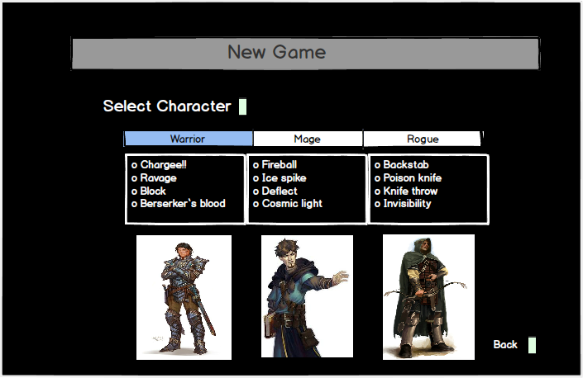

**Figure 5.2.1.2 Screen shot of New Game Menu**

**Warrior:** After player selects one of the characters based on their skills (for example warrior), he can start the game. Figure 5.2.1.3 is a screen shot from gameplay. The upper left space is for console messages, the upper right side is for multifunctional purposes such as map or visualization of war and the bottom space is text box to get commands from player.

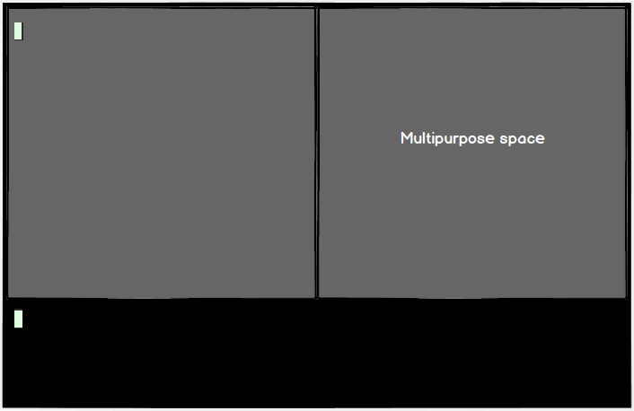

**Figure 5.2.1.3 Screen shot of gameplay**

**Change Settings:** When change settings button is pressed a list of options are shown on screen. These settings can be changed by Player manually. (Figure 5.2.1.4) Player can on/off game sounds and change the difficulty level of the game as easy or hard. The selected ones is shown in red color. Player can go to main menu by clicking on the Back butt

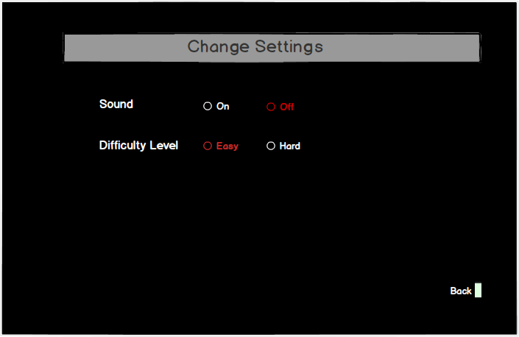

**Figure 5.2.1.4 Screen shot of Change Settings**

**View Credits:** When view credits button is pressed the developers of the game and the contact information will be shown on the screen. (Figure 5.2.1.5) Player can go to main menu by clicking on the Back button.

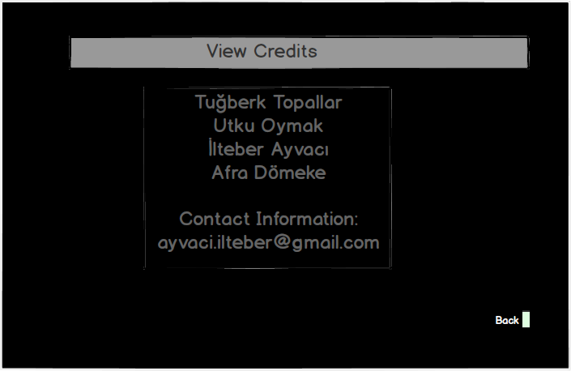

**Figure 5.2.1.5 Screen shot of View Credits**

**View Own Statistics:** When View Own Statistics button is pressed, the percentage of completed content and the number of completed Quests, killed monsters, collected items will be shown. (Figure 5.2.1.6) Player can go to main menu by clicking on the Back button.

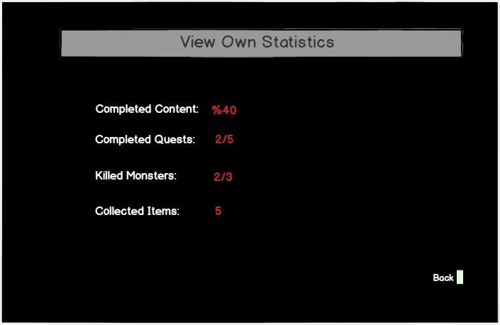

**Figure 5.2.1.6 Screen shot of View Own Statistics**

**View Help:** When the player selects View Help button System displays the help guide which contains information about game dynamics, monsters, and quests that is prepared by developer team. (Figure 5.2.1.7) Player can go to main menu by clicking on the Back button.

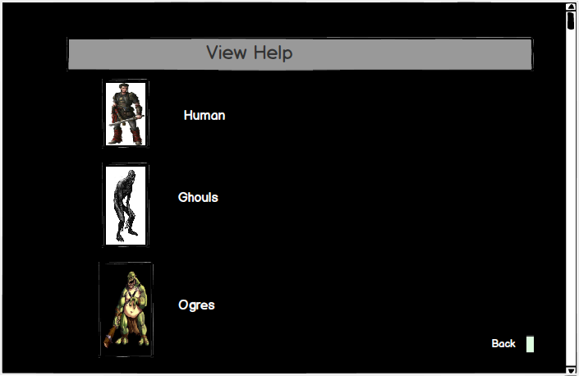

**Figure 5.2.1.7 Screen shot of View Help Menu**

**Ogres:** When the player wants to get information of the objects on the View Help Menu, he can click on it and the further information will be supplied about the selected item. (For example Ogres is selected in this particular example (Figure 5.2.1.8)) Player can go to main menu by clicking on the Back button.

**Figure 5.2.1.8 Screen shot of Help menu of Ogres**

