International Program on Computer Science
Providence University
Graduation Project Proposal

Project Name: | Autonomous Indoor Delivery Robot with LiDAR Safety and QR Locker System
Class: | International Program on Computer Science
Student: | ID: 411221532 許俊成 - Leader  ID: 411221566 張美勤  ID: 411221558 菲茲雷  ID: 411214802 特達
Advisor: | 蔡英德
Submission Date: | 1st June 2026

Abstract
This proposal presents the design and current prototype of an autonomous indoor delivery robot. The original project direction was a security self-driving car. During the first stage, the group evaluated Raspberry Pi 4 and Raspberry Pi 5 as possible controllers, and later studied Jetson Xavier NX because real-time object detection requires stronger AI acceleration. After reviewing the difficulty of outdoor patrol, outdoor navigation, and security monitoring, the group changed the topic to an indoor autonomous delivery car after May 1.
The current semester prototype is a software-oriented demo running on a laptop with an iPhone LiDAR camera through the Record3D application. The system includes a Python GUI, RGBD camera input, LiDAR/depth safety checking, two operation modes, mapping, visual odometry, YOLO-based object detection preparation, face recognition support, QR-code locker unlocking, and save/load map functions. The current demo is not yet a completed vehicle. Instead, it is a working foundation that proves the main sensing, interface, and delivery-locker logic before integration with physical motors and an embedded controller.
For the next semester, the project will move from the laptop demo to a real robot platform. The planned hardware includes Jetson Xavier NX for AI computation, ESP32 for motor and locker control, motor drivers, a power system, and a physical delivery locker. The expected result is a small indoor robot that can move safely in a building, detect nearby obstacles, support delivery authentication through QR code, and provide a practical demonstration of autonomous indoor delivery.

Table of Contents
Contents
Abstract 2
Table of Contents 3
1. Introduction 3
1.1 Background and Motivation 3
1.2 Problem Statement 5
1.3 Project Objectives 6
1.4 Project Scope and Limitations 7
2. Literature Review and Technical Background 8
2.1 Embedded AI Computing Platforms 8
2.2 RGBD Camera and LiDAR Streaming 8
2.3 Object Detection and Face Recognition 9
2.4 Mapping, Visual Odometry, and QR Authentication 9
3. Methods, Procedures, and Progress 9
3.1 System Overview 9
3.2 Hardware Plan 10
3.3 Software Architecture 11
3.4 AI model preloading 12
3.5 Camera Connection Failure Handling 13
3.6 Drive Mode 13
3.7 Map Mode 13
3.8 QR Locker Delivery Function 15
3.9 Save and Load Map Function 15
3.10 Testing Results and Demonstration Evidence 17
3.11 Current Progress 17
3.12 Anticipated Problems and Means of Resolution 18
4. Anticipated Results and Achievements 18
5. Next Semester Plan 19
6. References 20
7. Meeting Records 21

1. Introduction

1.1 Background and Motivation
Indoor delivery has become a meaningful robotics topic because many buildings require repeated movement of documents, small packages, tools, or personal items between rooms, offices, laboratories, classrooms, and reception areas. Although human delivery is flexible, many of these tasks are simple, repetitive, and time-consuming. In places such as universities, offices, hospitals, and laboratories, a small autonomous delivery robot can reduce unnecessary walking, improve delivery organization, and provide a safer way to transport items in controlled indoor environments.
The motivation of this project is to build a practical prototype that connects computer science knowledge with a real robotic application. Instead of only studying algorithms separately, this project allows us to combine camera input, depth sensing, object detection, mapping, user interface design, QR authentication, and embedded control into one system. Through this project, our group can better understand how an autonomous robot receives sensor data, makes decisions, and interacts with users.
At the beginning, our group considered building a security self-driving car. The first version of the idea focused on patrolling, monitoring, and recognizing people or objects. At that stage, Raspberry Pi boards were considered because they are affordable, common in student projects, and suitable for basic camera and motor control. However, after discussing YOLO detection and recognition, we found that real-time AI detection would be difficult on Raspberry Pi without additional acceleration. The group then considered Jetson Xavier NX as a stronger AI platform, especially because NVIDIA describes the Jetson Xavier NX as an edge AI module capable of running modern neural networks with accelerated computing.
However, the security car direction also introduced many practical difficulties. Outdoor navigation is more complex than indoor movement because lighting conditions, road surfaces, weather, localization, and unpredictable obstacles can change quickly. For a one-year graduation project, building a reliable outdoor security patrol car would be too broad and risky. Therefore, after May 1, the group changed the topic to an autonomous indoor delivery robot.
This new direction is more suitable for our time, hardware, and testing environment. It still includes important technical topics such as object detection, depth sensing, LiDAR safety, mapping, QR-code authentication, and embedded control, but the indoor environment is more controlled and easier to evaluate. The delivery robot topic also gives the project a clearer real-world purpose: transporting small items safely and verifying the receiver before unlocking the delivery locker. For this semester, the project focuses on a software prototype using a laptop and an iPhone LiDAR camera. This allows the group to validate the main perception and delivery workflow before moving to Jetson Xavier NX, ESP32 motor control, and a physical robot platform in the next semester.

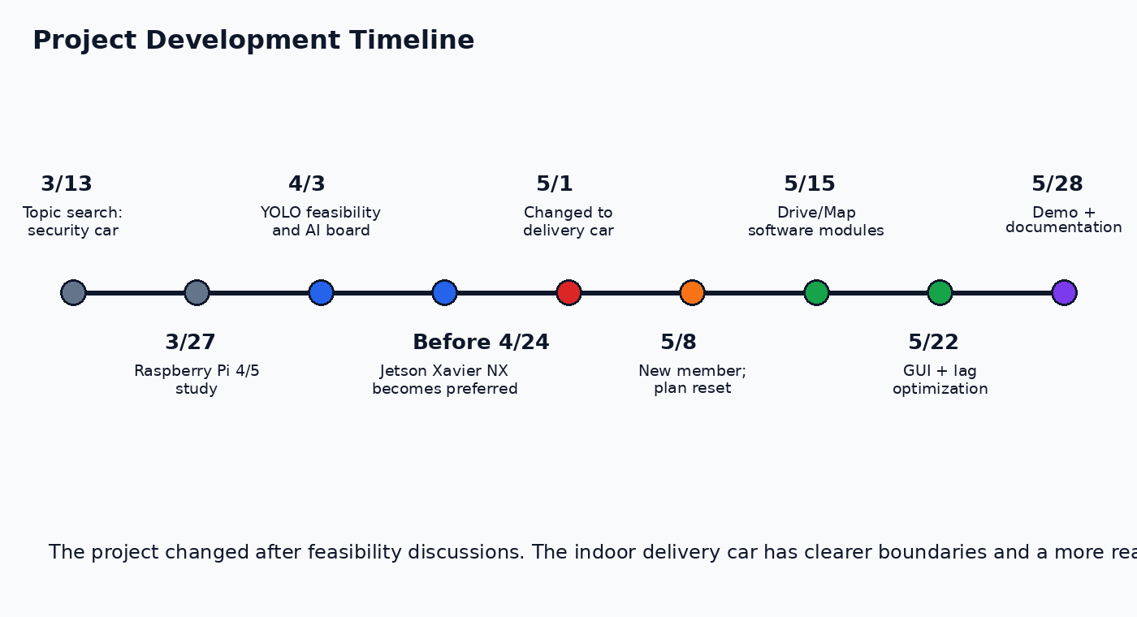
Figure 1. Project topic and platform decision timeline.

1.2 Problem Statement
The main problem addressed by this project is how to design a small indoor delivery robot that can deliver items safely, verify the receiver, and be developed step by step before the complete robot hardware is finished. A practical delivery robot should not only move from one place to another, but also understand the space in front of it, detect nearby obstacles, provide a clear control interface, and protect the delivered item until the correct receiver is authorized.
For a student graduation project, the development process also creates another challenge. The complete robot platform, including motors, battery, chassis, and physical locker, cannot be finished immediately. However, the software system still needs to be tested early. If the group waits until all hardware is ready, many problems in camera input, depth processing, mapping, GUI design, and delivery authentication may appear too late. Therefore, this project needs a prototype that can test the main perception and delivery workflow before full hardware integration.
The current semester focuses on solving this problem through a desktop-based RGBD prototype. An iPhone LiDAR camera is used as a temporary depth sensor through Record3D, while the laptop runs the Python GUI and processing modules. This setup allows the group to test RGBD camera streaming, depth measurement, LiDAR safety zones, mapping preview, visual odometry, QR-code delivery authentication, and save/load map functions before moving the system to Jetson Xavier NX, ESP32 motor control, and a real locker mechanism in the next semester.
In this way, the project separates the problem into two stages. The first stage proves the software pipeline and user interaction. The second stage will connect the tested software logic to physical movement and real robot hardware.

1.3 Project Objectives
The main objective of this project is to develop a working software prototype for an autonomous delivery robot. Since the physical robot platform is still under development, this semester focuses on validating the sensing, safety, mapping, interface, and delivery-authentication workflow through a laptop-based RGBD demo.
The specific objectives are as follows:
- Develop a software prototype for an indoor delivery robot.
The system should provide a clear foundation for future integration with a real robot chassis, motor control, and locker mechanism.
- Use RGBD data for depth-based perception.
The prototype uses an iPhone LiDAR camera through Record3D to obtain RGB images and depth frames. These data are used to test distance measurement, obstacle detection, and safety warnings.
- Implement two operation modes.
Drive mode is designed for lightweight real-time operation, including camera preview, LiDAR safety, and QR delivery operation. Map mode is designed for environment mapping, visual odometry testing, and save/load map functions.
- Design a modular and usable GUI.
The interface separates main controls from mode-specific options. This makes the system easier to operate during testing and final demonstration.
- Develop a QR-code locker delivery workflow.
The system generates a random delivery code and QR payload. During delivery, the locker state becomes locked. The locker is unlocked only when the camera scans the matching QR payload.
- Prepare for next-stage hardware integration.
The software structure is designed for future migration to Jetson Xavier NX, ESP32 motor control, and a physical locker mechanism.
Overall, the objective of this semester is not to complete the full autonomous vehicle, but to prove that the core software pipeline works before connecting it to real hardware.

1.4 Project Scope and Limitations
This project should be understood as a current-semester software prototype, not a finished autonomous delivery robot. The focus of this stage is to verify the main perception and delivery workflow before physical robot integration.
The current project scope includes:
- RGBD camera connection through Record3D.
- Python GUI with Start Camera and Stop Camera controls.
- Drive mode and Map mode operation.
- Depth-based center distance and front safety detection.
- LiDAR safety zone visualization.
- Lightweight local/global mapping preview.
- Visual odometry testing using RGBD frames.
- QR-code locker simulation.
- Save and load map functions.
- Modular software structure for future development.
The current project does not yet include a completed robot chassis, real motor movement, battery system, or physical locker mechanism. These parts are planned for the next stage. The current locker is simulated in software, but the code is prepared to send LOCK and UNLOCK commands to ESP32 through serial communication when the real hardware is connected.
The prototype also has several limitations. First, the frame rate is limited by Record3D RGBD streaming, Tkinter rendering, and CPU-based depth processing. In practice, the system is closer to a stable demo frame rate rather than high-speed real-time robot operation. Second, the current mapping method is a lightweight occupancy-grid approach. It is useful for demonstrating depth-based mapping, but it is not a complete SLAM system because it does not include loop closure, pose graph optimization, or long-term map correction. Third, visual odometry is not always stable. It may fail when the camera faces a flat wall, a monitor, a dark area, or a scene without enough visual features. Fourth, YOLO and InsightFace are computationally heavy, so they must be preloaded or executed less frequently to avoid camera delay.
Even with these limitations, the current prototype is valuable because it validates the software architecture, GUI workflow, RGBD input, depth safety logic, mapping concept, and QR delivery authentication before the group moves to the real robot platform next semester.

2. Literature Review and Technical Background

2.1 Embedded AI Computing Platforms
The group originally evaluated Raspberry Pi 4 and Raspberry Pi 5. Raspberry Pi is attractive because it is inexpensive, widely documented, and suitable for basic GPIO, camera input, and motor-control experiments. Raspberry Pi 5 uses a 64-bit quad-core Arm Cortex-A76 processor at 2.4 GHz and is positioned as a much faster generation than Raspberry Pi 4 . This makes it practical for general programming and simple robotics experiments.
However, the project requires real-time or near-real-time AI functions such as object detection and possible face recognition. These tasks are more suitable for a board with GPU acceleration. Jetson Xavier NX was therefore selected as the preferred next-stage AI computer because it is designed for edge AI applications and provides accelerated computing for neural networks . In our project plan, Jetson Xavier NX will run the camera, AI, mapping, and high-level robot logic, while ESP32 will handle low-level motor and locker control.

2.2 RGBD Camera and LiDAR Streaming
The current prototype uses the iPhone LiDAR camera as the depth sensor. Since direct ARKit access from a Windows Python program is not straightforward, the project uses Record3D as a bridge. The Record3D Python library can stream RGBD video from supported iOS devices to a computer through USB or related methods . This makes it suitable for a quick prototype before the final robot camera and sensor configuration is fixed.
The RGBD data consists of a normal color image and a depth image. The color image is used for camera preview, object detection, face recognition, and QR scanning. The depth image is a matrix of distance values. The program uses this matrix to estimate center distance, front safety distance, and map updates.

2.3 Object Detection and Face Recognition
YOLO is used as the planned object detection method. YOLO is suitable for robotics demos because it can predict bounding boxes and class probabilities directly from full images in a single evaluation, which makes it faster than many two-stage object detectors . In this project, YOLO can be used to detect persons or objects when needed, but it is not forced to run on every frame because real-time camera performance is more important during driving.
Face recognition is implemented with InsightFace. InsightFace is an open-source face analysis toolbox that includes face recognition, face detection, and face alignment functions . In our prototype, the face module can register a face profile and compare a new face embedding with saved embeddings using cosine similarity. This is treated as an optional function rather than a core requirement for the delivery robot.

2.4 Mapping, Visual Odometry, and QR Authentication
Mapping is built around the idea of an occupancy grid. The robot marks some cells as free space and some cells as obstacles according to depth measurements. The local map represents the space near the robot, while the global map is intended to represent a larger area when camera pose or visual odometry is available.
Open3D is used for RGBD visual odometry and 3D data processing support. Open3D is an open-source library designed for rapid development of software that handles 3D data . In this project, visual odometry estimates relative camera movement so that depth observations can be placed into a larger map. QR authentication is implemented using QR code generation and OpenCV QR detection. OpenCV provides QRCodeDetector functions for detecting and decoding QR codes from images .

3. Methods, Procedures, and Progress

3.1 System Overview
The system is divided into a current demo stage and a future robot stage. In the current stage, the laptop runs the main Python application and receives RGBD data from the iPhone LiDAR camera. In the future stage, the same high-level structure will be moved to Jetson Xavier NX. ESP32 will be added for motor control and locker control, because small microcontrollers are reliable for real-time low-level signals.
The prototype is designed around two main modes. Drive mode is lightweight and focuses on camera preview, LiDAR safety, and delivery QR scanning. Map mode is heavier and focuses on mapping, visual odometry, and save/load functions. This separation is important because running all functions at the same time causes lag.
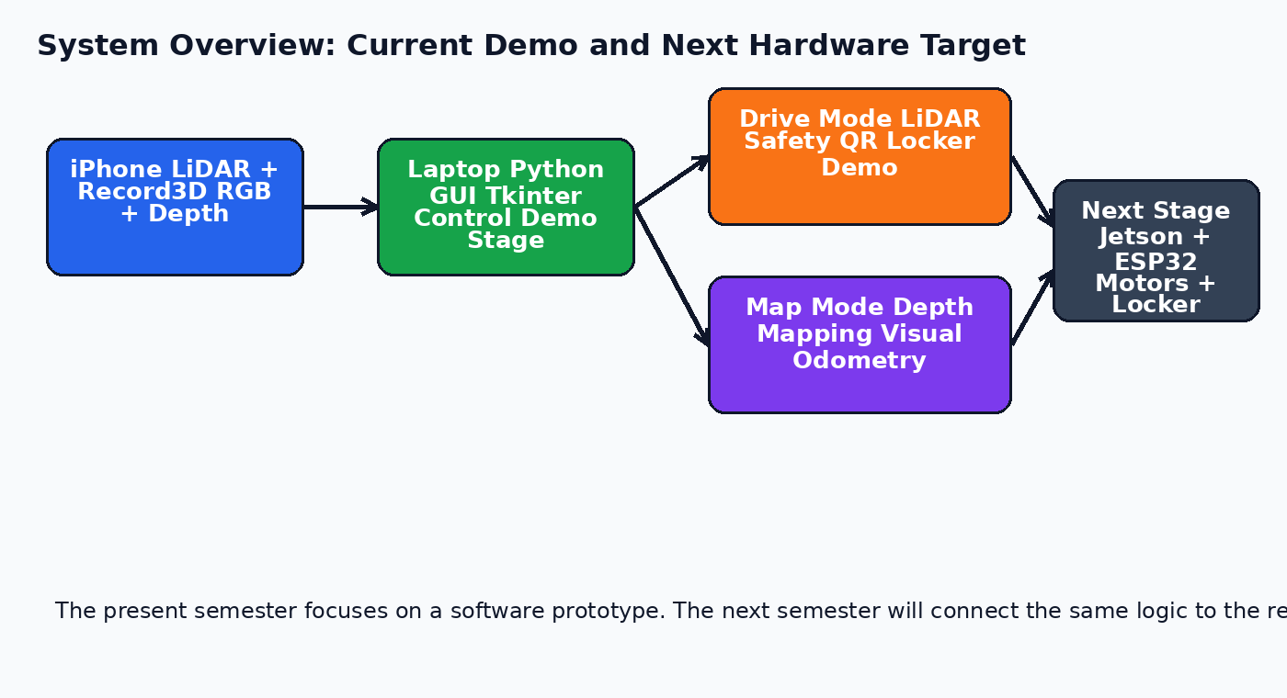
Figure 2. Current demo system and next-stage hardware target.

3.2 Hardware Plan
The current demo hardware and next-stage hardware are summarized below.
Part | Current Semester Demo | Next Semester Target
Main computer | Laptop running Python GUI | Jetson Xavier NX
Depth sensor | iPhone LiDAR through Record3D | Depth camera or iPhone/Record3D during transition
Motor control | Not physically connected yet | ESP32 + motor driver
Locker | Software simulation | Servo/solenoid locker controlled by ESP32
Power | Laptop and phone battery | Battery pack with voltage regulation
Chassis | Not finalized | 3D printed or assembled robot frame

3.3 Software Architecture
The code was divided into modules so that the project can be managed and debugged more easily. The GUI file controls the application flow, while camera, depth processing, LiDAR safety, mapping, visual odometry, model loading, locker logic, and save/load functions are placed in separate files. This prevents one large file from becoming too difficult to maintain.
The most important files are main.py, gui.py, config.py, app_state.py, camera_record3d.py, depth_utils.py, lidar_safety.py, mapping.py, visual_odometry.py, models.py, face_recognition_utils.py, locker.py, and save_load.py. The file config.py stores parameters such as thresholds, map sizes, FPS limits, and mode configurations. The file app_state.py stores shared runtime state, such as map arrays, LiDAR display status, and visual odometry state.
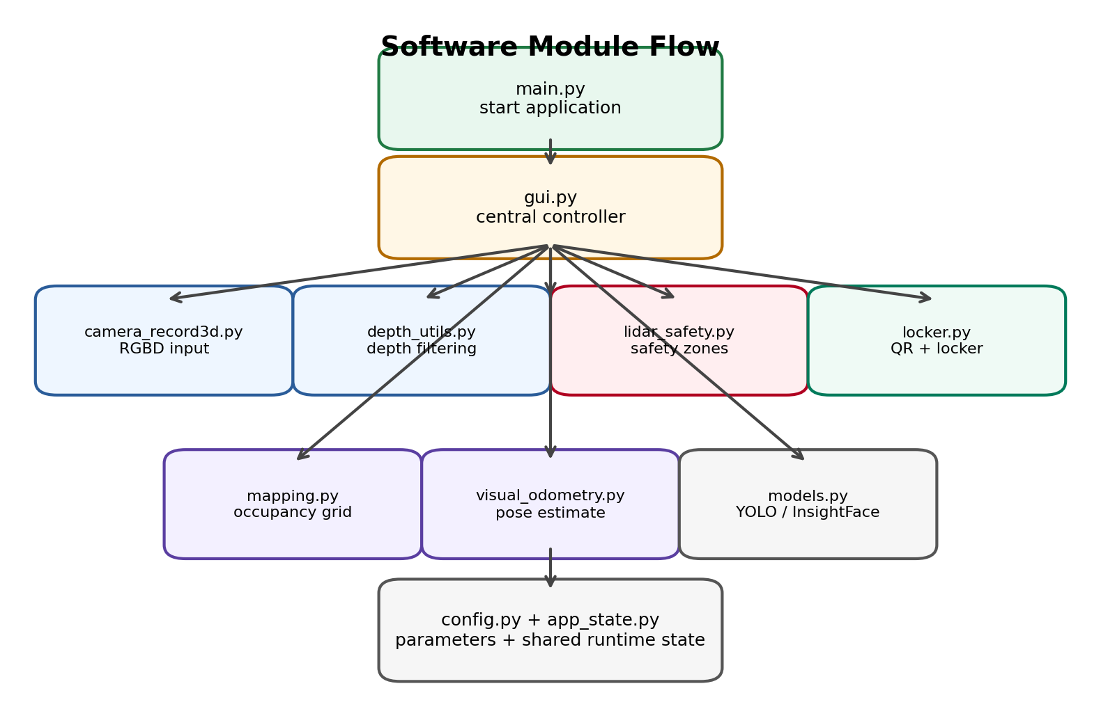
Figure 3. Modular software architecture.
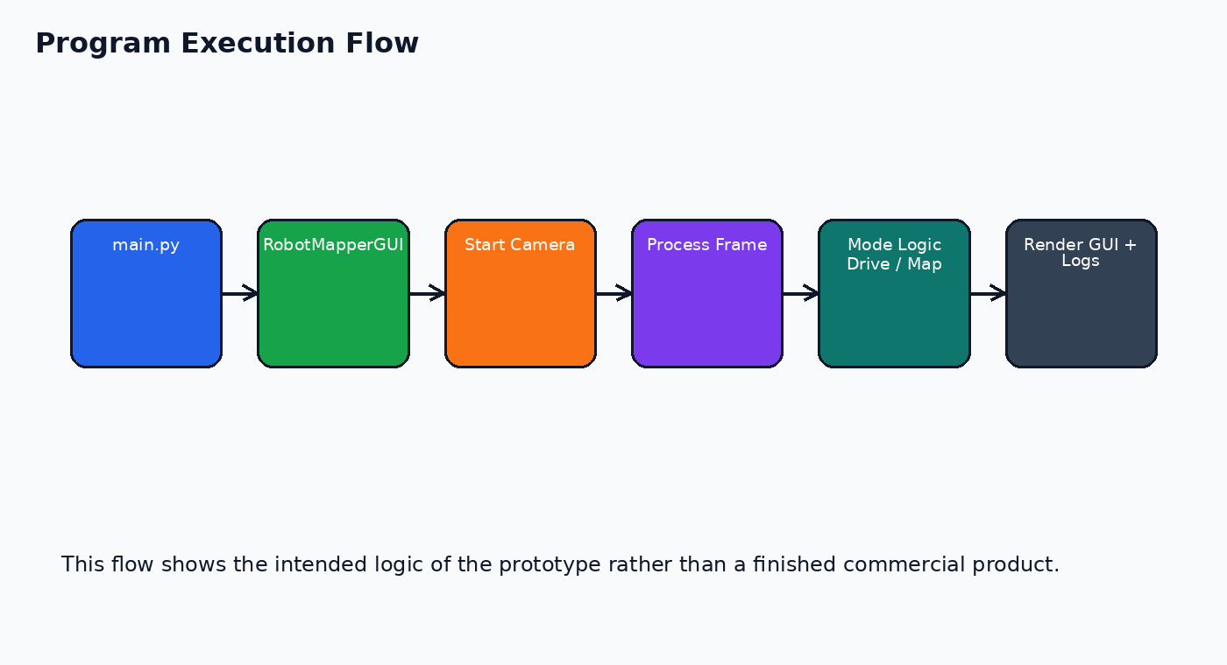
Figure 4. Main program execution flow.

3.4 AI Model reloading
The program preloads YOLO and InsightFace before the user starts the camera. During this time, a loading window appears and disables user controls. This design prevents the user from starting Record3D streaming while heavy models are still loading. It reduces the chance of strong delay at camera startup.
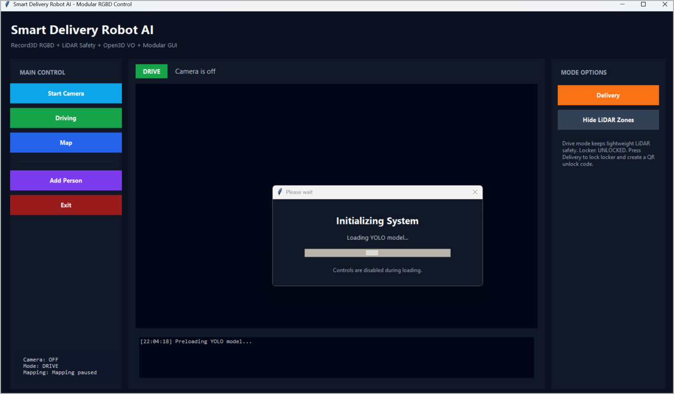
Figure 5. Loading overlay used while YOLO and InsightFace are initialized.

3.5 Camera Connection Failure Handling
If the iPhone or Record3D USB stream is not found, the program should show a clear English error message instead of crashing. This is important for classroom demonstration because the camera cable, phone app, or USB connection may not be ready. A friendly error message helps the operator correct the problem quickly.

3.6 Drive Mode
Drive mode is designed for the robot operating stage. In this mode, the priority is low latency. The program keeps camera preview and LiDAR safety active, while heavy functions such as mapping, visual odometry, face recognition, and YOLO can be disabled or run only at long intervals. This design decision was made after the group observed that running many functions together caused camera delay.
The safety logic reads the depth frame and checks important front zones. The prototype distinguishes between center distance and front safety distance. Center distance is a quick measurement from a small region at the middle of the depth image. Front distance is calculated from larger safety zones such as left, center, right, and low areas. This gives a more useful safety warning than looking at only one pixel in the center.
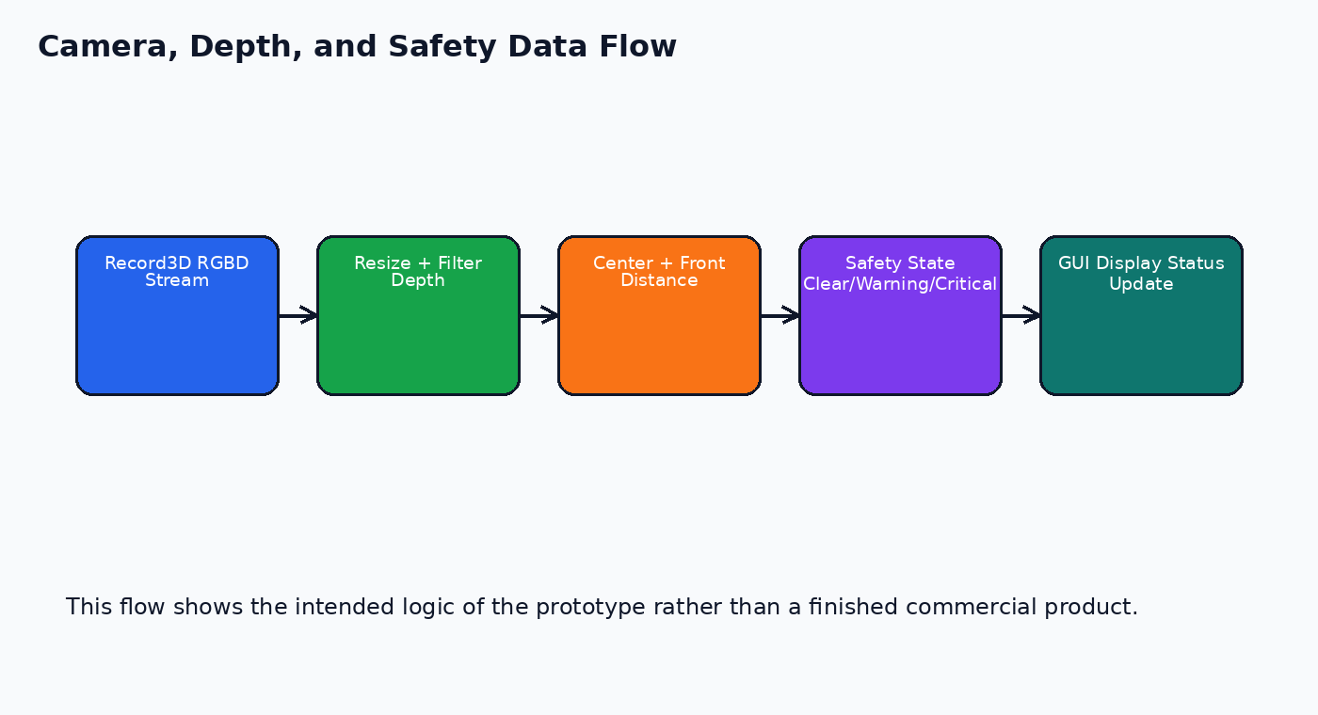
Figure 6. Camera, depth, and LiDAR safety flow.

3.7 Map Mode
Map mode is used when the user wants to scan and store information about the environment. The program uses the depth frame to update an occupancy grid. A ray from the
camera to a measured surface marks the space before the surface as free. The endpoint may be marked as an obstacle if it satisfies the obstacle conditions.
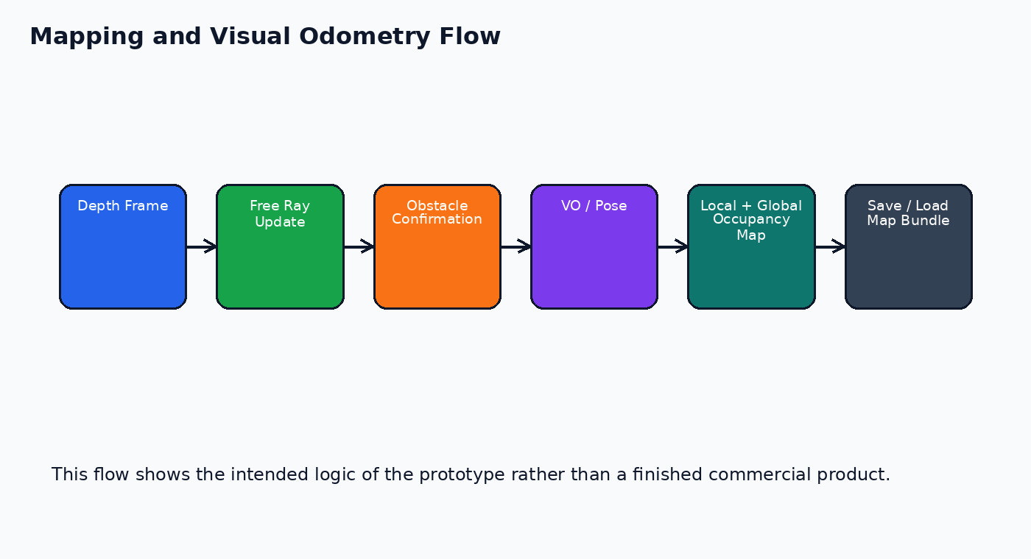
Figure 7. Mapping and visual odometry flow.
To reduce false obstacles, the system ignores lower image regions that are likely to be floor and requires repeated obstacle hits before strong confirmation.
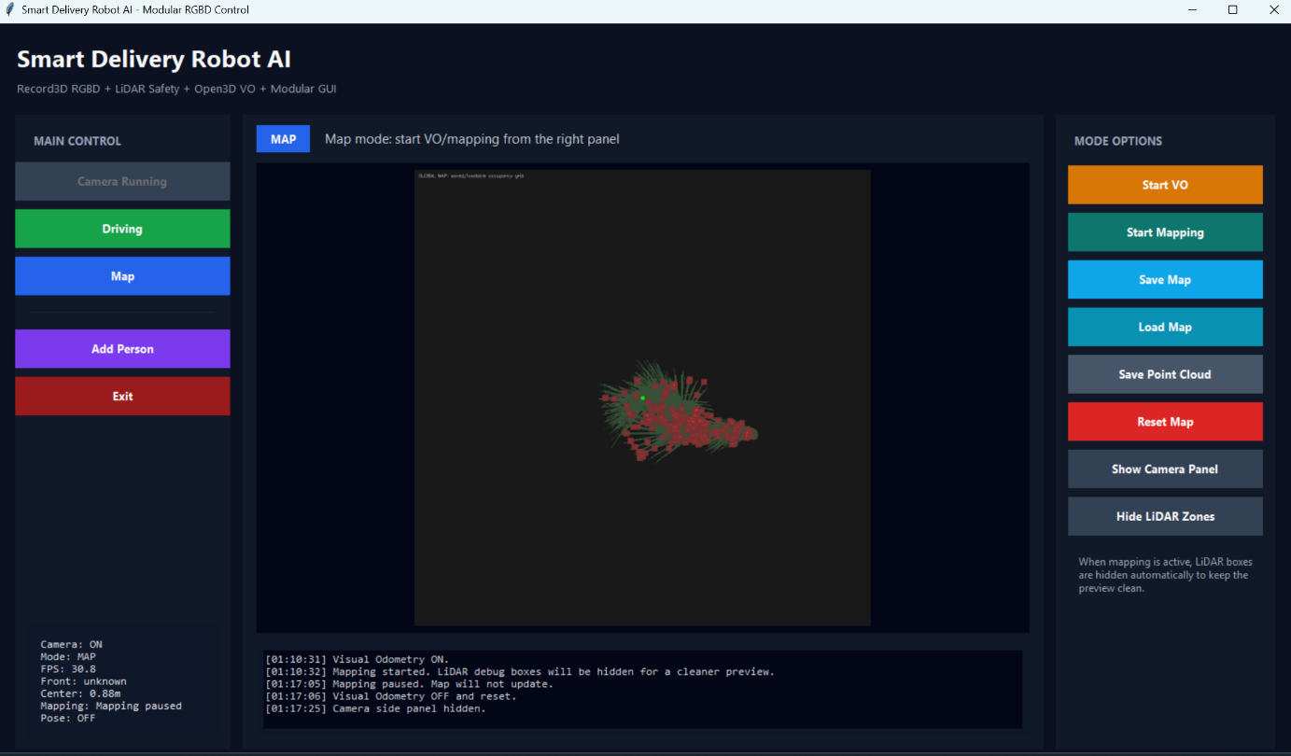
Figure 8. Mapping GUI.
Visual odometry is used when available to estimate the movement of the camera. Without pose information, the robot can still use local mapping, but global mapping becomes unreliable because the program cannot know where the camera has moved. This is why the project treats the current mapping as a lightweight SLAM-like prototype rather than a complete SLAM implementation.

3.8 QR Locker Delivery Function
The QR locker function is the clearest delivery-related function in the current demo. When the user presses the Delivery button in Drive mode, the program generates a random delivery code and creates a QR payload. The locker state becomes locked. A QR window appears, and the user can show this QR code to the robot camera. If the camera reads the same payload, the locker is unlocked.
At this stage the locker is simulated in software. This is intentional, because the current semester focuses on software behavior and demo flow. The locker controller is written so that a future ESP32 can be connected through serial communication. When ESP32 is connected, the Python program can send simple text commands such as LOCK and UNLOCK.
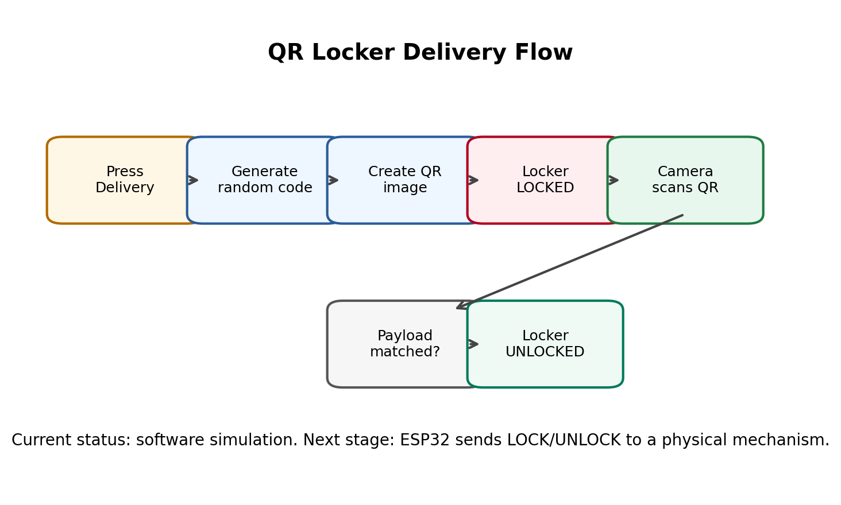
Figure 9. Delivery QR locker flow
Why QR Code Is the Main Authentication Method?
QR code is selected as the main locker authentication method because it is simple, fast, and stable for a classroom prototype. Compared with face recognition, QR authentication is less affected by lighting, camera angle, facial occlusion, or recognition accuracy. Therefore, the current system uses QR code as the main method to unlock the locker.

Face recognition is kept as an optional identity-support module. In the future, it can be used to record who received the package, provide secondary verification, or support operator permission control. However, it is not required for the current locker unlocking process.

3.9 Save and Load Map Function
The Save Map and Load Map functions are included because a delivery robot should not need to rebuild the same map from zero every time. The current save dialog records the user/operator name, project note, and optional autosave setting. The saved data can later be loaded for demonstration or testing.
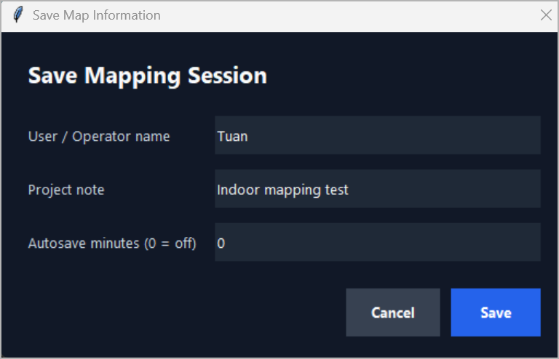
Figure 10. Save Mapping Session dialog with operator name and project note.
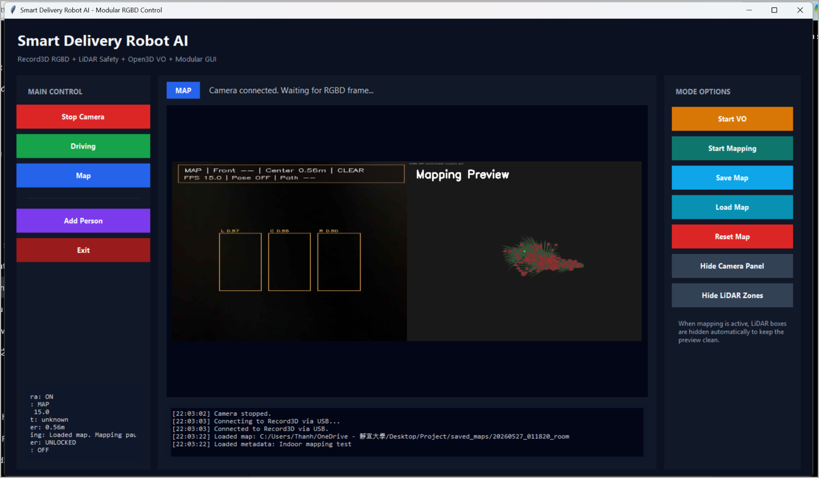
Figure 11. Loaded map preview displayed in Map mode.
The current map is not yet a complete navigation map for a finished robot, but it is useful for testing the software workflow. It shows that the program can store mapping results and return to the same map session later.

3.10 Testing Results and Demonstration Evidence
The screenshots collected during the demo show that the prototype can start, preload AI models, connect to Record3D, show camera and depth values, display safety overlays, generate QR codes, switch between Drive and Map modes, and save/load map information. These results prove that the current semester work produced a functional software pipeline.
Function | Result | Notes
Startup and model loading | Works | Loading overlay prevents user actions before YOLO and InsightFace finish loading.
Camera connection | Works with Record3D USB | Requires iPhone unlocked and Record3D opened.
Drive mode | Works | Shows camera, FPS, center/front depth, and locker status.
LiDAR safety | Partially stable | Depth may become unknown on reflective surfaces or extremely close distances.
QR locker | Works in software | QR generation and camera scanning can change locker state from LOCKED to UNLOCKED.
Map mode | Works as preview | Occupancy map can update and be saved/loaded.
VO / Pose | Experimental | Can fail in low-texture scenes; currently demo-level only.

3.11 Current Progress
By the end of this semester, the following functions have been implemented or partially implemented:
- Modular Python GUI with Start Camera and Stop Camera controls.
- Drive mode and Map mode with different right-side option panels.
- Record3D camera connection through USB and RGBD frame reading.
- Depth health checking, center distance, and front LiDAR safety state.
- Local and global occupancy-map logic with save/load map bundles.
- Open3D visual odometry testing for relative camera movement.
- YOLO model loading and optional object detection support.
- InsightFace-based face registration and recognition support.
- QR delivery locker simulation with QR generation and camera scanning.
- Performance adjustments such as frame resizing, lower processing frequency, and lighter Drive mode.

3.12 Anticipated Problems and Means of Resolution
Problem | Cause | Planned Resolution
Camera lag | Record3D RGBD streaming, Tkinter rendering, and CPU depth processing | Reduce frame size, process fewer frames, use Jetson/GPU for AI tasks, separate Drive and Map workloads
Unstable depth readings | Reflective surfaces, floor detection, or missing depth points | Use valid-depth filtering, repeated obstacle confirmation, and floor ignore rules
Mapping drift | Visual odometry may fail without good texture or stable motion | Improve camera calibration, reduce motion speed, and evaluate better SLAM methods
YOLO load delay | Model loading is heavy when camera is already running | Preload YOLO before camera start or run it on GPU when the environment is stable
Physical locker integration | Current locker is only simulated | Connect ESP32 with servo or solenoid and test serial commands
Motor control not yet integrated | Current semester focuses on software demo | Implement ESP32 motor control and test basic movement next semester

4. Anticipated Results and Achievements
The expected outcome of this project is a small indoor autonomous delivery robot prototype. The final version should be able to move inside a controlled indoor space, detect close obstacles, provide a GUI for testing, generate and scan QR codes for locker access, and store a simple map of the test environment.
For the current semester, the main achievement is not a complete moving vehicle but a working software foundation. This foundation proves that the group can obtain RGBD data, process depth safely, separate functions into Drive and Map modes, create a user interface, and implement the delivery authentication logic. These parts are essential before spending time on physical integration.
The project also produces practical learning outcomes. The group has studied embedded AI platforms, camera streaming, depth data, object detection, face recognition, visual odometry, occupancy mapping, and serial communication planning. The project therefore connects classroom computer science knowledge with a real robotics system.
- A clearer project scope: indoor delivery instead of broad outdoor security patrol.
- A modular Python codebase that can be extended next semester.
- A GUI workflow that supports demo operation and debugging.
- A QR-based locker authentication flow that matches the delivery scenario.
- A realistic next-stage plan for hardware integration and testing.

5. Next Semester Plan
The next semester will focus on transforming the current software prototype into a real robot platform. The first major task will be building and assembling the physical car structure, including motors, wheels, motor driver, battery, and a simple delivery box. The team will also integrate an ESP32 microcontroller to handle low-level functions such as motor movement and electrical locker control. This stage is important because it connects the software developed during the first semester with actual hardware, allowing the robot to perform real-world tasks.
Another key objective will be transferring the high-level Python system to Jetson Xavier NX, or at minimum testing the same modules on Jetson. The Jetson will provide more computing power for future autonomous functions and serve as the main processing unit for the robot.
The group will also need to design a simple indoor test field. The first movement target should be basic manual or semi-autonomous control. After the motors are stable, the robot can use LiDAR safety to stop near obstacles. Mapping and route planning should be added step by step after the robot can move reliably.
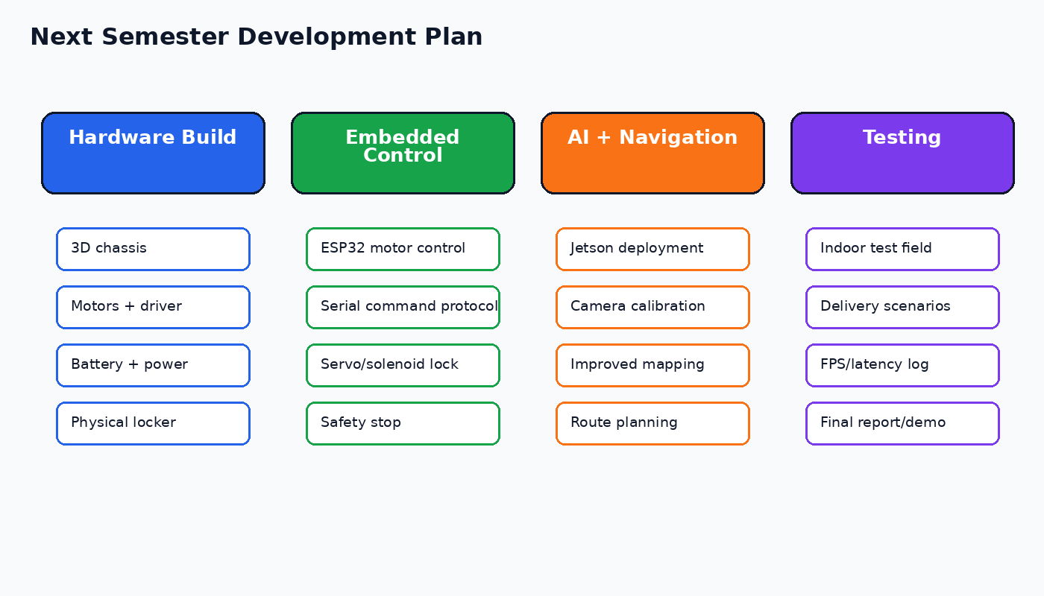
Figure . Next semester development plan.
Stage | Main Work | Expected Output | Risk
1 | Confirm chassis, motor driver, battery, and locker design | Robot body can be assembled safely | Mechanical parts may not fit
2 | ESP32 motor control and serial protocol | Laptop/Jetson can send drive commands | Motor power may be unstable
3 | Physical locker integration | LOCK/UNLOCK works with servo or solenoid | Lock may require more current
4 | Move AI and GUI logic toward Jetson Xavier NX | Camera, YOLO, and safety modules run on target board | GPU/CUDA setup may take time
5 | Indoor navigation test | Robot moves in a controlled indoor route | Mapping and odometry may drift
6 | Final demo preparation | Delivery task demo with QR unlocking | Need stable lighting and repeatable route

6. References
belovictor. (2024, 07 22). ROVER6 Hardware. From GitHub: https://github.com/belovictor/rover6_hardware#enclosure-and-other-3d-printed-parts
Franklin, D. (2025, 10 17). jetson-inference. FroGitHub: https://github.com/dusty-nv/jetson-inference
NVIDIA Jetson Xavier. (n.d.). From NVIDIA : https://www.nvidia.com/en-us/autonomous-machines/embedded-systems/jetson-xavier-series/
Patel, A. (2025, 5 9). autonomous-indoor-delivery-robot. FromGitHub: https://github.com/PAyush15/autonomous-indoor-delivery-robot
Šimoník, M. (2024, 05 27). Record3D – Point Cloud Animation and Streaming: the accompanying library. From GitHub: https://github.com/marek-simonik/record3d/blob/master/README.md
OpenCV, O. (n.d.). Geometric Transformations of Images. From opencv: https://docs.opencv.org/4.x/da/d6e/tutorial_py_geometric_transformations.html
Zhou, Q.-Y., Park, J., & Koltun, V. (2018). Open3D: A Modern Library for 3D Data Processing. From Open3D: https://www.open3d.org/docs/release/introduction.html
Vries, J. d. (n.d.). Transformations. From LearnOpenGL: https://learnopengl.com/Getting-started/Transformations
ylabo0717. (2021, 8 17). iPhone-3D-Reconstruction. GitHub: https://github.com/ylabo0717/iPhone-3D-Reconstruction/blob/main/doc/recording_with_record3d.md

7. Meeting Records
Date | Discussion Focus | Conclusion
3/13 | Security self-driving car topic research; Raspberry Pi 4/5 considered | Continue researching camera modules, basic object detection, and motor control.
3/27 | Roboflow annotation and platform comparison | Check YOLO detection, camera input, and obstacle avoidance requirements.
4/3 | YOLO feasibility and AI board discussion | Raspberry Pi remained possible, but a stronger AI board might be needed.
5/1 | Feasibility review | Jetson Xavier NX became the preferred AI platform.
5/8 | Topic adjustment and new member | Outdoor security navigation was too difficult; indoor delivery became the final direction.
5/15 | Main function definition | Confirmed needed functions: camera, LiDAR safety, QR locker, mapping, and recognition support.
5/22 | Demo preparation and 3D model discussion | Improved GUI, camera flow, and performance issues.
5/28 | Final demo and report discussion | Confirmed the phone LiDAR/camera demo and prepared the final report and presentation.

